Microservices with API gateway

- Hands-On: Creating Microservices for account and loan
- In this hands on exercise, we will create two microservices for a bank. One microservice for handing accounts and one for handling loans.

- Step 1: Create directory structure:
- Create a folder named microservices (e.g., in D drive)
- Inside it, create two subfolders-
  - account
  - loan

- Step 2: Generate Spring Boot Project using Spring initializr:
- Go to https://start.spring.io
- Project setup:
  - Group: com.cognizant
  - Artifact ID: account
  - Language: Java
  - Project: Maven
  - Dependencies selected:
    - Spring Boot Dev Tools
    - Spring Web

- OUTPUT:
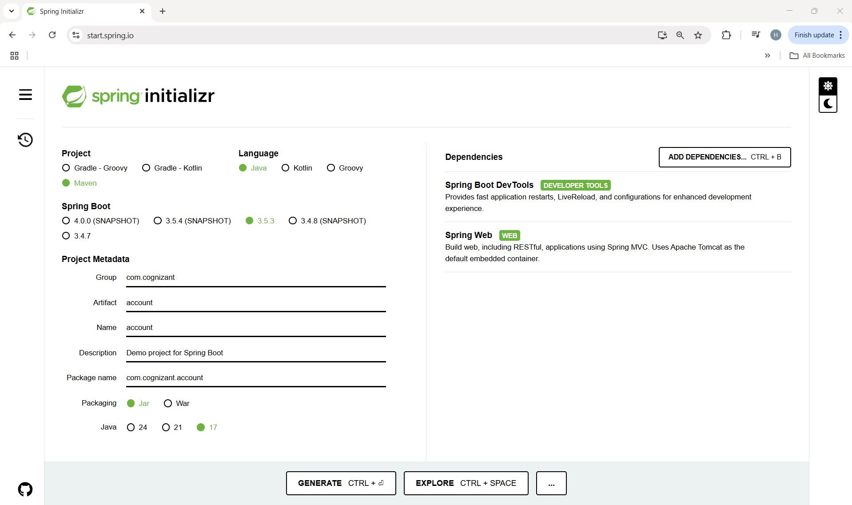
- Step 3: Open the project in IntelliJ IDEA:
- Generate the project and download the zip file.
- Extract it into the C:\microservices folder.
- Open IntelliJ → File > Open, select the extracted account folder in C drive. Intellij will load it as a Maven project.

- Step 4: Add Controller package and class:
- In the path- src/main/java/com/cognizant/account, add a new package named controller.
- In controller package, add a new class named AccountController.java.

- Code:

package com.cognizant.account.controller;

import org.springframework.web.bind.annotation.GetMapping;
import org.springframework.web.bind.annotation.PathVariable;
import org.springframework.web.bind.annotation.RestController;
import java.util.Map;

@RestController
public class AccountController {

@GetMapping("/accounts/{number}")
public Map<String, Object> getAccountDetails(@PathVariable String number) {
return Map.of(
"number", number,
"type", "savings",
"balance", 234343
);
}
}

- OUTPUT:
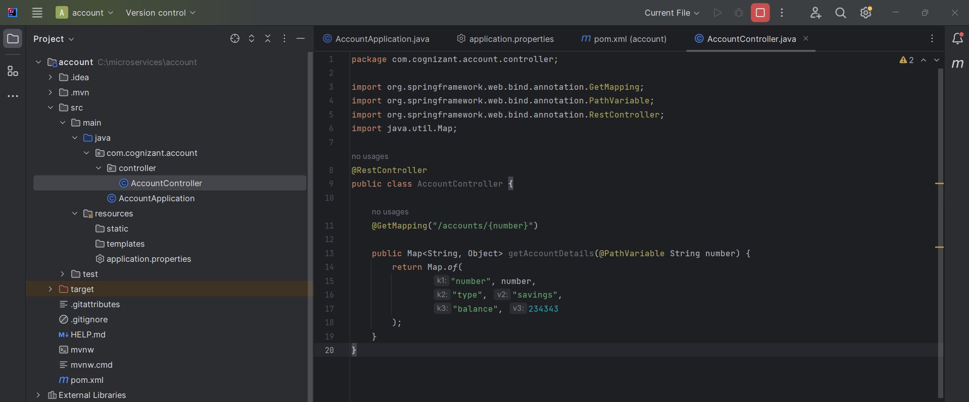

- Step 5: Run the Application:
- Change the port number if the original port(8080) doesn’t work.
In the path- src/main/resources, go to applicaion.properties and add this code:
server.port=8081

- Run the main() method AccountApplication.java

- OUTPUT:
- In Intellij Console-
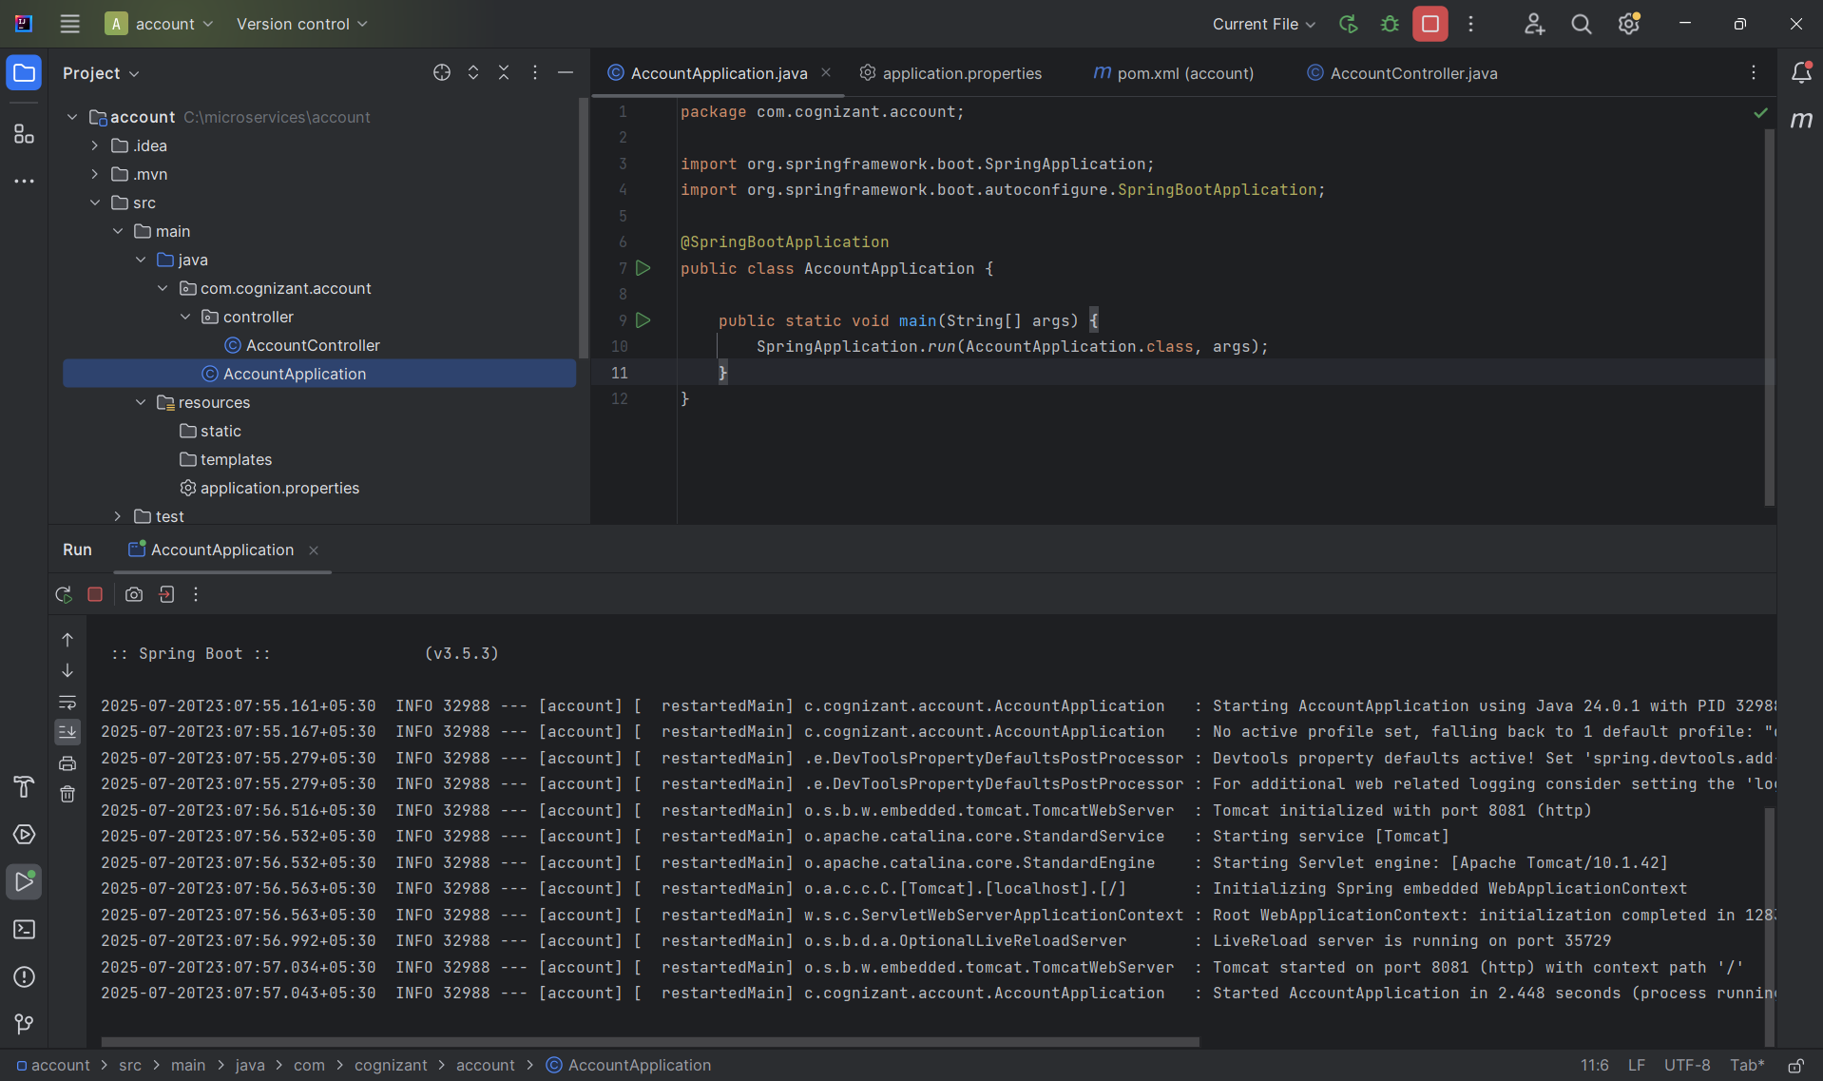

- In the browser-
  - Type this url in the web browser-
http://localhost:8081/accounts/00987587973342
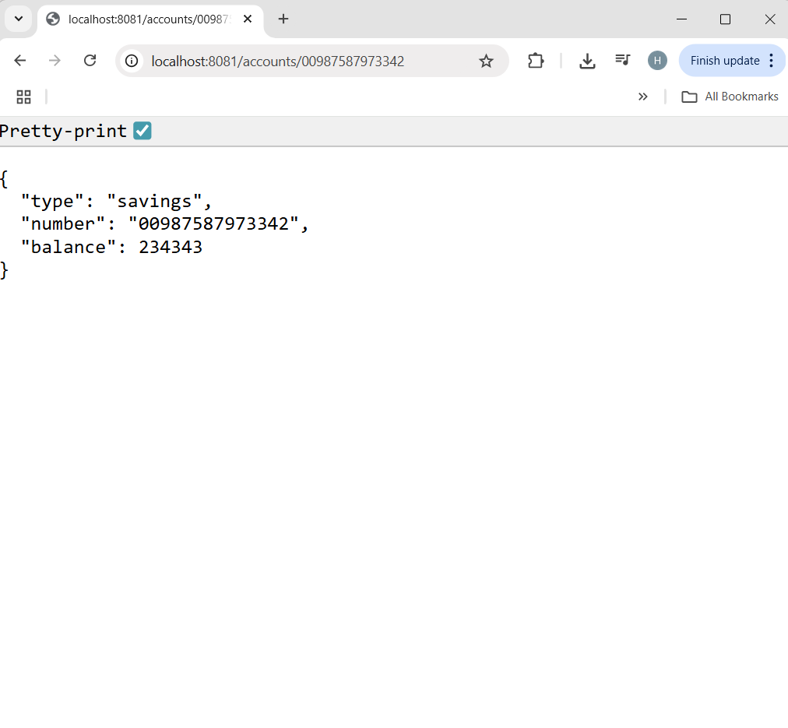
- In Postman-
  - Open postman.
  - Click "New" > HTTP Request or just click the "+ New Tab".
  - Select GET from the dropdown.
  - Type this url in the url bar-
http://localhost:8081/accounts/00987587973342
  - Click Send.
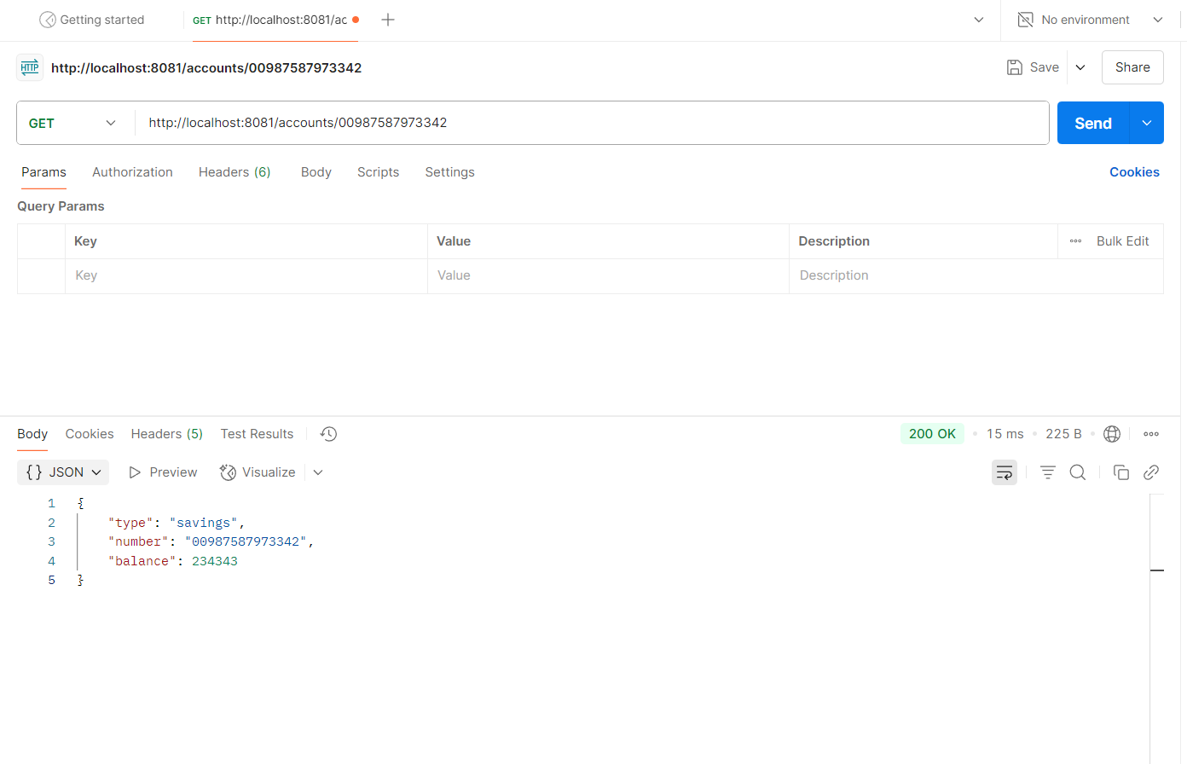

This was the account microservice; for loan microservice, follow the same steps with minor changes-
- Step 1: Generate Spring Boot Project using Spring initializr:
- Go to https://start.spring.io
- Project setup:
  - Group: com.cognizant
  - Artifact ID: loan
  - Language: Java
  - Project: Maven
  - Dependencies selected:
    - Spring Boot Dev Tools
    - Spring Web

- OUTPUT:
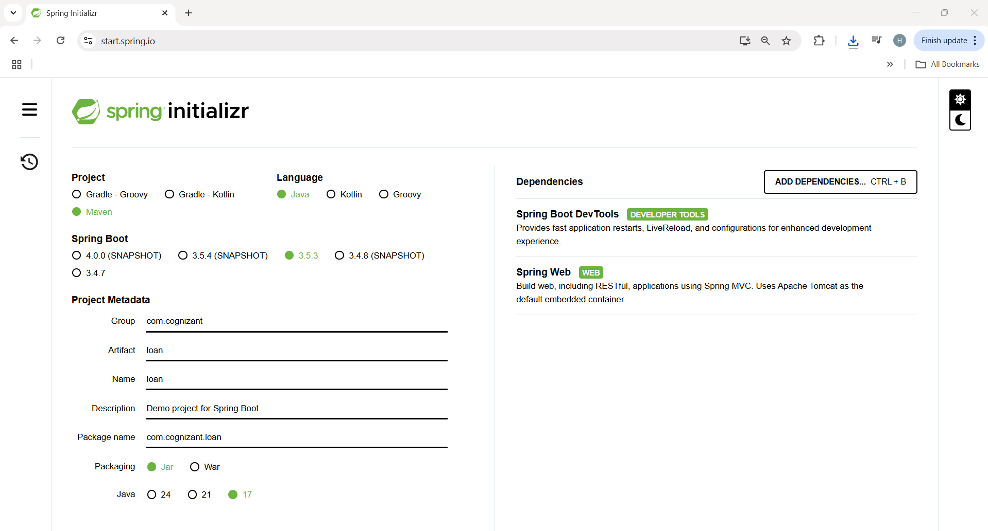
- Step 2: Open the project in IntelliJ IDEA:
- Generate the project and download the zip file.
- Extract it into the C:\microservices folder.
- Open IntelliJ → File > Open, select the extracted account folder in C drive. Intellij will load it as a Maven project.

- Step 3: Add Controller package and class:
- In the path- src/main/java/com/cognizant/loan, add a new package named controller.
- In controller package, add a new class named LoanController.java.

- Code:

package com.cognizant.loan.controller;
import org.springframework.web.bind.annotation.GetMapping;
import org.springframework.web.bind.annotation.PathVariable;
import org.springframework.web.bind.annotation.RestController;
import java.util.Map;
@RestController
public class LoanController {
@GetMapping("/loans/{number}")
public Map<String, Object> getLoanDetails(@PathVariable String number) {
return Map.of(
"number", number,
"type", "car",
"loan", 400000,
"emi", 3258,
"tenure", "18"
);
}
}

- OUTPUT:
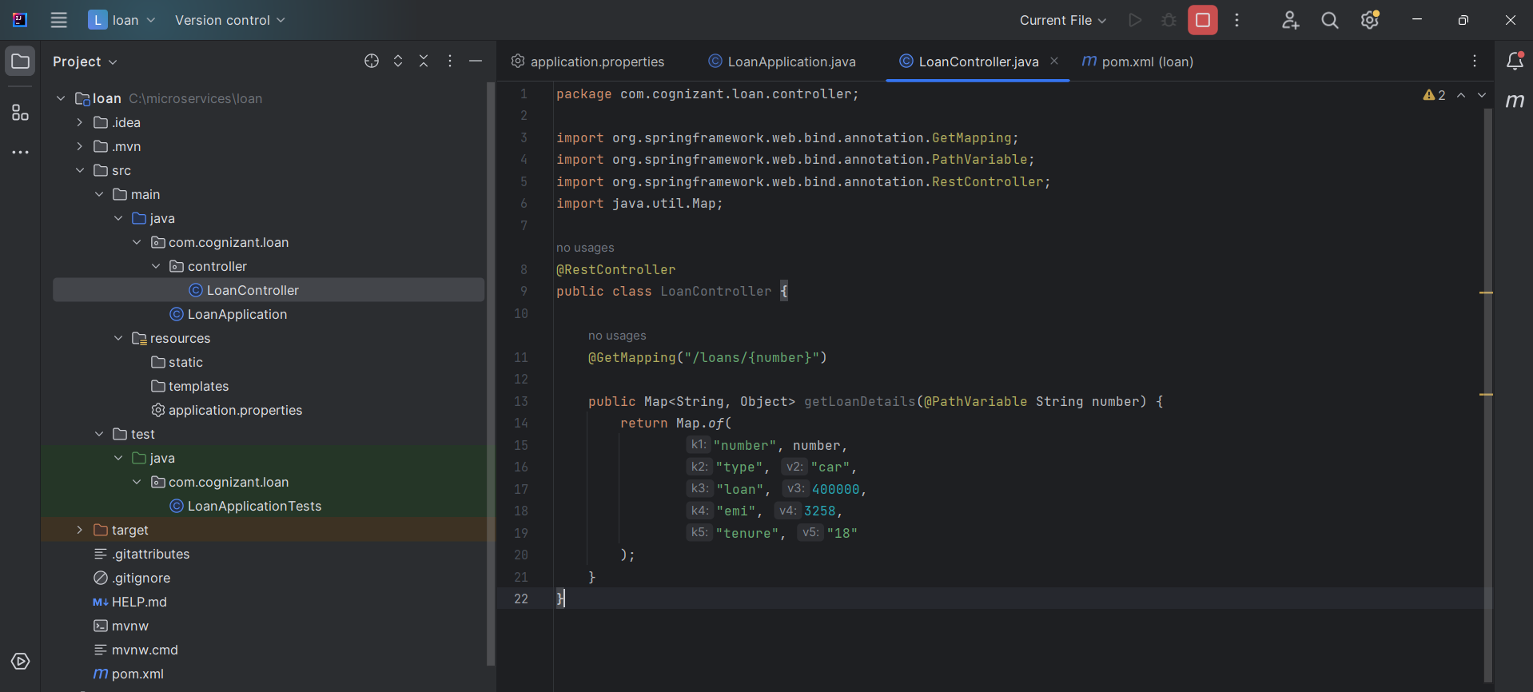

- Step 4: Run the Application:
- Change the port number.
In the path- src/main/resources, go to applicaion.properties and add this code:
server.port=8082

- Run the main() method LoanApplication.java

- OUTPUT:
- In Intellij Console-

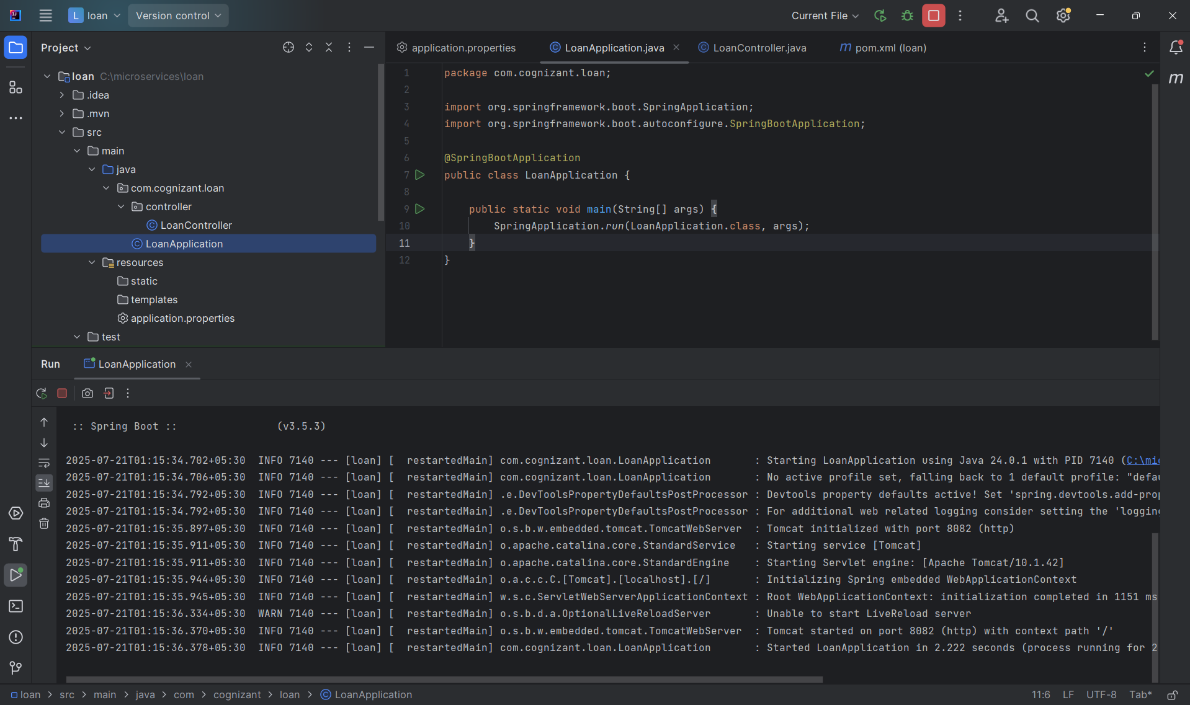

- In the browser-
  - Type this url in the web browser-
http://localhost:8082/accounts/90897897973242
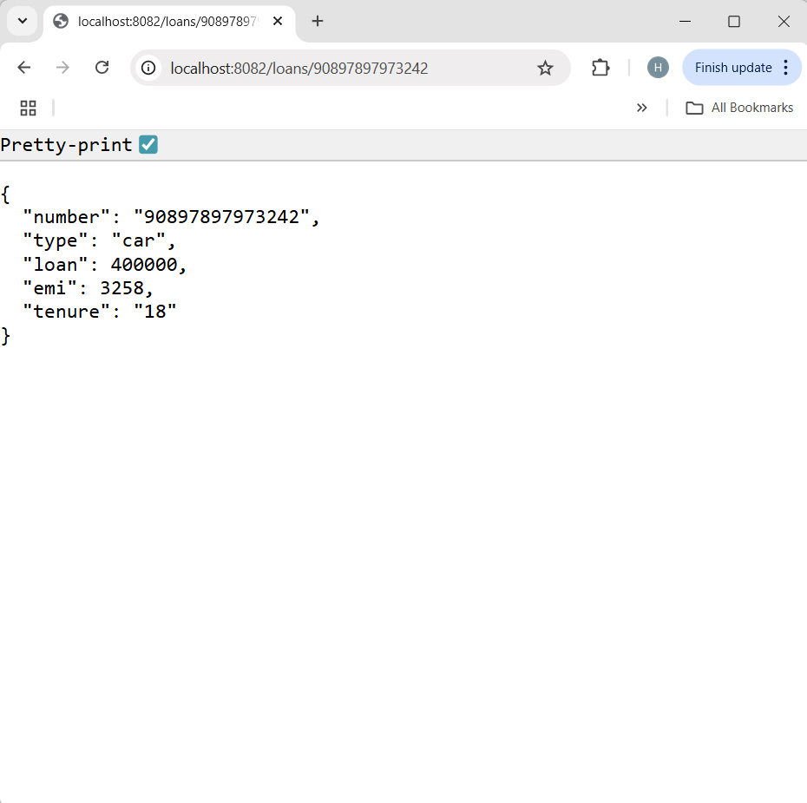
- In Postman-
  - Open postman.
  - Click "New" > HTTP Request or just click the "+ New Tab".
  - Select GET from the dropdown.
  - Type this url in the url bar-
http://localhost:8082/accounts/90897897973242
  - Click Send.
