ReactJS Hands-on

- Hands-On 5 :–
- Software Pre-requisites:
- Node.js
- NPM
- VS Code

- Scenario:
  - My Academy team at Cognizant want to create a dashboard containing the details of ongoing and completed cohorts.
  - A react application is created which displays the detail of the cohorts using react component.
  - You are assigned the task of styling these react components.

- Step 1: Check Pre-requisites
  - Click start and type ‘cmd’ in the search box; Click command prompt to open it.
  - Run the following commands in the command prompt to check if Node.js and npm are installed in your computer or not:
    - node -v
- npm -v

- OUTPUT:

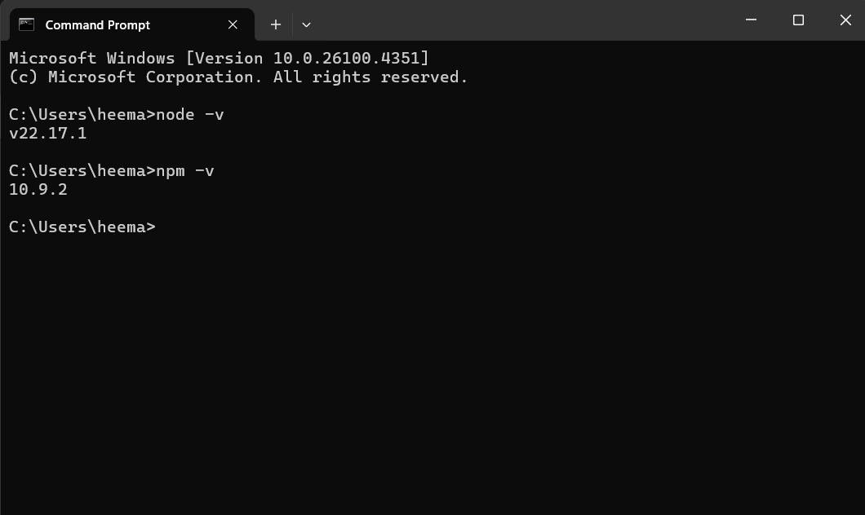

- Step 2: Download and unzip the React App
  - Double click on the cohottracker.zip package given in the hands on and hence download it.
  - Once downloaded, open it and extract it or unzip it in a known folder, say C:\Users\heema\Documents\cohorttracker

- Step 3: Open the project in VS Code
  - Open VS Code.
  - Go to File > Open Folder, and select the unzipped folder.

- OUTPUT:

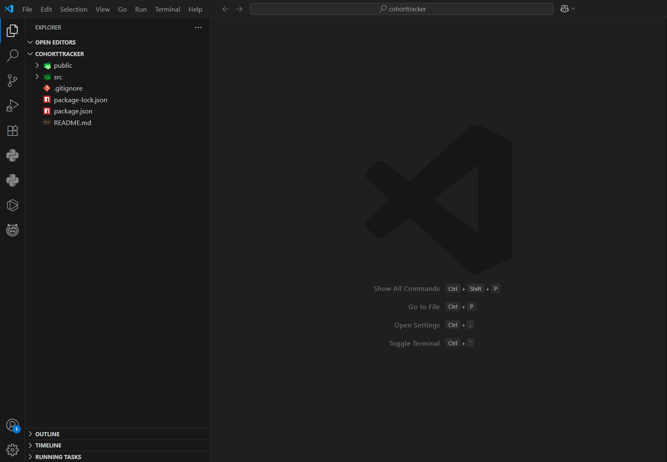

- Step 4: Install Node packages
  - In the command prompt, navigate to the project folder by running the command:
    - cd C:\Users\heema\Documents\cohorttracker
  - Run the following command next to install dependencies:
    - npm install

- OUTPUT:
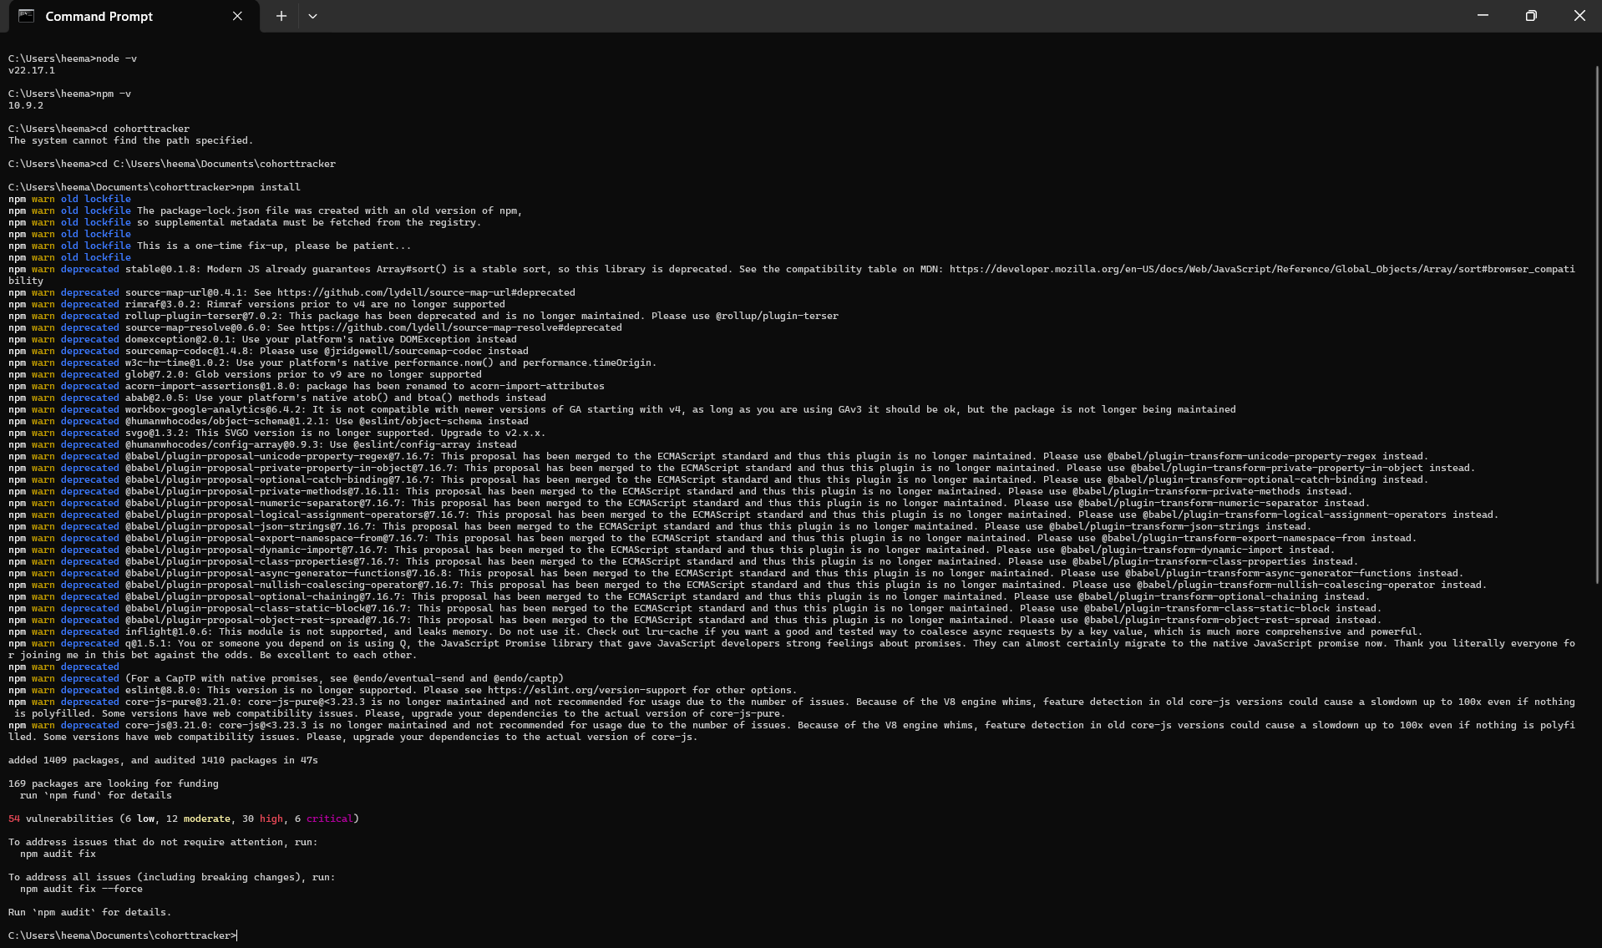

- Step 5: Run the React App
  - In the command prompt, run the command:
    - npm start
This shows the default cohort app, opened in the browser at http://localhost:3000; showing the app as-is, before changes.

- OUTPUT:

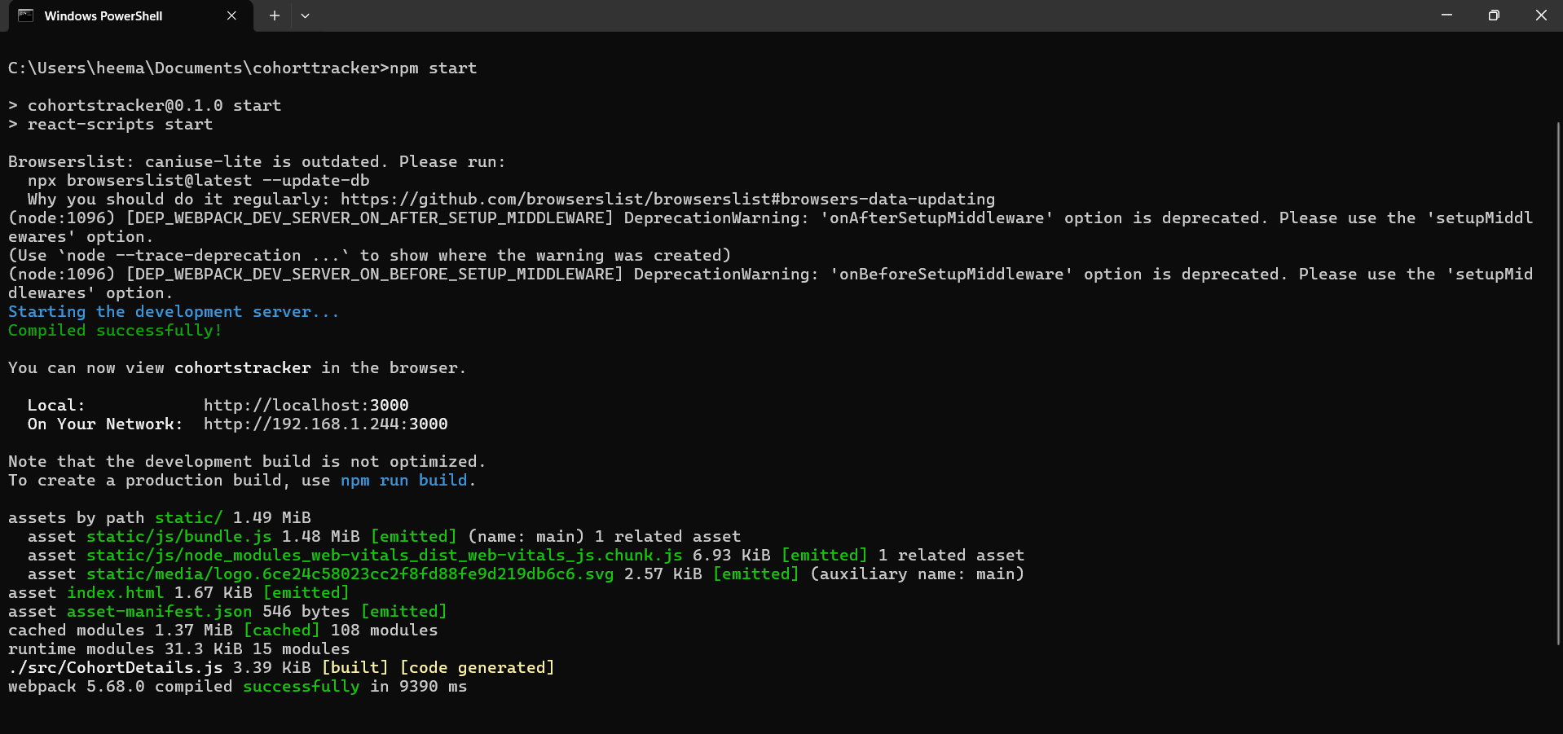
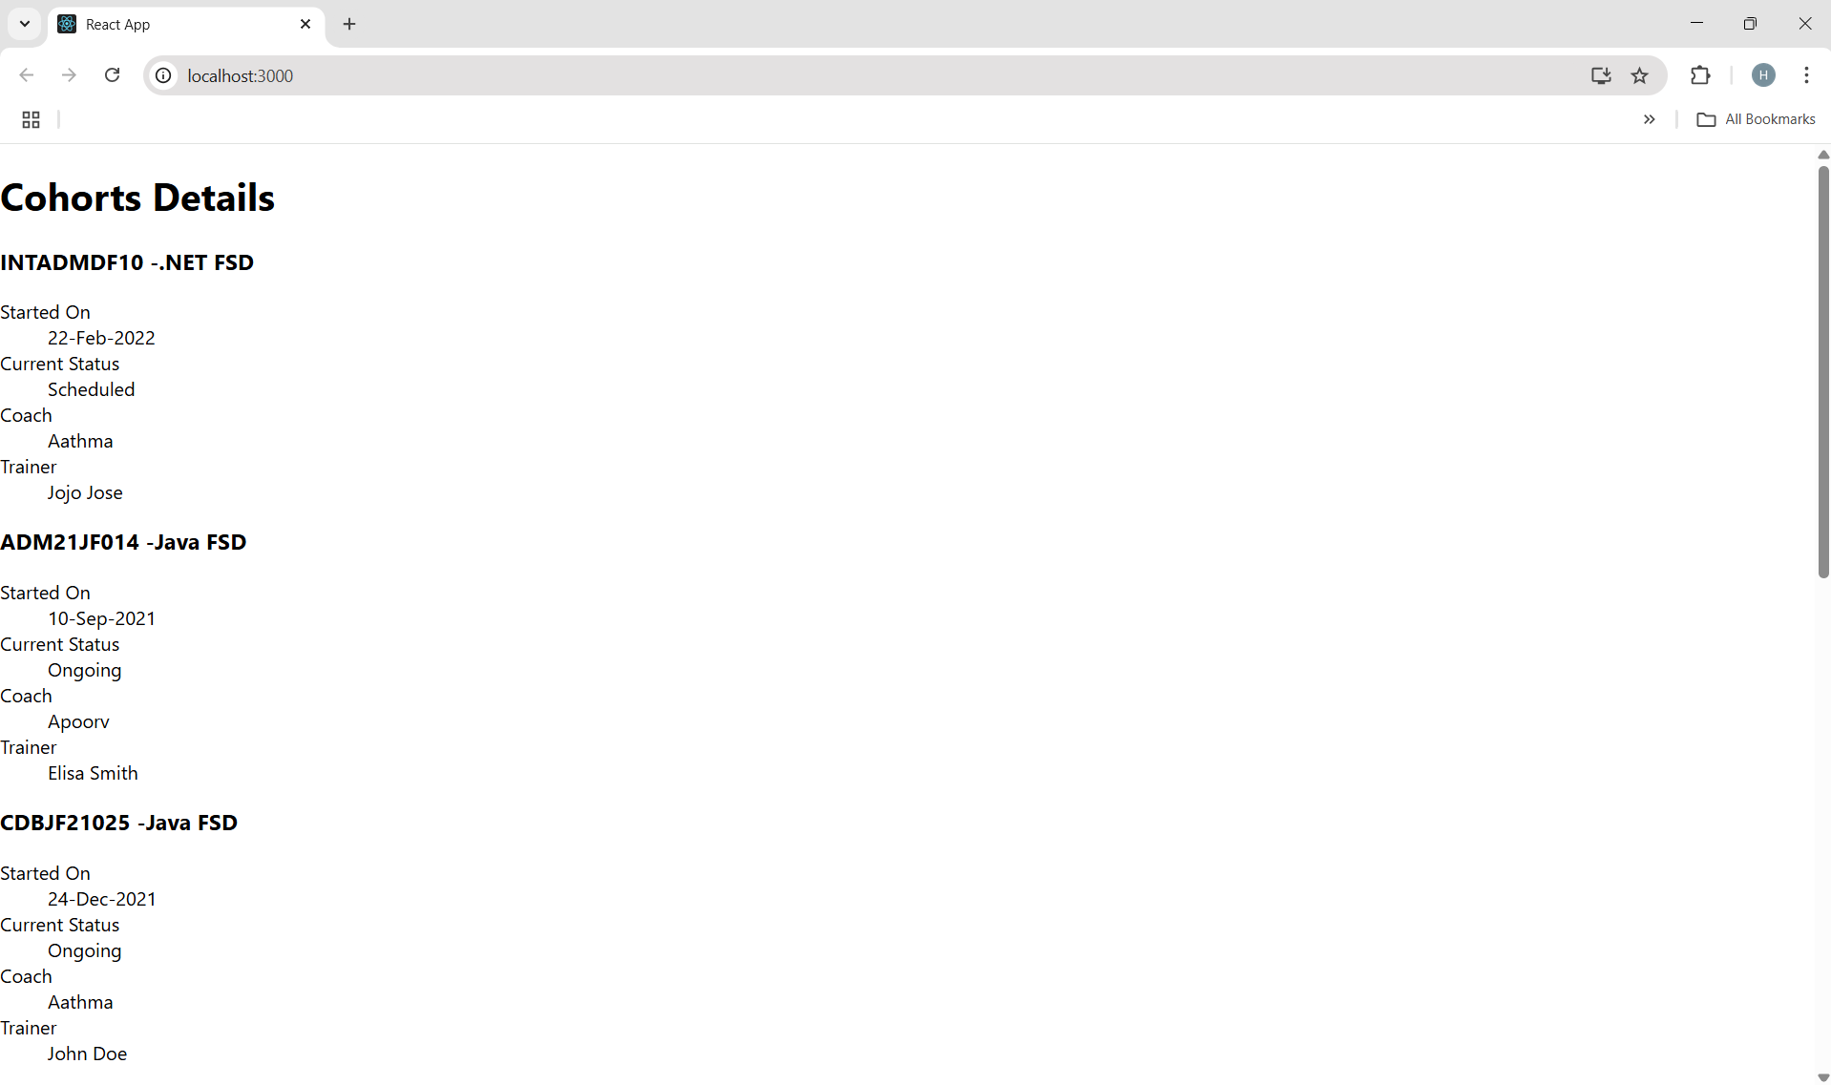

- Step 6: Styling the App – Create CSS Module
  - Inside src folder, create a new file – CohortDetails.module.css
  - Write code for the newly created file.

- Code-
.box {
width: 300px;
display: inline-block;
margin: 10px;
padding: 10px 20px;
border: 1px solid black;
border-radius: 10px;
}

dt {
font-weight: 500;
}

- Save the file- Ctrl+S

- OUTPUT:

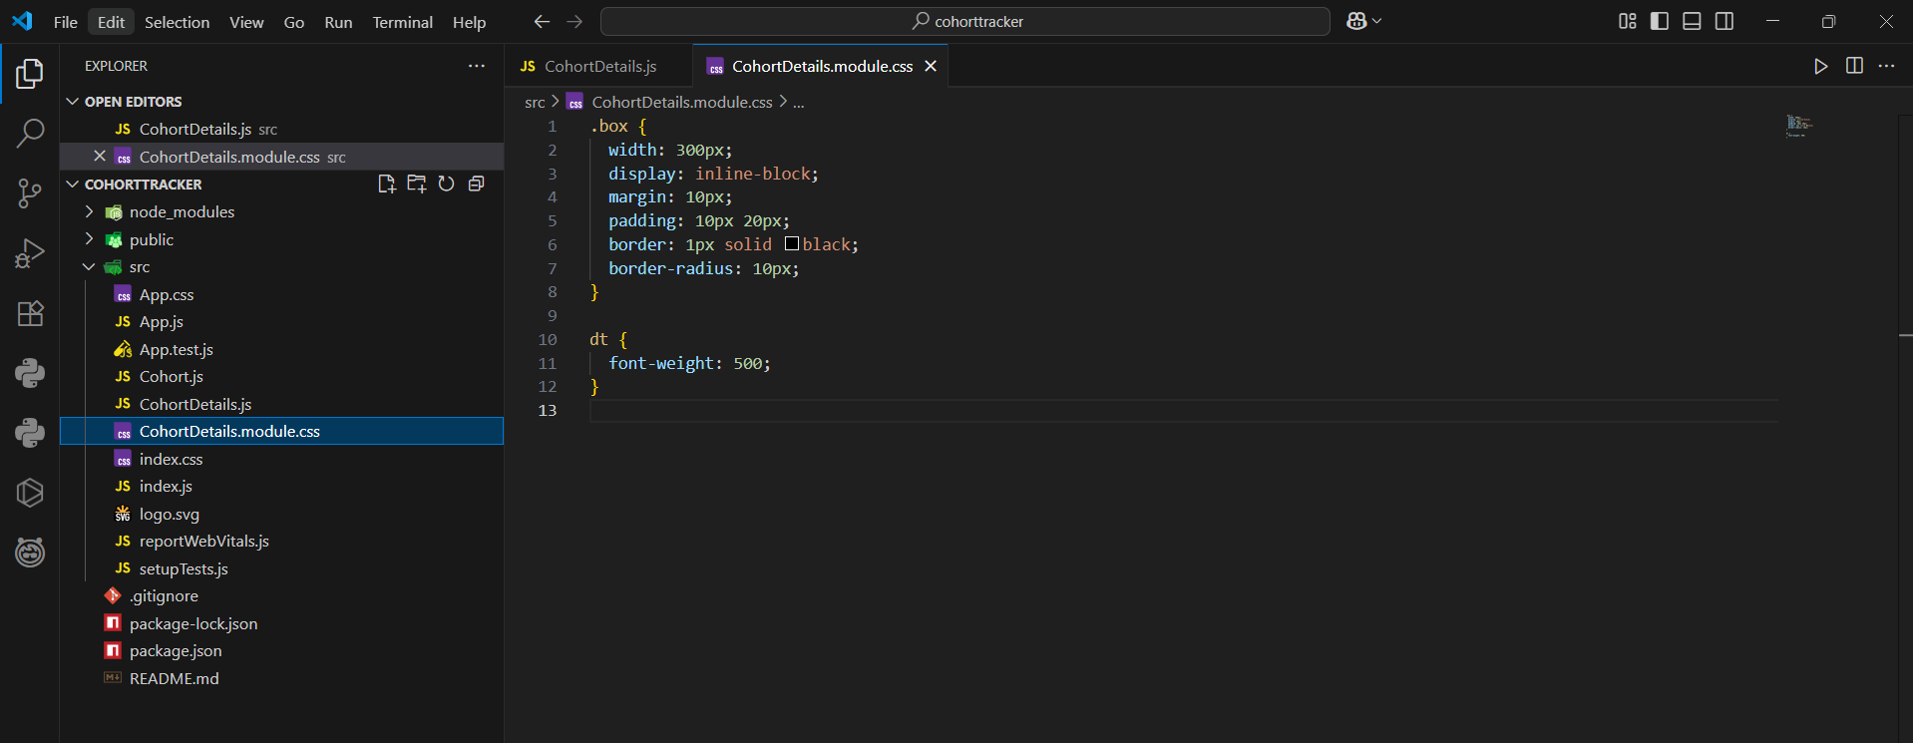

- Step 7: Apply styles in component
- In the src folder, open the CohortDetails.js component file.
- Import the CSS Module at the top by adding following code at the top of the file-
  - import styles from './CohortDetails.module.css';
- Apply the class box to the container div by adding this code to the div tag-
  - < div className={styles.box}>

- Step 8: Add Color Condition for Status
- In the same component file, CohortDetails.js, update the <h3> tag with conditional styling:
  - <h3 style={{ color: props.cohort.currentStatus === "Ongoing" ? "green" : "blue" }}>
{props.status}
</h3>

- Save the file after writing the code- Ctrl+S

- OUTPUT:
The final code looks like this-
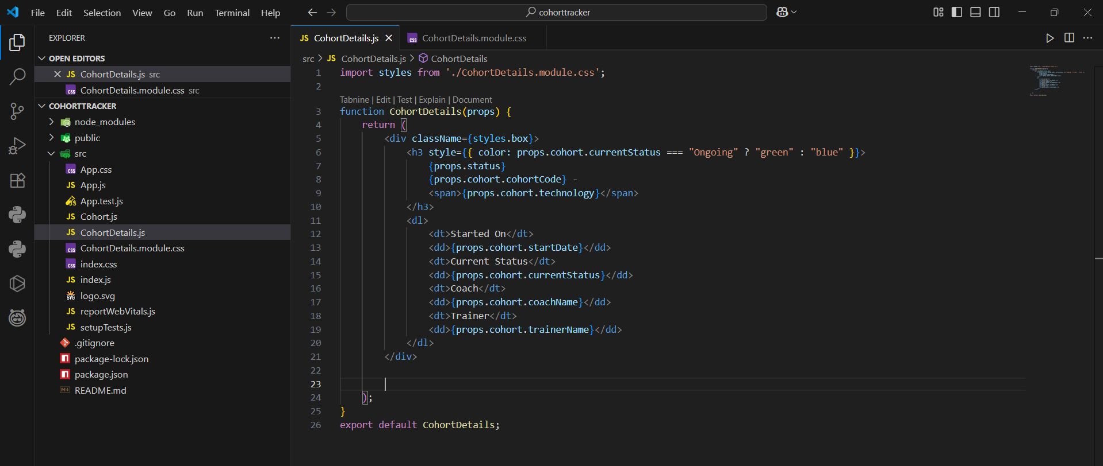

- Step 9: The final output
  - If the app is already running form before then the output will be there on the browser, if not, run the following command in the command prompt:
    - npm start
  - This will compile the app and open http://localhost:3000 in your browser automatically, with the desired output.

- OUTPUT:

