Spring Core Maven

- Exercise 2: Implementing Dependency Injection
- Scenario:
In the library management application, you need to manage the dependencies between the BookService and BookRepository classes using Spring's IoC and DI.

- Step 1: Modify the XML Configuration:
- Update applicationContext.xml to wire BookRepository into BookService.
- Update your existing applicationContext.xml to inject BookRepository into BookService using the <property> tag (setter injection):

<beans xmlns="http://www.springframework.org/schema/beans"
xmlns:xsi="http://www.w3.org/2001/XMLSchema-instance"
xsi:schemaLocation="
http://www.springframework.org/schema/beans
http://www.springframework.org/schema/beans/spring-beans.xsd">

<!-- BookRepository bean -->
<bean id="bookRepository" class="com.library.repository.BookRepository"/>

<!-- BookService bean with DI -->
<bean id="bookService" class="com.library.service.BookService">
<property name="bookRepository" ref="bookRepository"/>
</bean>

</beans>

- OUTPUT:
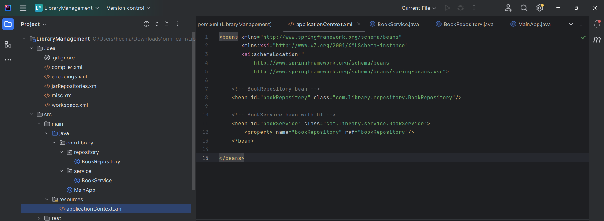
- Step 2: Update the BookService Class:
- Ensure that BookService class has a setter method for BookRepository.
- Modify the BookService class to include:
A private BookRepository field.
A public setter method named setBookRepository(BookRepository repo).

package com.library.service;

import com.library.repository.BookRepository;

public class BookService {
private BookRepository bookRepository;

// Setter method for DI
public void setBookRepository(BookRepository bookRepository) {
this.bookRepository = bookRepository;
}

public void displayService() {
System.out.println("BookService is working!");
if (bookRepository != null) {
bookRepository.displayRepository(); // Call method from BookRepository
} else {
System.out.println("BookRepository not injected!");
}
}
}

- OUTPUT:
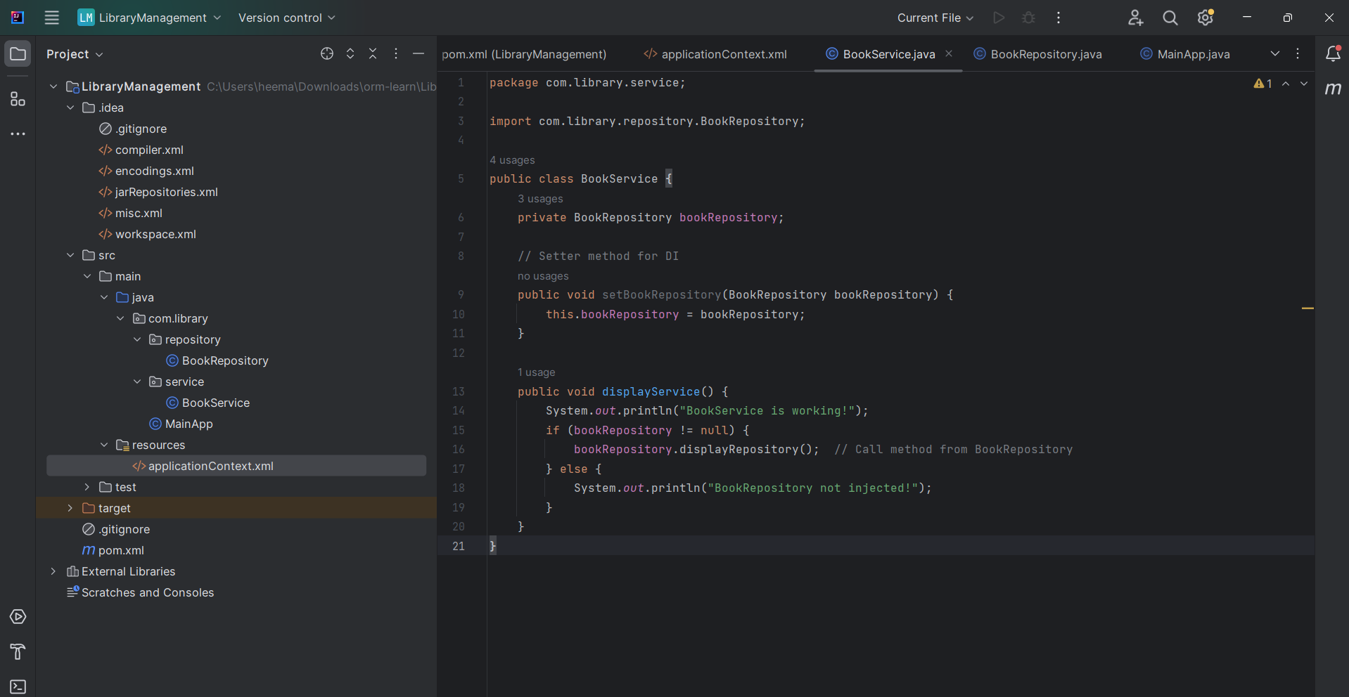

- Step 3: Test the Configuration:
- Run the LibraryManagementApplication main class to verify the dependency injection.
- Update your MainApp.java (or LibraryManagementApplication) to test DI:

package com.library;

import com.library.service.BookService;
import org.springframework.context.ApplicationContext;
import org.springframework.context.support.ClassPathXmlApplicationContext;

public class MainApp {
public static void main(String[] args) {
ApplicationContext context = new ClassPathXmlApplicationContext("applicationContext.xml");

BookService service = context.getBean("bookService", BookService.class);
service.displayService();
}
}

- OUTPUT:
