ReactJS Hands-on

- Hands-On 3 :–
- Software Pre-requisites:
- Node.js
- NPM
- VS Code

- Scenario:
  - Create a react app for Student Management Portal named scorecalculatorapp and create a function component named “CalculateScore” which will accept Name, School, Total and goal in order to calculate the average score of a student and display the same.

- Step 1: Create the React App
  - Click start and type ‘cmd’ in the search box; Click command prompt to open it.
  - Run the following commands in the command prompt to check if Node.js and npm are installed in your computer or not:
    - node -v
- npm -v
  - After making sure the required pre-requisites, run the following command:
- npx create-react-app scorecalculatorapp
This will create a folder named scorecalculatorapp.

- OUTPUT:

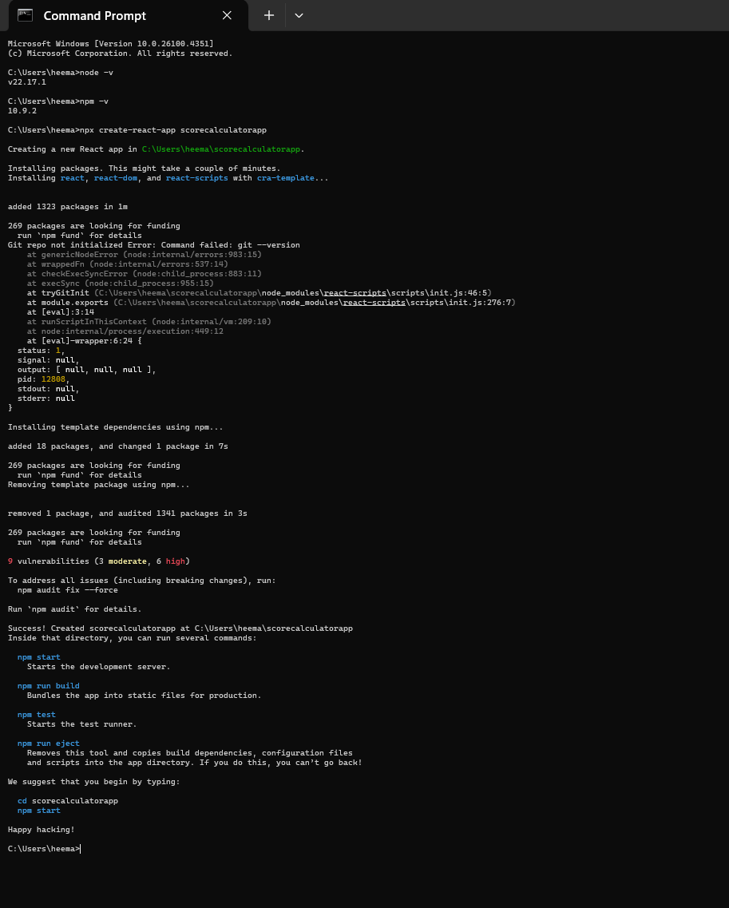

- Step 2: Navigate into the project folder
  - Run the following command next:
    - cd scorecalculatorapp

- OUTPUT:
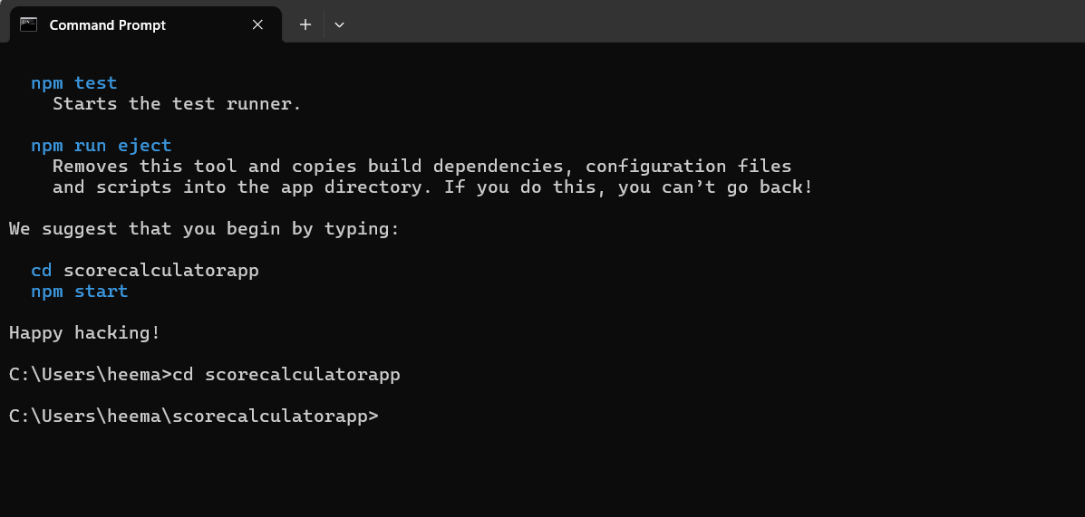

- Step 3: Open the project in VS Code
  - You can either –
Open VS Code, go to File > Open Folder, and select scorecalculatorapp.
  - Or –
If you are still inside the project folder in the terminal, run the following command:
    - code .
This will open the project folder ‘scorecalculatorapp’ in VS Code.

- OUTPUT:
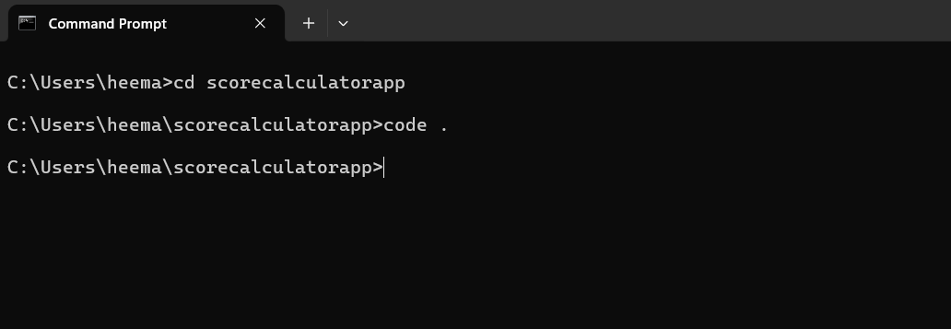
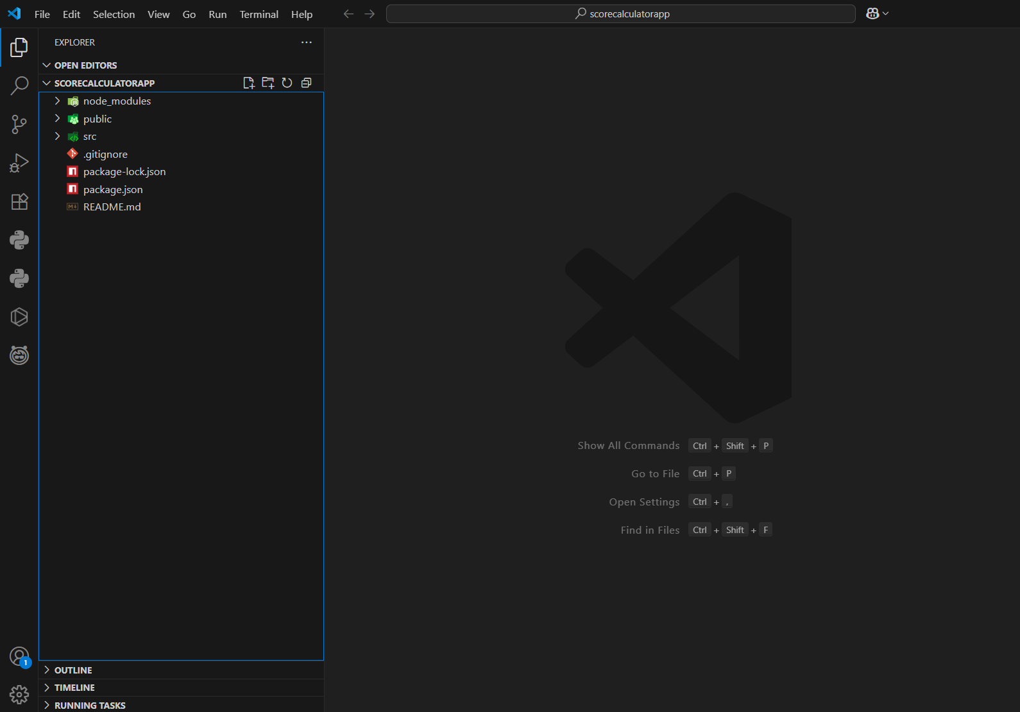

- Step 4: Create "Components" Folder and Files
  - In the path- scorecalculatorapp/src, create a folder named Components.
  - Inside Components, add the file named CalculateScore.js

- Step 5: Add Code to CalculatorScore.js
- In the path- src/Components, write code for the file CalculatorScore.js-

- Code-
import '../Stylesheets/mystyle.css';

const percentToDecimal = (decimal) => {
return (decimal.toFixed(2) + "%");
};

const calcScore = (total, goal) => {
return percentToDecimal(total / goal);
};

export const CalculateScore = ({ Name, School, total, goal }) => (
<div className="formatstyle">
<h1><font color="brown">Student Details:</font></h1>
<div className="Name">
<b><span> Name: </span></b>
<span>{Name}</span>
</div>
<div className="School">
<b><span> School: </span></b>
<span>{School}</span>
</div>
<div className="Total">
<b><span>Total: </span></b>
<span>{total}</span>
<span> Marks</span>
</div>
<div className="Score">
<b>Score:</b>
<span>
{calcScore(total, goal)}
</span>
</div>
</div>
};

- Save the file after writing the code- Ctrl+S

- OUTPUT:
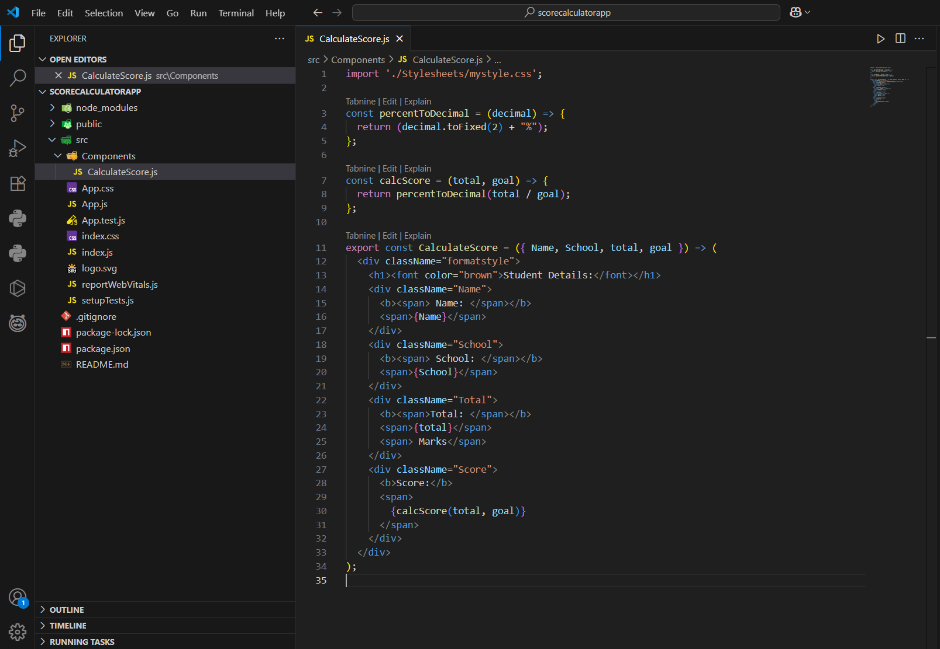
- Step 6: Add the CSS file
  - In the path- scorecalculatorapp/src, create a new folder named Stylesheets.
  - Inside Stylesheets, create a new file named mystyle.css and write code for the file-

- Code-
.Name {
font-weight: 300;
color: blue;
}

.School {
color: crimson;
}

.Total {
color: darkmagenta;
}

.formatstyle {
text-align: center;
font-size: large;
}

.Score {
color: forestgreen;
}

  - Save the code- Ctrl+S

- OUTPUT:
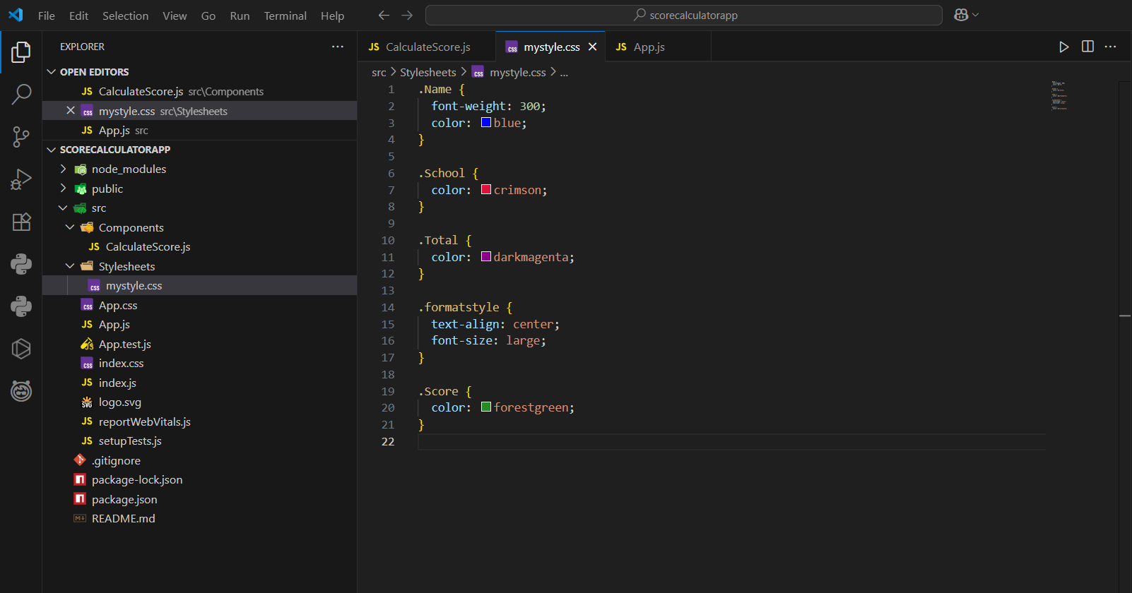
- Step 7: Modify the App.js file
  - In the path- scorecalculatorapp/src/App.js, replace the existing code with the following code:

- Code-
import { CalculateScore } from './components/CalculateScore';

function App() {
return (
<div>
<CalculateScore
Name="Steeve"
School="DNV Public School"
total={284}
goal={3}
/>
</div>
);
}

export default App;

  - Save the code- Ctrl+S

- OUTPUT:
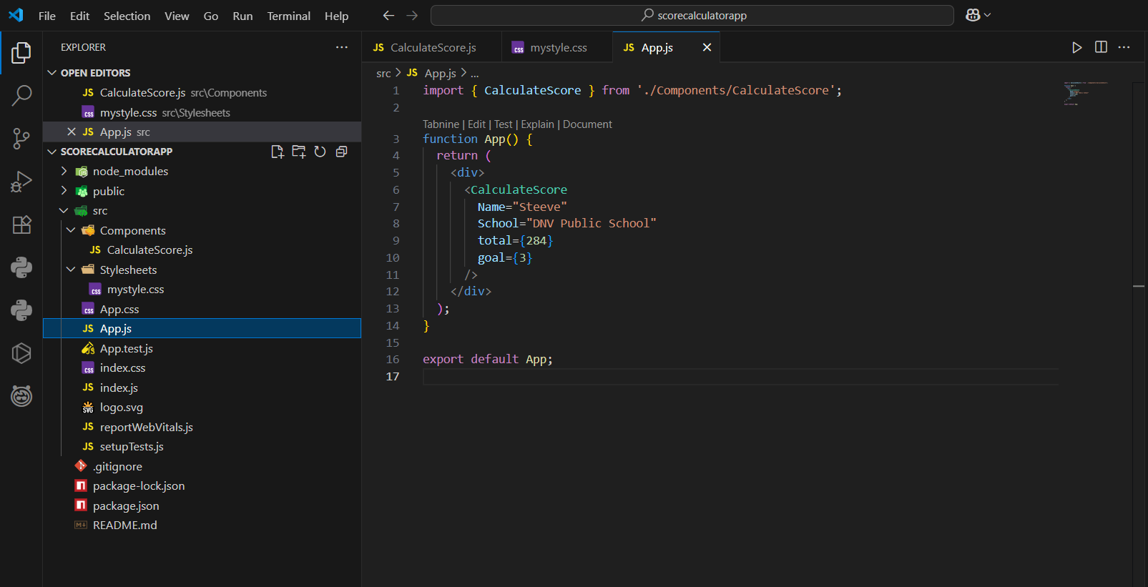

- Step 8: Run the React App
  - Inside the project folder scorecalculatorapp, in the terminal, run the following command:
    - npm start
  - This will compile the app and open http://localhost:3000 in your browser automatically, with the desired output.

- OUTPUT:
