Spring Rest Hands-on

- Hands-On 1: Create a Spring Web Project using Maven

- Step 1: Create a Spring project using Spring Initializr:
- Project Setup:
- Group: com.cognizant
- Artifact ID: spring-learn
- Language: Java
- Project: Maven
- Dependencies selected:
  - Spring Boot Dev Tools
  - Spring Web

- OUTPUT:
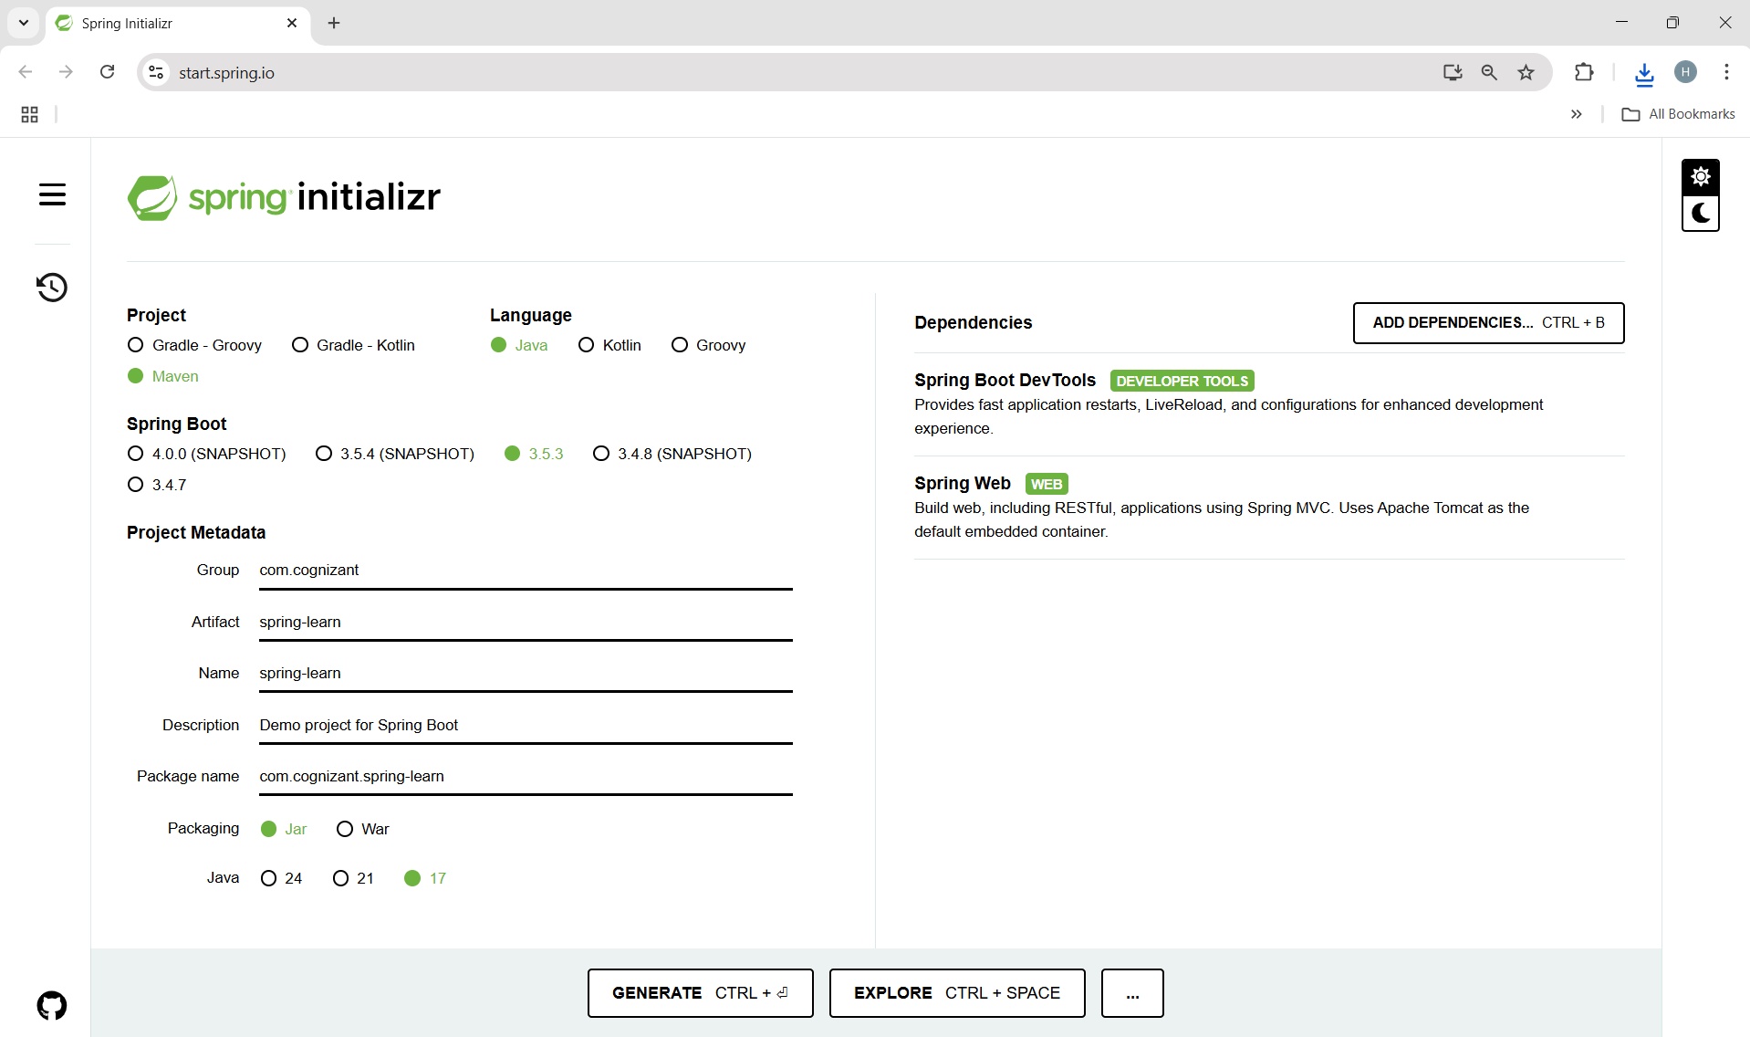

- Project import in IDE:
- Extract the ZIP File after clicking GENERATE button.
- In Intellij, do the following-
File > New > Project from Existing Sources > Maven > Select folder > Finish
- Intellij will detect the Maven project and auto import.

  - In the imported file,
- src/main/java/com/cognizant- Folder with application code.
- src/main/resources- Folder for application configuration.
- src/test/java- Folder with code for testing the application.
- SpringLearnApplication.java- Main springboot class [main() method]
- pom.xml- Maven configuration(dependencies, plugins etc.)

- Step 2: Run the Application:
- Run the main method SpringLearnApplication.java -

package com.cognizant.spring_learn;
import org.springframework.boot.SpringApplication;
import org.springframework.boot.autoconfigure.SpringBootApplication;
@SpringBootApplication
public class SpringLearnApplication {
public static void main(String[] args) {
SpringApplication.run(SpringLearnApplication.class, args);
}
}

- OUTPUT:
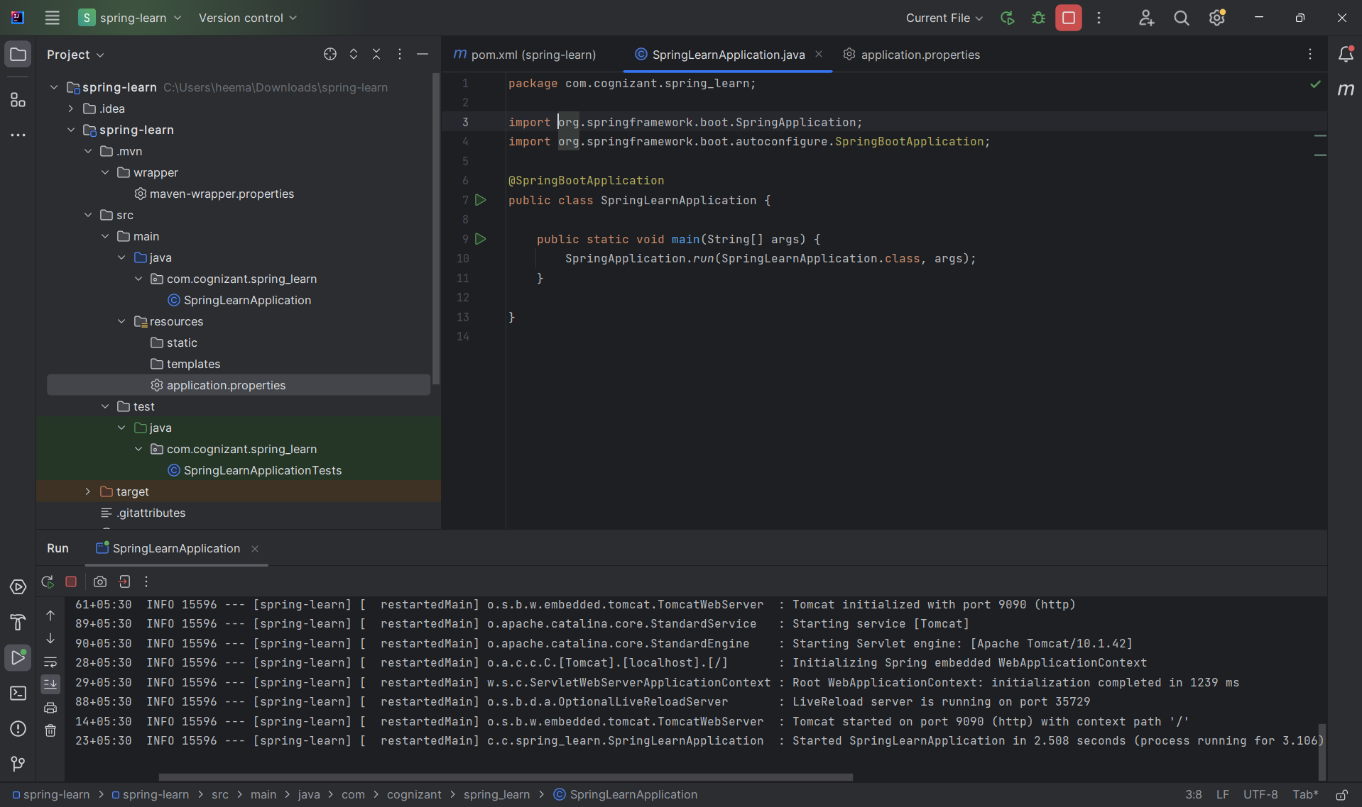
- Step 3: Add logs to main() method:
- Make changes in code of main() method SpringLearnApplication.java

package com.library.service;
package com.cognizant.spring_learn;
import org.springframework.boot.SpringApplication;
import org.springframework.boot.autoconfigure.SpringBootApplication;
@SpringBootApplication
public class SpringLearnApplication {
public static void main(String[] args) {
SpringApplication.run(SpringLearnApplication.class, args);
System.out.println("SpringLearnApplication started successfully!");
}
}

- OUTPUT:
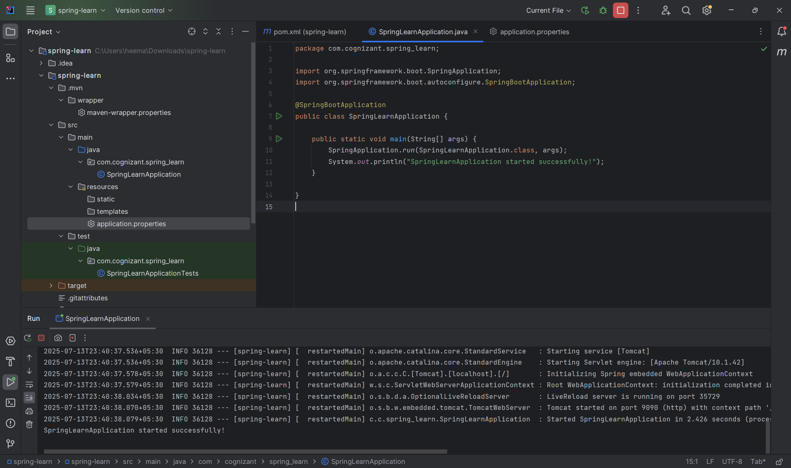

- Step 4: Dependency Hierarchy & Dependency Tree:
- Open pom.xml file.
- Go to View > Tool Windows > Maven
- Expand Dependencies to view the full tree.
- OUTPUT:

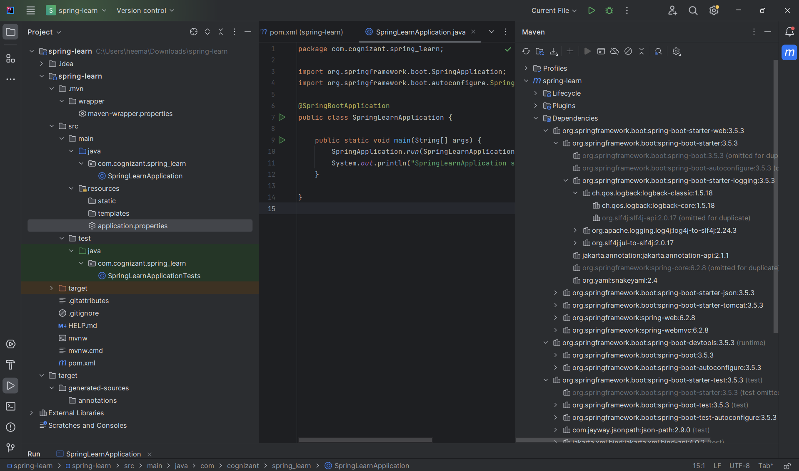

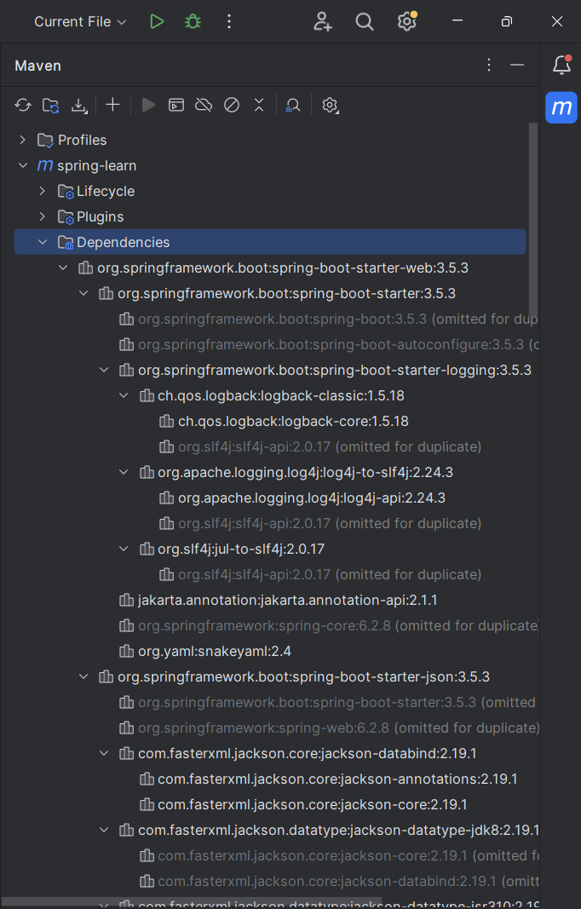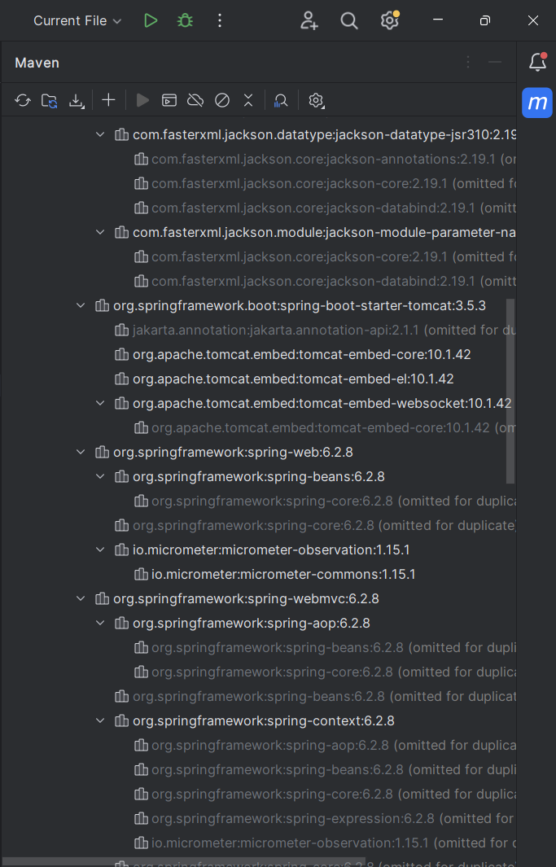
- Purpose of @SpringBootApplication annotation:
  - The purpose of the @SpringBootApplication annotation is to enable several key Spring Boot features in a single, convenient annotation. It is used on the main class of a Spring Boot application.
  - This annotation is a shortcut for three important annotations:
    - @Configuration
Marks the class as a source of bean definitions (like a config file for Spring).
    - @EnableAutoConfiguration
Tells Spring Boot to automatically configure your project based on the dependencies on the classpath (e.g., auto-set up Spring MVC if spring-boot-starter-web is present)
    - @ComponentScan
Enables scanning for @Component, @Service, @Repository, and @Controller classes in the same package (and sub-packages) to register them as Spring Beans.

So, in short,
@SpringBootApplication sets up the Spring Application Context, auto-configuration, and component scanning — everything needed to launch and run a Spring Boot app with minimal code.

