Spring Rest Hands-on

- Hands-On: REST - Country Web Service
(This is a continuation of the earlier Spring Rest Hands-On files)

- Step 1: Create the model package:
- In the path- src/main/java/com/cognizant/spring_learn,
Right-click → New > Package
- Create a new package named com.cognizant.spring_learn.model
- In this package, create a new java class named Country.java

- Code:

package com.cognizant.spring_learn.model;

public class Country {
private String code;
private String name;

public Country() {}

public String getCode() {
return code;
}

public void setCode(String code) {
this.code = code;
}

public String getName() {
return name;
}

public void setName(String name) {
this.name = name;
}

@Override
public String toString() {
return "Country [code=" + code + ", name=" + name + "]";
}
}

- Step 2: Create the REST Controller:
- In the path- src/main/java/com/cognizant/spring_learn/controller, create a new java class named CountryController.java

  - Code:

package com.cognizant.spring_learn.controller;

import com.cognizant.spring_learn.model.Country;
import org.slf4j.Logger;
import org.slf4j.LoggerFactory;
import org.springframework.context.ApplicationContext;
import org.springframework.context.support.ClassPathXmlApplicationContext;
import org.springframework.web.bind.annotation.RequestMapping;
import org.springframework.web.bind.annotation.RestController;

@RestController
public class CountryController {
private static final Logger LOGGER = LoggerFactory.getLogger(CountryController.class);

@RequestMapping("/country")
public Country getCountryIndia() {
LOGGER.info("Start");

ApplicationContext context = new ClassPathXmlApplicationContext("country.xml");
Country country = context.getBean("country", Country.class);

LOGGER.info("End");
return country;
}
}

- Step 3: Create country.xml file:
- In the path- src/main/resources, make the file country.xml

- Code:

<?xml version="1.0" encoding="UTF-8"?>
<beans xmlns="http://www.springframework.org/schema/beans"
xmlns:xsi="http://www.w3.org/2001/XMLSchema-instance"
xsi:schemaLocation="http://www.springframework.org/schema/beans
https://www.springframework.org/schema/beans/spring-beans.xsd">

<bean id="country" class="com.cognizant.spring_learn.model.Country">
<property name="code" value="IN"/>
<property name="name" value="India"/>
</bean>

</beans>

  - OUTPUT:
The structure of the program now looks like this-
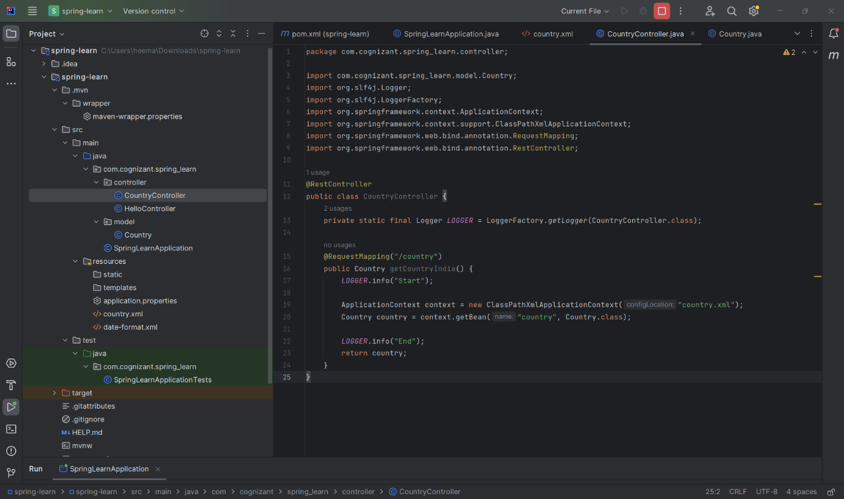

- Step 4: Test the Application in browser:
- Run the main() method SpringLearnApplication.java
- In the browser go to http://localhost:9090/country

- OUTPUT:
- In Browser-
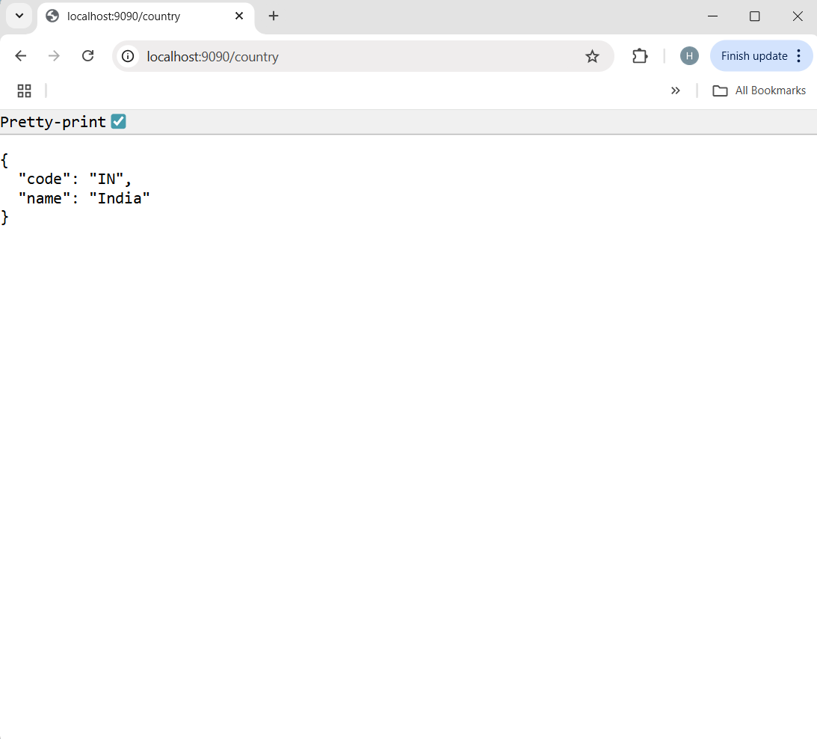

- In Intellij Console-
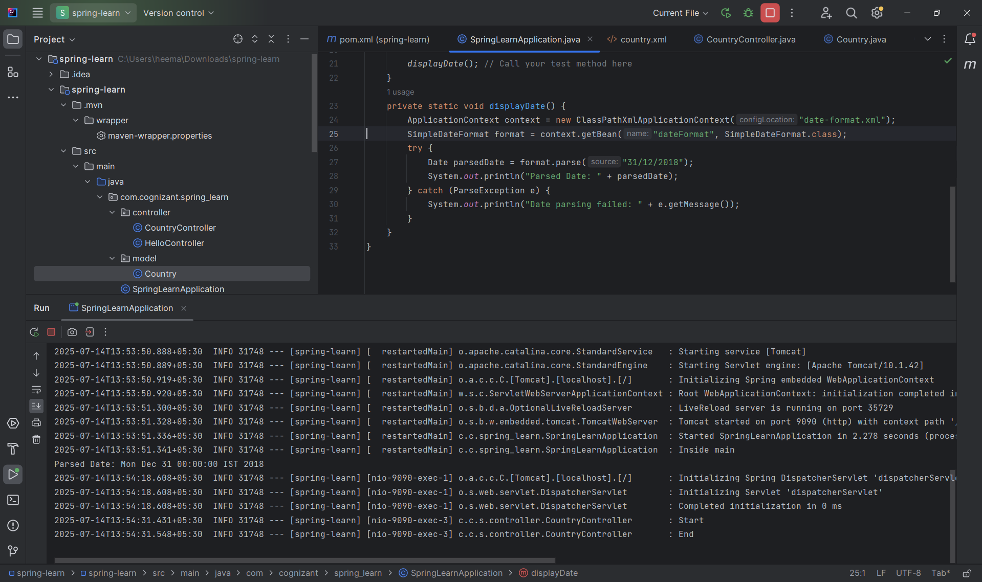

- Step 5: Test the Application in postman:
- Open postman.
- Click on “+” tab to open a new request tab (or click "New > HTTP Request").
- On the top-left of the tab, there’s a dropdown with HTTP methods — by default it shows GET.
- In the URL bar, type-
http://localhost:9090/country
- Click on the blue “Send” button.
- Click the header section in the output console.

- OUTPUT:
