Spring Rest Hands-on

- Hands-On: REST – Get country based on country code
(This is a continuation of the earlier Spring Rest Hands-On files)

- Step 1: Create the service package:
- In the path- src/main/java/com/cognizant/spring_learn,
Right-click → New > Package
- Create a new package named com.cognizant.spring_learn.service
- In this package, create a new java class named CountryService.java

- Code:

package com.cognizant.spring_learn.service;
import com.cognizant.spring_learn.model.Country;
import org.springframework.context.ApplicationContext;
import org.springframework.context.support.ClassPathXmlApplicationContext;
import org.springframework.stereotype.Service;
import java.util.List;
@Service
public class CountryService {
public Country getCountry(String code) {
ApplicationContext context = new ClassPathXmlApplicationContext("country.xml");
List<Country> countryList = context.getBean("countryList", List.class);
// Case-insensitive search using lambda
return countryList.stream()
.filter(country -> country.getCode().equalsIgnoreCase(code))
.findFirst()
.orElse(null);
}
}

- Step 2: Create the REST Controller:
- In the path- src/main/java/com/cognizant/spring_learn/controller, update the file CountryController.java
  - Code:

package com.cognizant.spring_learn.controller;
import com.cognizant.spring_learn.model.Country;
import com.cognizant.spring_learn.service.CountryService;
import org.slf4j.Logger;
import org.slf4j.LoggerFactory;
import org.springframework.beans.factory.annotation.Autowired;
import org.springframework.web.bind.annotation.*;
@RestController
public class CountryController {
private static final Logger LOGGER = LoggerFactory.getLogger(CountryController.class);
@Autowired
private CountryService countryService;
@GetMapping("/countries/{code}")
public Country getCountry(@PathVariable String code) {
LOGGER.info("Start - getCountry");
Country result = countryService.getCountry(code);
LOGGER.info("End - getCountry");
return result;
}
}

- Step 3: Create country.xml file:
- In the path- src/main/resources, make the following changes in the file country.xml

- Code:

<?xml version="1.0" encoding="UTF-8"?>
<beans xmlns="http://www.springframework.org/schema/beans"
xmlns:xsi="http://www.w3.org/2001/XMLSchema-instance"
xsi:schemaLocation="http://www.springframework.org/schema/beans
https://www.springframework.org/schema/beans/spring-beans.xsd">
<bean id="countryList" class="java.util.ArrayList">
<constructor-arg>
<list>
<bean class="com.cognizant.spring_learn.model.Country">
<property name="code" value="IN"/>
<property name="name" value="India"/>
</bean>
<bean class="com.cognizant.spring_learn.model.Country">
<property name="code" value="US"/>
<property name="name" value="United States"/>
</bean>
<bean class="com.cognizant.spring_learn.model.Country">
<property name="code" value="FR"/>
<property name="name" value="France"/>
</bean>
</list>
</constructor-arg>
</bean>
</beans>

  - OUTPUT:
The structure of the program now looks like this-
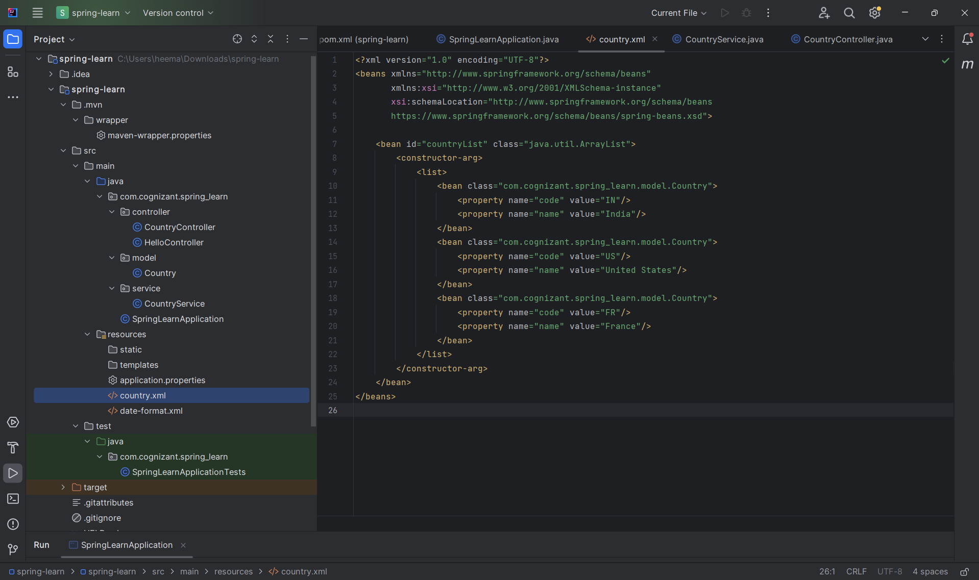

- Step 4: Test the Application in browser:
- Run the main method- SpringLearnApllication.java
- In the browser go to these urls-
http://localhost:9090/countries/in
http://localhost:9090/countries/fr
http://localhost:9090/countries/US

- OUTPUT:
- In Browser-
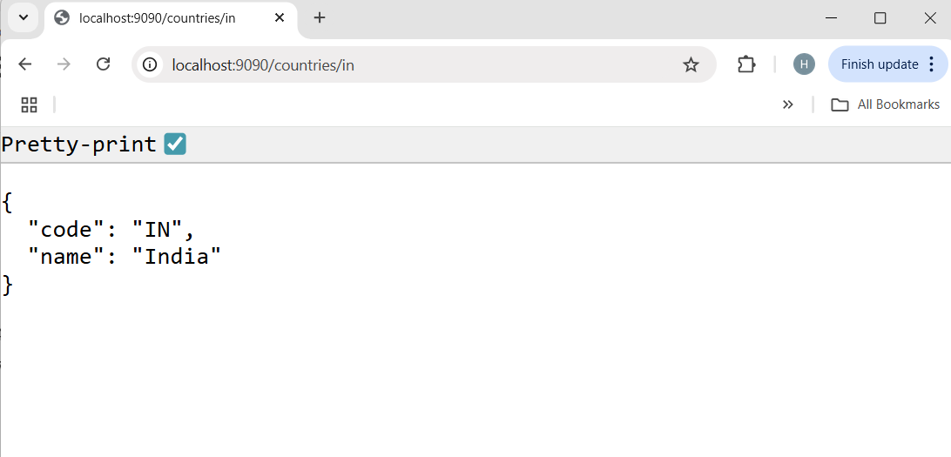
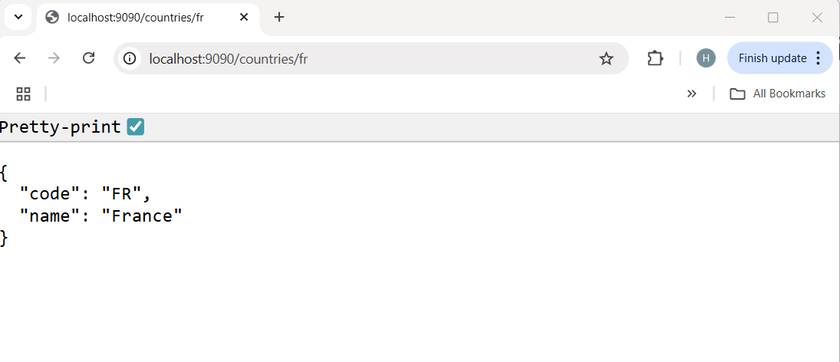
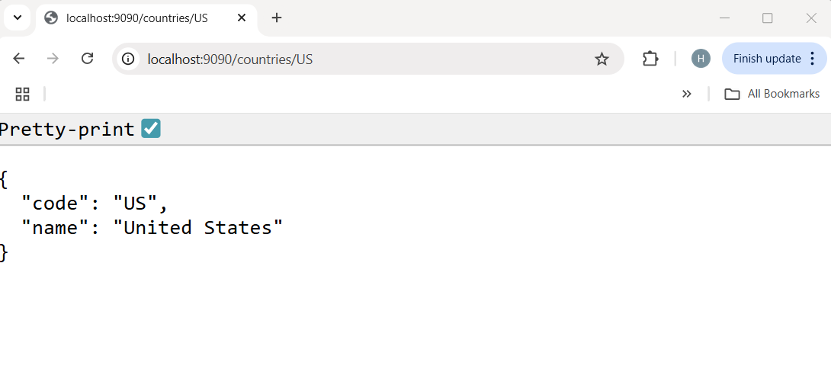

- In Intellij Console-
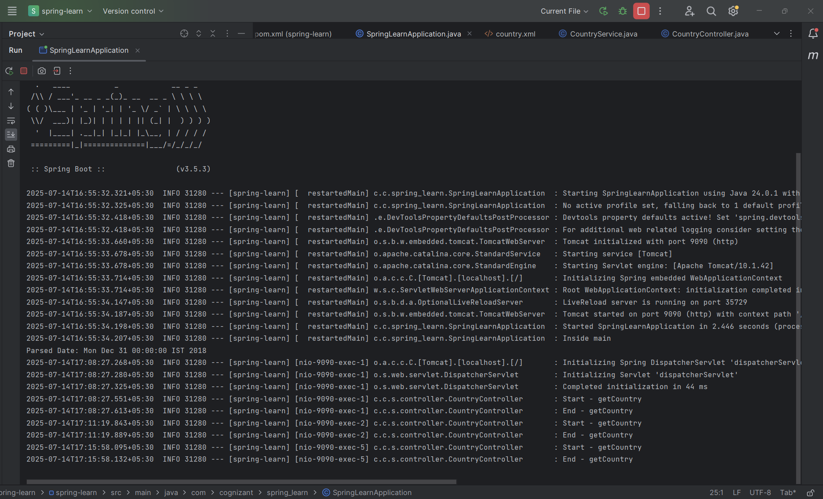

- Step 5: Test the Application in postman:
- Open postman.
- Click on “+” tab to open a new request tab (or click "New > HTTP Request").
- On the top-left of the tab, there’s a dropdown with HTTP methods — by default it shows GET.
- In the URL bar, type-
http://localhost:9090/countries/in
- Click on the blue “Send” button.
- Click the header section in the output console.

- OUTPUT:
