ReactJS Hands-on

- Hands-On 2 :–
- Software Pre-requisites:
- Node.js
- NPM
- VS Code

- Scenario:
  - Create a react app for Student Management Portal named StudentApp and create a component named Home which will display the Message “Welcome to the Home page of Student Management Portal”.
  - Create another component named About and display the Message “Welcome to the About page of the Student Management Portal”.
  - Create a third component named Contact and display the Message “Welcome to the Contact page of the Student Management Portal”.
  - Call all the three components.

- Step 1: Create the React App
  - Click start and type ‘cmd’ in the search box; Click command prompt to open it.
  - Run the following commands in the command prompt to check if Node.js and npm are installed in your computer or not:
    - node -v
- npm -v
  - After making sure the required pre-requisites, run the following command:
- npx create-react-app student-app
This will create a folder named student-app.

- OUTPUT:

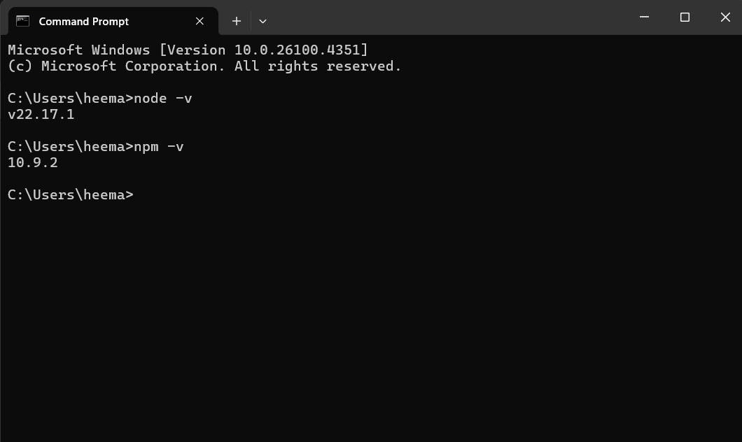
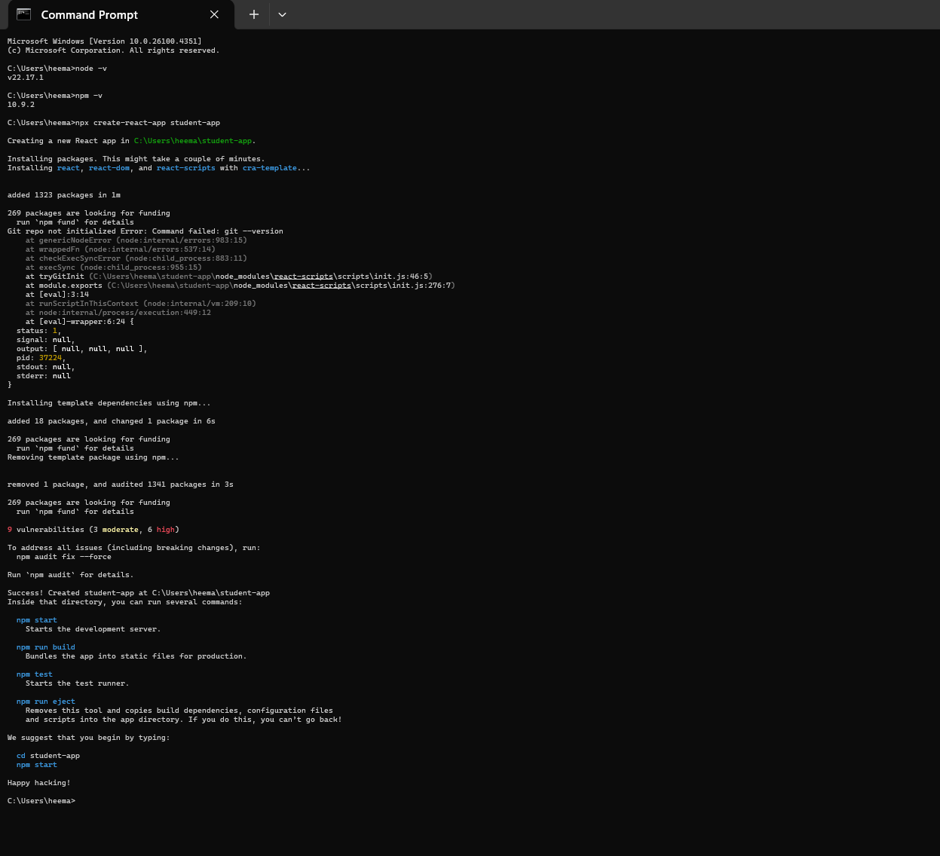

- Step 2: Navigate into the project folder
  - Run the following command next:
    - cd student-app

- OUTPUT:
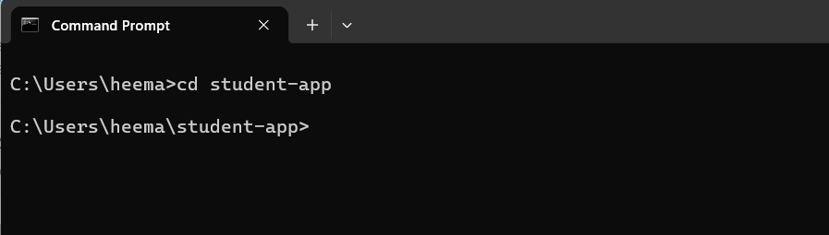

- Step 3: Open the project in VS Code
  - You can either –
Open VS Code, go to File > Open Folder, and select student-app.
  - Or –
If you are still inside the project folder in the terminal, run the following command:
    - code .
This will open the project folder ‘student-app’ in VS Code.

- OUTPUT:
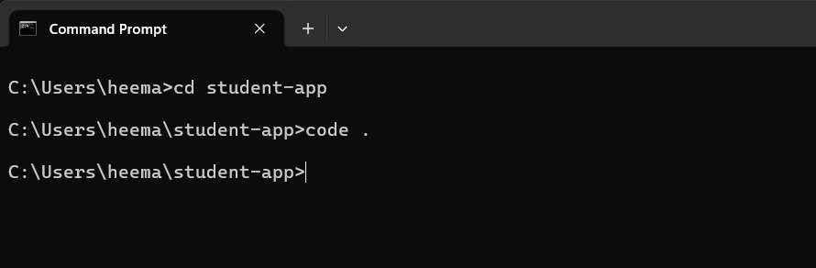
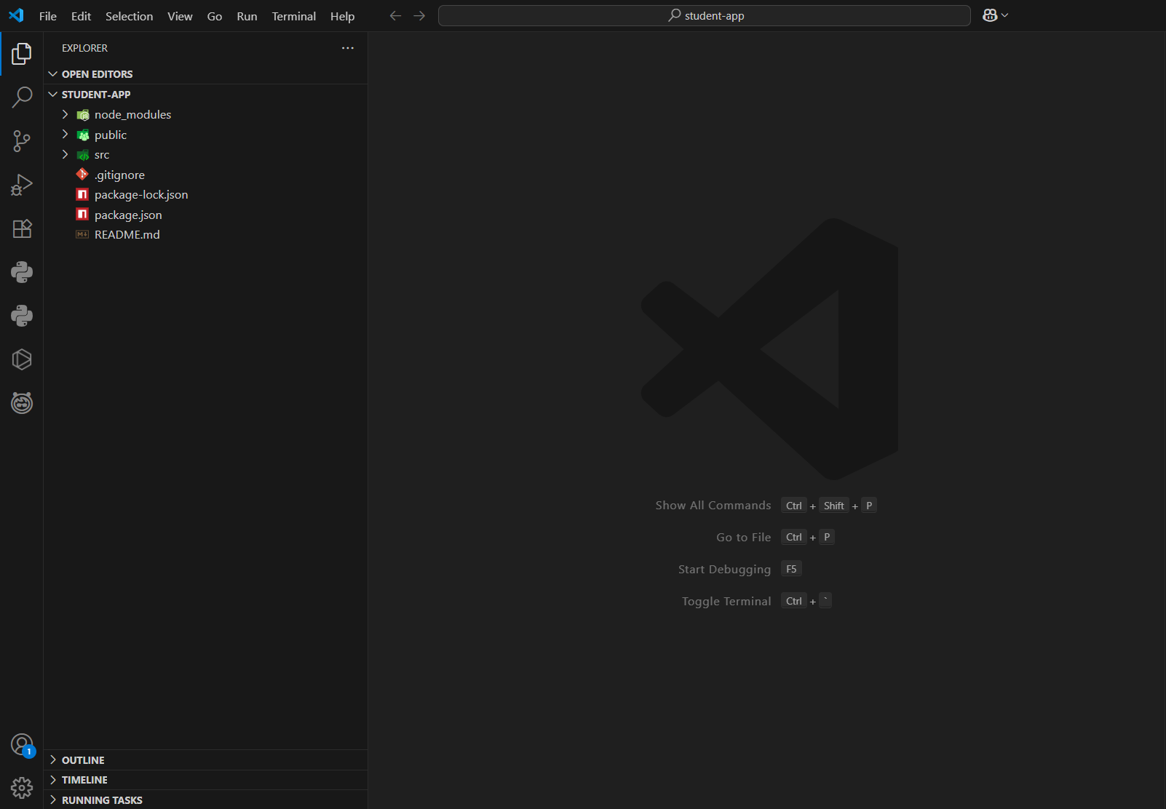
- Step 4: Create "Components" Folder and Files
  - In the path- student-app/src, create a folder named Components.
  - Inside Components, add the following files:
- Home.js
- About.js
- Contact.js

- OUTPUT:
The structure of the project now looks like this-
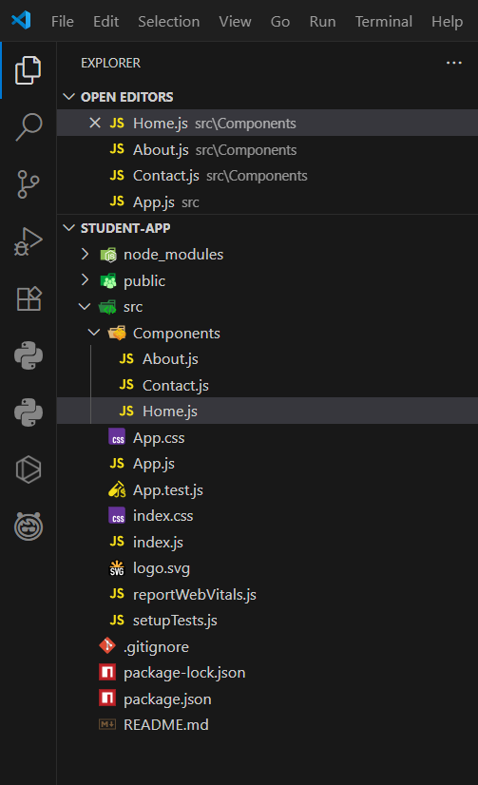

- Step 5: Add Code to Components
- Home.js:
- In the path- src/Components/home.js, write the following code-

import React, { Component } from 'react';

class Home extends Component {
render() {
return (
<div>
<h3>Welcome to the Home Page of Student Management Portal</h3>
</div>
);
}
}

export default Home;

- About.js:
- In the path- src/Components/About.js, write the following code-

import React, { Component } from 'react';

class About extends Component {
render() {
return (
<div>
<h3>Welcome to the About Page of Student Management Portal</h3>
</div>
);
}
}

export default About;

- Contact.js:
- In the path- src/Components/Contact.js, write the following code-

import React, { Component } from 'react';

class Contact extends Component {
render() {
return (
<div>
<h3>Welcome to the Contact Page of Student Management Portal</h3>
</div>
);
}
}

export default Contact;

- Save all the files after writing the code- Ctrl+S

- OUTPUT:
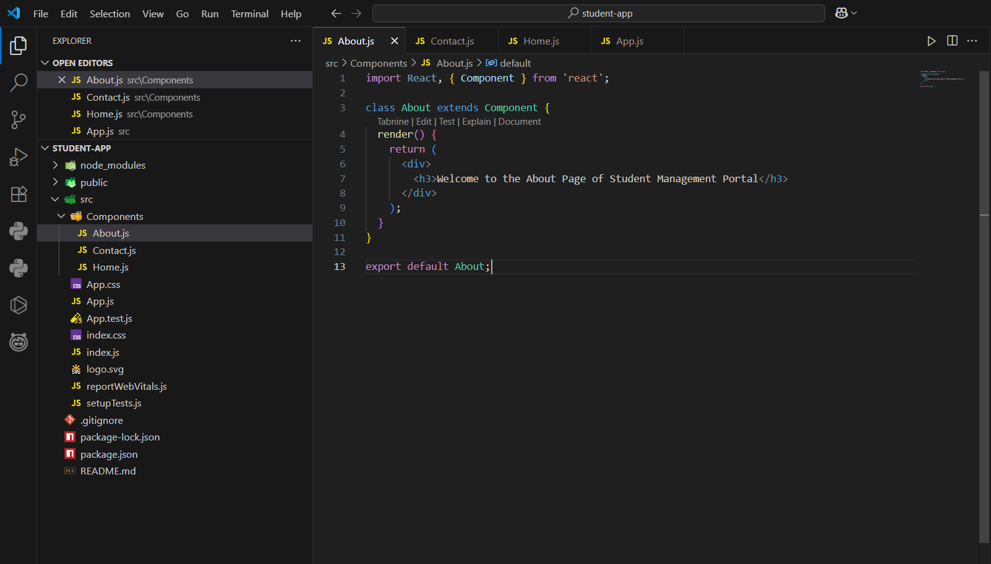
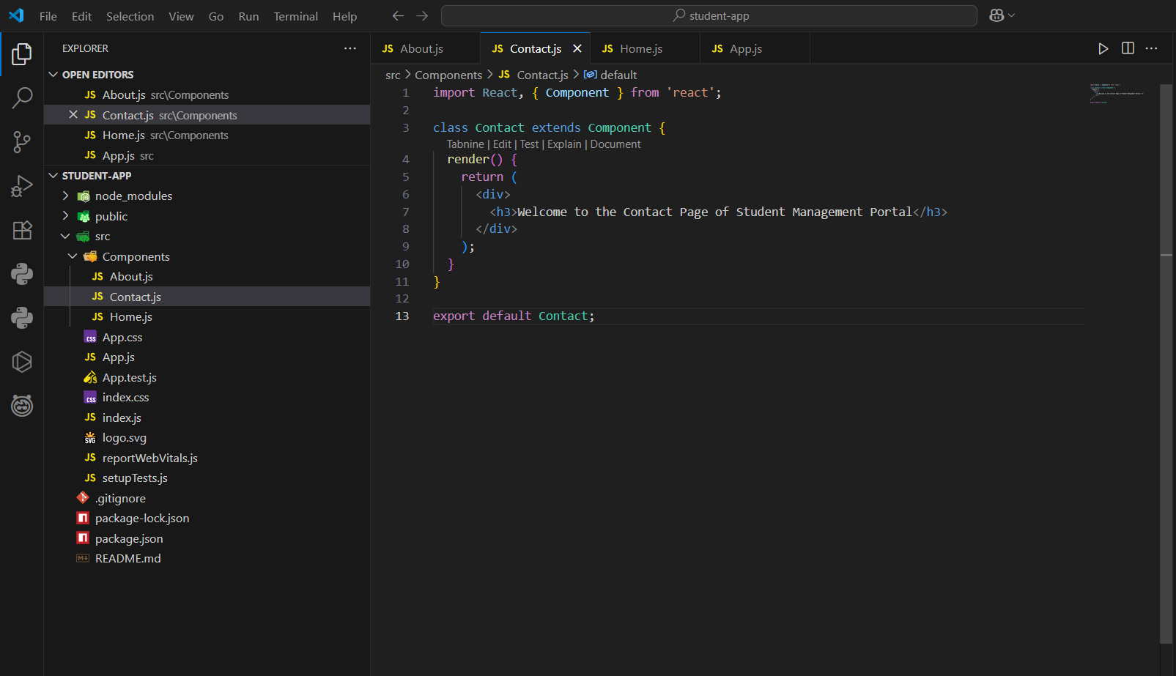
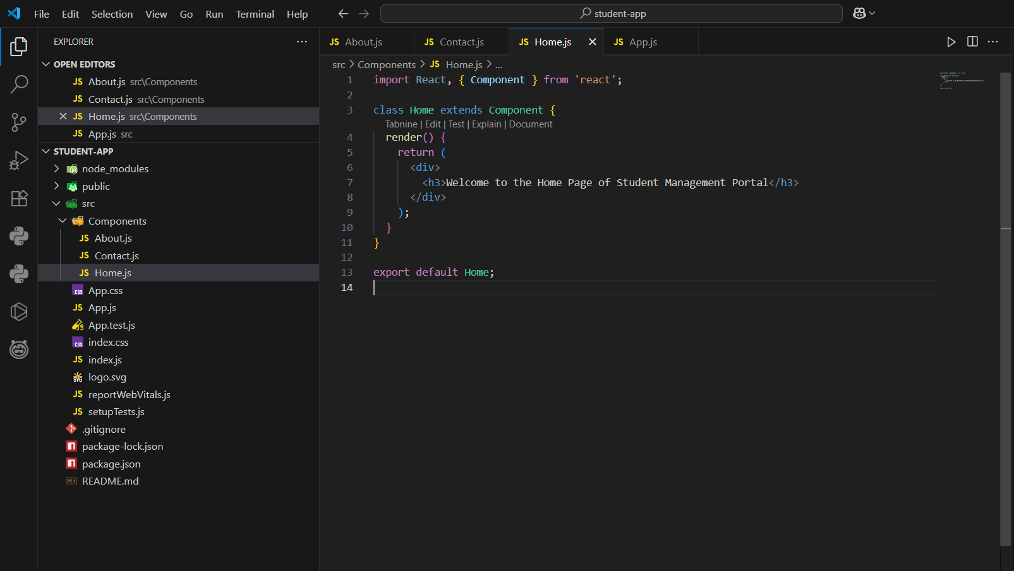
- Step 6: Modify the App.js file
  - In the path- student-app/src/App.js, replace the existing code with the following code:

- Code-
import './App.css';
import Home from './Components/Home';
import About from './Components/About';
import Contact from './Components/Contact';

function App() {
return (
<div className="container">
<Home />
<About />
<Contact />
</div>
);
}

export default App;

  - Save the code- Ctrl+S

- OUTPUT:
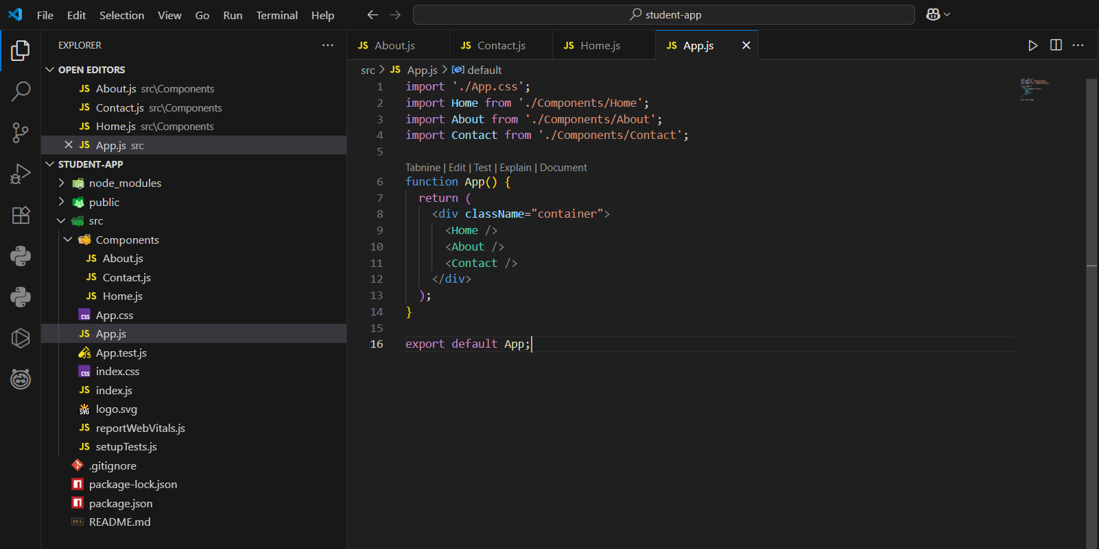

- Step 6: Run the React App
  - Inside the project folder student-app, in the terminal, run the following command:
    - npm start
  - This will compile the app and open http://localhost:3000 in your browser automatically, with the desired output.

- OUTPUT:
