JWT Hands-on

- Hands-On: Create authentication service that returns JWT
(This is a continuation of the earlier Spring Rest Hands-On files)

- Step 1: Add dependencies:
- Open pom.xml file
- In the <dependencies> … </dependencies> section, add these dependencies, then Right-click pom.xml → Maven → Reload project.

- Code:

<dependency>
<groupId>org.springframework.boot</groupId>
<artifactId>spring-boot-starter-security</artifactId>
</dependency>

<dependency>
<groupId>io.jsonwebtoken</groupId>
<artifactId>jjwt</artifactId>
<version>0.9.1</version>
</dependency>

<dependency>
<groupId>javax.xml.bind</groupId>
<artifactId>jaxb-api</artifactId>
<version>2.3.1</version>
</dependency>

- Step 2: Create the config package:
- In the path- src/main/java/com/cognizant/spring_learn, Right-click → New > Package
- Create a new package named com.cognizant.spring_learn.config
- In this package, create a new java class named SecurityConfig.java

- Code:

package com.cognizant.spring_learn.config;
import org.springframework.context.annotation.Bean;
import org.springframework.context.annotation.Configuration;
import org.springframework.security.core.userdetails.User;
import org.springframework.security.core.userdetails.UserDetails;
import org.springframework.security.provisioning.InMemoryUserDetailsManager;
import org.springframework.security.config.annotation.web.builders.HttpSecurity;
import org.springframework.security.config.annotation.web.configurers.AbstractHttpConfigurer;
import org.springframework.security.web.SecurityFilterChain;
import org.springframework.security.config.Customizer;
@Configuration
public class SecurityConfig {
@Bean
public SecurityFilterChain securityFilterChain(HttpSecurity http) throws Exception {
http
.authorizeHttpRequests(request -> request
.requestMatchers("/authenticate").permitAll()
.anyRequest().authenticated()
)
.csrf(AbstractHttpConfigurer::disable)
.httpBasic(Customizer.withDefaults());
return http.build();
}
@Bean
public InMemoryUserDetailsManager userDetailsService() {
UserDetails user = User
.withUsername("user")
.password("{noop}pwd") // No password encoding
.roles("USER")
.build();
return new InMemoryUserDetailsManager(user);
}
}

- Step 2: Create the REST AuthenticationController:
- In the path- src/main/java/com/cognizant/spring_learn/controller, create a new java class named AuthenticationController.java

  - Code:

package com.cognizant.spring_learn.controller;
import org.springframework.http.HttpStatus;
import org.springframework.web.bind.annotation.*;
import org.springframework.web.server.ResponseStatusException;
import io.jsonwebtoken.Jwts;
import io.jsonwebtoken.SignatureAlgorithm;
import java.util.*;
@RestController
public class AuthenticationController {
@PostMapping("/authenticate")
public Map<String, String> authenticate(@RequestHeader("Authorization") String authHeader) {
String[] credentials = getCredentials(authHeader);
String username = credentials[0];
String password = credentials[1];
if ("user".equals(username) && "pwd".equals(password)) {
String token = Jwts.builder()
.setSubject(username)
.signWith(SignatureAlgorithm.HS256, "secretkey")
.compact();
return Collections.singletonMap("token", token);
} else {
throw new ResponseStatusException(HttpStatus.UNAUTHORIZED, "Invalid credentials");
}
}
private String[] getCredentials(String authHeader) {
String base64Creds = authHeader.substring("Basic ".length());
byte[] decodedBytes = Base64.getDecoder().decode(base64Creds);
return new String(decodedBytes).split(":", 2);
}
}

  - OUTPUT:
The structure of the program now looks like this-
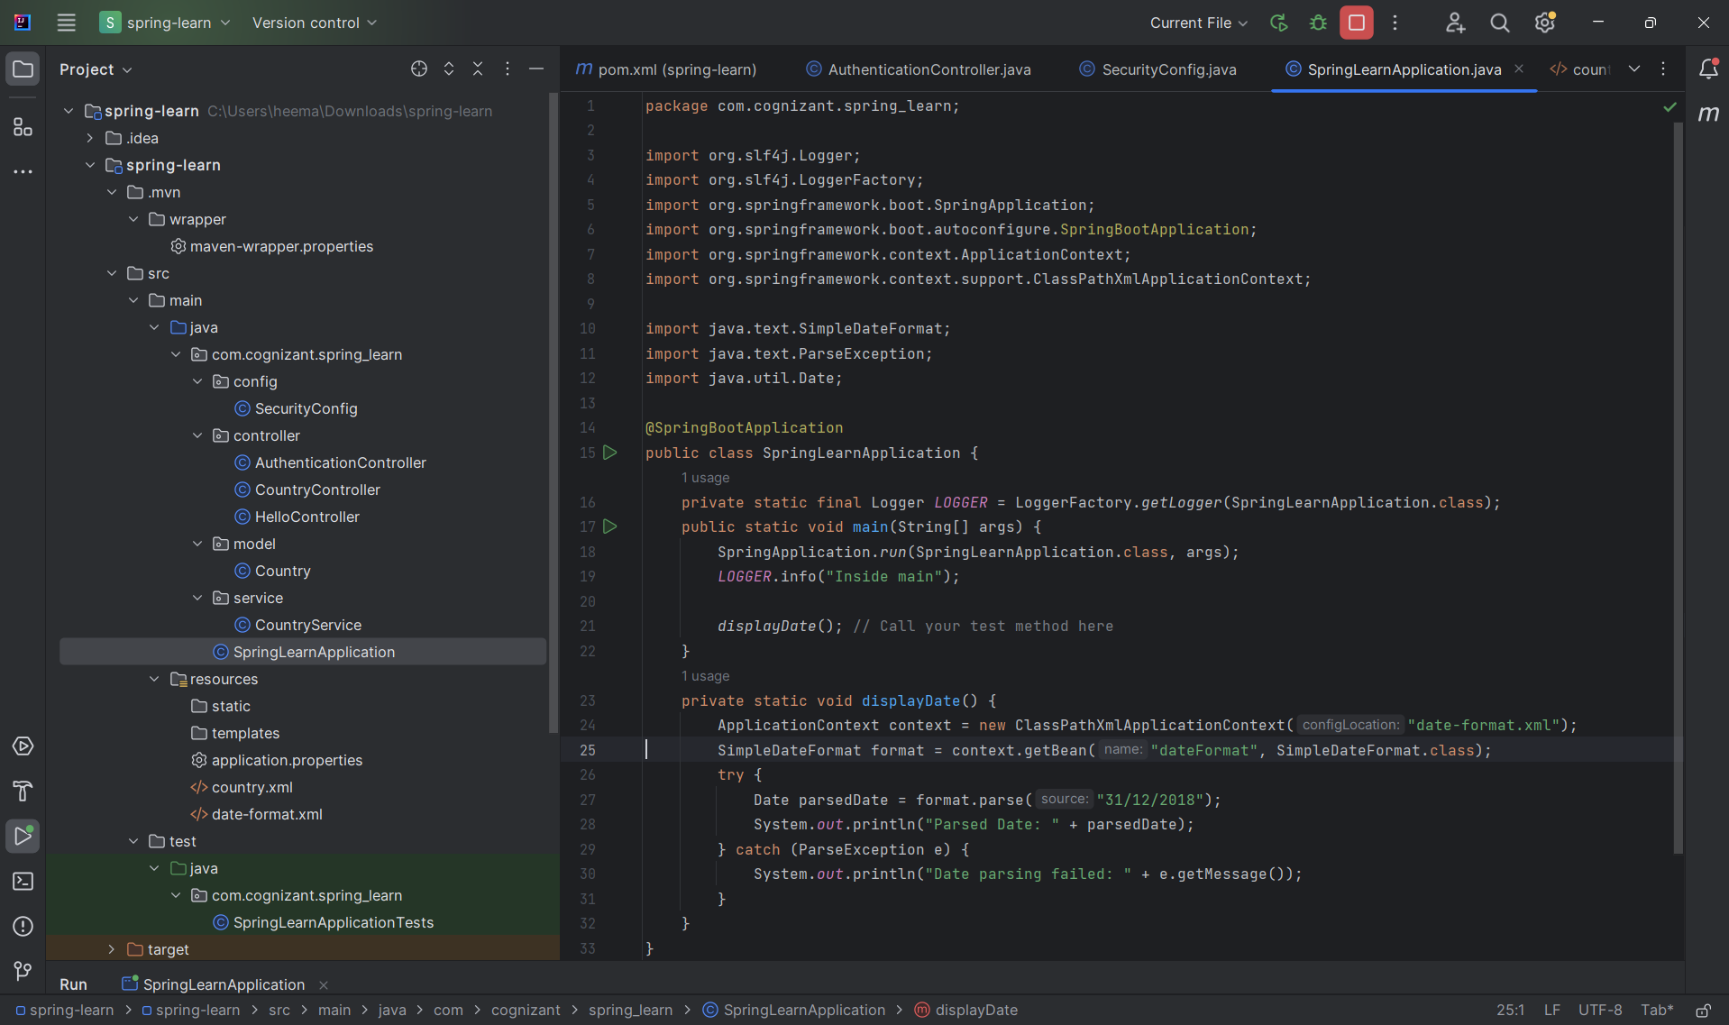

- Step 4: Run the Application:
- Run the main() method SpringLearnApplication.java

- OUTPUT:
- In Intellij Console-
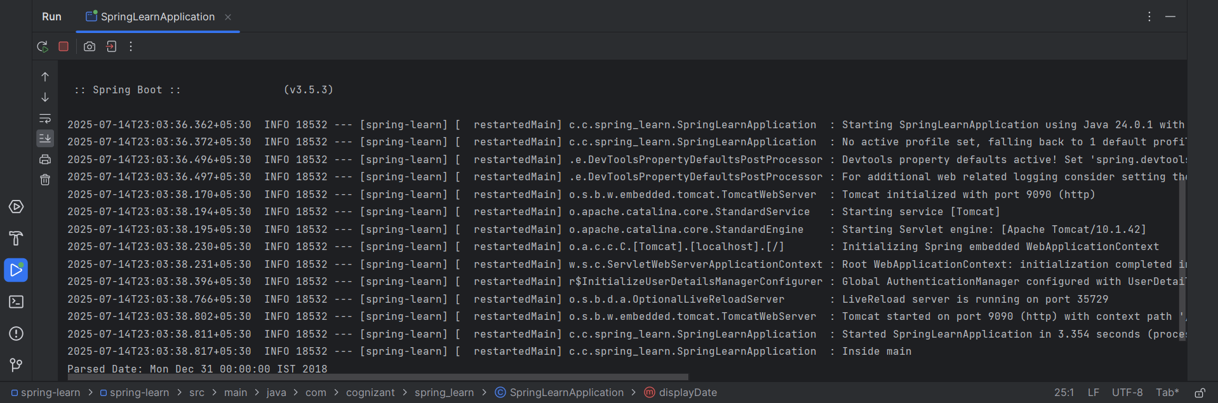

- Step 5: Test the Application in postman:
- Open postman.
- Click on “+” tab to open a new request tab (or click "New > HTTP Request").
- On the top-left of the tab, there’s a dropdown with HTTP methods — by default it shows GET, select POST.
- In the URL bar, type-
http://localhost:9090/authenticate
- Go to Authorization tab,
    - Select, Auth Type - Basic Auth
    - Username - user
    - Password - pwd
- Click on the blue “Send” button, it will generate the token.
- Click the header section in the output console.

- OUTPUT:
    - In postman-
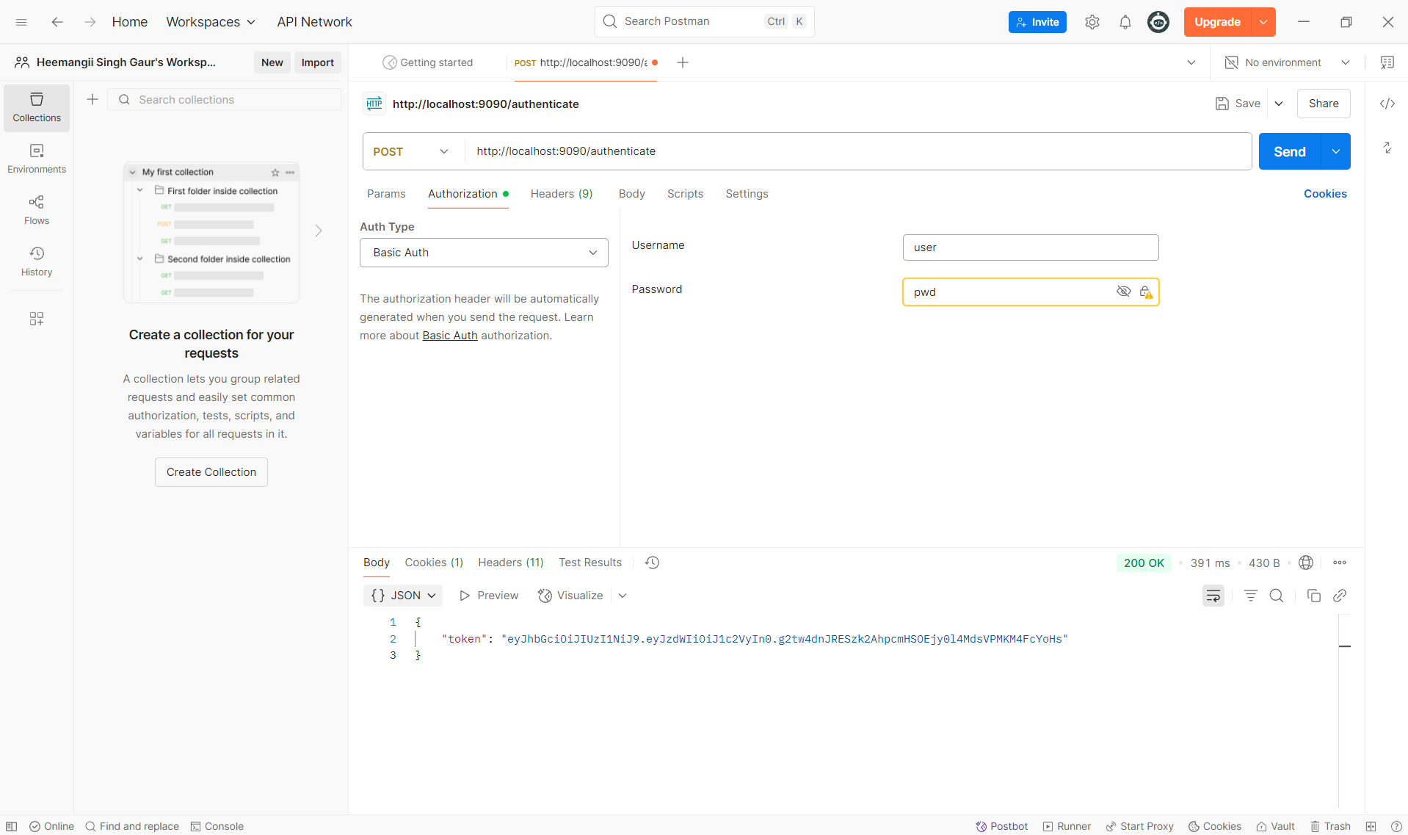
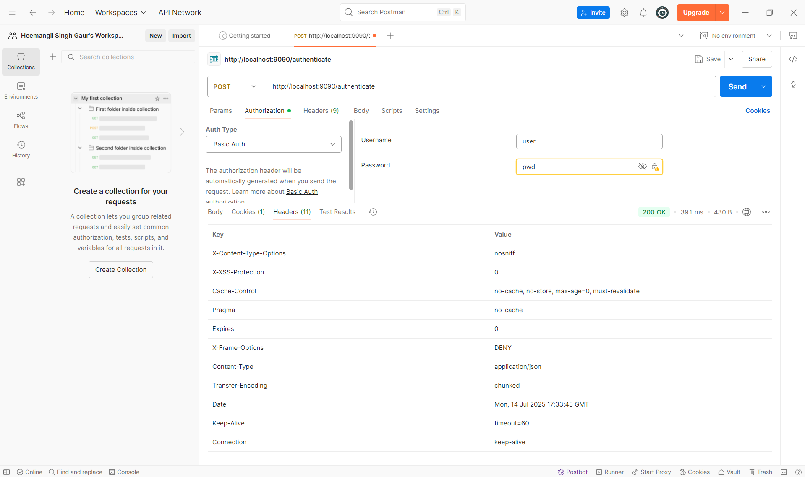

    - In Intellij console-

