ReactJS Hands-on

- Hands-On 1 :–
- Software Pre-requisites
- Node.js
- NPM
- VS Code

- Scenario:
  - Create a new React Application with the name “myfirstreact”.
  - Run the application to print “Welcome to the first session of React” as heading of that page.

- Step 1: Install create-react-app globally
  - Click start and type ‘cmd’ in the search box; Click command prompt to open it.
  - Run the following commands in the command prompt to check if Node.js and npm are installed in your computer or not:
    - node -v
- npm -v
  - After making sure the required pre-requisites, run the following command:
    - npm install -g create-react-app

- OUTPUT:

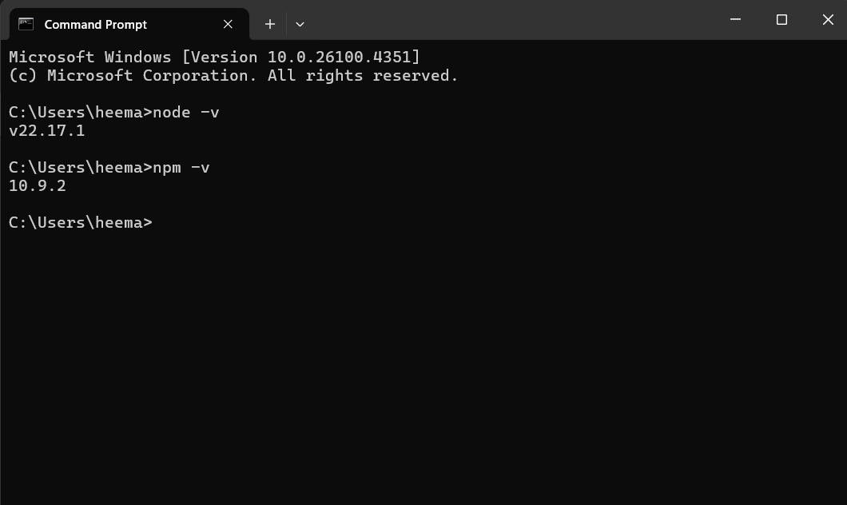
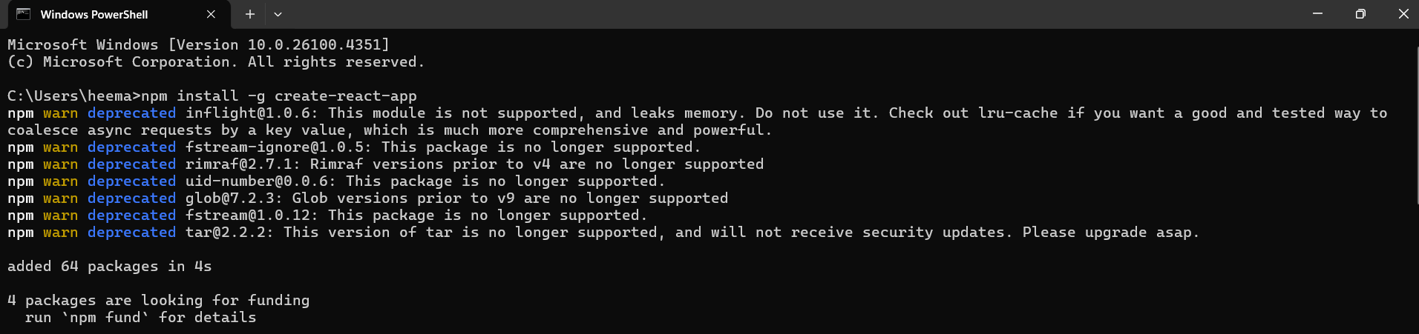

- Step 2: Create the React app
  - In the command prompt, run the following command:
    - npx create-react-app myfirstreact
This creates a folder named myfirstreact.

- OUTPUT:
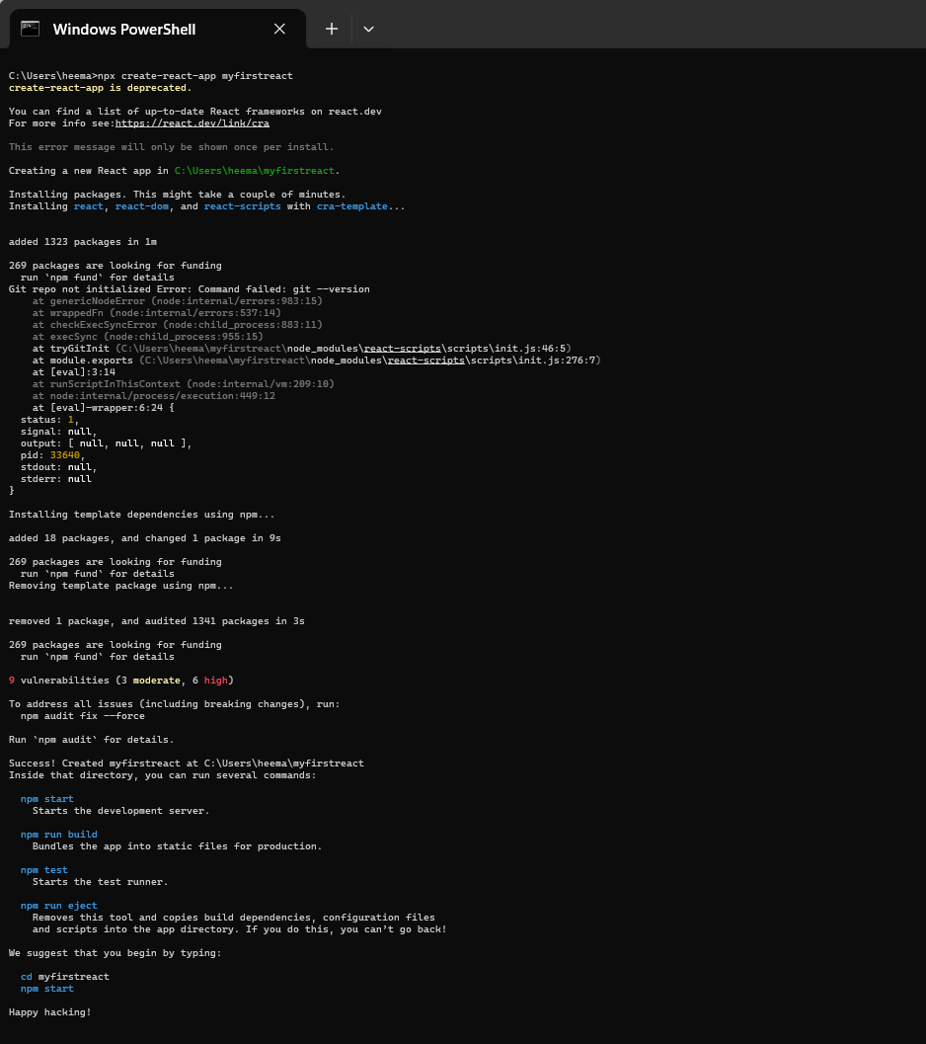
- Step 3: Navigate into the project folder
  - Run the following command next:
    - cd myfirstreact

- OUTPUT:
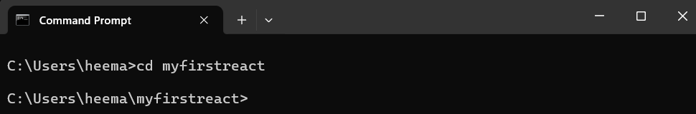

- Step 4: Open the project in VS Code
  - You can either –
Open VS Code, go to File > Open Folder, and select myfirstreact.
  - Or –
If you are still inside the project folder in the terminal, run the following command:
    - code .
This will open the project folder ‘myfirstreact’ in VS Code.

- OUTPUT:
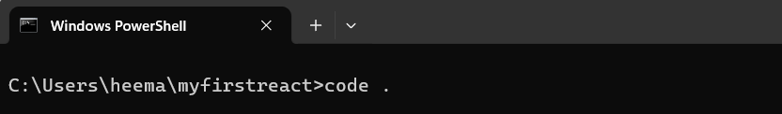
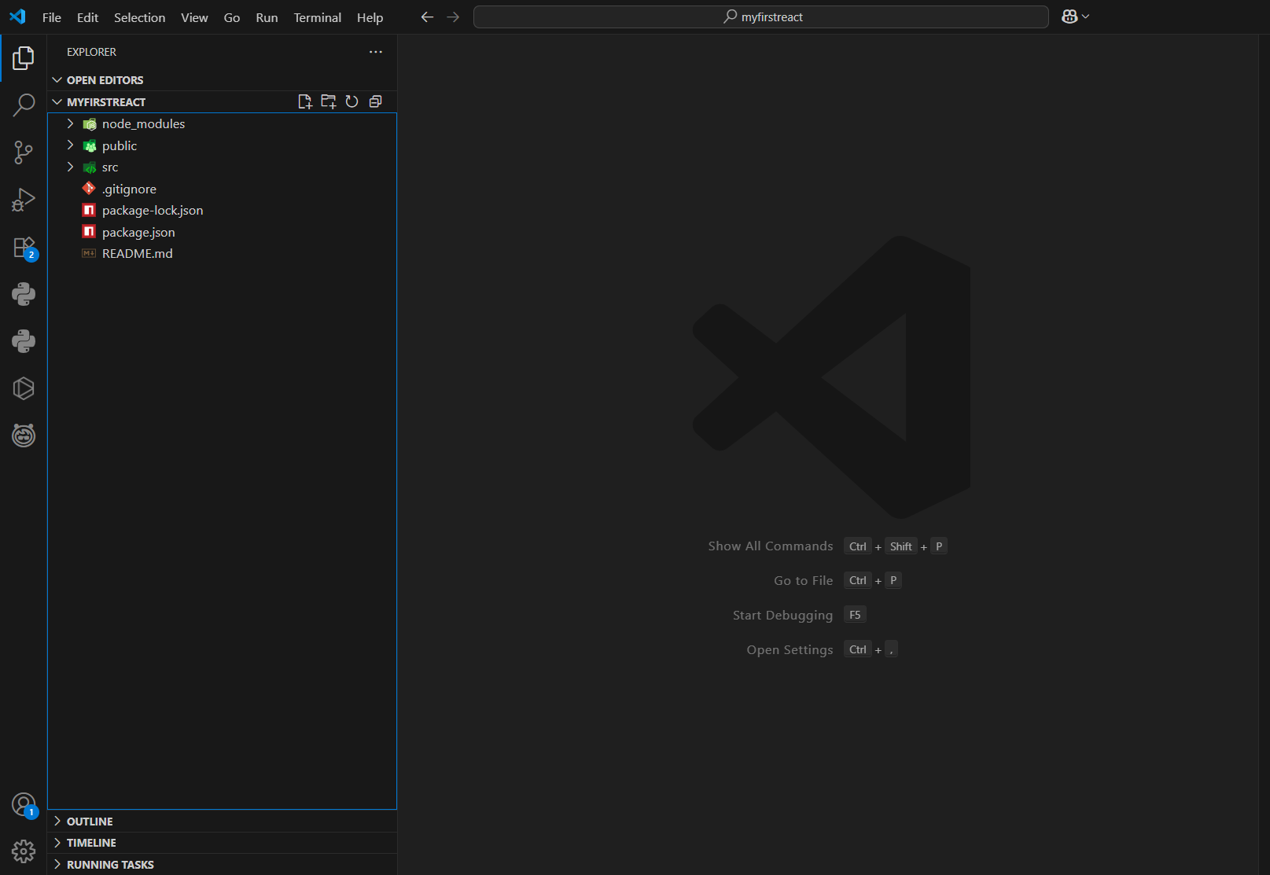
- Step 5: Modify the App.js file
  - In the path- myfirstreact/src/App.js, replace the existing code with the following code:

- Code-
function App() {
return (
<h1>Welcome the first session of React</h1>
);
}
export default App;

  - Save the code- Ctrl+S

- OUTPUT:
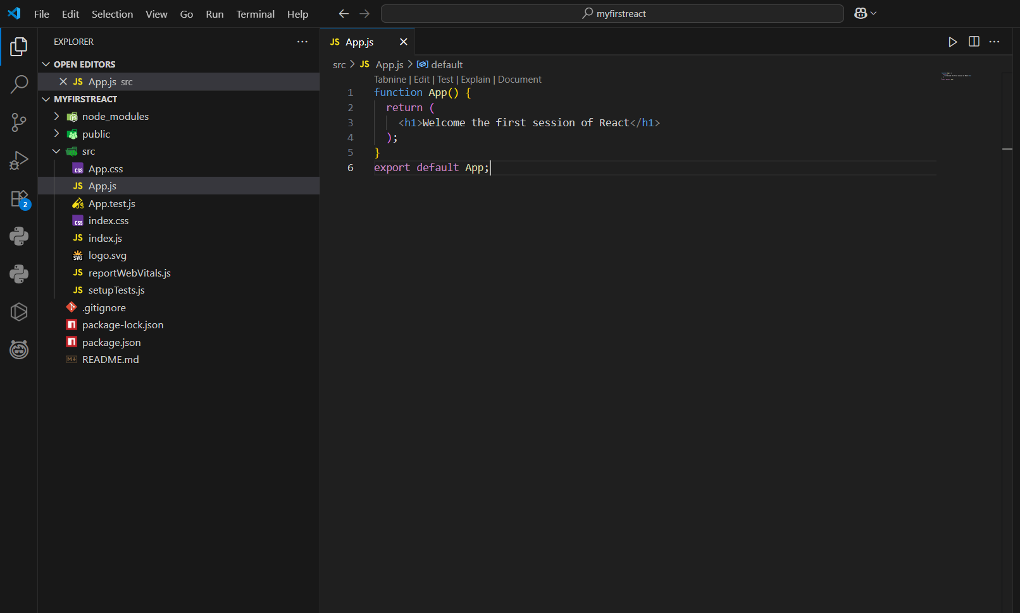

- Step 6: Run the React App
  - Inside the project folder myfirstreact, in the terminal, run the following command:
    - npm start
  - This will compile the app and open http://localhost:3000 in your browser automatically, showing the typed message.

- OUTPUT:

