Spring Rest Hands-on

- Hands-On: Hello World RESTful Web Service
(This is a continuation in the Spring Rest Hands-On 2 file)

- Step 1: Create the controller package:
- In the path- src/main/java, Right-click → New > Package
- Create a new package named com.cognizant.spring_learn.controller
- In this package, create a new java class named HelloController.java

- Code:

package com.cognizant.spring_learn.controller;

import org.slf4j.Logger;
import org.slf4j.LoggerFactory;
import org.springframework.web.bind.annotation.GetMapping;
import org.springframework.web.bind.annotation.RestController;

@RestController
public class HelloController {

private static final Logger LOGGER = LoggerFactory.getLogger(HelloController.class);

@GetMapping("/hello")
public String sayHello() {
LOGGER.info("Start sayHello()");
String message = "Hello World!!";
LOGGER.info("End sayHello()");
return message;
}
}

- OUTPUT:
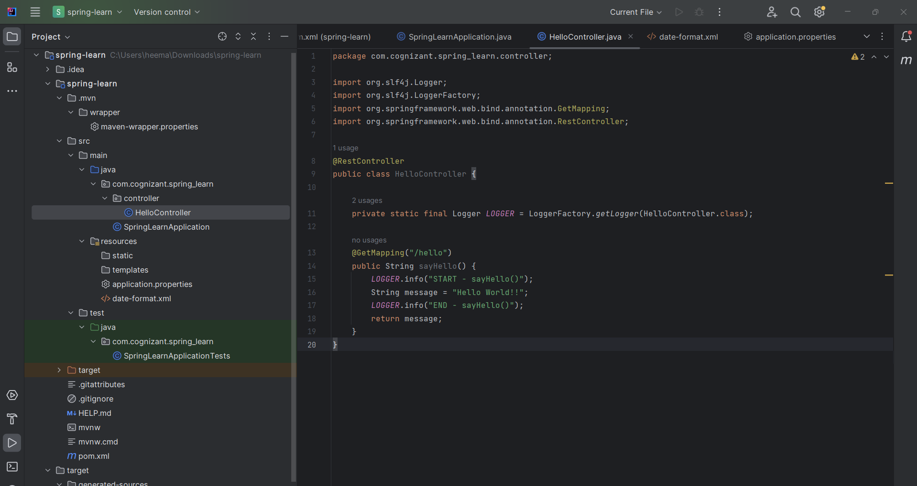

- Step 2: Run the Application:
- Run the main() method SpringLearnApplication.java

- OUTPUT:
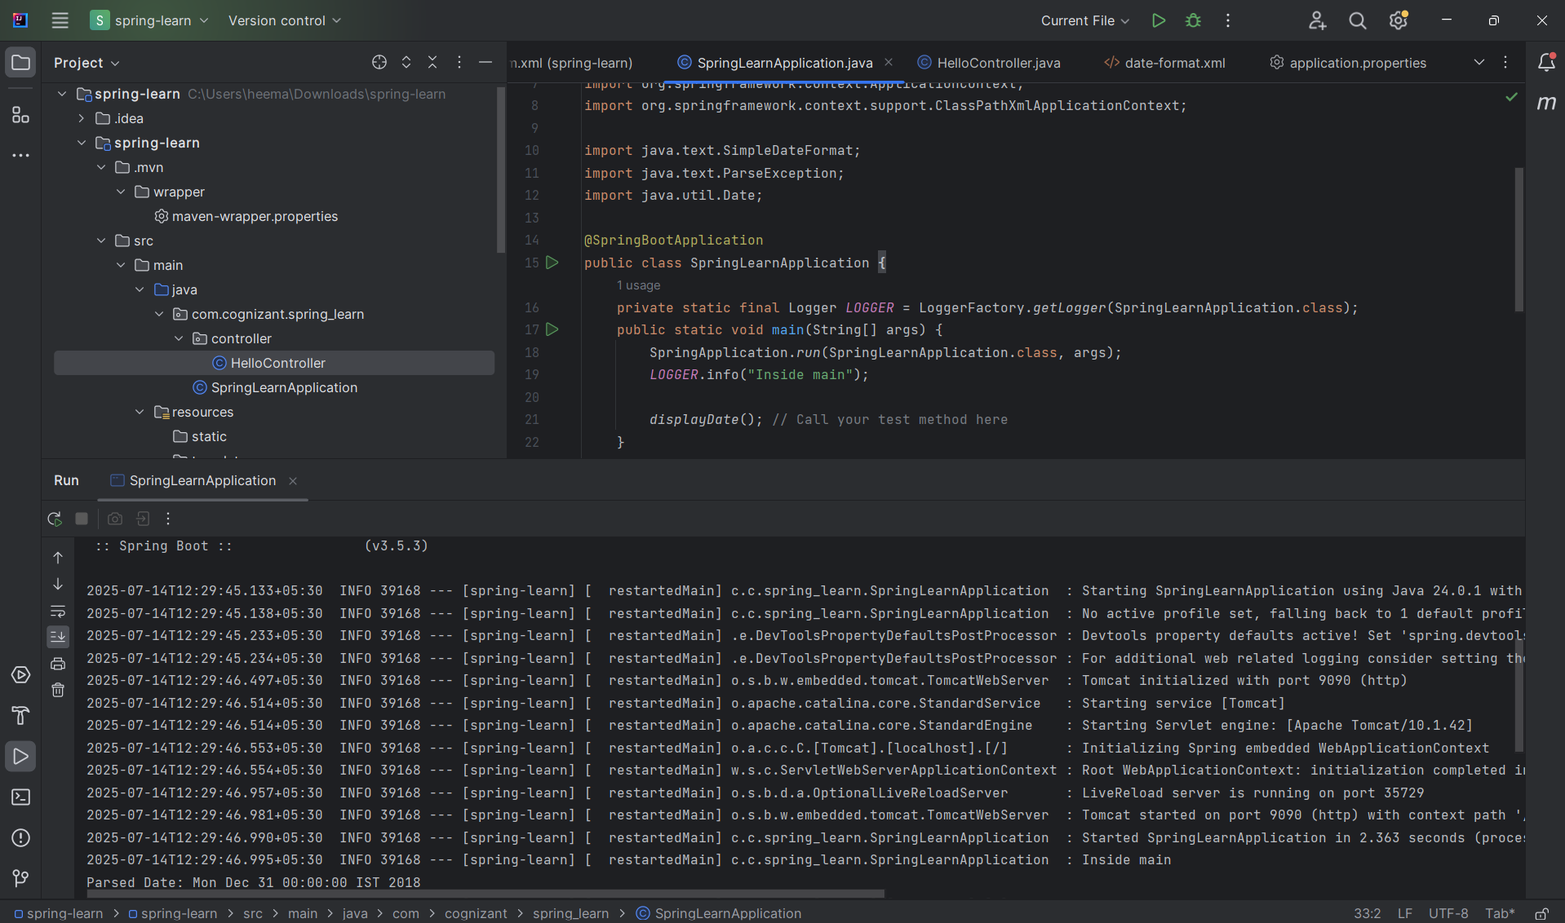

- Step 3: Test the Application in browser:
- In the browser go to http://localhost:9090/hello
- OUTPUT:
- In Browser-
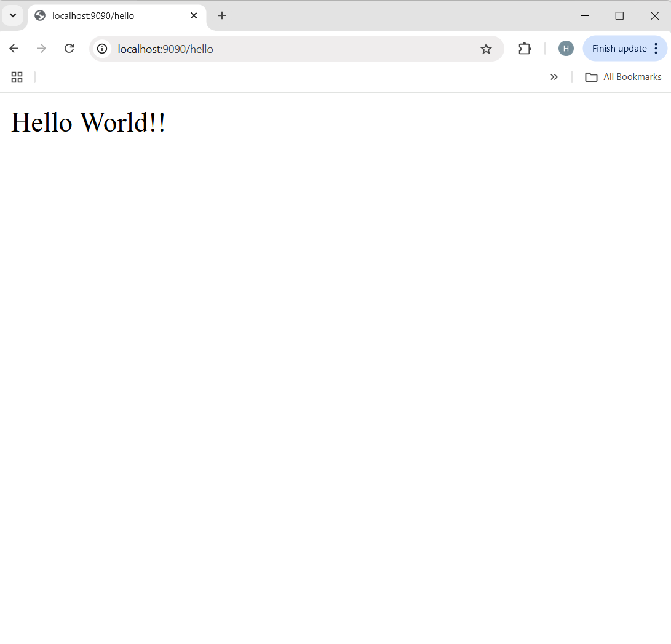
- In Intellij Console-
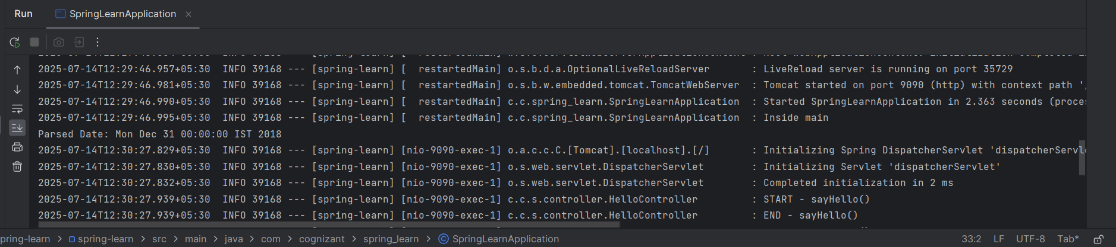

- Step 4: Test the Application in postman:
- Open postman.
- Click on “+” tab to open a new request tab (or click "New > HTTP Request").
- On the top-left of the tab, there’s a dropdown with HTTP methods — by default it shows GET.
- In the URL bar, type-
http://localhost:9090/hello
- Click on the blue “Send” button.
- Click the header section in the output console.

- OUTPUT:
