Spring Core Maven

- Exercise 4: Creating and Configuring a Maven Project
- Scenario:
You need to set up a new Maven project for the library management application and add Spring dependencies.

- Step 1: Create a New Maven Project:
- Create a new Maven project named LibraryManagement.
- In IntelliJ IDEA, Go to File → New → Project.
- In the dialog you're on:
Name: LibraryManagement
Build system: Maven
Language: Java
JDK: Choose Java 11 or higher
Uncheck "Add sample code"
Uncheck "Generate code with onboarding tips"
- Then click Create.

- OUTPUT:
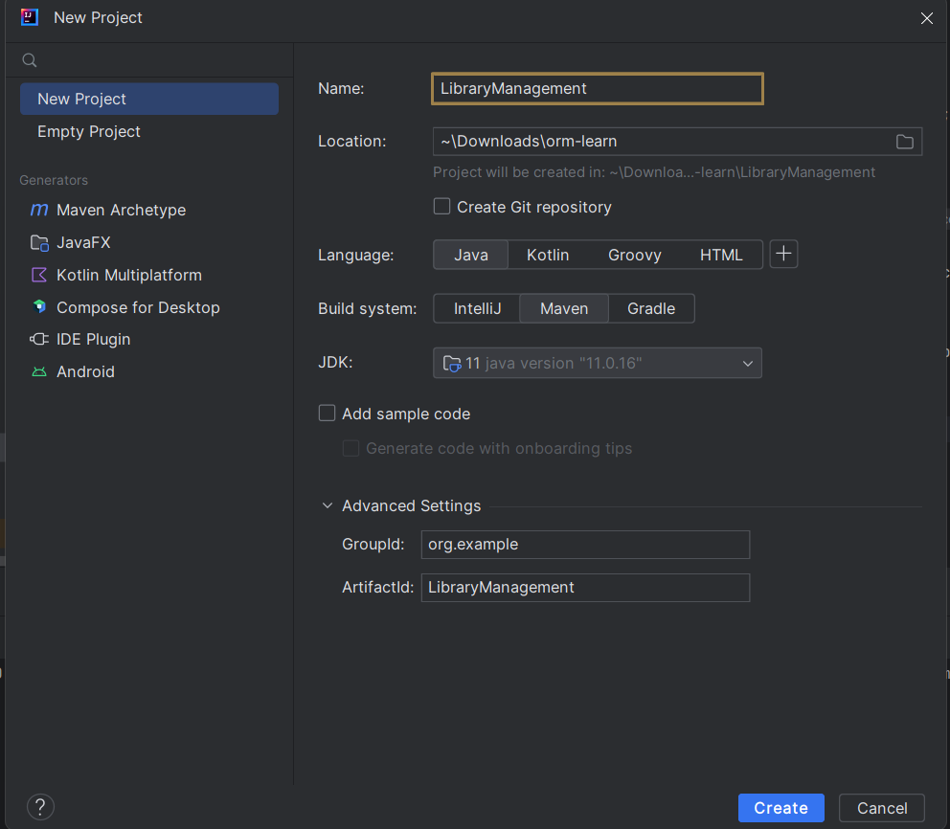
- Step 2: Add Spring Dependencies in pom.xml:
- Include dependencies for Spring Context, Spring AOP, and Spring WebMVC.
- Open the pom.xml file and add this inside <dependencies>:

<dependencies>

<!-- Spring Context -->
<dependency>
<groupId>org.springframework</groupId>
<artifactId>spring-context</artifactId>
<version>5.3.36</version>
</dependency>

<!-- Spring AOP -->
<dependency>
<groupId>org.springframework</groupId>
<artifactId>spring-aop</artifactId>
<version>5.3.36</version>
</dependency>

<!-- Spring WebMVC -->
<dependency>
<groupId>org.springframework</groupId>
<artifactId>spring-webmvc</artifactId>
<version>5.3.36</version>
</dependency>

</dependencies>

- Step 3: Configure Maven Plugins:
- Configure the Maven Compiler Plugin for Java version 1.8 in the pom.xml file.
- Still inside your pom.xml, below the <dependencies> section, add:

<build>
<plugins>
<plugin>
<groupId>org.apache.maven.plugins</groupId>
<artifactId>maven-compiler-plugin</artifactId>
<version>3.8.1</version>
<configuration>
<source>1.8</source>
<target>1.8</target>
</configuration>
</plugin>
</plugins>
</build>

- Then click the blue "Load Maven Changes" popup or right-click → Maven → Reload Project.

- OUTPUT:
