Spring Rest Hands-on

- Hands-On 2: Spring Core – Load SimpleDateFormat form Spring Configuration XML
(This is a continuation of the Spring Rest Hands-On 1 project)

- Step 1: Create the Spring Configuration XML file:
- In the path- src/main/resources, create a new file named date-format.xml
- To create a new file,
Right-click → New > File

- Code:

<?xml version="1.0" encoding="UTF-8"?>
<beans xmlns="http://www.springframework.org/schema/beans"
xmlns:xsi="http://www.w3.org/2001/XMLSchema-instance"
xsi:schemaLocation="http://www.springframework.org/schema/beans
https://www.springframework.org/schema/beans/spring-beans.xsd">

<bean id="dateFormat" class="java.text.SimpleDateFormat">
<constructor-arg value="dd/MM/yyyy" />
</bean>

</beans>

- OUTPUT:
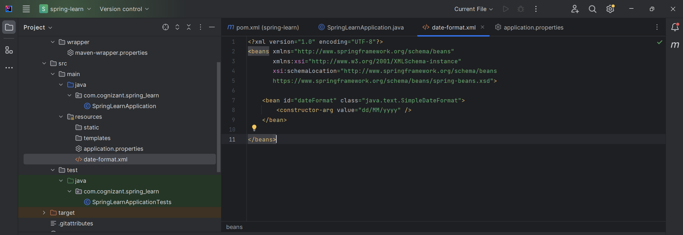

- Step 2: Edit the main() method:
- Make changes in the SpringLearnApplication.java file as follows-
  - Add necessary import statements.
  - Add displayDate() method and define it.
package com.cognizant.spring_learn;

import org.slf4j.Logger;
import org.slf4j.LoggerFactory;
import org.springframework.boot.SpringApplication;
import org.springframework.boot.autoconfigure.SpringBootApplication;
import org.springframework.context.ApplicationContext;
import org.springframework.context.support.ClassPathXmlApplicationContext;

import java.text.SimpleDateFormat;
import java.text.ParseException;
import java.util.Date;

@SpringBootApplication
public class SpringLearnApplication {
private static final Logger LOGGER = LoggerFactory.getLogger(SpringLearnApplication.class);

public static void main(String[] args) {
SpringApplication.run(SpringLearnApplication.class, args);
LOGGER.info("Inside main");

displayDate(); // Call your test method here
}

private static void displayDate() {
ApplicationContext context = new ClassPathXmlApplicationContext("date-format.xml");
SimpleDateFormat format = context.getBean("dateFormat", SimpleDateFormat.class);
try {
Date parsedDate = format.parse("31/12/2018");
System.out.println("Parsed Date: " + parsedDate);
} catch (ParseException e) {
System.out.println("Date parsing failed: " + e.getMessage());
}
}
}
- OUTPUT:
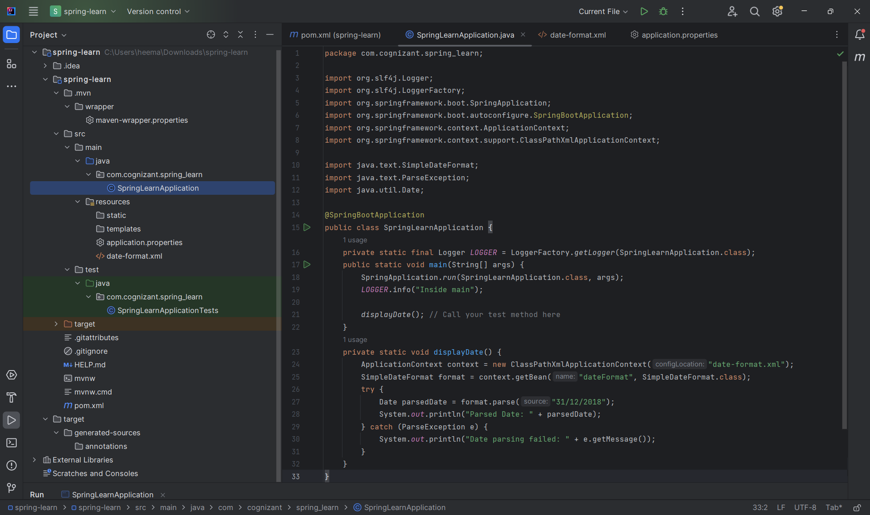

- Step 3: Run the main() method:
- After making the necessary changes, run the main() method i.e.
SpringLearnApplication.java

- OUTPUT:
