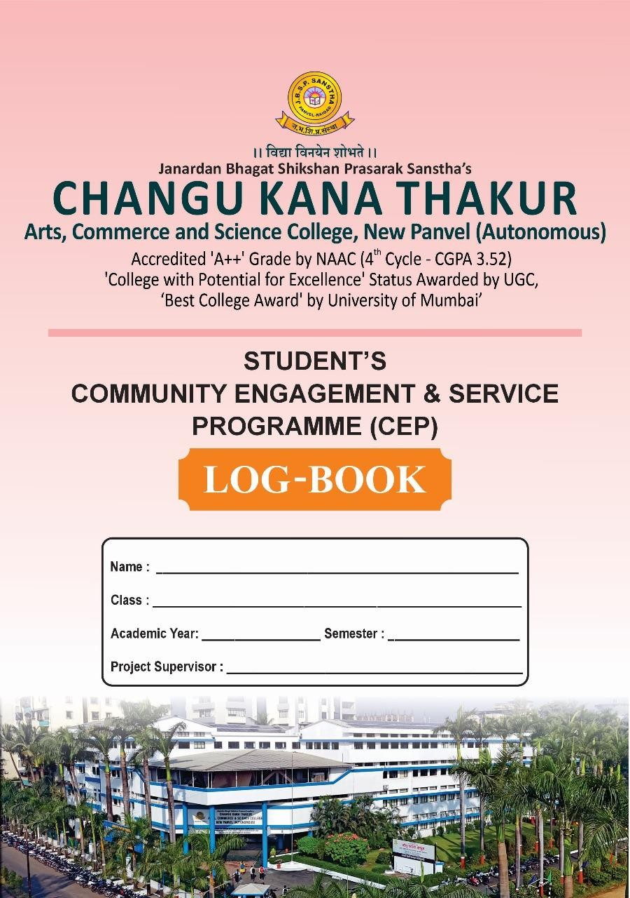

Janardan Bhagat Shikshan Prasarak Sanstha’s
Changu Kana Thakur Arts, Commerce and Science College, New Panvel
(AUTONOMOUS)
Re-accredited ‘A++’ Grade by NAAC
‘College with Potential for Excellence’ Status Awarded by University Grants Commission
Best College Award’ by University of Mumbai

CERTIFICATE

This is to certify that Mr/Ms Heemani Shailesh Patil of class SY.IT has successfully completed ‘Community Engagement and Service
Programme’ titled Basic Mathematics , say no to plastic and other gaming activities for children’s at Nere “ Girija Welfare Association” panvel for the period from 13/11/2025 to 19/11/2025 having total engagement hours 30
His/her progress is satisfactory.

Signature  Project Supervisor | Signature Head of Department

Date

Signature of Examiner with date

Seal

INTRODUCTION

Community Engagement & Service Programme is compulsory course to the second year students. This log-book is to assist the student to maintain record of Community Engagement & Service Programme. It will show the student’s involvement, daily activities and the time spent in/for community.

INSTRUCTIONS
The Community Engagement & Service Programme must involve the student for minimum 30 hours of total engagement with a significant portion dedicated to outreach activity beneficial to community. The whole exercise is marked out of 50 (2 credits) marks. The marks distribution will be as follows-
• Project proposal 10 marks,
• Participation/attendance (Log book entry) 10 marks,
• Summary report 20 marks and
• Presentation/ Viva-voce 10 marks.

CONSENT FORM
The student is supposed to notify the Project supervisor by filling a consent form provided regarding the details where he/she is attached. This should be communicated/ submitted to the project supervisor before starting the activity.

DAILY REPORT

The daily work carried out during the period of engagement is to be recorded clearly in logbook with geo-tagged photographs, sketches and diagrams where necessary.

SUMMARY REPORT

The summary of the work done in the total engagement period should cover in a summary report that also include student’s work covered during engagement, experiences, life skills learned, impact of the engagement on students’ own personality and remark/feedback by the respective community member, if available. Students are required to present the logbook certified by project supervisor and Head of Department for assessment of content and progress.

CHANGE OF ENGAGEMENT ACTIVITY/PROJECT

A student is expected to start and finish his/her engagement in one establishment. If it becomes absolutely necessary that he/she must change his/her engagement project, the student should first secure permission in writing from the project supervisor and Head of respective department.

STUDENT’S PARTICULARS
Name of student: Patil Heemani Shailesh
Roll No. of the student: 75
Mobile No.: 9372005109
Address: Near Saibaba mandir At- Gavthan (Chirle), Post-jasai , Tal-Uran, Dist Raigad.
Faculty: Science
Course of Study: information Technology
Class: SY.IT
Name and address of NGO/GO attached (if applicable) : Girija Welfare Association, om Bunglow, Nere, Matheran Road.
Name of Project Supervisor: Ms. Kumudinee Bhosale
Designation: Assistant Professor
Department: Information Technology
Mobile:
Duration
From:13th November 2025
To: 19th November 2025

5 | C O M M U M N I T Y E N G A G E M E N T A N D S E R V I C E P R O G R A M M E

PROJECT PROPOSAL

(Attach sheets if required)
Name of student: Patil Heemani Shailesh
Roll No. of the student: 75
Title of the Project: Basic Mathematics , say no to plastic and other gaming activities for children’s
Location of the Project: At- panvel , Nere, Chipale.
Background of the Project: This project is conducted in an orphanage at Panvel to support children in their educational and social development. Many children in orphanages need extra guidance in basic mathematics and awareness about environmental issues. Through this project, we aim to teach basic math concepts, create awareness about avoiding plastic, and engage children in healthy gaming activities for their overall development.
Objectives of the Project :
- To improve basic mathematics skills of children.
- To create awareness about the harmful effects of plastic.
- To encourage eco-friendly habits among children.
- To promote teamwork and confidence through fun learning games.
- To provide emotional support and motivation to orphan children.
Requirements (if any) :
- Chart papers and markers
- Basic mathematics worksheets
- Blackboard / Whiteboard
- Stationery items (pencils, erasers, notebooks)
- Dustbin for plastic awareness activity
- Small prizes for games

Outline of the project : This project will be conducted at an orphanage in Panvel to support children in their academic and personal development. The program will begin with an introduction and interaction session with the children. Basic mathematics concepts such as addition, subtraction, multiplication, and division will be taught through simple and interesting methods. After the educational session, awareness will be created about the harmful effects of plastic and the importance of using eco-friendly alternatives. The session will conclude with fun and educational games to improve teamwork, confidence, and communication skills among the children. This project aims to contribute to the overall development of children by combining education, environmental awareness, and recreational activities.
Expected Outcomes:
- Children will improve their basic mathematics skills.
- Children will understand the harmful effects of plastic.
- Increased awareness about cleanliness and eco-friendly habits.
- Improved confidence and communication skills among children.
- Development of teamwork and social interaction through games.

Conclusion: The project was a meaningful and enriching experience. It helped in enhancing the academic knowledge and environmental awareness of the children. Through interactive teaching and fun activities, the children actively participated and showed great enthusiasm. This project not only benefited the children but also helped us develop a sense of social responsibility and teamwork. Overall, the project successfully contributed to the educational and personal development of the children.

Signature  Project Supervisor | Signature Head of Department

Signature  Project Supervisor | Signature Head of Department

DAILY ENGAGEMENT RECORD
Title of Project:______________________________________________________

Venue:______________________________________________________________

DATE | TIME From……  To……… | DISCRIPTION OF  WORK | SKILLS ACQUIRED | SIGNATURE OF STUDENT | REMARK &  SIGNATURE OF  AUTHORITY

DAILY ENGAGEMENT RECORD

Title of Project:_______________________________________________________ Venue:______________________________________________________________

DATE | TIME  From……  To……… | DISCRIPTION OF  WORK | SKILLS ACQUIRED | SIGNATURE OF STUDENT | REMARK &  SIGNATURE OF THE  AUTHORITY

SUMMARY REPORT

(It must be typed) (Attach more sheeets if required)

12 | C O M M U M N I T Y E N G A G E M E N T A N D S E R V I C E P R O G R A M M E

SUMMARY REPORT

NGO/GO-BASED COORDINATOR’S COMMENTS

(If Applicable)
Name of the
coordinator……………………………………………………………………………
Name of
organization…………………………………………………………………………… Date……………………………………………………………………………………
Signature………………………………………………………………………………

16 | C O M M U M N I T Y E N G A G E M E N T A N D S E R V I C E P R O G R A M M E

CONSENT FORM (To be submitted to project supervisor before project starts)
(To be filled by the student and signed by parent)

Name of student ………………………………………………Roll.No……………..…
Class…………………………………………………………..Mobile No. …………… Email: …………………………………………………………………………………..
Name of the Course: Community Engagement and Service Programme (CEP)
Name of Organization (if any): ……………………………………………………..….
Location:……………………………………………………………………………..….
Period: From:………………………………. To:…………………………………..…..
Name of the Parent/ Guardian………………………………………………………… Address………………………………………………………………………………...
Mobile No.………………………………………………. E mail..……………………

I hereby state that I shall complete all the requirements of the said course sincerely. I am abide all the rules and regulations of Changu Kana Thakur Arts, Commerce and Science College, New Panvel (Autonomous) and the organization I’m associated with and give my best efforts for community welfare. I undertake professional behavior all the time. I strictly follow precautionary health/safety measures throughout the period of engagement.
I am aware that I entitled to disciplinary action in case of any misbehavior or deviation from rules and regulations. I further declare that, I am undertaking this engagement at my own risk.

Student’s Signature with name………………………………………..
Date…………………………………………………………………..

Parent’s Undertaking I have knowledge about the requirements of the course ‘Community Engagement and Service Programme (CEP)’ and am aware that my ward will be working for the assigned work in this programme which is mandatory requirement of the said course.
I am also aware of the nature and workdone by the ward and herby give my consent to my ward’s participation in community Engagement and Service Programme. I shall ensure that he/she takes due care follow the rules and regulations laid down by organization/institution. We further declare that the engagement undertaken by my ward is at our own risk.

Parent’s Signature with name……………………………………….. Date…………………………………………………………………..

ENGAGEMENT ASSESSMENT FORM
(To be filled by the Project Supervisor)
Name of the student …………………………….……………………………………… Roll No …………………………………………………………………………………
Class ……………………………………………………………………………………
Please rate the student on scale of 1 – 5 with 5 being best and 1 being poor.
Observations | 1 | 2 | 3 | 4 | 5
1. Ability to interact
2. Teamwork
3. Communication Skill
4. Patience
5. Observe of rules/regulations
6. Punctuality/Attendance
7. Willingness to learn
8. Reliability
9. Grooming
10. Direct Observations
Name of Project Supervisor: …………………………………………………
Signature ………………………………………………………………………..
Date ……………………
Official Stamp

SELF ASSESSMENT FORM
(To be filled by the student and evaluated by project supervisor)
Name of the student …………………………….……………………………………… Roll No …………………………………………………………………………………
Class:……………………………………………………………………………………
Please rate on scale of 1 – 5 with-
(5 – Excellent; 4- Very good; 3- Good; 2- Average; 1- Poor; 0-Very poor)

Skills/Values Developed | Student | Project Supervisor
1. Networking
2. Communication Skill
3. Adapting
4. Planning
5. Volunteering
6. Teamwork
7. Public speaking
8. Decision-making,
9. Problem-solving,
10. Action-taking
Name of Project Supervisor: …………………………………………………
Signature ………………………………………………………………………..
Date ……………………
Official Stamp

