

Program :
B.tech(CSE)

Specialization :AIML
Course Title :AI Assisted Coding
Course Code :24CS002PC215
Semester :3rd semester
Academic Session :2025-2026
Name of Student : Md heena
Enrollment No. :2403A54067
Batch No. :01
Date :04/11/2025

#LAB ASSIGNMENT-16.2

#TASK DESCRIPTION-1:
Task: Ask AI to design a schema for a Library Management System (Tables: Books, Members, Loans).
SQL Code
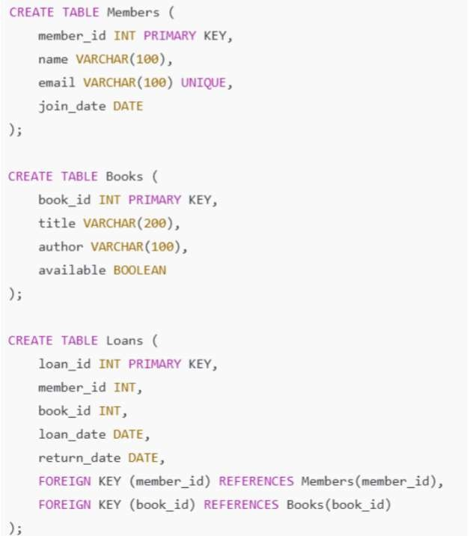
#PROMPT:
Design an SQL schema for a Library Management System that includes three tables — Members, Books, and Loans.
Each table should have appropriate primary keys, foreign keys, and relevant columns such as member details, book details, and loan records.
Write complete and executable SQL CREATE TABLE statements.
Also include sample INSERT statements to add example data into each table.
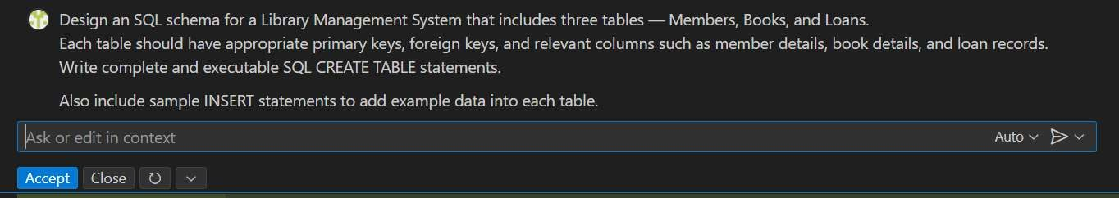
#CODE:
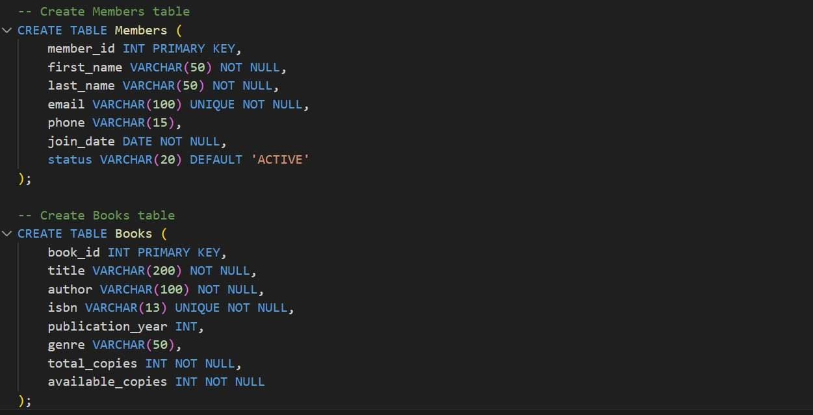
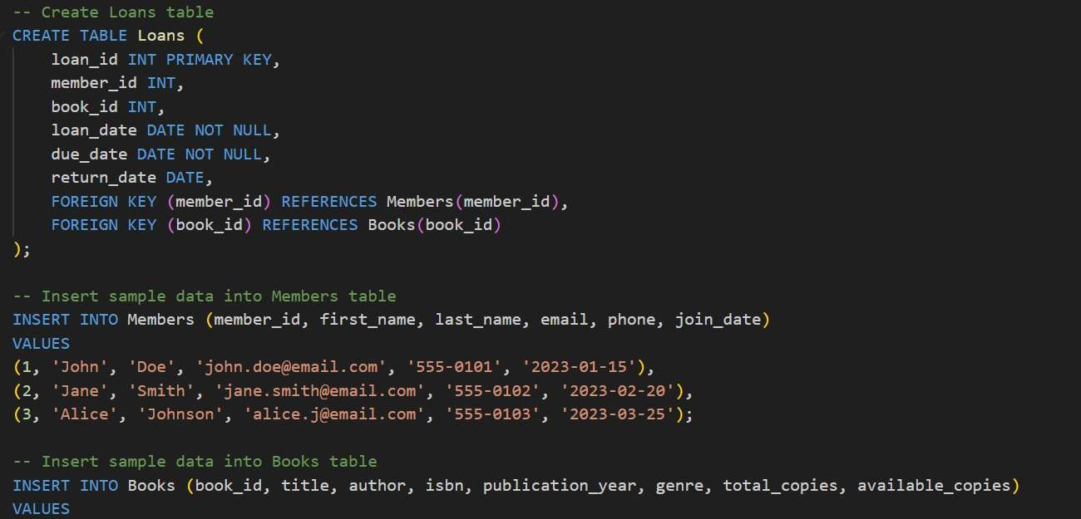
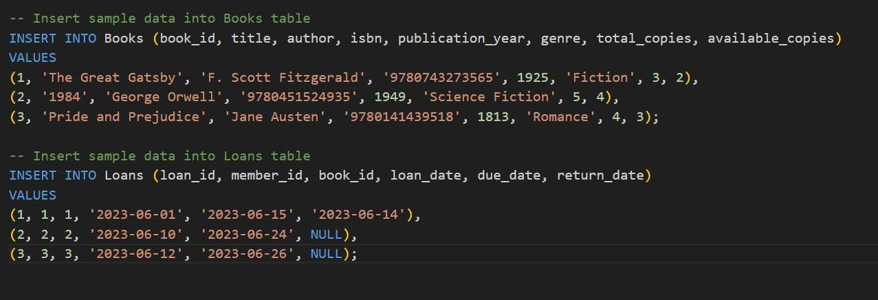
# OUTPUT:
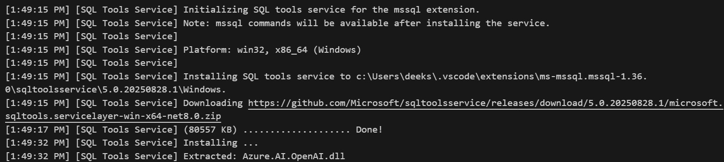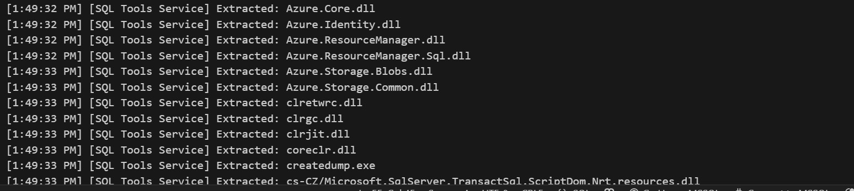
#TASK DESCRIPTION-2:
Error Insert Data
Task: Ask AI to generate INSERT INTO queries for the schema above (3 sample records per table). Give me simple and perfect prompt for this
#PROMPT:
Generate SQL INSERT INTO statements for the Library Management System schema (tables: Members, Books, and Loans).
Add 3 sample records per table with realistic values.
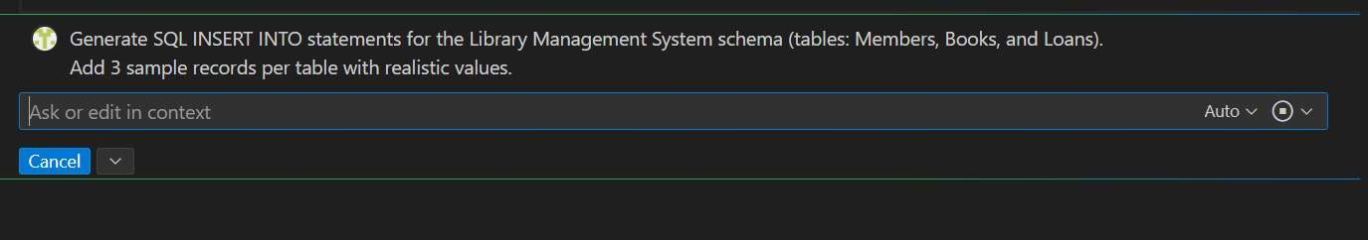
#CODE:
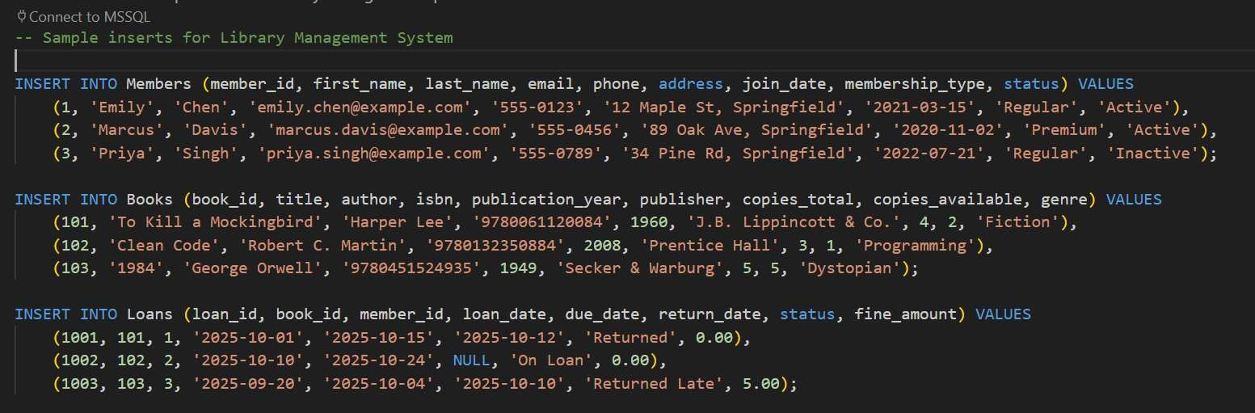

#TASK DESCRIPTION-3:
Basic Queries
Task: Use AI to generate a query to list all books borrowed by a specific member
#PROMPT:
Generate an SQL query to list all books borrowed by a specific member from the Library Management System database (tables: Members, Books, and Loans).
The query should display the member’s name, book title, author, and loan date.
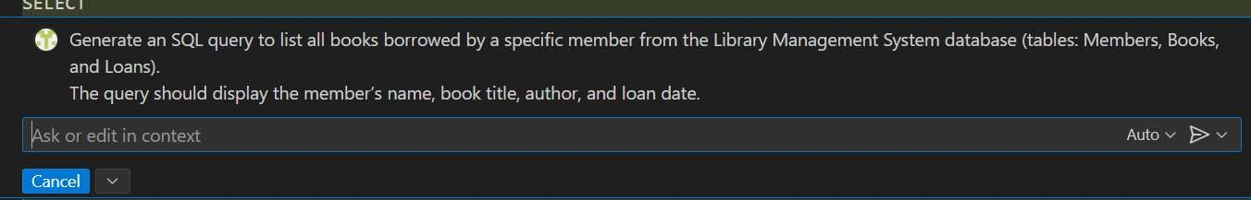
#CODE:
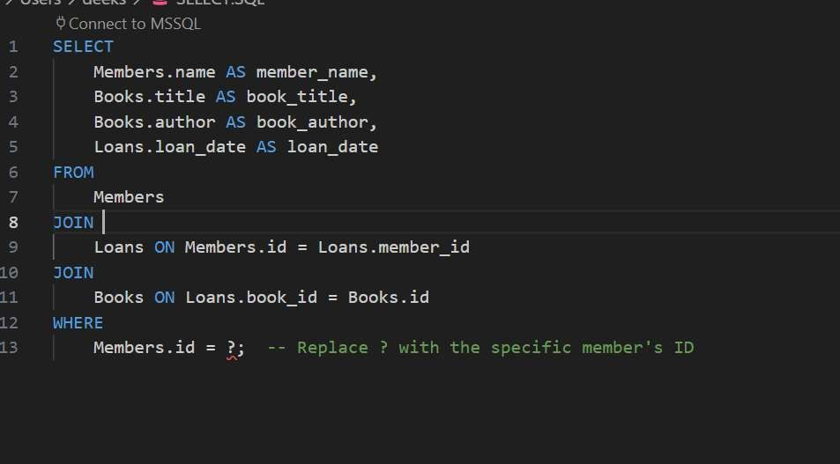
#OUTPUT:

#TASK DESCRIPTION-4:
Update and Delete Queries
Task: Generate queries with AI for:
- Updating a book’s availability to FALSE when borrowed.
- Deleting a member record safely. Give me perfect and simple prompt
#PROMPT:
Generate SQL queries for the Library Management System to:
1.Update a book’s available status to FALSE when it is borrowed.
2. Safely delete a member record (ensure related loan records are handled properly).
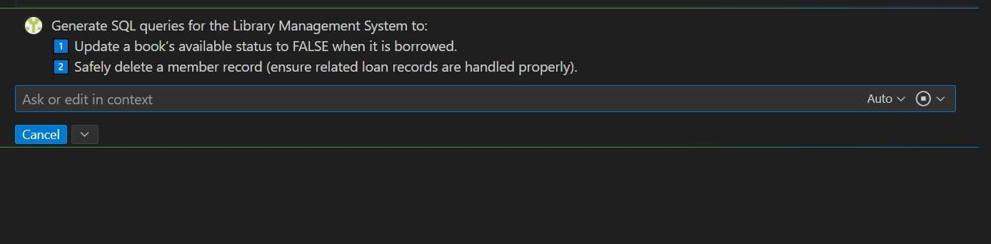
#CODE:
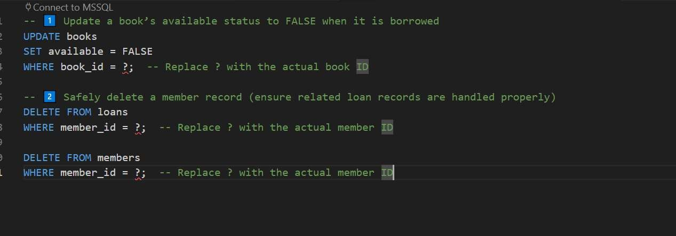
#OUTPUT:
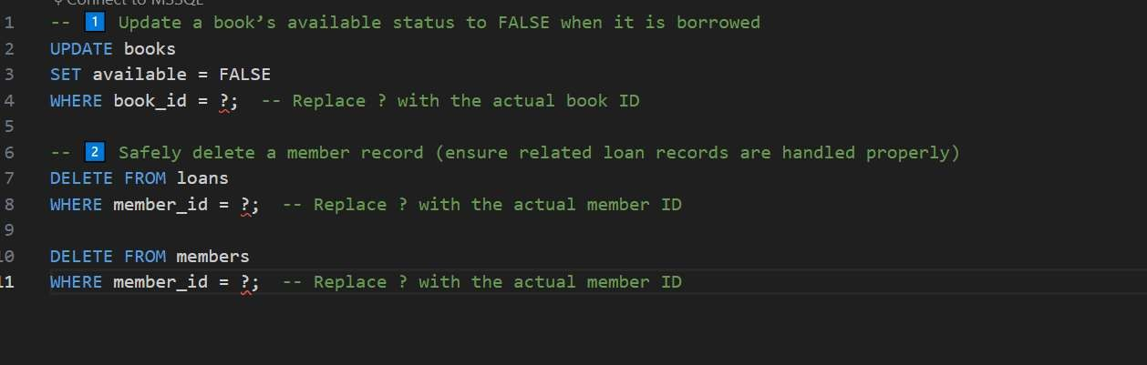

------- Thank You-------

