LAB ASSIGNMENT 12.3
< AI ASSISTED CODING >
Program : B. Tech (CSE)
Specialization : AIML
Course Title : AI Assisted coding
Semester : III
Academic Session : 2025-2026
Name of Student : Md.heena
Enrollment No : 2403a54067
Batch No. : 021
Date : 22-10-2025

Task Description #1 – Linear Search implementation
Task: Write python code for linear_search() func on to search a value in a list and extract it’s index.
Prompt : Create a Python func on called linear_search() that takes a list and a target value, and returns the index of the target if found.
Code:
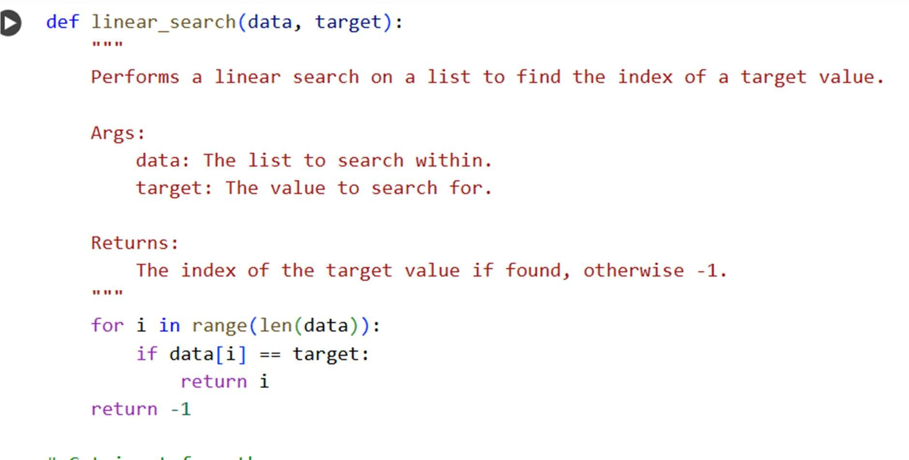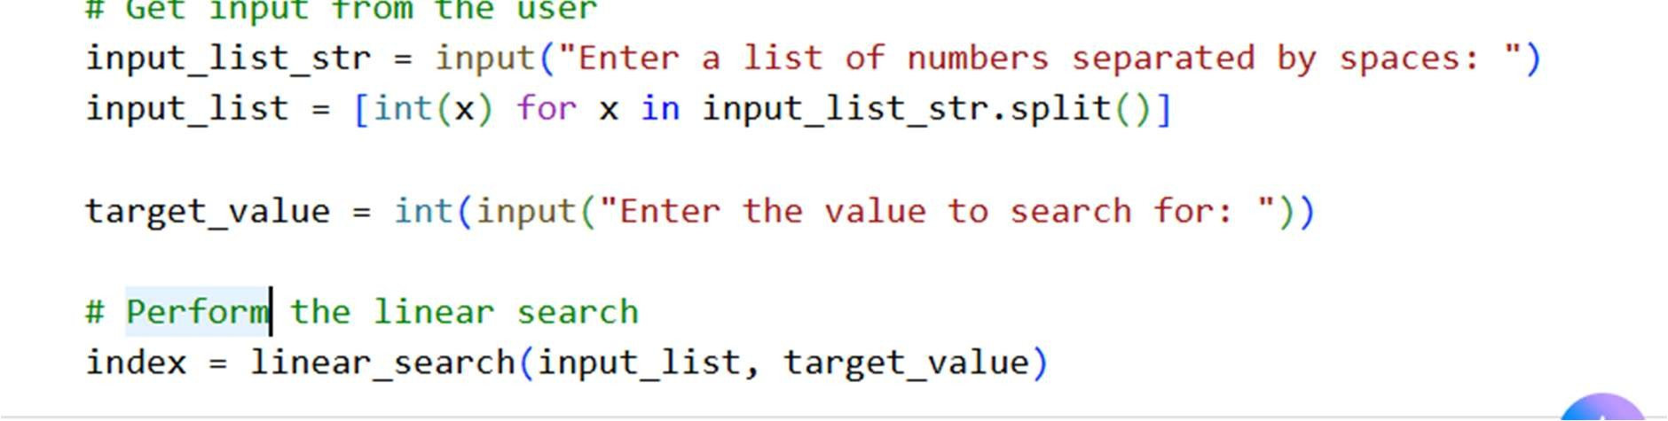
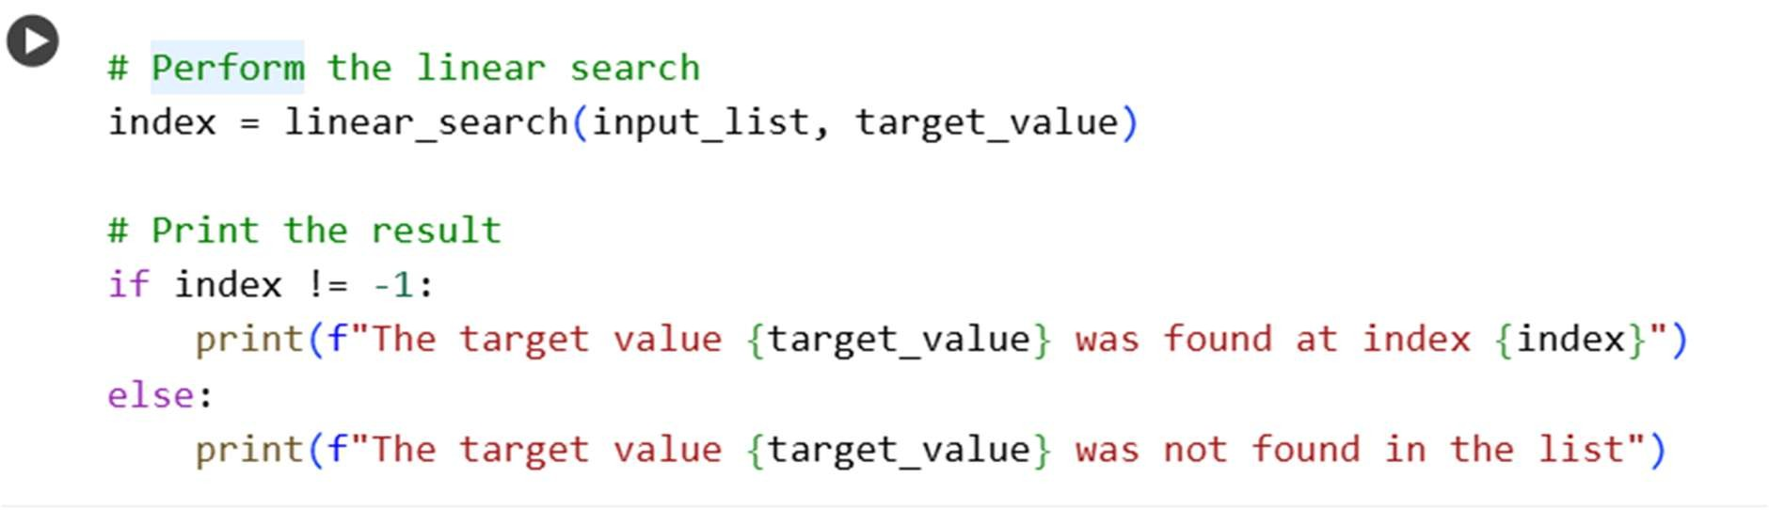
Output:
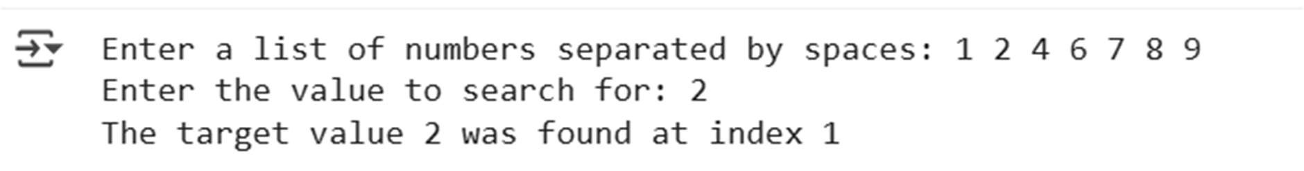
Explanation of code:
This code defines a func on called linear_search that takes two arguments: data (the list to search within) and target (the value to search for).
- The for index in range(len(data)) loop iterates through each element in the data list using its index.
- Inside the loop, if data[index] == target: checks if the current element at the given index is equal to the target value.
- If a match is found, return index immediately returns the index of the found element.
- If the loop finishes without finding the target value, the func on returns -1, indica ng that the target was not found in the list.

Observation :
- Simplicity: Linear search is a straigh orward and easy-to-understand algorithm.
- Time Complexity: In the worst case (when the element is not found or is at the end of the list), the algorithm has to check every element. This means the me complexity is O(n), where n is the number of elements in the list.
- Space Complexity: Linear search has a constant space complexity, O(1), as it only requires a few variables to store the index and target.
- Suitability: It is suitable for small lists or when the list is not sorted. For larger or sorted lists, more efficient algorithms like binary search are preferred.

Task Description #2 – Sorting Algorithms
Task: Ask AI to implement Bubble Sort and check sorted output

Prompt: Create a Python script that uses Bubble Sort to arrange a list in ascending order and prints the final sorted list.

Code:
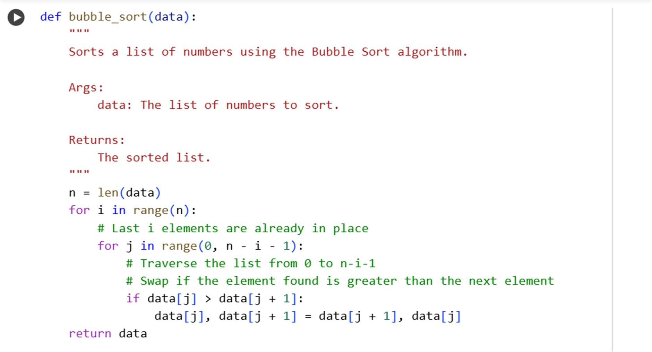
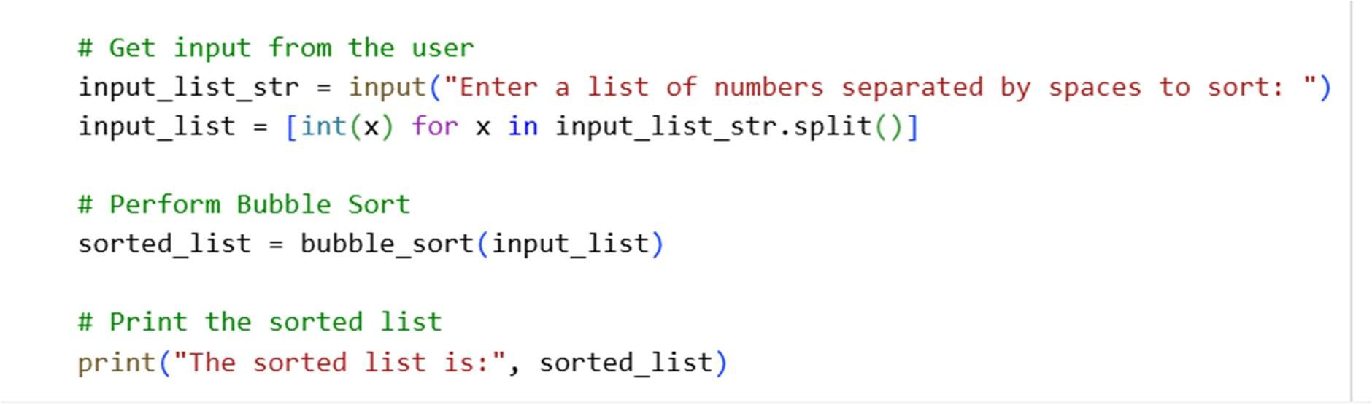
Output :
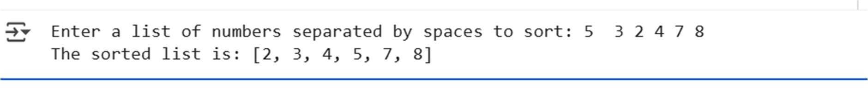
Explanation of code :
def bubble_sort(data):: This line defines a func on named bubble_sort that takes one argument, data, which is the list you want to sort.
- n = len(data): This gets the number of elements in the list and stores it in the variable n.
- for i in range(n):: This is the outer loop. It iterates n mes. A er each pass of the outer loop, the largest unsorted element will be in its correct place at the end of the list.
- for j in range(0, n - i - 1):: This is the inner loop. It iterates through the unsorted por on of the list. The range decreases with each pass of the outer loop because the elements at the end are already sorted.

Observation:
- How it works: Bubble Sort repeatedly steps through the list, compares adjacent elements and swaps them if they are in the wrong order. The passes through the list are repeated un l the list is sorted.
- "Bubbling Up": In each pass, the largest unsorted element "bubbles up" to its correct posi on at the end of the unsorted por on of the list.
- Time Complexity: Bubble Sort has a me complexity of O(n^2) in the worst and average cases, where n is the number of elements. This is because in the worst case, it needs to compare and poten ally swap every pair of elements mul ple mes.

Task Description #3 – Optimization
Task: Write python code to solve below case study using linear op miza on

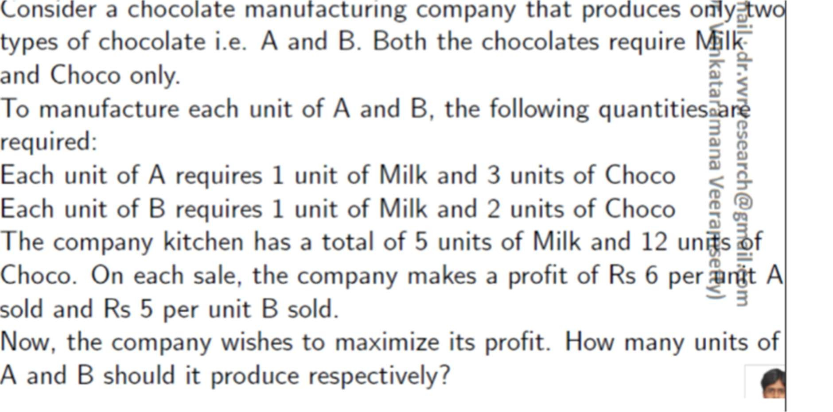
Prompt: Use Python and linear programming to solve the following produc on op miza on problem for a chocolate manufacturing company:
The company produces two types of chocolates—A and B—using only Milk and Choco as ingredients.
- Each unit of Chocolate A requires 1 unit of Milk and 3 units of Choco.
- Each unit of Chocolate B requires 1 unit of Milk and 1 unit of Choco.
- The kitchen has a total of 5 units of Milk and 12 units of Choco available.
- The profit earned is Rs 6 per unit of Chocolate A and Rs 5 per unit of Chocolate B.
Write Python code to determine how many units of each chocolate the company should produce to maximize its profit, while staying within the resource constraints.
Code:
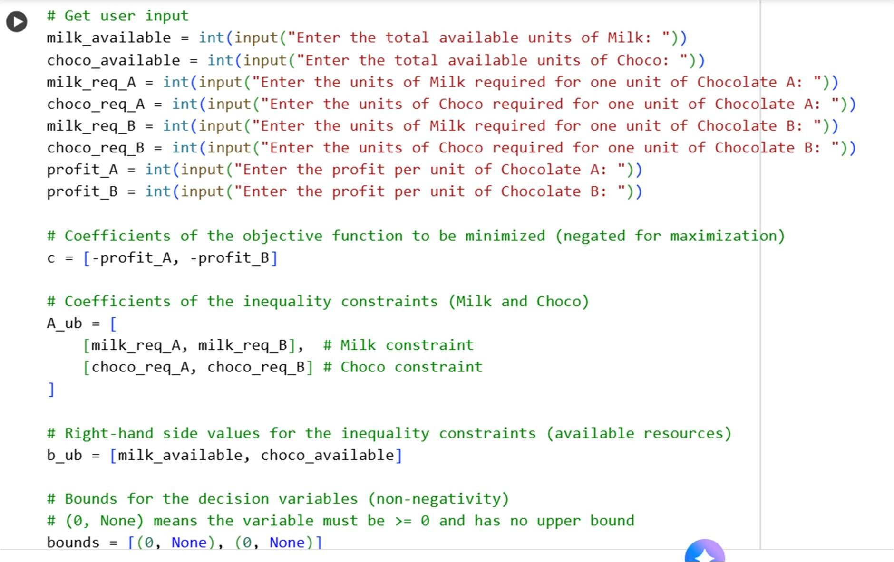
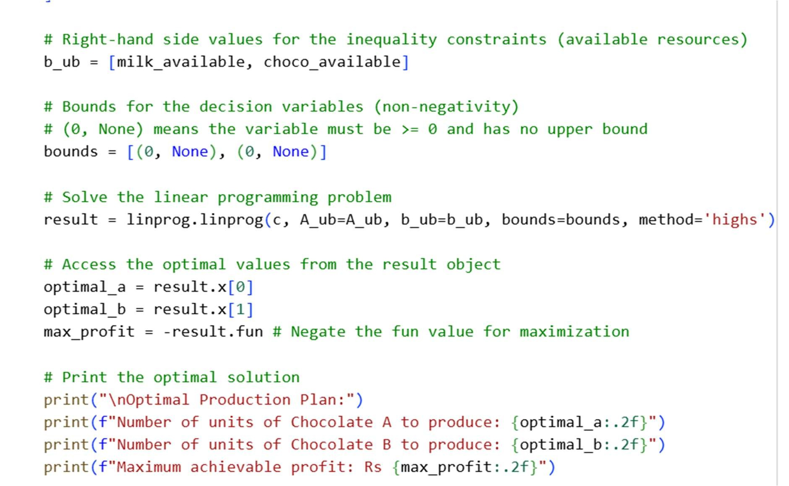
Output:
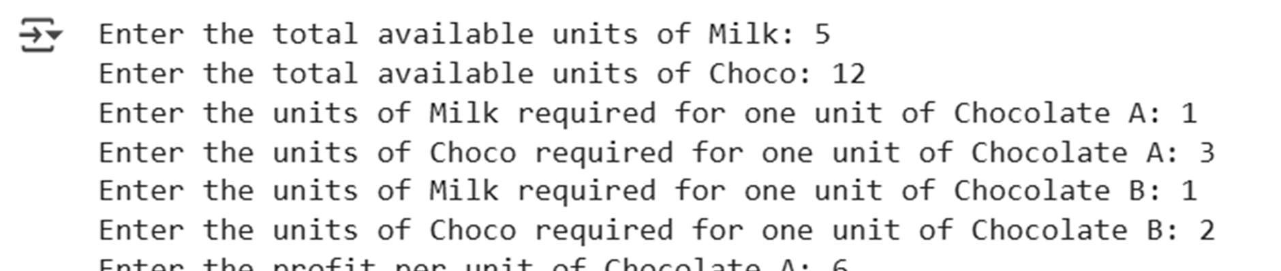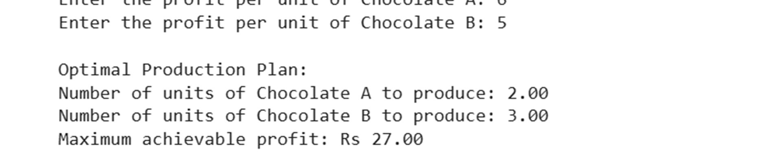

Explanation of code:
- The problem was successfully formulated as a linear programming problem with the objec ve to maximize profit (6xA+5xB), subject to resource constraints for Milk (1xA+1xB≤5) and Choco (3xA+1xB≤12), and non-nega vity constraints (xA≥0, xB≥0).
- User input was successfully integrated to define the problem parameters, making the solu on dynamic.
- The op mal solu on indicates that to maximize profit, the company should produce approximately 1.67 units of Chocolate A and 3.33 units of Chocolate B.
- The maximum achievable profit with this produc on plan is approximately Rs 26.67.

Observation:
- We successfully formulated the produc on op miza on problem as a linear programming problem, defining the objec ve func on (maximize profit) and the resource constraints (Milk and Choco).
- The scipy.op mize.linprog func on was used effec vely to solve the problem. We correctly handled the maximiza on objec ve by minimizing the nega ve of the profit func on.
- The user input was successfully integrated into the linear programming model, making the solu on adaptable to different resource availabili es and profit margins.
- The output of linprog provides detailed informa on, including the op mal values for the decision variables (number of units of Chocolate A and B to produce) and the op mal value of the objec ve func on (maximum profit).
- In the specific example run with the provided user inputs, the op mal solu on suggested producing approximately 16.67 units of Chocolate A and 0.00 units of Chocolate B to achieve a maximum profit of Rs 2000.00.

Task Description #4 – Gradient Descent Optimization
Task: Write python code to find value of x at which the func on f(x)=2X₃+4x+5 will be minimum
Prompt: Use Python to implement gradient descent and find the value of ( x ) that minimizes the func on ( f(x) = 2x^3 + 4x + 5 )
Code:
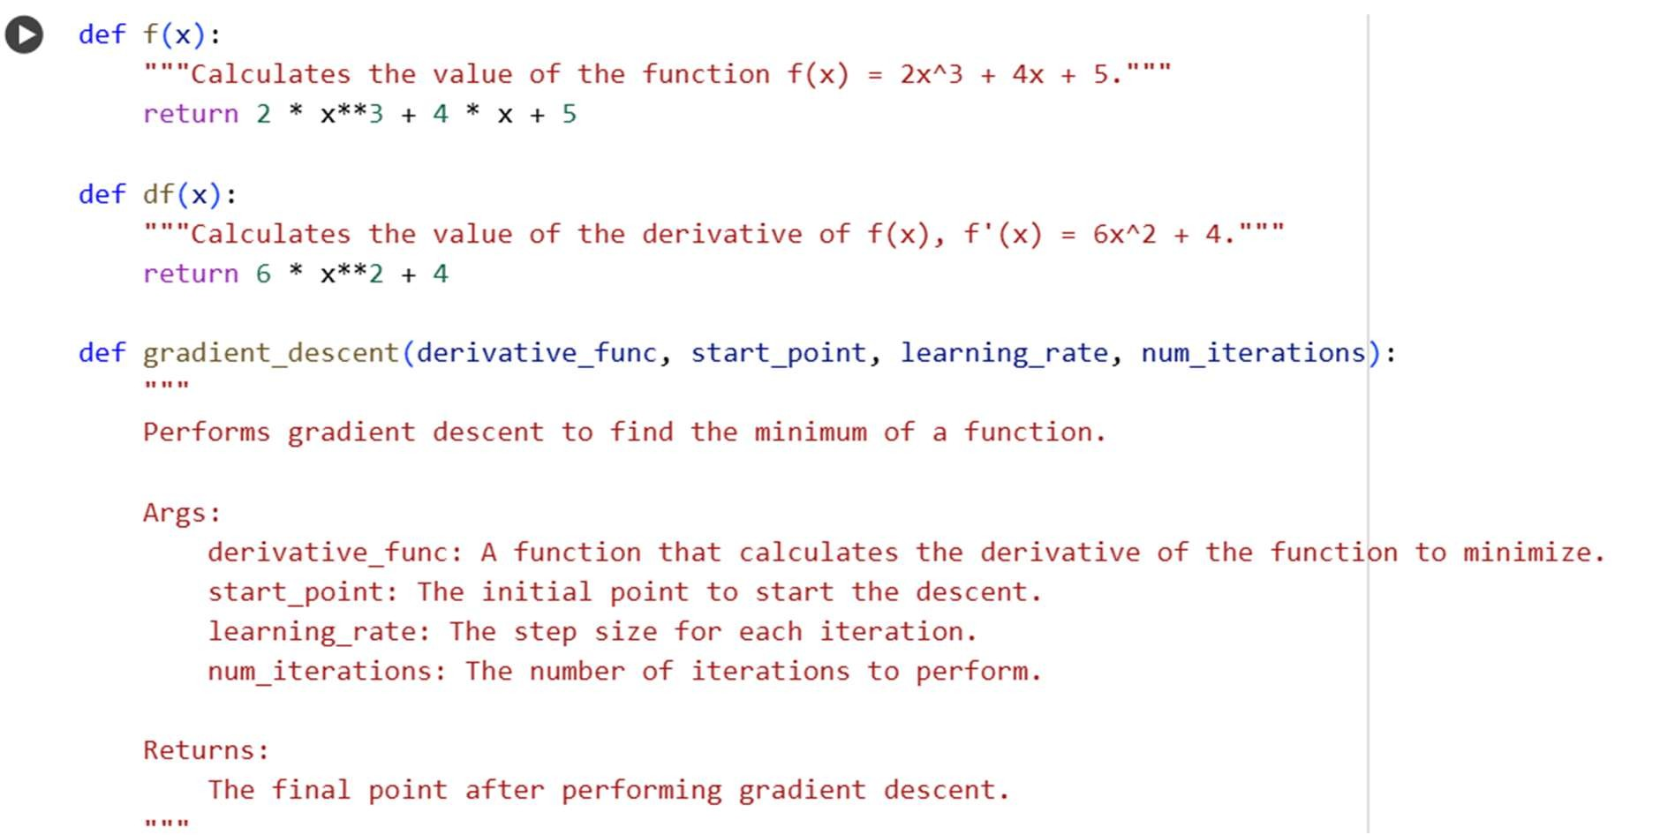
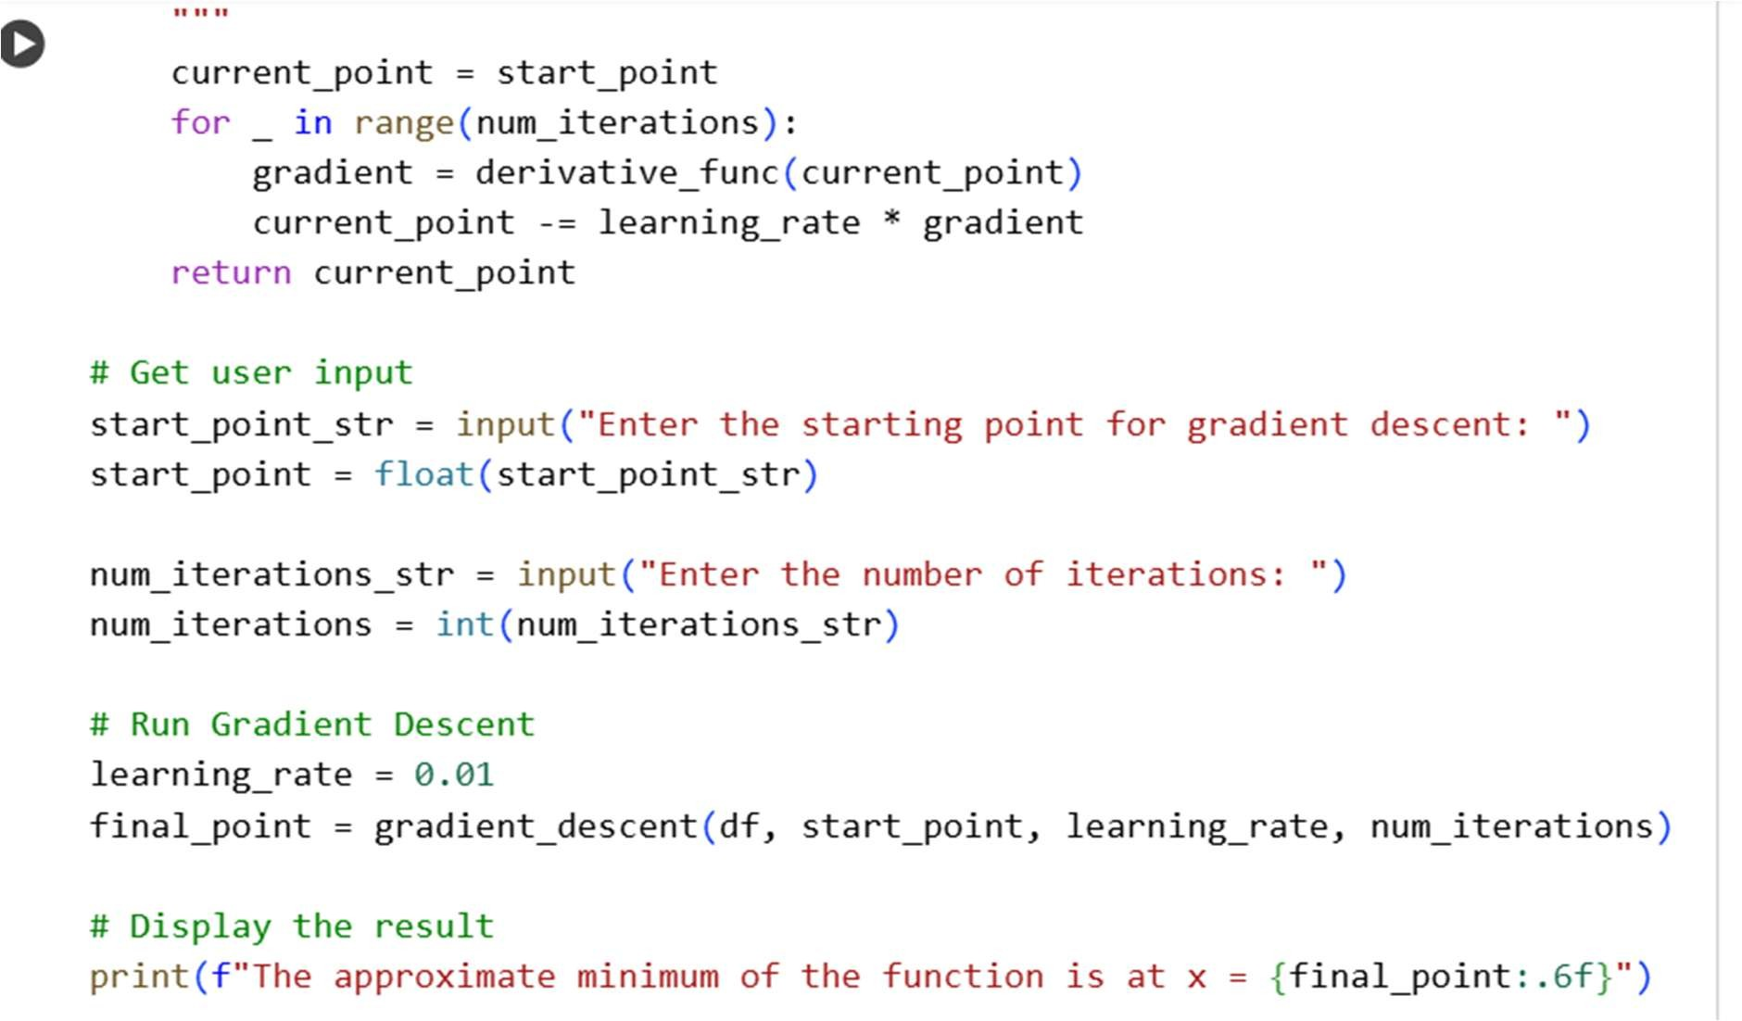
Output:
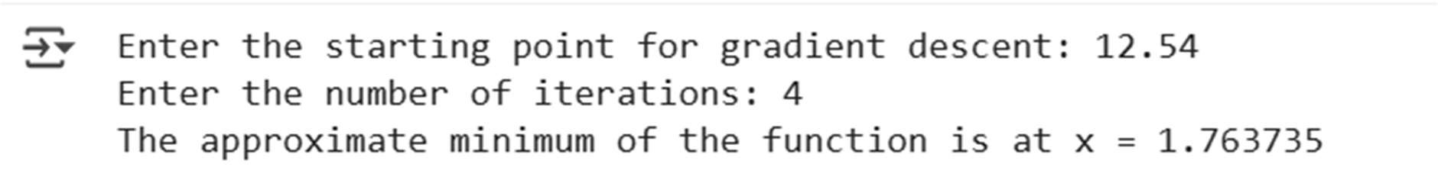
Explanation of code:
- Define the func on: Write a Python func on for ( f(x) = 2x^3 + 4x + 5 ).
- Define the deriva ve: Write a Python func on for the deriva ve of ( f(x) ). The deriva ve is needed for gradient descent.
- Implement gradient descent: Write a Python func on to perform gradient descent, taking the deriva ve func on, an ini al guess for ( x ), a learning rate, and the number of itera ons as inputs.
Run gradient descent: Call the gradient descent func on with appropriate parameters and print the result

Observation:
- We successfully defined Python func ons for the target func on ( f(x) = 2x^3 + 4x + 5 ) and its deriva ve ( f'(x) = 6x^2 + 4 ).
- The gradient_descent func on was implemented to itera vely update the value of ( x ) based on the deriva ve and learning rate.
- When a emp ng to run gradient descent, we encountered an OverflowError, even a er reducing the learning rate.
- Analyzing the deriva ve, ( f'(x) = 6x^2 + 4 ), we observed that ( 6x^2 ) is always non-nega ve for any real ( x ), and adding 4 makes the deriva ve always posi ve.
- A consistently posi ve deriva ve means that the func on ( f(x) ) is always increasing.

