LAB ASSIGNMENT 15.3
< AI ASSISTED CODING >
Program : B. Tech (CSE)
Specializa on : AIML
Course Title : AI Assisted coding
Semester : III
Academic Session : 2025-2026
Name of Student : Md Heena
Enrollment No : 2403a54067
Batch No. : 01


Task Description #1 – Basic REST API Setup
Task: Ask AI to generate a Flask REST API with one route:
GET /hello → returns {"message": "Hello, AI Coding!"}

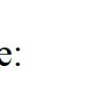
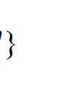
PROMPT: Generate a Flask REST API with one route:
GET /hello → returns {"message": "Hello, AI Coding!"}


➢ CODE:
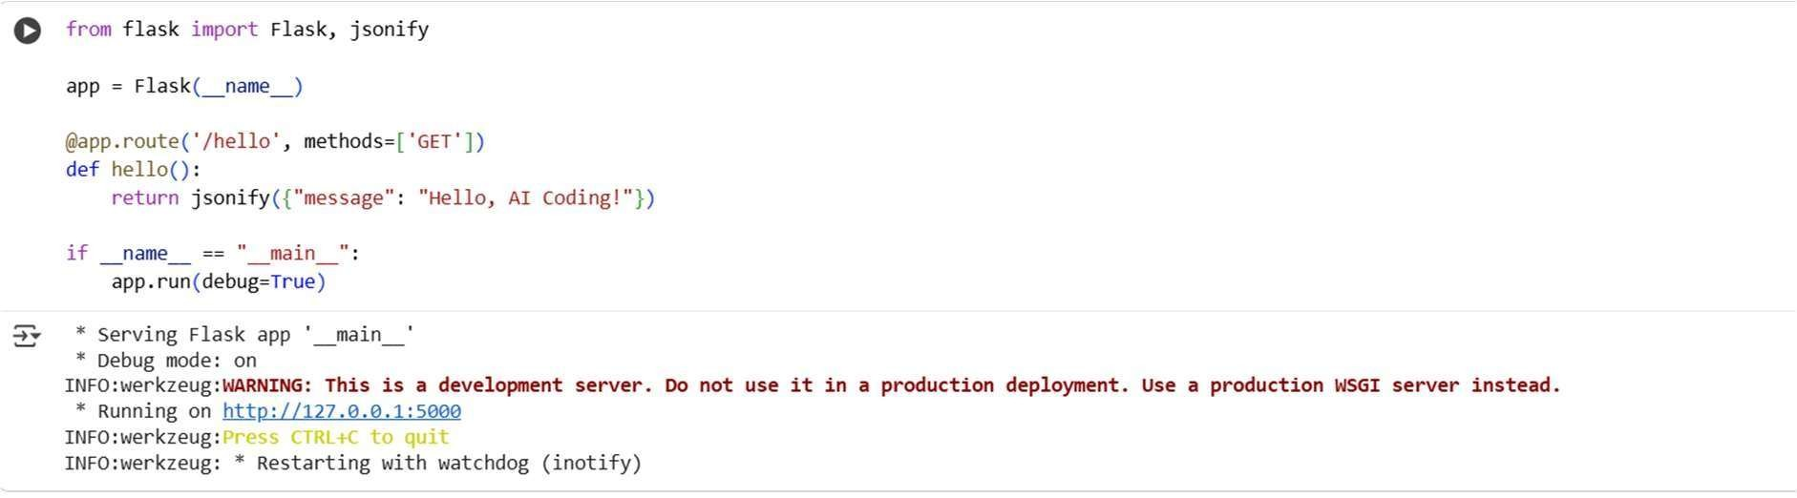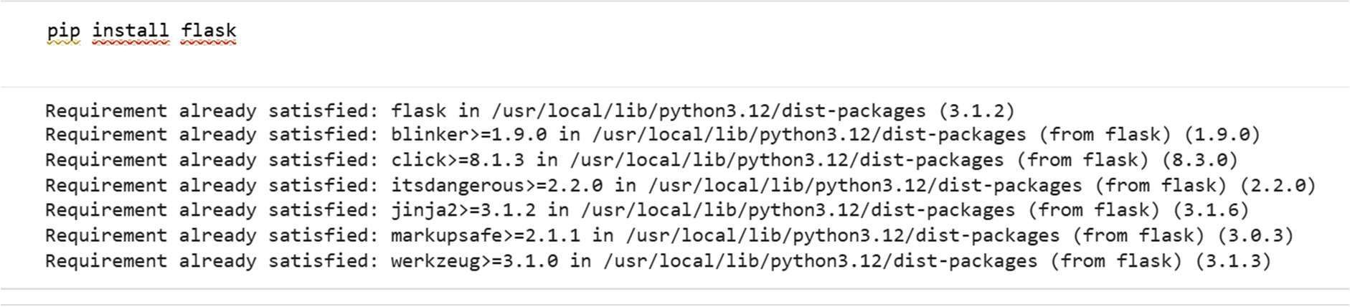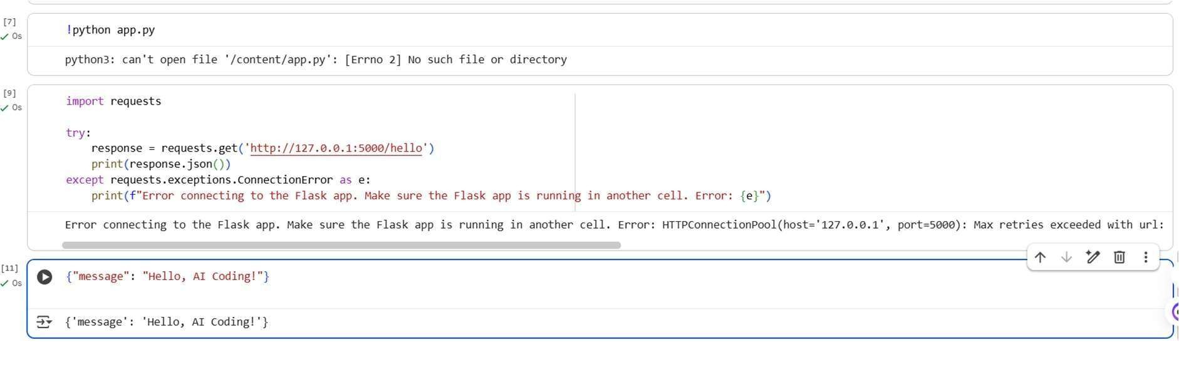
OBSERVATION:
I have observed that flask rest and api is generated by ai and created a message hello, ai coding.


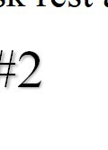
^{Task Description #2} – CRUD Operations (Students API)
Task:
Use AI to build REST endpoints for a Student API:
- GET /students → List all students.
- POST /students → Add a new student.
- PUT /students/<id> → Update student details.
- DELETE /students/<id> → Delete a student.

Expected Output:
- Flask API with dictionary/list storage.
- JSON responses for each operation

Prompt:
Generate GET /students → List all studentsPOST /students → Add a new student. PUT /students/<id> → Update student details. DELETE /students/<id> → Delete a student

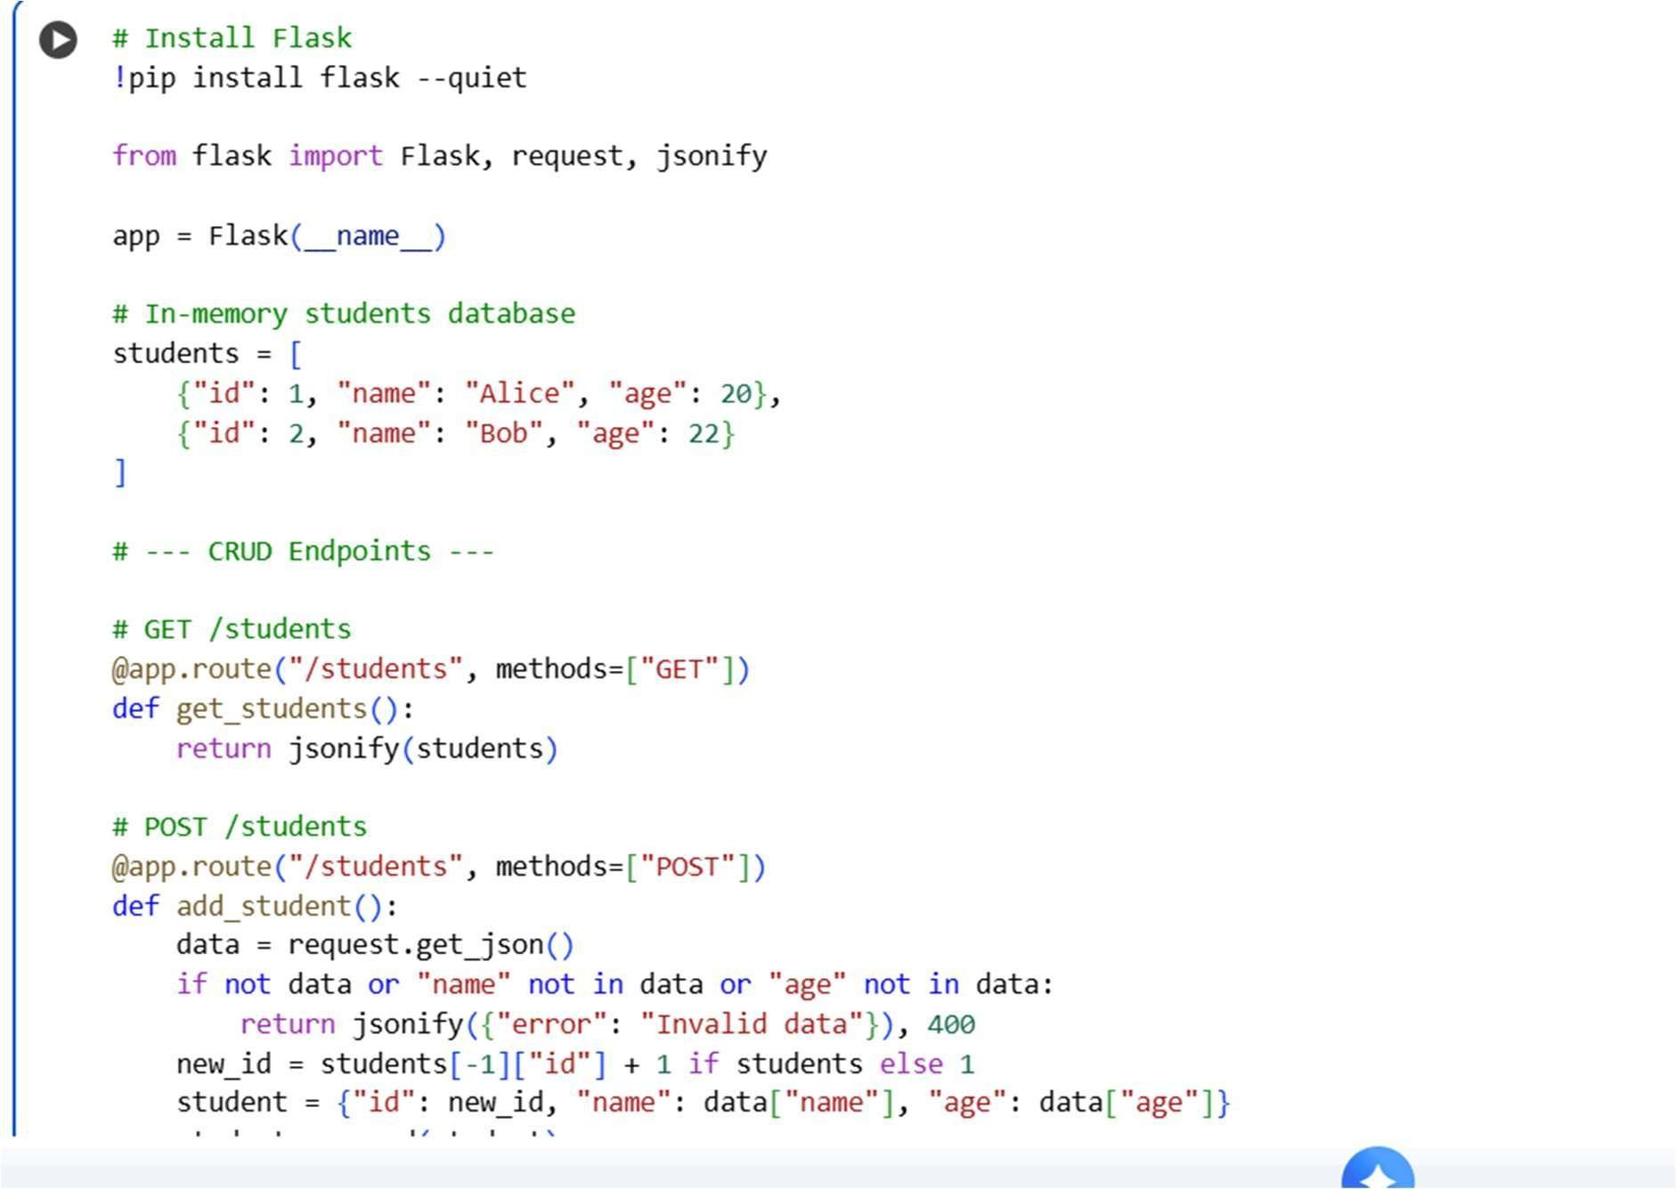
Code:

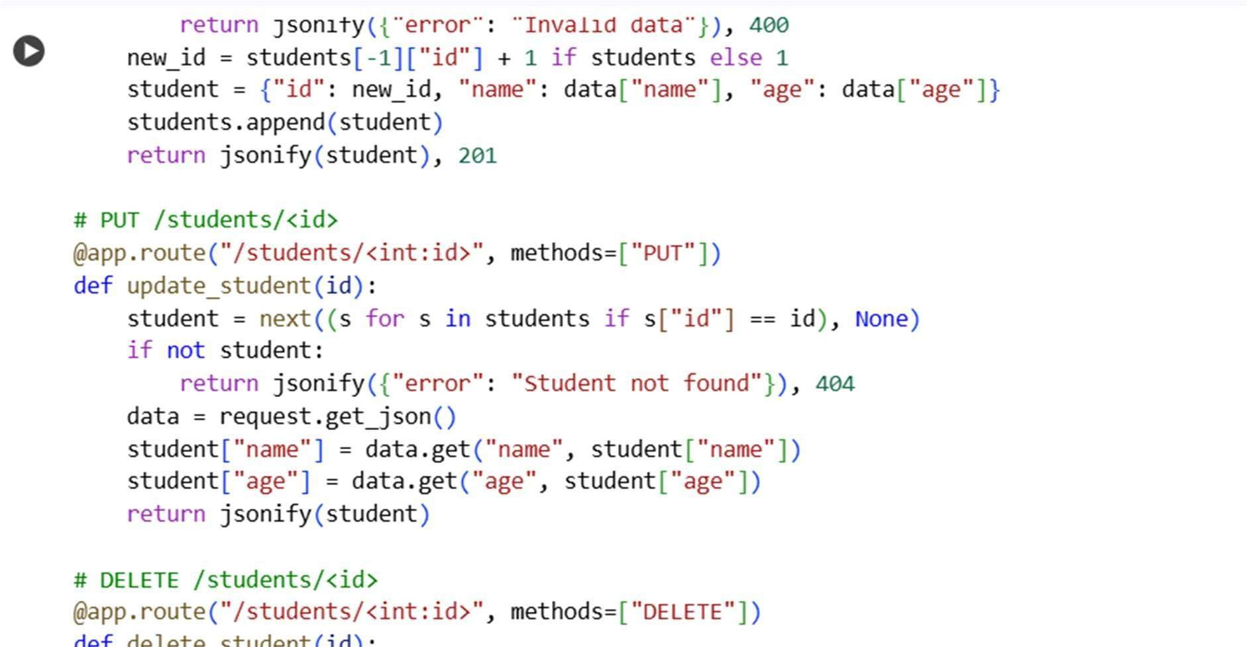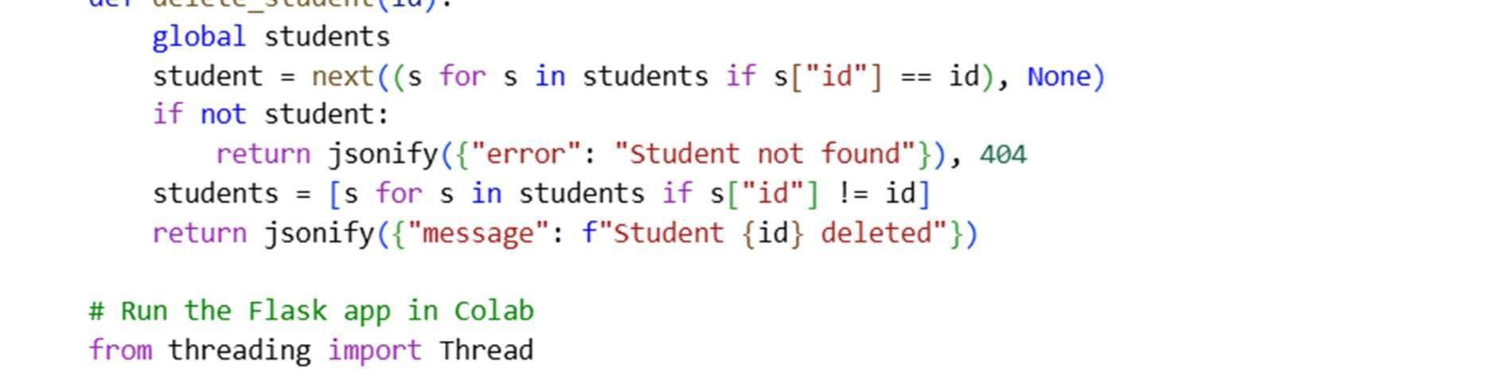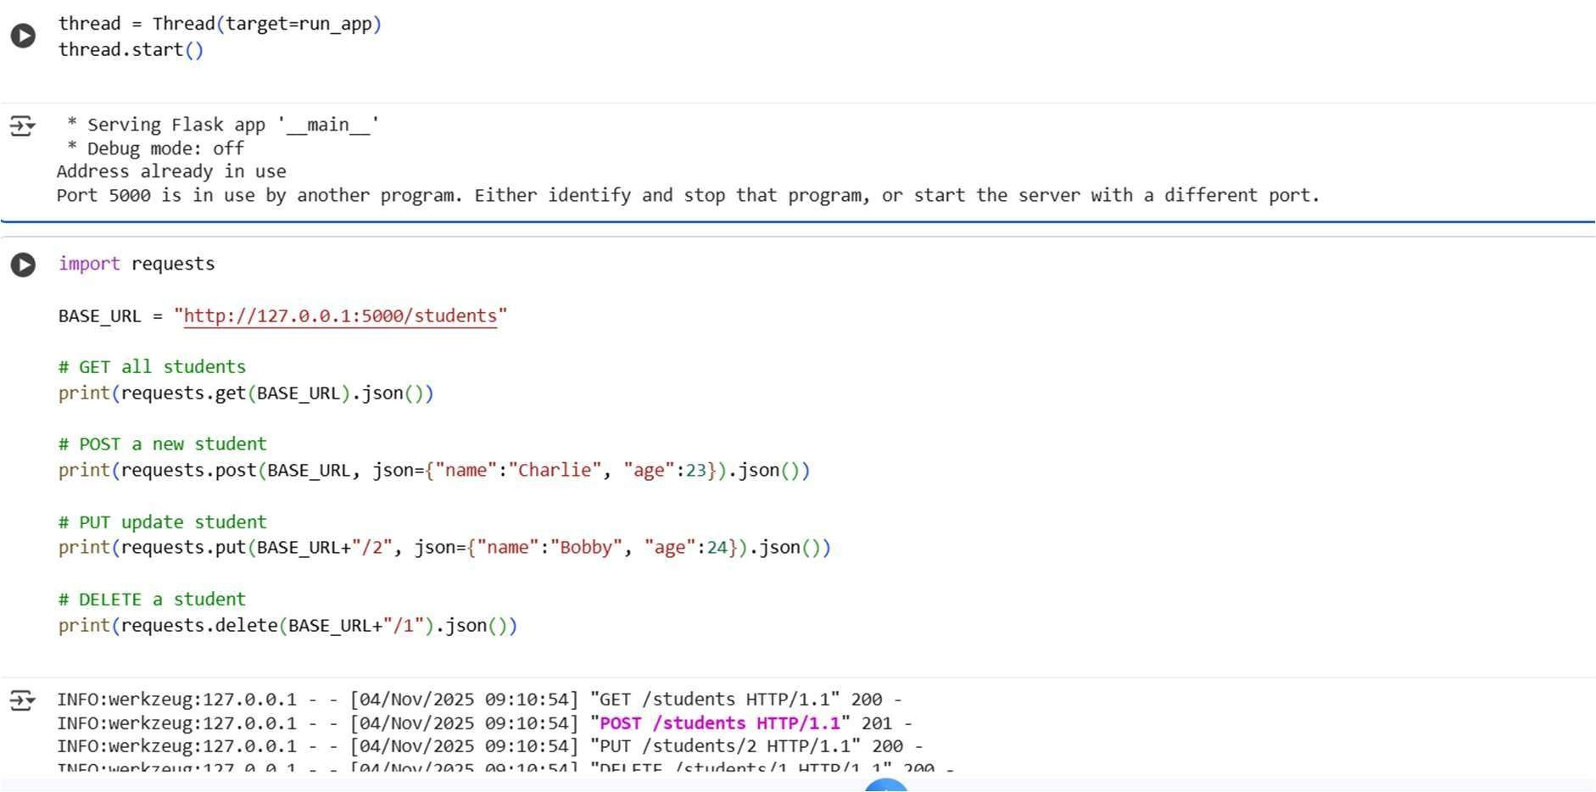
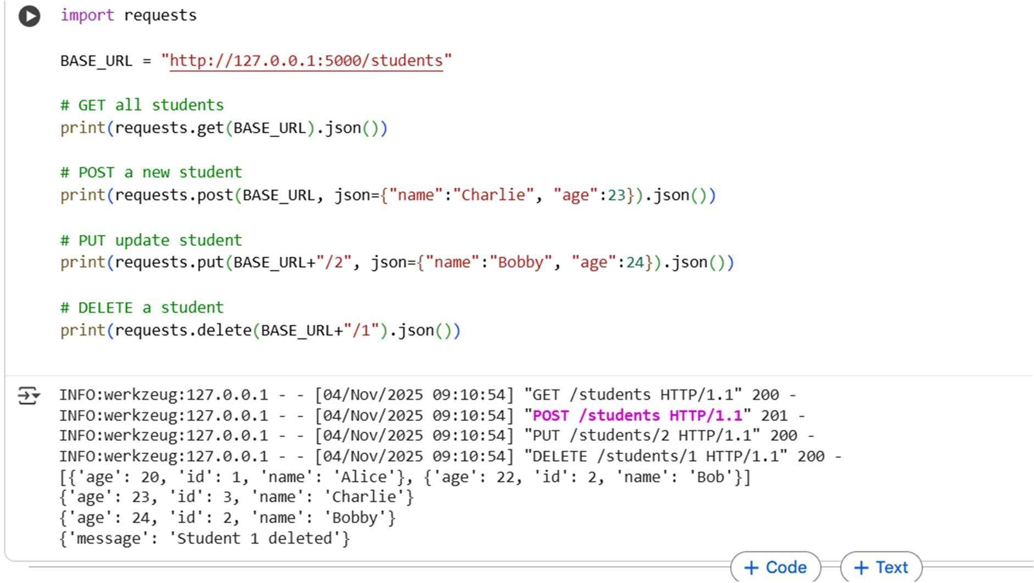
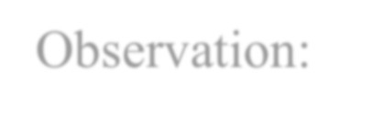
Observation:
This code creates an in-memory Students REST API in Colab using Flask, supporting GET, POST, PUT, and DELETE operations. It runs locally without ngrok, letting you test all endpoints directly in Colab.


Task Description #3 – API with Query Parameters
Task: Ask AI to generate a REST API endpoint

Expected Output:
Working search function with query param handling



Prompt: generate a REST API endpoint Code:
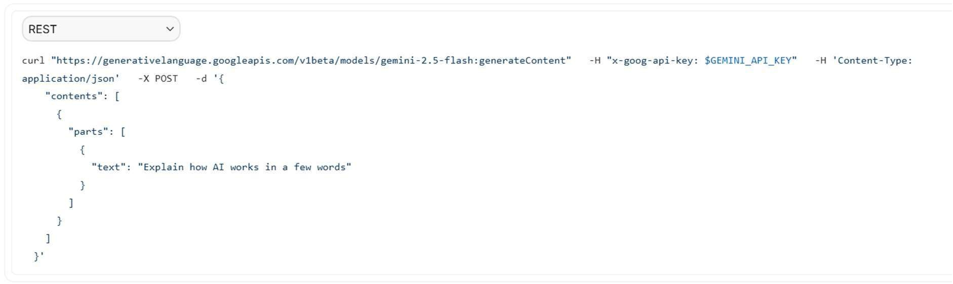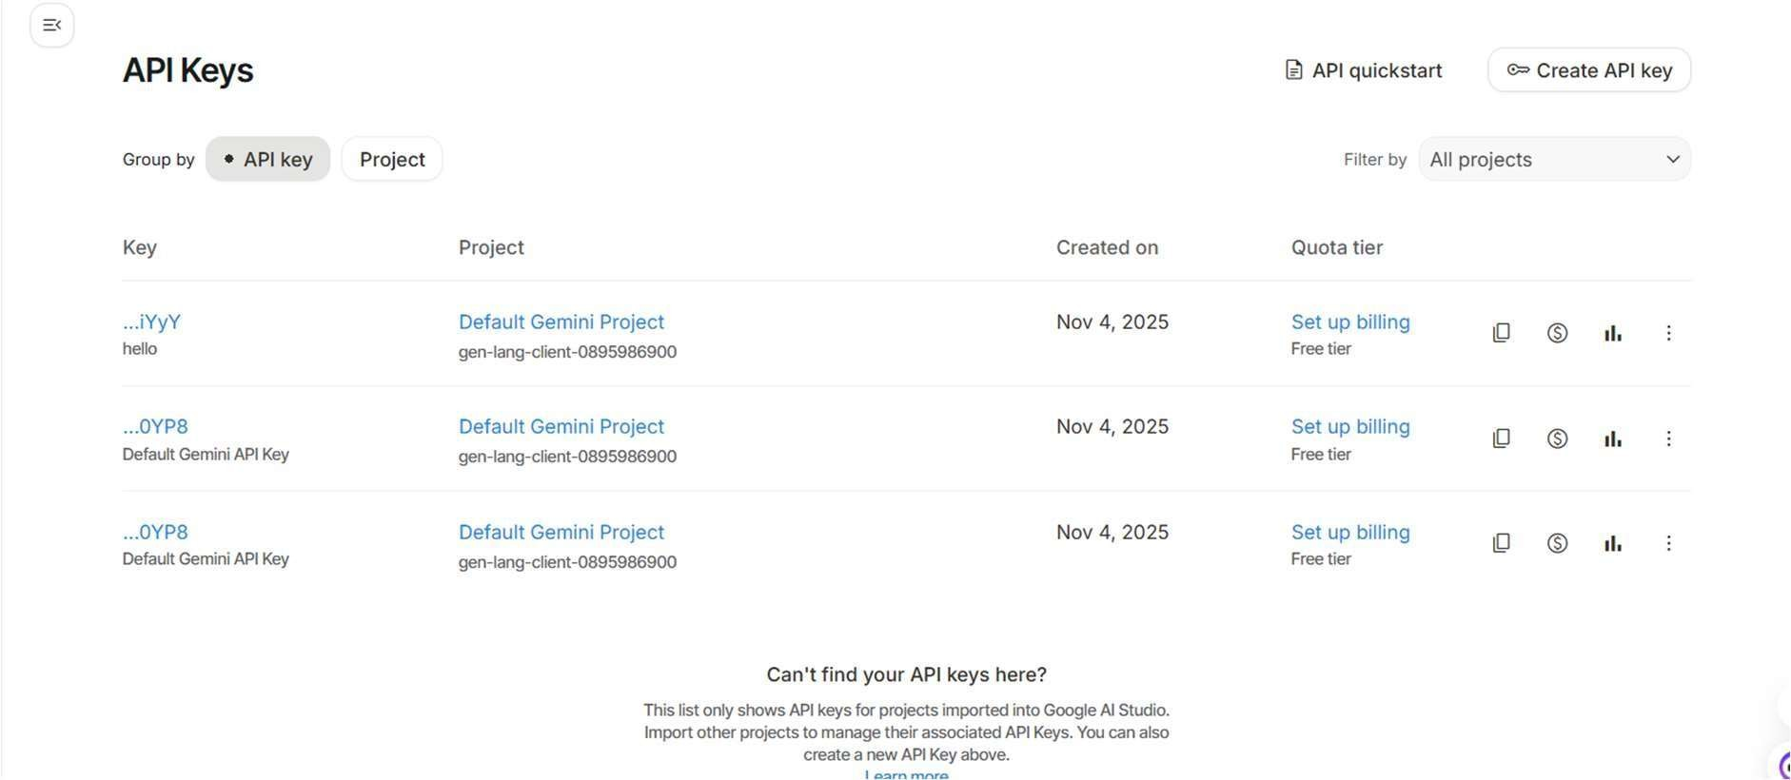
Task Description #4 – Integration & Testing




Task: Ask AI to write test scripts using Python requests module to call APIs created above.

Prompt:
Generate scripts using Python requests module to call APIs created above.


Code:

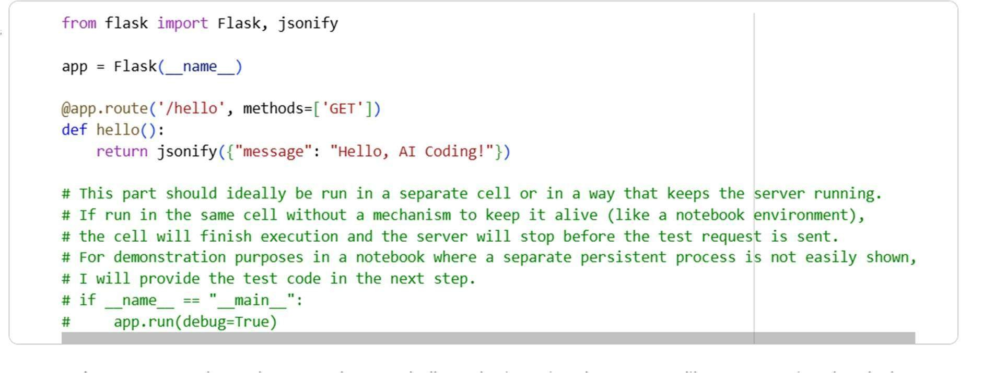

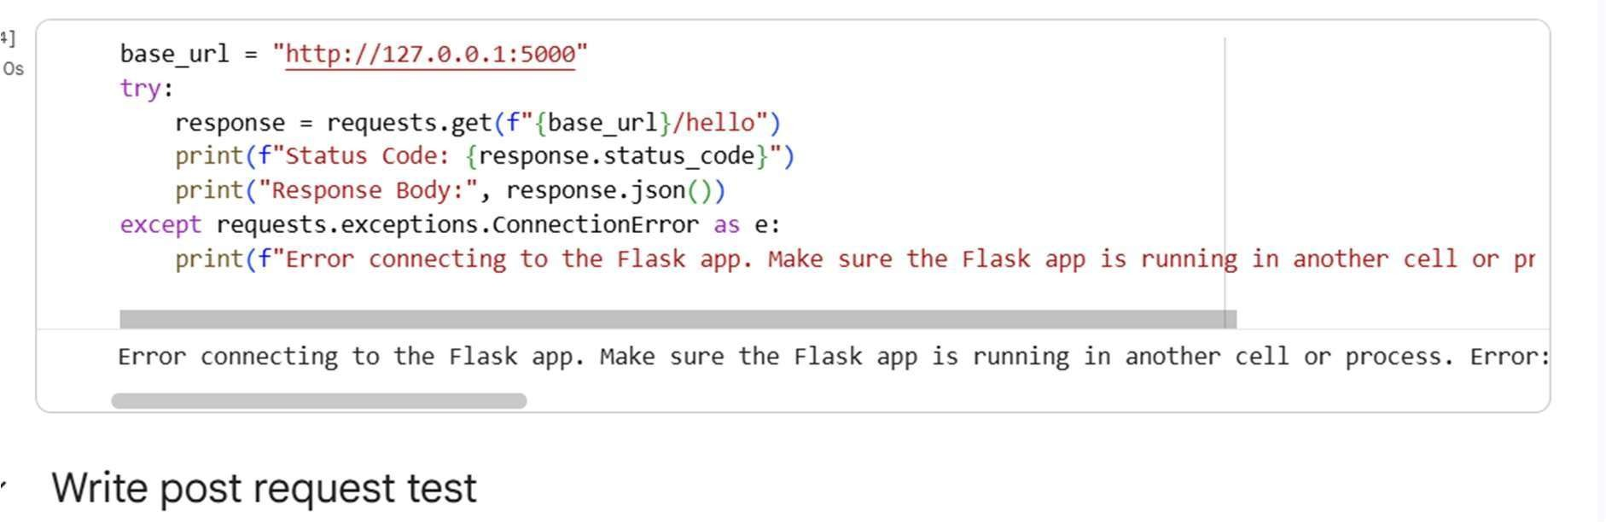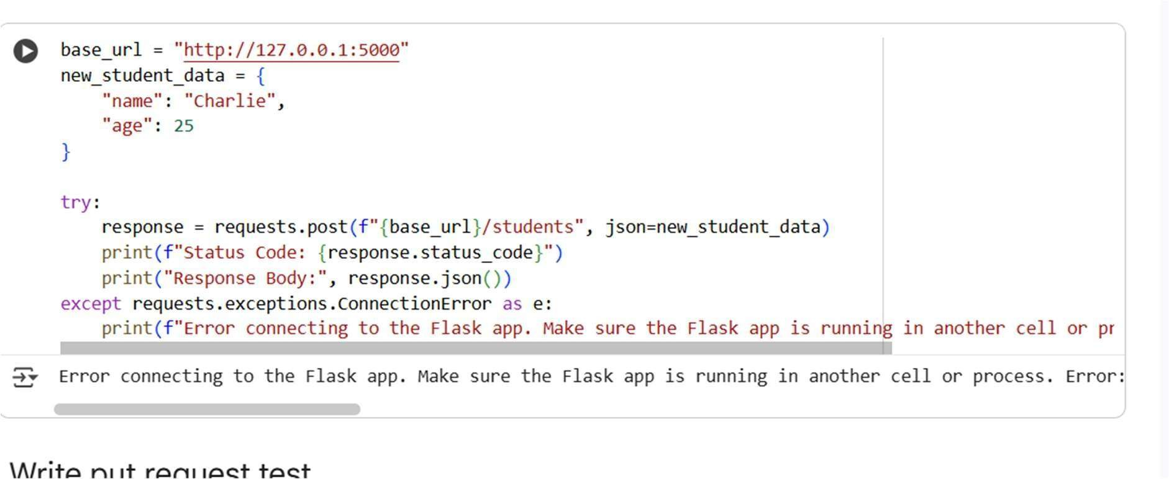

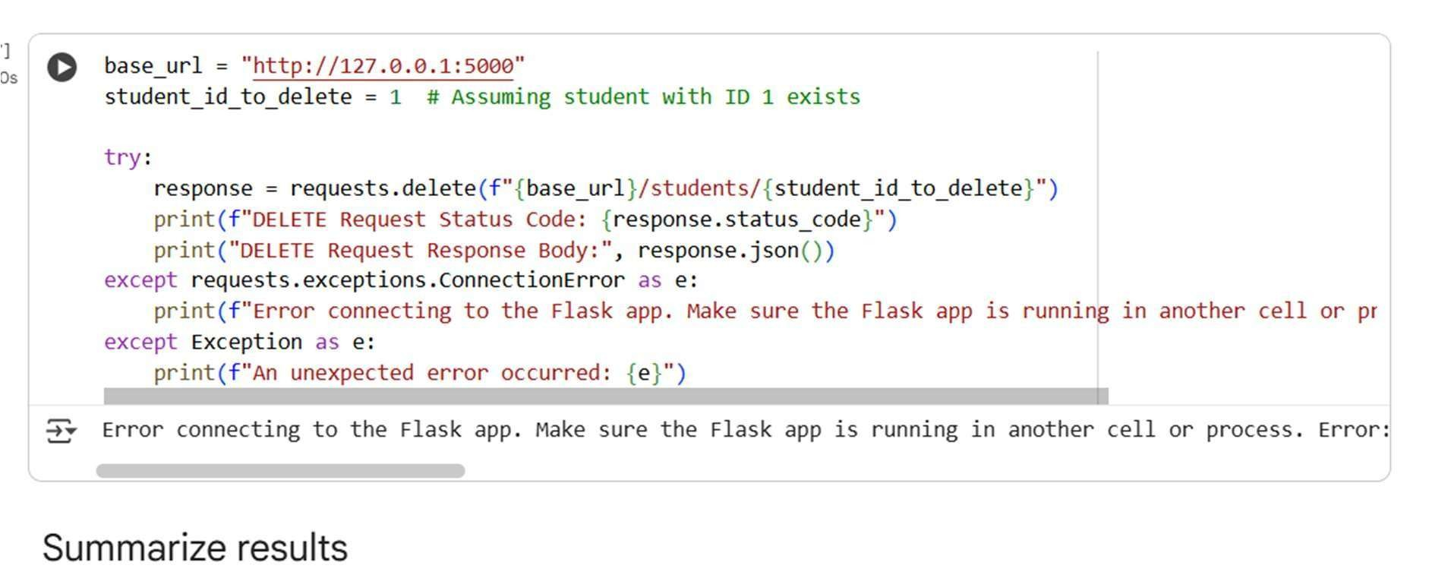
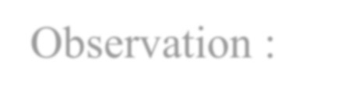
Observation :
Attempts to test the API endpoints with requests resulted in ConnectionError. This indicates the Flask application is not running or accessible. The tests for GET, POST, PUT, and DELETE all failed. To run the tests successfully, the Flask app must be active. Ensure the cell running the Flask server is executed before the test cells.

