In

[

]:

In

[1]:

Low cost recharge packs

*# multiple inheritance*

A

B

C

**class**

Vodafone

:

**def**

internet

(

self

):

print

(

"fast internet"

)

**class**

Idea

:

**def**

service

(

self

):

print

(

"Providing fast and better service"

)

**class**

VI

(

Vodafone

,

Idea

):

**def**

pack

(

self

):

print

(

"Low cost recharge packs"

)

obj

**=**

VI

()

obj

.

pack

()

obj

.

service

()

obj

.

internet

()

Providing fast and better service fast internet

In

[

]:

*# Hybrid Inheritace*

"""

A

|

V

-----------------

| |

V V

B D

|

V

C

"""

"""

A

B C

D

"""

In

[5]:

Enter number 1: 12

**class**

A

:

**def**

inputData

(

self

):

self

.

num1

**=**

int

(

input

(

"Enter number 1: "

))

self

.

num2

**=**

int

(

input

(

"Enter number 2: "

))

**class**

B

(

A

):

**def**

displayAddition

(

self

):

self

.

inputData

()

self

.

ans

**=**

self

.

num1

**+**

self

.

num2

**return**

self

.

ans

**class**

C

(

A

):

**def**

displayMultiplicatoin

(

self

):

self

.

inputData

()

self

.

ans

**=**

self

.

num1

**\***

self

.

num2

**return**

self

.

ans

**class**

D

(

B

,

C

):

**def**

display

(

self

):

print

(

B

.

displayAddition

(

self

))

print

(

C

.

displayMultiplicatoin

(

self

))

obj

**=**

D

()

obj

.

display

()

Enter number 2: 2

14

Enter number 1: 12

Enter number 2: 2

24

In [ ]: *# Encapsulation : it is a wrapping of data - collection of data elementsand data*

*# _membername : if there _ in prifix it mens protected data (parant and child bot*

*# __membername : if there __ in prifix it means private data (only current class*

In

[7]:

mobile price : 5000

**class**

Shop

:

**def**

__init__

(

self

):

self

.

mobile

**=**

5000

self

.

__laptop

**=**

10000

**def**

display

(

self

):

print

(

"mobile price : "

,

self

.

mobile

)

print

(

"laptop price : "

,

self

.

__laptop

)

**def**

changePrice

(

self

,

newLaptopPrice

):

self

.

__laptop

**=**

newLaptopPrice

obj

**=**

Shop

()

obj

.

display

()

*#change price*

obj

.

mobile

**=**

25000

obj

.

__laptop

**=**

50000

obj

.

display

()

new_price

**=**

int

(

input

(

"Enter laptop price: "

))

obj

.

changePrice

(

new_price

)

obj

.

display

()

laptop price : 10000 mobile price : 25000 laptop price : 10000 Enter laptop price: 60000 mobile price : 25000 laptop price : 60000

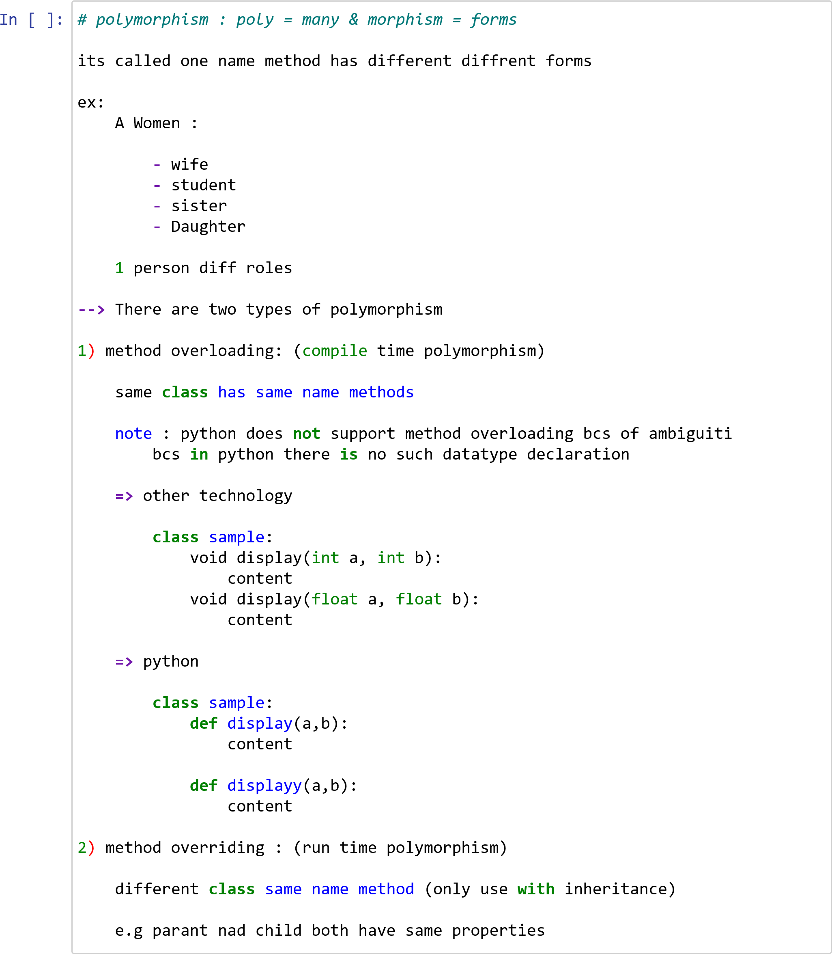

HONDA CAARS AVAILABLE HERE

In

[8]:

CAR DETAILS HERE

*# method overriding*

**class**

car

:

**def**

display

(

self

):

print

(

"CAR DETAILS HERE"

)

**class**

Honda

(

car

):

**def**

display

(

self

):

car

.

display

(

self

)

print

(

"HONDA CAARS AVAILABLE HERE"

)

obj

**=**

Honda

()

obj

.

display

()

In [ ]:

In [ ]:

In [ ]: