**Selenium Grid Setup**

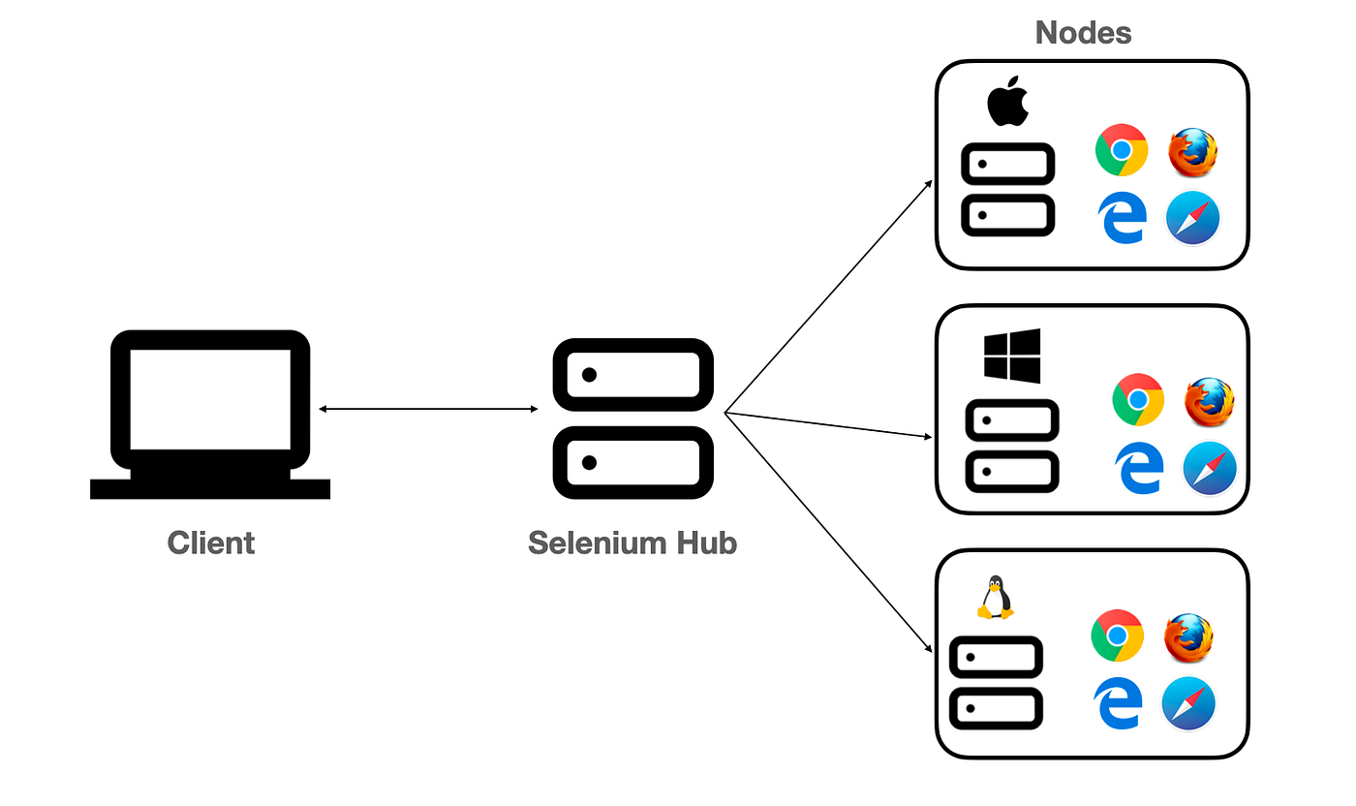

**Standalone Setup (Single machine):**

1. Download selenium-server-4.20.0.jar and place it somewhere.(search in browser for selenium server & download)
2. 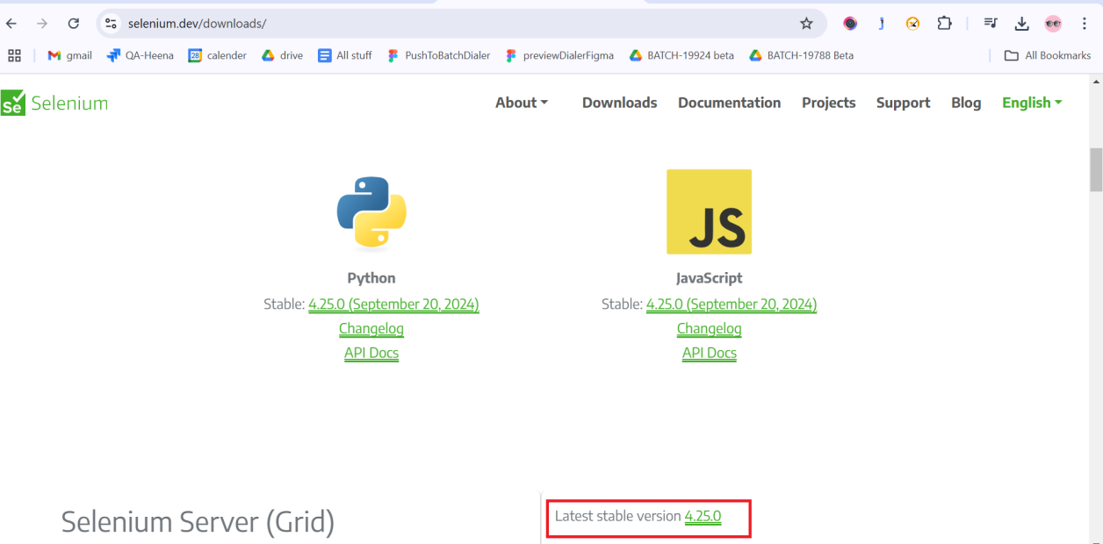
3. Run below command to start Selenium Grid(go to folder where we have downloaded this jar file & then from there only open cmd prompt)

java -jar selenium-server-4.20.0.jar *standalone*

1. URL to see sessions: http://localhost:4444/ (copy this url which you can get after hitting above cmd & paste in browser)(do not close cmd propmt window otherwise it will stop grid execution. So keep it as it is or minimise)

Note : (If you open this url on browser then it will open grid dashboard. there will numbers of sessions for each broswer )

**Hub & Node Setup (Multiple machines):**

1. Download selenium-server-4.20.0.jar and place it somewhere in both (hub & node) the machines.
2. Run below command to make machine as hub

java -jar selenium-server-4.20.0.jar hub

1. Run below command to make machine as node

java -jar selenium-server-4.20.0.jar node --hub http://<hub-ip>:4444

(note : if you have different nodes & those nodes having different OS then those Os will be shown on grid dashboard of hub)

Example:

java -jar '/home/pavan/Desktop/selenium-server-4.20.0.jar' node --hub http://192.168.1.6:4444 --selenium-manager true

1. URL to see sessions: http://localhost:4444/

==========================================================

**If automation in Grid Environment, you need below code :**

**public class SeleniumGrid {**

**public static void main(String args[]) throws MalformedURLException, InterruptedException**

**{**

**// The URL will be IP Address of Hub Machine + Hub Port + /wd/hub**

**//http://192.168.13.1:4444/wd/hub or http://localhost:4444/wd/hub**

**String huburl = "http://localhost:4444/wd/hub";**

**DesiredCapabilities cap = new DesiredCapabilities();**

**cap.setPlatform(Platform.*WIN11*); //cap.setPlatform(Platform.MAC);**

**cap.setBrowserName("chrome"); //cap.setBrowserName("MicrosoftEdge")**

**WebDriver driver = new RemoteWebDriver(new URL(huburl), cap);**

**driver.get("https://www.google.com");**

**System.*out*.println(driver.getTitle());**

**driver.quit();**

**}**

**}**