**FRAGMENTATION**

**HORIZONTAL FRAGMENTATION**

Doctor1 (doc_id < 106)

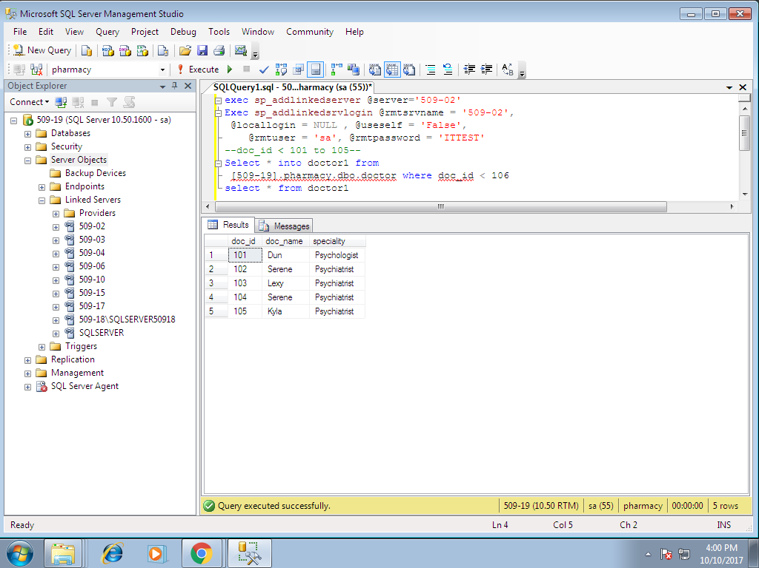

Doctor2 (doc_id >=106)

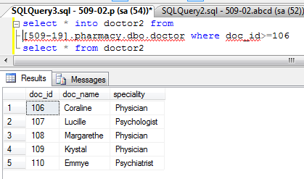

**DERIVED HORIZONTAL FRAGMENTATION**

prescription 1 patients prescribed by doctor 1

prescription 2 patients prescribed by doctor 2

Precription 1

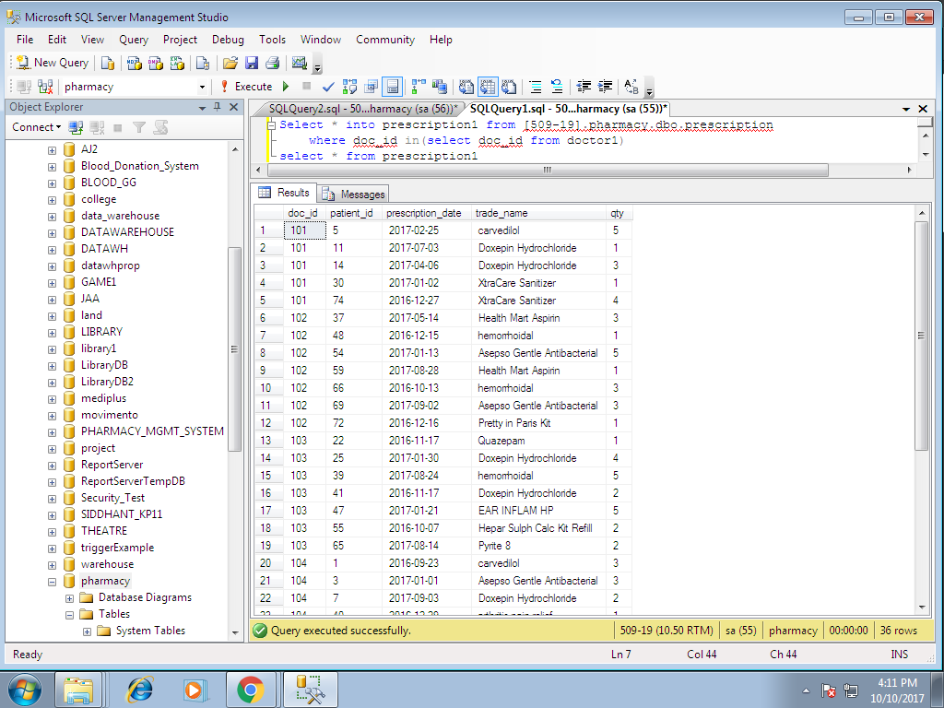

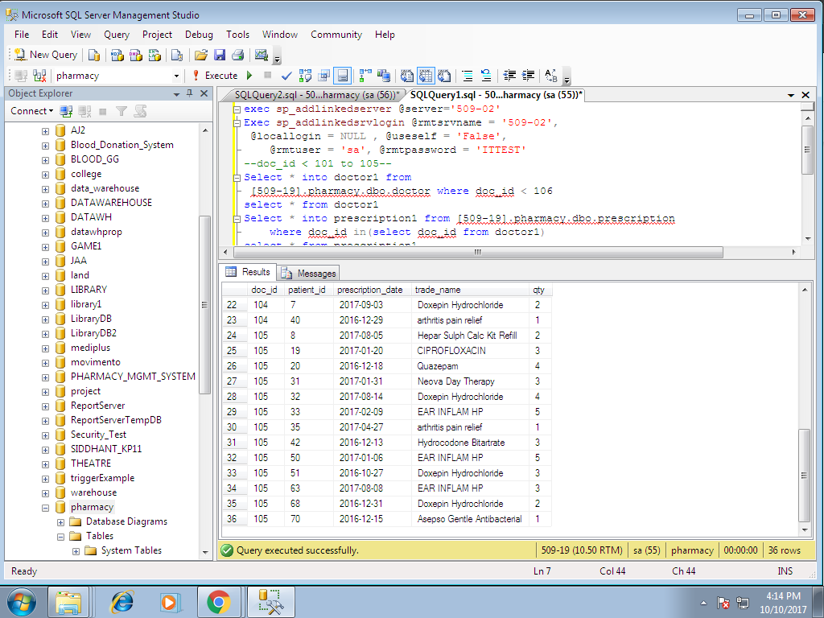

Precription 2

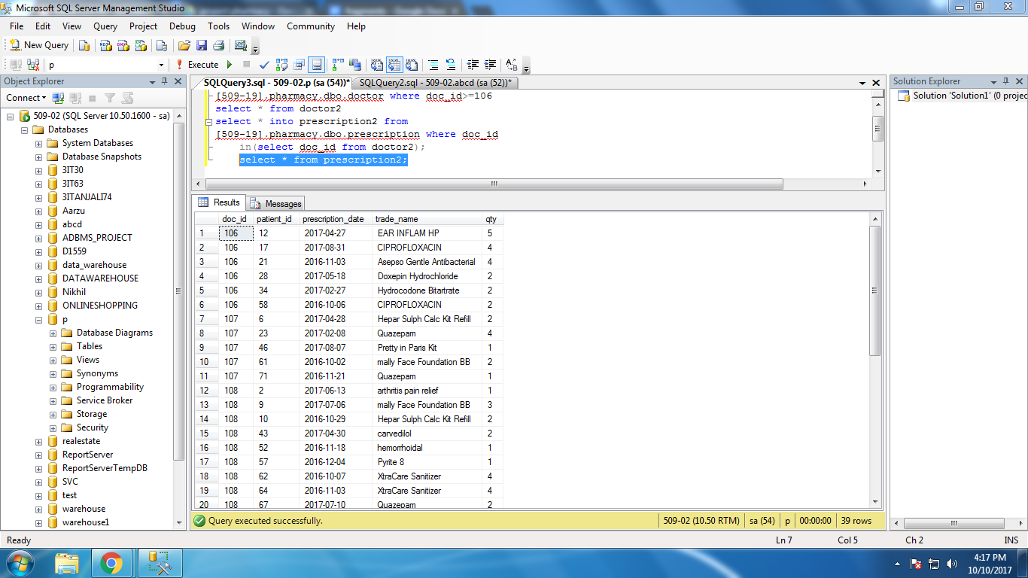

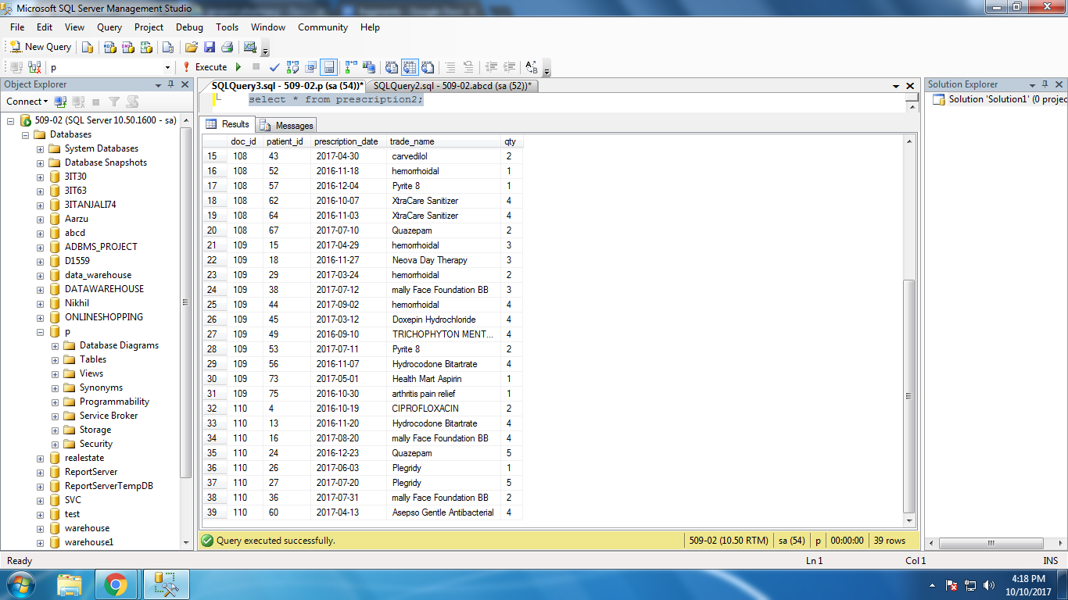

**VERTICAL FRAGMENTATION**

Patient1 (patient_id,name and age)

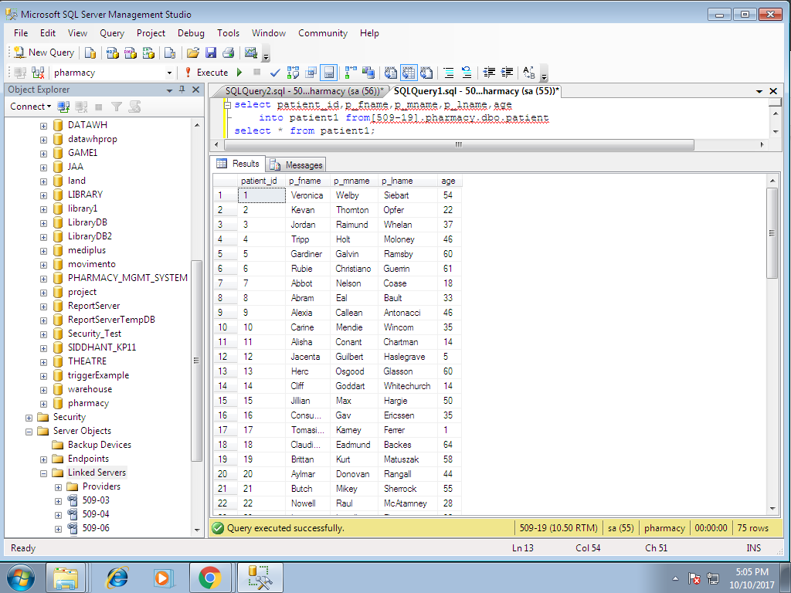

Patient2 (patient_id,gender,address,number and dob)

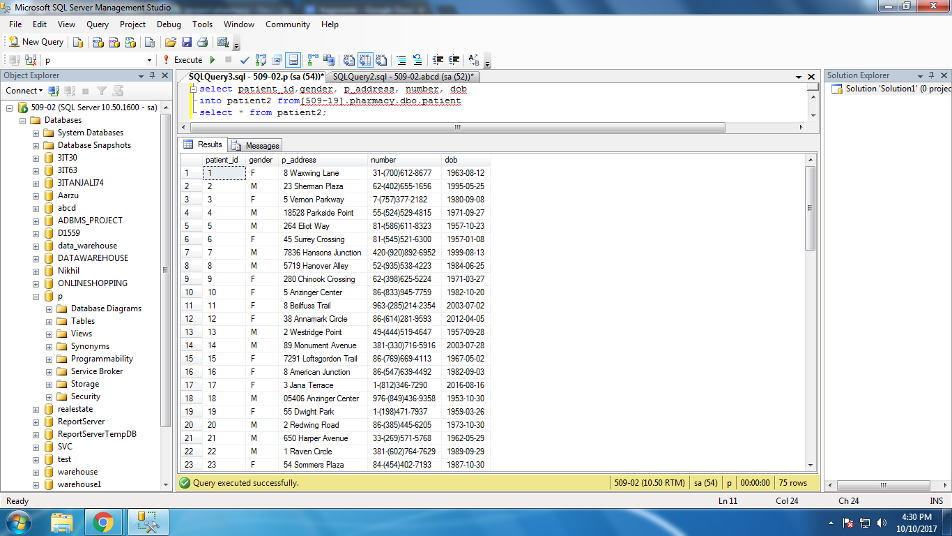

**HYBRID FRAGMENTATION**

Prescription 1 table is fragmented horizontally

Patient11 (patient_id,doc_id,prescription_date)

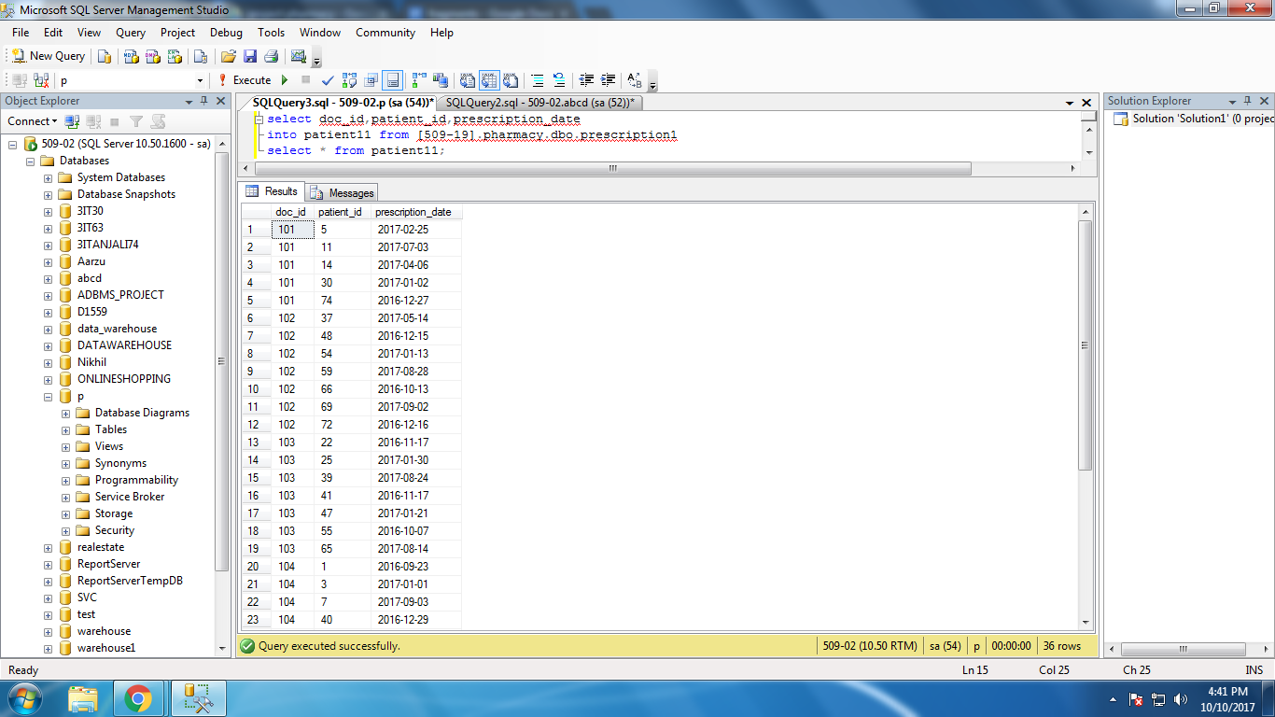

Patient12 (patient_id,doc_id,trade_name and qty)

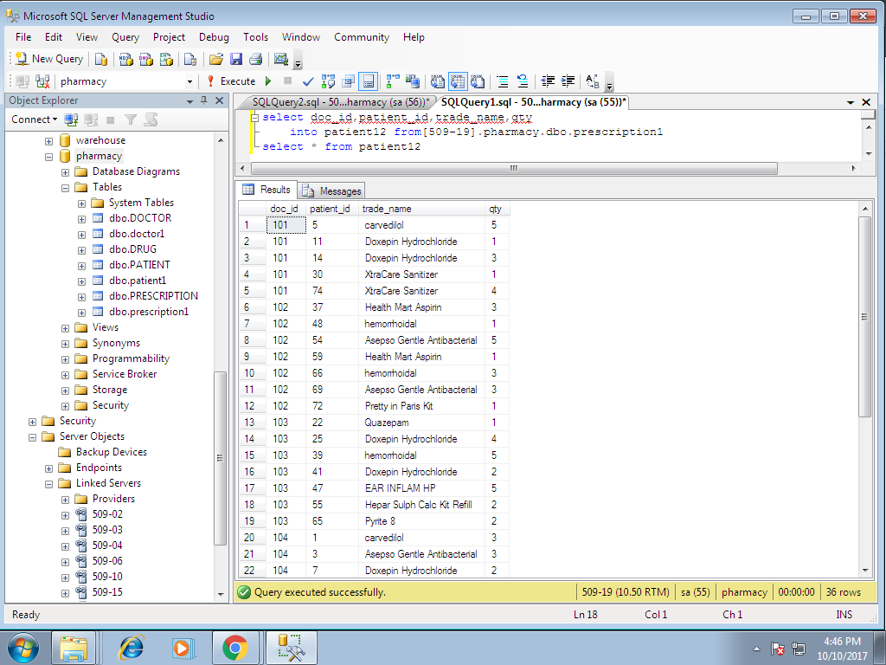

**CORRECTNESS CRITERIA**

**For horizontal Fragmentation**

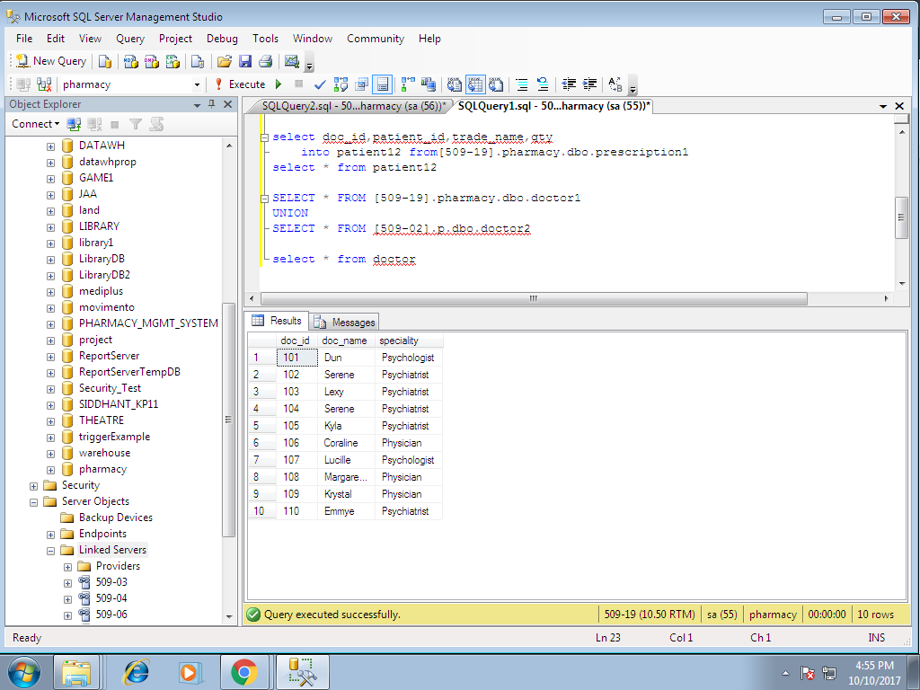 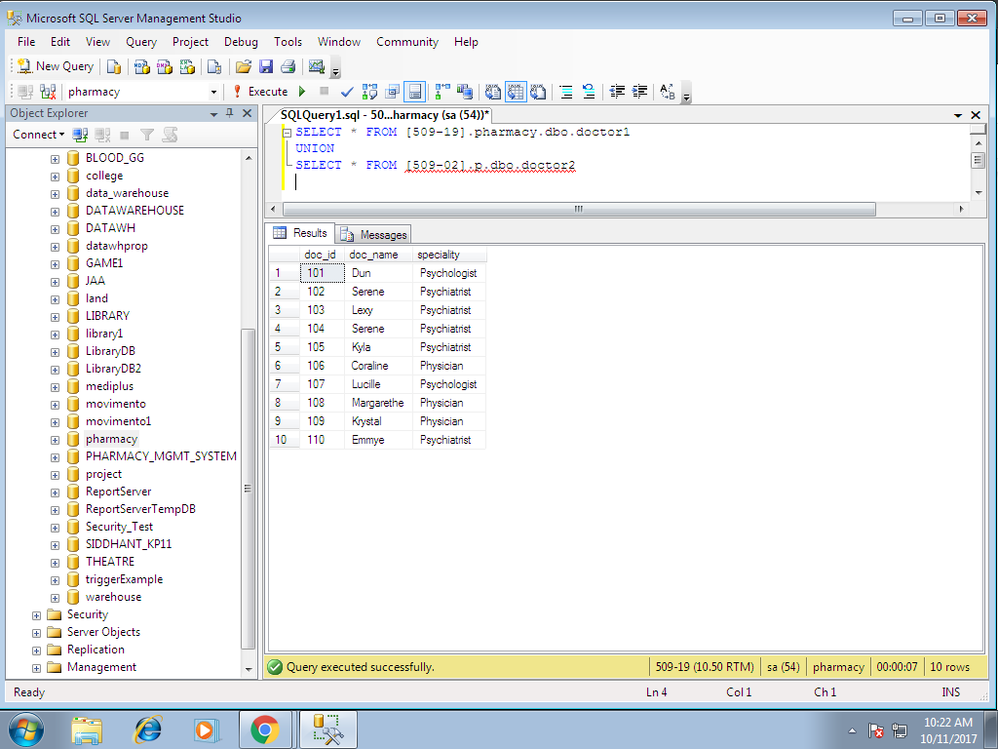

**Complex Queries**

**Names female patients in fragment patient2**

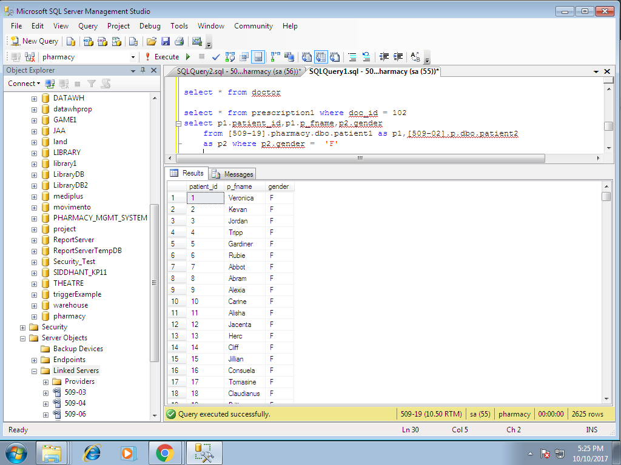

**Count the no.of female patients in fragment patient2**

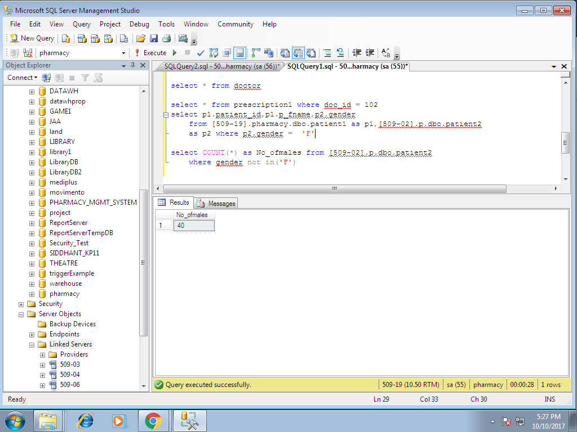

**Count the no.of of patients attended by doctors in doctor1 fragment.**

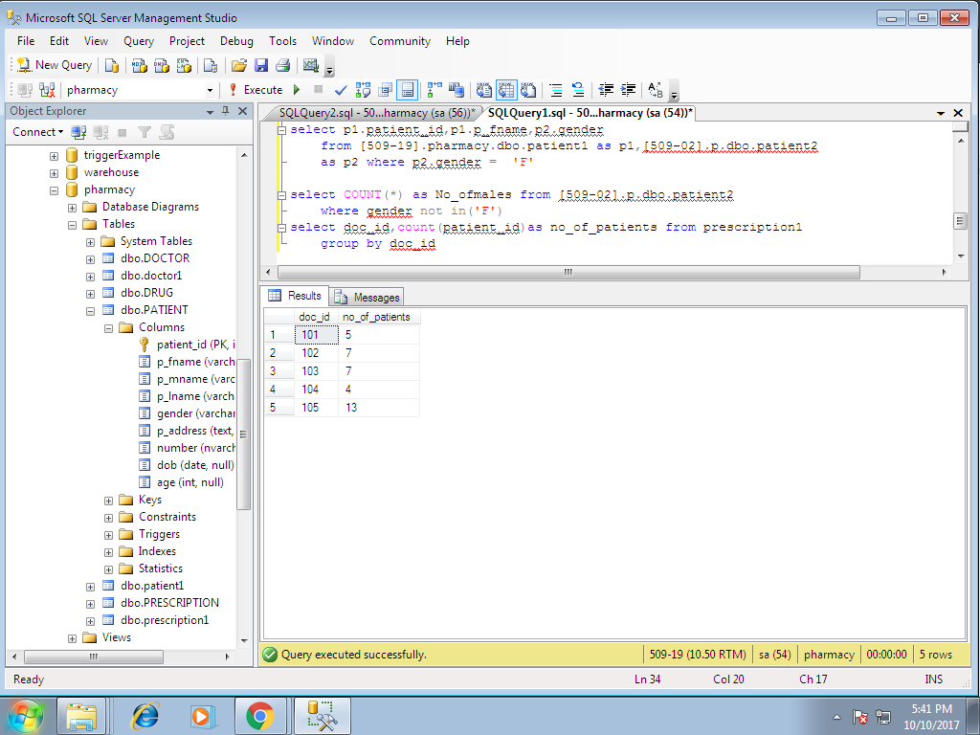

**Patients attended by doctor having id 102 in prescription 1 fragment**

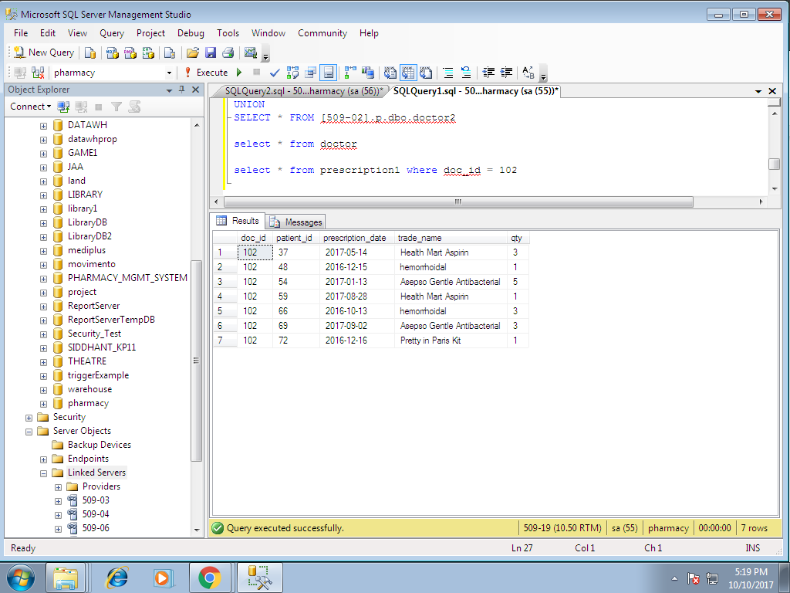

**No.of patients consuming drug arthritis pain relief from patient1 fragment\**

