**EXPERIMENT NO 11**

**iNDEXING**

**Non Clustered Indexing:**

SELECT * FROM PATIENT WHERE p_fname='Cliff';

CREATE NONCLUSTERED INDEX FNameIndex ON Patient(p_fname);

BEFORE INDEXING:

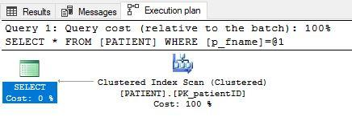

AFTER iNDEXING :

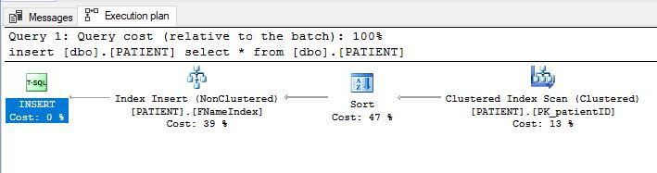

OBJECT EXPLORER

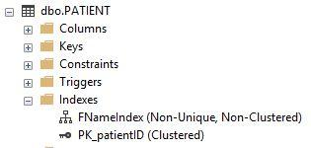

**CLUSTERED INDEXING**

SELECT * FROM patient1 WHERE patient_id='2';

CREATE CLUSTERED INDEX PI_ID ON patient1(patient_id);

BEFORE INDEXING :

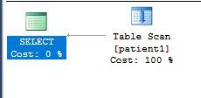

AFTER INDEXING :

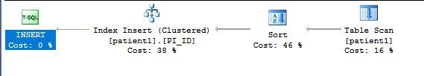

OBJECT EXPLORER :

