**EXPERIMENT NO 7**

**STAR SCHEMA**

**/*Count of drugs ordered from the company by the pharmacy in the year 2017*/**

create table fact

(

f_id int not null,

ph_id int NOT NULL,

time_key time,

c_id int not null,

trade_name varchar(30) NOT NULL,

qty int

)

alter table fact

add constraint PK_factID primary key(f_id);

ALTER TABLE fact

ADD CONSTRAINT FK_phID_fact FOREIGN KEY(ph_id) REFERENCES PHARMACY(ph_id);

ALTER TABLE fact

ADD CONSTRAINT FK_tradename_fact FOREIGN KEY(trade_name) REFERENCES DRUG(trade_name)

ALTER TABLE fact

ADD CONSTRAINT FK_time_fact FOREIGN KEY(time_key) REFERENCES dnt(time_key)

ALTER TABLE fact

ADD CONSTRAINT FK_c_id_fact FOREIGN KEY(c_id) REFERENCES company(c_id)

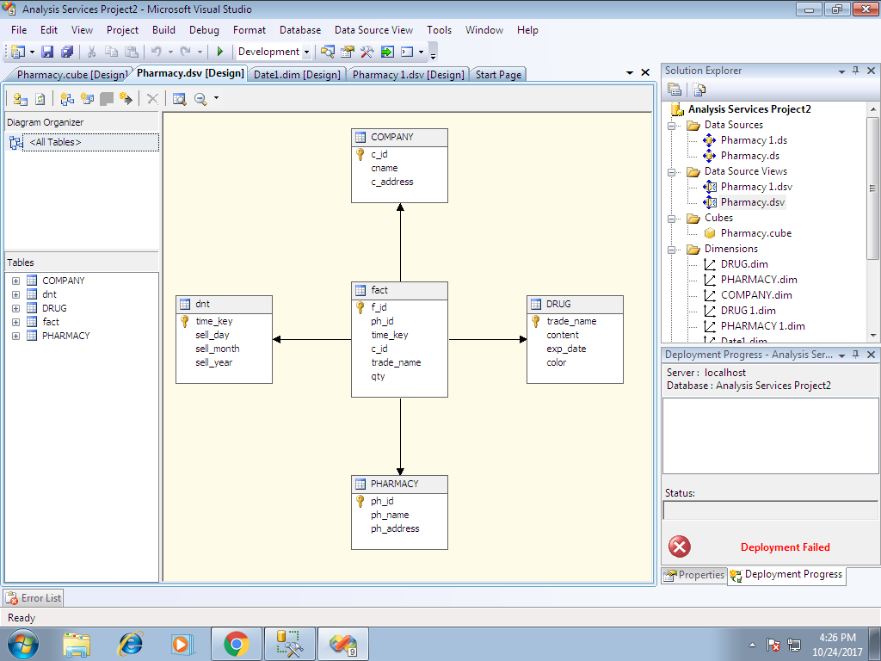

**SNOWFLAKE SCHEMA**

**/*Derived date dimension*/**

create table snow_fact

(

f_id int not null,

ph_id int NOT NULL,

date_key date,

c_id int not null,

trade_name varchar(30) NOT NULL,

qty int

)

alter table snow_fact

add constraint PK_snow_factID primary key(f_id);

ALTER TABLE snow_fact

ADD CONSTRAINT FK_phID_snow_fact FOREIGN KEY(ph_id) REFERENCES PHARMACY(ph_id);

ALTER TABLE snow_fact

ADD CONSTRAINT FK_tradename_snow_fact FOREIGN KEY(trade_name) REFERENCES DRUG(trade_name)

ALTER TABLE snow_fact

ADD CONSTRAINT FK_time_snow_fact FOREIGN KEY(date_key) REFERENCES date1(date_key)

ALTER TABLE snow_fact

ADD CONSTRAINT FK_c_id_snow_fact FOREIGN KEY(c_id) REFERENCES company(c_id)

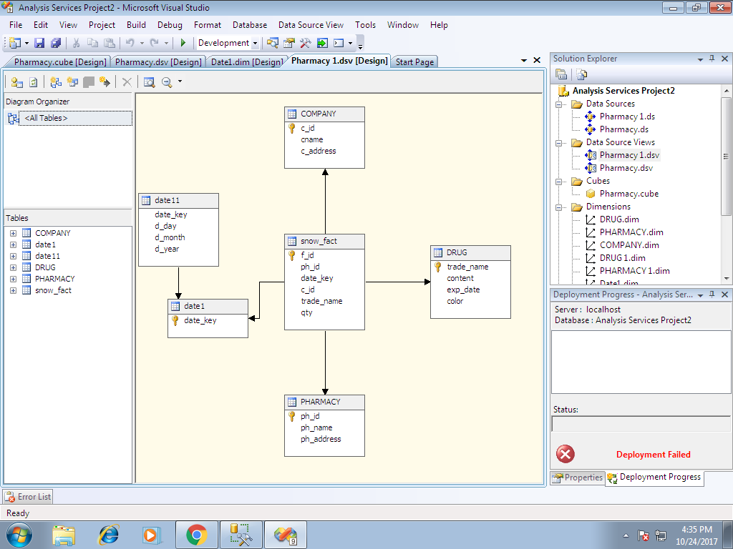

**FACT CONSTELLATION SCHEMA**

**/*No. Of employees working in the pharmacy*/**

create table no_of_emp

(

num_key int PRIMARY KEY,

ph_id int FOREIGN KEY(ph_id) REFERENCES pharmacy(ph_id),

eid int FOREIGN KEY(eid) REFERENCES employee(eid)

)

