EX:No.1 221501043

25/01/25

**Program to implement time series data for import library, load data,Preprocessing and visualising**

**Aim:**

Write a program to implement time series data for import library, load data, Preprocessing and visualising.

**Algorithm:**

1. **Load the Data**:
   * Read the CSV file containing the weather data.
   * Parse the date column as a datetime index.
2. **Clean the Data**:
   * Handle missing values by performing forward and backward filling.
   * Drop any remaining NaN values.
3. **Normalize the Data**:
   * Apply **Min-Max Scaling** to normalize each column's values between 0 and 1.
4. **Add Time-Based Features**:
   * Extract additional features from the datetime index: day, month and year
5. **Visualize the Data**:
   * Plot the time series for a specific column (e.g., temperature T) over time.
6. **Execute the Program**:
   * Sequentially call the functions to load, clean, normalize, add features, and visualize the data.

**Code:**

import pandas as pd

import numpy as np

from scipy import stats

import matplotlib.pyplot as plt

from sklearn.preprocessing import StandardScaler

data = pd.read_csv('D:/221501043/daily-minimum-temperatures-in-me.csv')

print(data.columns)

data.columns = data.columns.str.strip()

data['Date'] = pd.to_datetime(data['Date'], format='%m/%d/%Y', errors='coerce')

data.set_index('Date', inplace=True)

data['Daily minimum temperatures'] = pd.to_numeric(data['Daily minimum temperatures'], errors='coerce')

data['Daily minimum temperatures'] = data['Daily minimum temperatures'].fillna(method='ffill')

z_scores = np.abs(stats.zscore(data['Daily minimum temperatures'].dropna()))

data = data[z_scores < 3]

data['year'] = data.index.year

data['month'] = data.index.month

data['day'] = data.index.day

data['weekday'] = data.index.weekday

scaler = StandardScaler()

data['scaled_temp'] = scaler.fit_transform(data[['Daily minimum temperatures']])

plt.figure(figsize=(10, 6))

data['Daily minimum temperatures'].plot()

plt.title('Daily Minimum Temperatures Over Time')

plt.xlabel('Date')

plt.ylabel('Daily Minimum Temperature (°C)')

plt.show()

print(data.head())

**Output:**

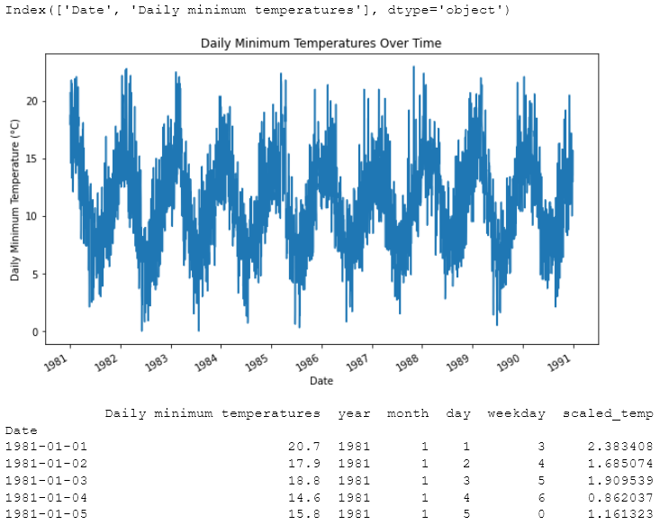

**Result:**

Thus, the program using the time series data implementation has been done successfully.