EX:No.10 221501043

22/03/25

**Program to Vector Auto Regression (VAR) for Multivariate Time Series Forecasting**

**Aim:**

Write a program implement to Vector Auto Regression (VAR) for Multivariate Time Series Forecasting

**Algorithm:**

1. **Load the Data**:
   * Read the CSV file containing the weather data.
   * Parse the date column as a datetime index.
2. **Clean the Data**:
   * Handle missing values by performing forward and backward filling.
   * Drop any remaining NaN values.
3. **Normalize the Data**:
   * Apply **Min-Max Scaling** to normalize each column's values between 0 and 1.
4. **Add Time-Based Features**:
   * Extract additional features from the datetime index: day, month and year
5. **Visualize the Data**:
   * Plot the time series for a specific column (e.g., temperature T) over time.
6. **Execute the Program**:
   * Sequentially call the functions to load, clean, normalize, add features, and visualize the data.

**Code:**

from statsmodels.tsa.api import VAR

from sklearn.preprocessing import StandardScaler

# Prepare multivariate dataset (Temperature + Lagged Temperature)

data = df.copy()

data['Lagged'] = data['Temperature'].shift(1)

data.dropna(inplace=True)

# Standardize the data

scaler = StandardScaler()

scaled = scaler.fit_transform(data)

# Convert to DataFrame

scaled_df = pd.DataFrame(scaled, index=data.index, columns=data.columns)

# Fit VAR model

model = VAR(scaled_df)

results = model.fit(15)

# Forecast next 30 days

forecast_input = scaled_df.values[-15:]

forecast = results.forecast(y=forecast_input, steps=30)

# Inverse transform

forecast_df = pd.DataFrame(forecast, columns=scaled_df.columns)

forecast_original = scaler.inverse_transform(forecast_df)

# Plot Temperature Forecast

forecast_dates = pd.date_range(start=data.index[-1] + pd.Timedelta(days=1), periods=30)

plt.figure(figsize=(12, 6))

plt.plot(data.index[-100:], data['Temperature'][-100:], label='Historical Temperature')

plt.plot(forecast_dates, forecast_original[:, 0], label='VAR Forecast (30 Days)', color='purple')

plt.title("VAR Forecast of Temperature")

plt.xlabel("Date")

plt.ylabel("Temperature")

plt.legend()

plt.tight_layout()

plt.show()

**Output:**

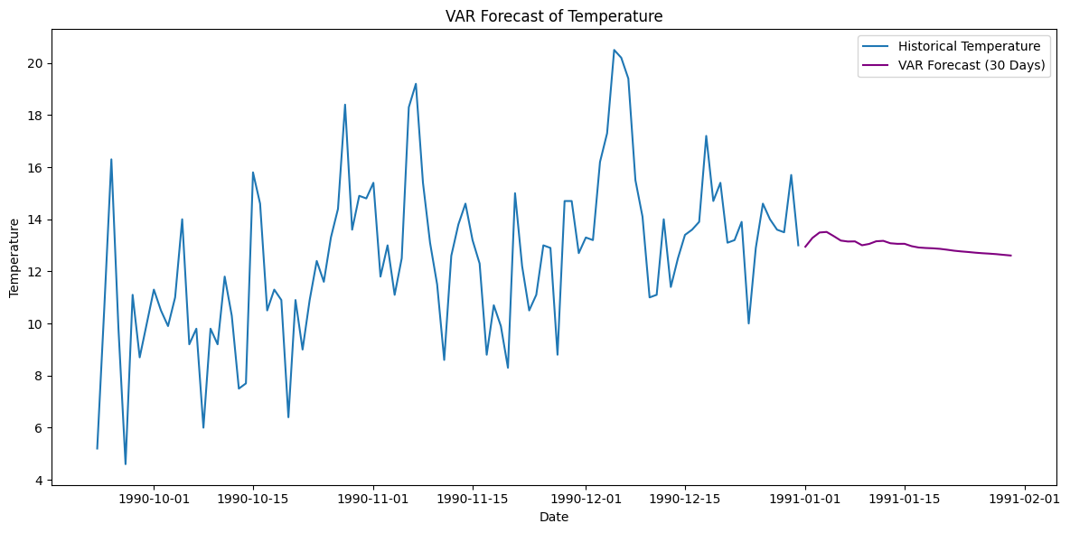

**Result:**

Thus, the program to implement VAR using the time series data has been done successfully.