EX:No.5 221501043

22/03/25

**Program to Develop a linear regression model for forecasting time series data.**

**Aim:**

Write a program to implement time series data for import library, load data, Preprocessing and visualising.

**Algorithm:**

1. **Load the Data**:
   * Read the CSV file containing the weather data.
   * Parse the date column as a datetime index.
2. **Clean the Data**:
   * Handle missing values by performing forward and backward filling.
   * Drop any remaining NaN values.
3. **Normalize the Data**:
   * Apply **Min-Max Scaling** to normalize each column's values between 0 and 1.
4. **Add Time-Based Features**:
   * Extract additional features from the datetime index: day, month and year
5. **Visualize the Data**:
   * Plot the time series for a specific column (e.g., temperature T) over time.
6. **Execute the Program**:
   * Sequentially call the functions to load, clean, normalize, add features, and visualize the data.

**Code:**

import pandas as pd

import matplotlib.pyplot as plt

# Load CSV with correct column names

df = pd.read_csv("/mnt/data/daily-minimum-temperatures-in-me.csv")

# Rename columns for easier use

df.columns = ['Date', 'Temp']

# Convert 'Date' column to datetime

df['Date'] = pd.to_datetime(df['Date'], errors='coerce')

# Convert Temp column to numeric (in case there are weird chars)

df['Temp'] = pd.to_numeric(df['Temp'], errors='coerce')

# Drop any rows with missing values

df.dropna(inplace=True)

# Set date as index for time series

df.set_index('Date', inplace=True)

# ---- 📉 Trend Analysis ----

# 1. Rolling average (30-day smoothing)

smoothed = df['Temp'].rolling(window=30).mean()

# 2. Monthly aggregation

monthly_avg = df['Temp'].resample('M').mean()

# ---- 🎨 Plotting the Pretty Graph ----

plt.figure(figsize=(14, 6))

# Plot daily temperature in baby pink

plt.plot(df.index, df['Temp'], color='#FFB6C1', alpha=0.4, label='Daily Temperature')

# Plot smoothed 30-day average in baby blue

plt.plot(smoothed.index, smoothed, color='#89CFF0', linewidth=2.5, label='30-Day Smoothed')

# Plot monthly average as dashed line

plt.plot(monthly_avg.index, monthly_avg, color='#87CEFA', linestyle='--', linewidth=2, label='Monthly Average')

plt.title("💗 Trend in Daily Minimum Temperatures 💙", fontsize=16)

plt.xlabel("Date")

plt.ylabel("Temperature (°C)")

plt.grid(alpha=0.3, linestyle='--')

plt.legend()

plt.tight_layout()

plt.show()

**Output:**

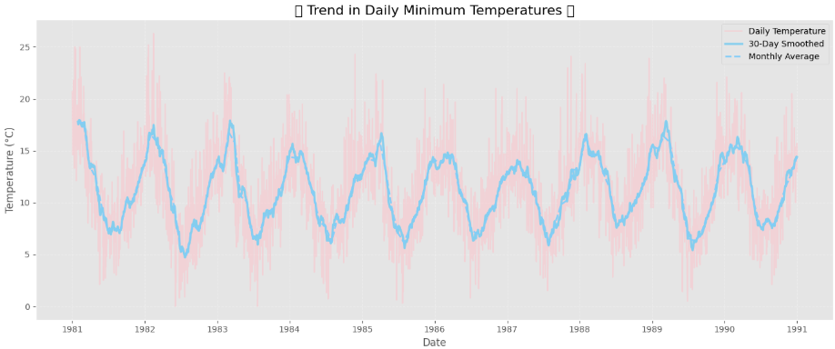

**Result:**

Thus, the program using the time series data implementation has been done successfully.