EX:No.6 221501043

22/03/25

**Program to Develop a linear regression model for forecasting time series data.**

**Aim:**

Write a program to implement time series data for import library, load data, Preprocessing and visualising.

**Algorithm:**

1. **Load the Data**:
   * Read the CSV file containing the weather data.
   * Parse the date column as a datetime index.
2. **Clean the Data**:
   * Handle missing values by performing forward and backward filling.
   * Drop any remaining NaN values.
3. **Normalize the Data**:
   * Apply **Min-Max Scaling** to normalize each column's values between 0 and 1.
4. **Add Time-Based Features**:
   * Extract additional features from the datetime index: day, month and year
5. **Visualize the Data**:
   * Plot the time series for a specific column (e.g., temperature T) over time.
6. **Execute the Program**:
   * Sequentially call the functions to load, clean, normalize, add features, and visualize the data.

**Code:**

import pandas as pd

import matplotlib.pyplot as plt

# Load dataset

df = pd.read_csv("daily-minimum-temperatures-in-me.csv")

# Rename columns

df.columns = ['Date', 'Temp']

# Clean data

df['Date'] = pd.to_datetime(df['Date'], errors='coerce')

df['Temp'] = pd.to_numeric(df['Temp'], errors='coerce')

df.dropna(inplace=True)

df.set_index('Date', inplace=True)

# Apply 7-day moving average

df['Smoothed'] = df['Temp'].rolling(window=7).mean()

# Forecast for next 7 days using last smoothed value

forecast_days = 7

last_date = df.index[-1]

forecast_index = pd.date_range(start=last_date + pd.Timedelta(days=1), periods=forecast_days)

forecast_values = [df['Smoothed'].dropna().iloc[-1]] * forecast_days

forecast_df = pd.DataFrame({'Forecast': forecast_values}, index=forecast_index)

plt.figure(figsize=(14, 6))

plt.bar(df.index[-30:], df['Temp'][-30:], label='Original', color='#FFB6C1', alpha=0.5)

plt.bar(df.index[-30:], df['Smoothed'][-30:], label='Smoothed', color='#ADD8E6', width=1.5)

plt.plot(forecast_df.index, forecast_df['Forecast'], label='Forecast', color='#FF69B4', linestyle='--', marker='o')

plt.title('💫 Moving Average Smoothing & Forecasting - Bar Graph', fontsize=15)

plt.xlabel('Date')

plt.ylabel('Temperature (°C)')

plt.grid(alpha=0.3)

plt.legend()

plt.tight_layout()

plt.xticks(rotation=45)

plt.show()

**Output:**

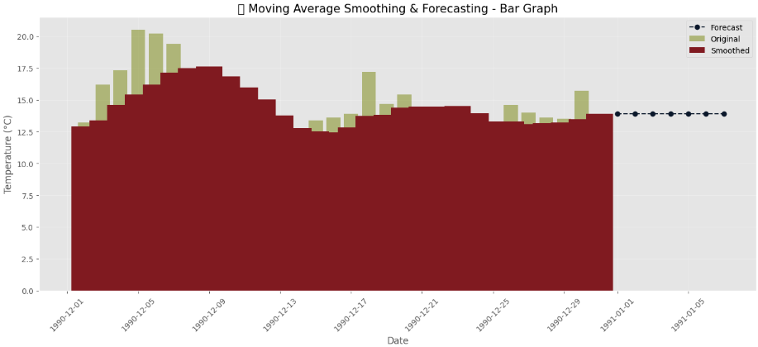

**Result:**

Thus, the program using the time series data implementation has been done successfully.