EX:No.7 221501043

01/04/25

**Program to decomposing time series data into trend and seasonality**

**Aim:**

Write a program to implement time series data for import library, load data, Preprocessing and visualising for decomposing time series data.

**Algorithm:**

1. **Load the Data**:
   * Read the CSV file containing the weather data.
   * Parse the date column as a datetime index.
2. **Clean the Data**:
   * Handle missing values by performing forward and backward filling.
   * Drop any remaining NaN values.
3. **Normalize the Data**:
   * Apply **Min-Max Scaling** to normalize each column's values between 0 and 1.
4. **Add Time-Based Features**:
   * Extract additional features from the datetime index: day, month and year
5. **Visualize the Data**:
   * Plot the time series for a specific column (e.g., temperature T) over time.
6. **Execute the Program**:
   * Sequentially call the functions to load, clean, normalize, add features, and visualize the data.

**Code:**

import pandas as pd

import matplotlib.pyplot as plt

from statsmodels.tsa.seasonal import seasonal_decompose

df = pd.read_csv("daily-minimum-temperatures-in-me.csv")

df.columns = ['Date', 'Temperature']

df['Date'] = pd.to_datetime(df['Date'])

df.set_index('Date', inplace=True)

# Remove any invalid temperature values

df = df[df['Temperature'].str.match(r'^-?\d+(\.\d+)?$', na=False)]

df['Temperature'] = df['Temperature'].astype(float)

decomposition = seasonal_decompose(df['Temperature'], model='additive', period=365)

plt.figure(figsize=(14, 8))

plt.subplot(3, 1, 1)

plt.plot(decomposition.trend, label='Trend', color='orange')

plt.title('Trend')

plt.legend()

plt.subplot(3, 1, 2)

plt.plot(decomposition.seasonal, label='Seasonality', color='green')

plt.title('Seasonality')

plt.legend()

plt.subplot(3, 1, 3)

plt.plot(df['Temperature'], label='Original Data', alpha=0.5, color='blue')

plt.title('Original Data')

plt.legend()

plt.tight_layout()

plt.show()

**Output:**

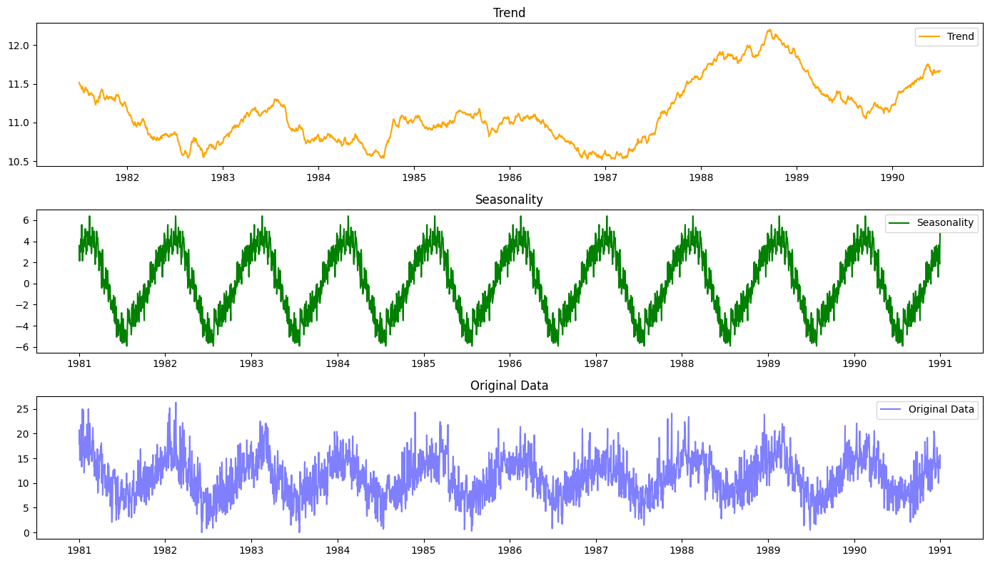

**Result:**

Thus, the program to decompose the time series data has been done successfully.