1. A**Series**is a one-dimensional labeled array capable of holding any data type (integers, strings, floating point numbers, Python objects, etc.). It has to be remembered that unlike Python lists, a Series will always contain data of the same type.



Empty series

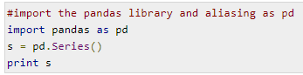

1. **Methods to create a Pandas Series**

**From Lists**

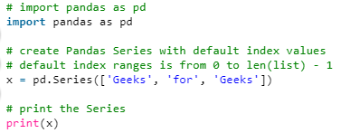 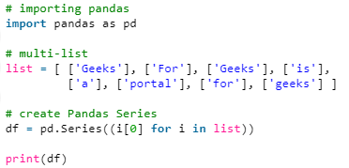

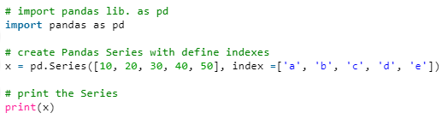

**From Numpy array**

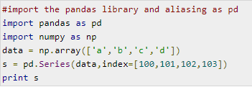

**From Dict**

A dict can be passed as input and if no index is specified, then the dictionary keys are taken in a sorted order to construct index. If index is passed, the values in data corresponding to the labels in the index will be pulled out.

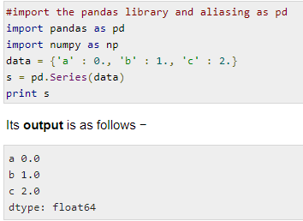 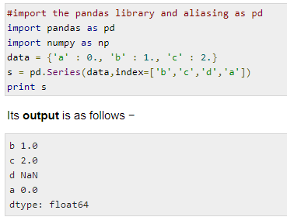

**From Scalar value**

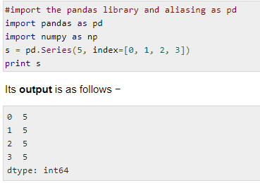

1. **Access data from a Pandas Series**

If a : is inserted in front of it, all items from that index onwards will be extracted. If two parameters (with : between them) is used, items between the two indexes (not including the stop index)

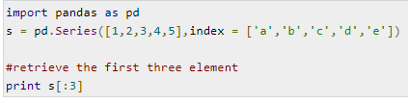 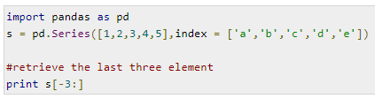

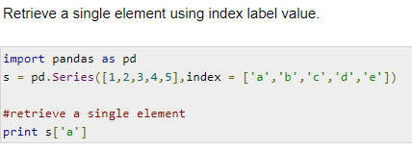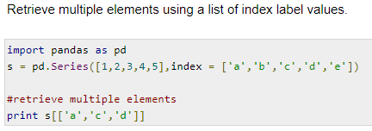

1. **Copy series**

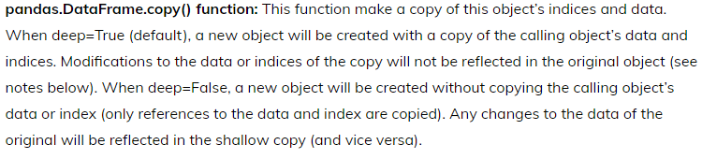

Default – Deep= True

1. **Dataframe**



1. **Methods to create a Pandas Dataframe**

**Empty Dataframe**

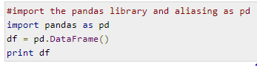

**From Lists**

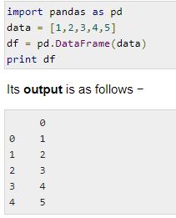 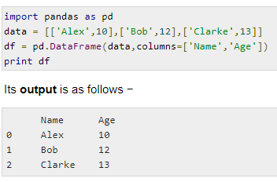

**From Dict**

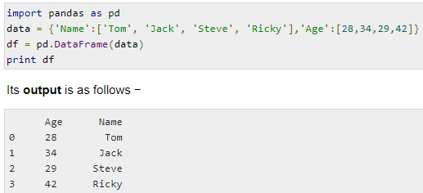 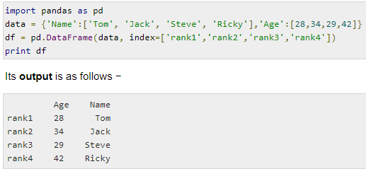

**From List Of Dicts**

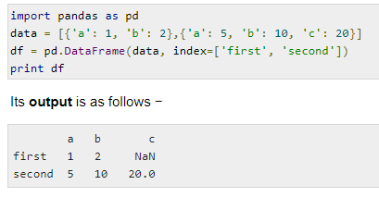 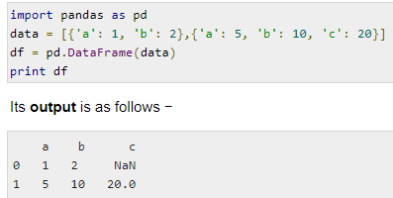

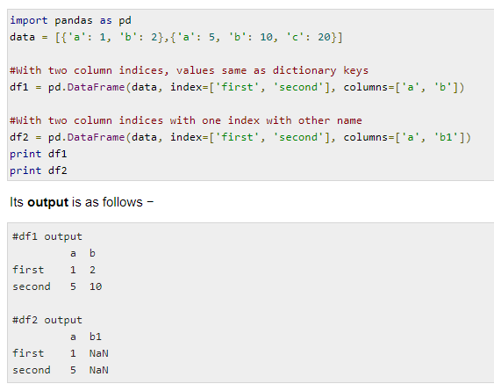

**From Dict of series**

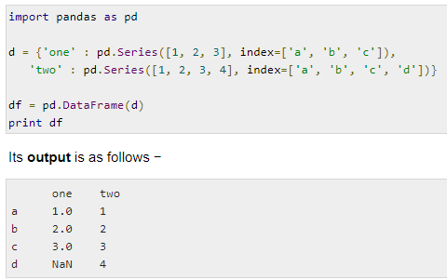

1. **Column level operation on a Pandas Dataframe**

**Selection**

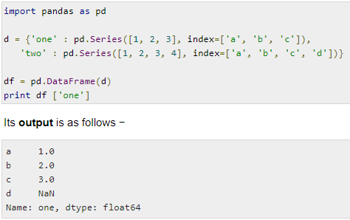

**Addition**

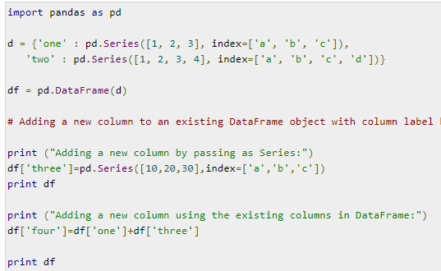

**Deletion**

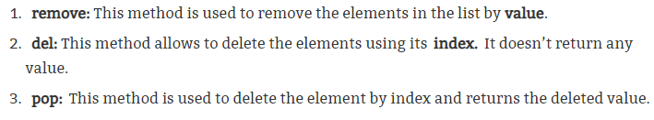

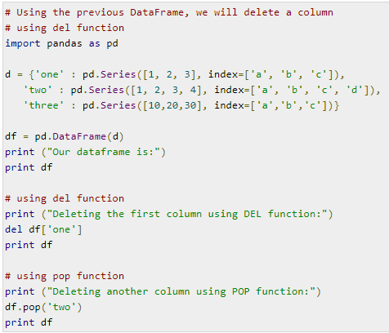

1. **Row level operation on a Pandas Dataframe**

**Selection by label – loc Selection by location – iloc**

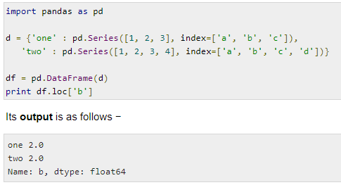 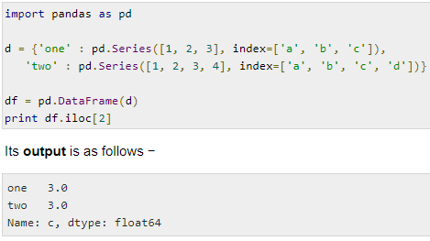

**Slice rows**

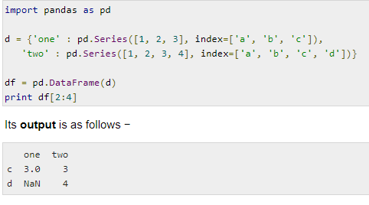

**Addition of rows**

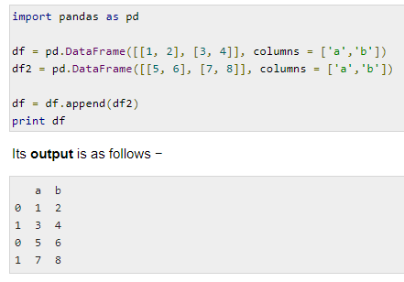

**Deletion**

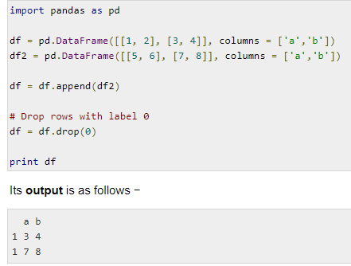

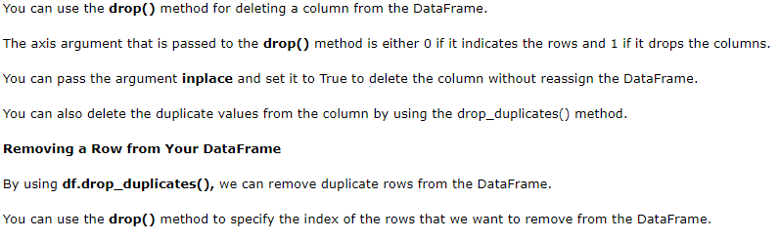

1. **Reindexing in pandas**

Pandas**dataframe.reindex()** function conform DataFrame to new index with optional filling logic, placing NA/NaN in locations having no value in the previous index. A new object is produced unless the new index is equivalent to the current one and copy=False

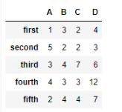 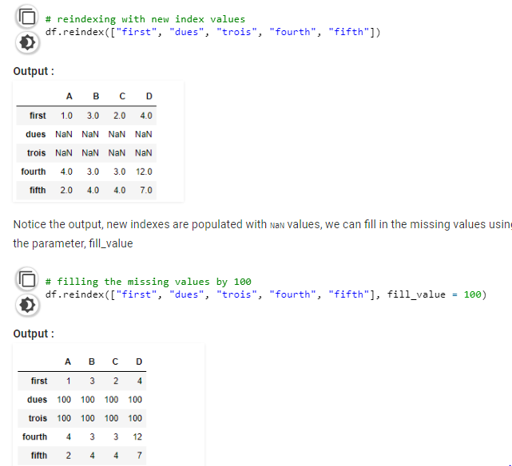

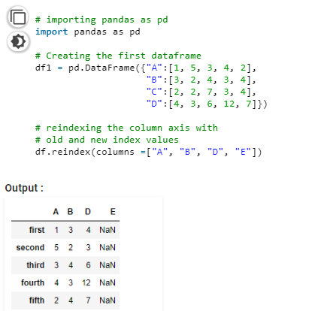

1. **Iterate rows and columns of dataframe**

**Iterate rows**

 iterrows() function return each index value along with a series containing the data in each row.

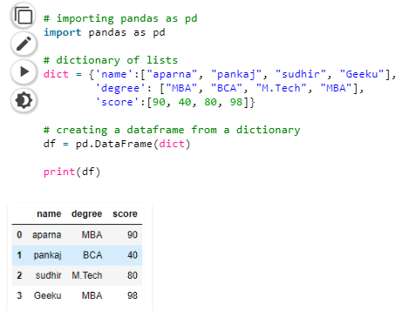 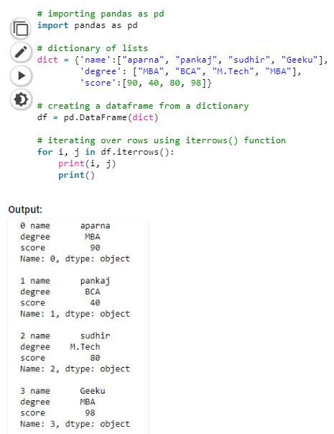

itertuples() this function return a tuple for each row in the DataFrame. The first element of the tuple will be the row’s corresponding index value, while the remaining values are the row values.

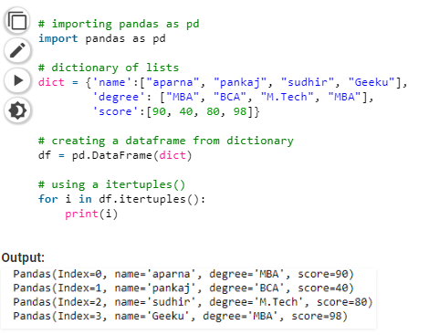

**Iterate over columns**

iteritems() function this function iterates over each column as key, value pair with label as key and column value as a Series object.

