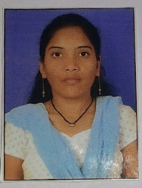

**Biodata**

Name: Patel Heena Karsanbhai

Present Address: 302,jaldeep,co-op-housing socity,manibag,abrama,valsad

Gender: female

Marital Status: Unmarried

Religion: Hindu

Birth Date: 26th may 1993

Birth Place: valsad,Gujarat

Native Place: Mogar(vallabh faliyu),navsari

Email:Patelheena202@yahoo.com

Qualification: M.C.A(Master of Computer Application)

Collage: Department of computer science of VNSGU University.

Height: 5’

Blood Group: o+

Hobbies: Painting,music,traveling

**Family Details:**

Father: Patel karsanbhai Gandabhai(Sugar Sales clerk at valsad Sugar factory)

Mother: Patel Sarswatiben karsanbhai (Houswife)