**1. Hold the web monitoring jobs under maintenance group before maintenance start.**

Please hold below Jobs for OD 01/15/18 @ 08:30 IST

**REQ0324339- RITM0369807:**

DP1-Maintenance --> DP1-0400-URLMonitor1--> DP1-00100-ManuURL1-CheckWebworks1

DP1-Maintenance --> DP1-0400-URLMonitor1 --> DP1-00200-ManuURL1-CheckWebworks2

DP1-Maintenance -->DP1-0400-URLMonitor1 --> DP1-00100-ManuURL1-CheckWebworksEVC

DP1-Maintenance --> DP1-0100-SpaceMonitor --> DP1-00100-DPRP_MonitoringWatchDog_sh

DP1-Targeted--> DP1-1100-Rpt_OrdFsTR --> DP1-03920-DPRP_MM_RunPlan_Deploy_Import

DP1-Targeted-->DP1-1100-Rpt_OrdFsTR-->DP1-03800-DPRP_MM_del-processsku_Sql17_TR

DP-0X-DPRPDMC_CONVERTFROMAUTO_COLLECTDATA

DP1-03700-DPRP_MM_RunPlan_Deploy_CD_TR

**2. Login to trypridrpdb2 server and do sudo manumgr and dprpadm . If there is any issue, contact Linux Admin team(AIX_HP_UX_Primary** [**aixtrpr@searshc.com**](mailto:aixtrpr@searshc.com)**). When**

Check if you are able to login,

Finished setting environment variables: SID is IDRPPRD.

[manumgr@trypridrpdb2.searshc.com:/home/manumgr]: sudo su - dprpadm

Finished setting environment variables: SID is IDRPPRD.

[dprpadm@trypridrpdb2.searshc.com:/home/dprpadm]:

**3. Login to IDRPPRD database with STSC and Superuser credentials (using sql developer). if there is any problem get Oracle DBA team(OracleDBA) Engaged to fix it.**

**Use below user id and pwd for database.**

|  |  |  |
| --- | --- | --- |
| IDRPPRD | STSC | pwd4stsc |
| IDRPPRD | SUPERUSER | pwd4superuser |

1. First check with STSC user.

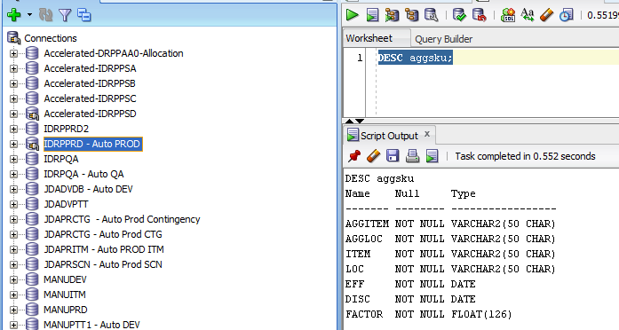

2. Second Check with superuser

superuser\*************

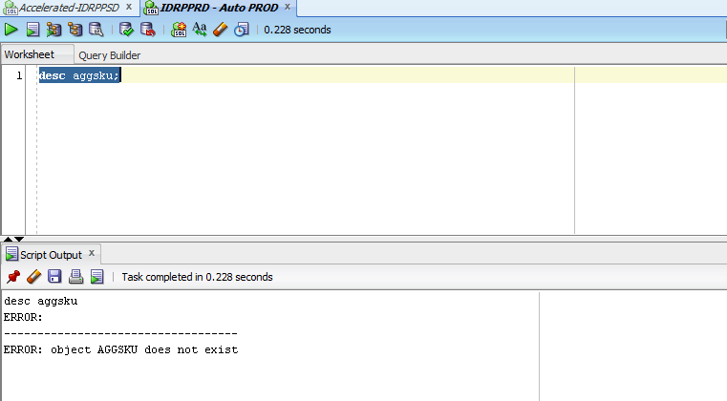

**4. Login to Production app server and see if Linux server is correctly mounted there i.e. /dprp/ and its child folders like /sql, /bin, /log etc exists. If there is problem contact UNIX Admin Team(DSTS_SUN_LINUX) to fix issue.**

**Please check on all the below servers.**

1. **tryprappidrp3**
2. **tryprappidrp4**

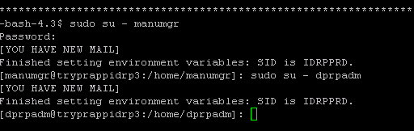







**5. Run Stop all and start all script at app server.**

First execute to stop the Apps and then to Start the Apps.

a. Execute the following as **manumgr** on server tryprappidrp3: /dprp/bin/DPRP_MM_StopAllApps.sh

b. Execute the following as manumgr on server tryprappidrp3: /dprp/bin/DPRP_MM_StartAllApps.sh



**6. Verify Production JDA link and login.**

Check all the 3 URL’s

<http://tryprappidrp4.searshc.com:7002/VP?frame=vpHomePage>

<http://tryprappidrp3.searshc.com:7001/VP?frame=vpHomePage>

<http://idrpprd1.intra.searshc.com/VP?frame=vpHomePage>

<http://idrpprd1.intra.searshc.com/> for current state BatchHost/manu1234

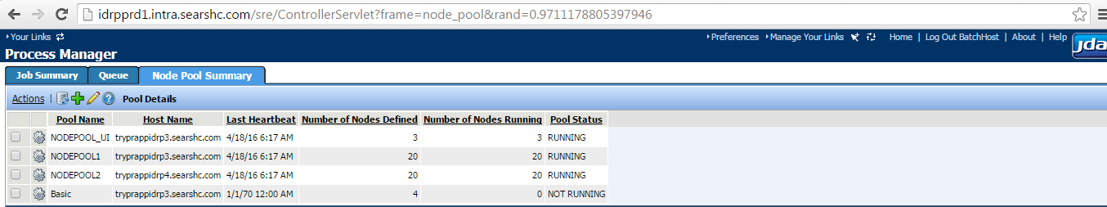

**7. Release web monitoring jobs held in step 1.**

Release hold Jobs for OD 01/15/18

DP1-Maintenance --> DP1-0400-URLMonitor1--> DP1-00100-ManuURL1-CheckWebworks1

DP1-Maintenance --> DP1-0400-URLMonitor1 --> DP1-00200-ManuURL1-CheckWebworks2

DP1-Maintenance -->DP1-0400-URLMonitor1 --> DP1-00100-ManuURL1-CheckWebworksEVC

DP1-Maintenance --> DP1-0100-SpaceMonitor --> DP1-00100-DPRP_MonitoringWatchDog_sh

DP1-Targeted--> DP1-1100-Rpt_OrdFsTR --> DP1-03920-DPRP_MM_RunPlan_Deploy_Import

DP1-Targeted-->DP1-1100-Rpt_OrdFsTR-->DP1-03800-DPRP_MM_del-processsku_Sql17_TR

------------------------------------may be refer REQ0324339

Hi Team,

Please hold below jobs for odate-170821-

DP1-Targeted-->DP1-1100-Rpt_OrdFsTR-->DP1-1100-Rpt_OrdFsTR-->DP1-03800-DPRP_MM_del-processsku_Sql17_TR

We will let you know once we need to release these jobs.

-----------------------------------

Hi Team,

/dprp directories are not mounted on tryprappidrp3.searshc.com.We have opened incident  [INC1391999](https://na01.safelinks.protection.outlook.com/?url=https%3A%2F%2Fsears.service-now.com%2Fnav_to.do%3Furi%3Dincident.do%253Fsys_id%3Db7d8e52c0fb88f049cec05cce1050e29%2526sysparm_stack%3Dincident_list.do%253Fsysparm_query%3Dactive%3Dtrue&data=01%7C01%7CPawan.Katariya%40searshc.com%7C383589348e3d4ed5ccd308d4e922eedf%7C27e4c16803234463acad7e124b566726%7C0&sdata=M7dgAGXtMp6r1tMDkAW9Quxrrbzupc%2BCWHBk%2BK0BP9g%3D&reserved=0) for this. Please look into this.

-----------------------------------END of Document