PROJECT REPORT
Digital Entrepreneur Portfolio & Pitch Deck Builder
Case startup: FounderFolio, the evidence-first portfolio and pitch-deck builder for Indian student and early-stage founders
Founder: [Your name] | Programme: [MBA / BBA / Entrepreneurship] | Institution: [Your institution] | Date: October 2026
STATUS: FounderFolio is a PROPOSED STARTUP CONCEPT created for this academic project. It is pre-launch. There are no customers, no revenue, no users, no investors and no partnerships. Every number is labelled with its evidence status.
Evidence labels used throughout
Label | Meaning
VERIFIED (source) | Taken from a named public source with year and link (see Section 14 and Appendix).
ASSUMPTION | A reasoned input the founder has chosen. It must be tested through research.
PROJECTION | A calculated forecast built from assumptions. It is not a result.
SYNTHETIC / DEMO DATA | Illustrative data created for demonstration only.
PROPOSED STRATEGY | A plan that has not been executed yet.

Before you submit: replace the bracketed founder details, run real customer interviews (Section 6), and re-check every price and statistic marked "verify" against the live source. The structure and calculations are ready; the evidence is yours to collect.

Contents

Part A. Foundations (Brief sections 1 to 4)

1. Project overview: key concepts in simple language
Concept | Plain-language explanation
Entrepreneurship | Spotting a problem or opportunity and organising resources (time, money, people, ideas) to create value, accepting uncertainty and risk.
Digital entrepreneur | A founder who builds, sells or markets mainly through digital channels: web, apps, social media, online payments, AI tools.
Entrepreneur portfolio | A curated body of evidence about the founder and the venture: profile, research, product, model, financials, learnings. It shows how you think and what you have done.
Startup pitch deck | A short visual presentation (usually 10 to 15 slides) that persuades an investor, judge or partner to take a next step.
Why founders need a deck | Investors and panels often see the deck before they meet the founder. It forces a clear story and is a first filter.
Business plan vs pitch deck | A business plan is a long document with full detail for planning and execution. A pitch deck is a short persuasive summary that points to that detail.
Pitch deck vs portfolio | The deck is a 10 minute persuasion tool for one audience. The portfolio is a permanent evidence library (research, models, learnings) that supports many audiences.
What investors look for | A real problem, a reachable market, a credible solution, early evidence of demand, sensible unit economics, a capable founder, and a clear reason for the money.
Why evidence beats presentation | Design makes a deck readable. Evidence makes it believable. A beautiful deck with invented traction destroys trust the moment someone checks.
How AI helps | Drafting, structuring, summarising research, testing alternative wording, building scenario tables, practising Q&A.
What AI cannot replace | Talking to real customers, verifying facts, taking accountability for claims, building relationships, and making the final judgement.

2. The startup idea
Item | Definition
Startup name | FounderFolio (working name; check domain and trademark availability before use)
Tagline | "Your story, investor-ready, and honest about the evidence."
Industry | Startup enablement / SaaS / EdTech-adjacent productivity tools
Product | Web tool that guides a founder through structured inputs, helps draft each section with AI suggestions, tags every claim as Verified, Assumption or Projection, then exports a public portfolio page and a 12-slide pitch deck (PPTX/PDF).
Target customer | Primary: student founders and first-time founders in India (E-Cell members, competition participants, incubator applicants). Secondary: solo founders, freelancers and consultants who need a credible portfolio. Institutional buyer: colleges, E-Cells and incubators.
Geography | India first, English first, with Tier 1 and Tier 2 cities as launch focus
Business model | Freemium SaaS subscription (individual) plus institutional licences (B2B2C)
Core problem | Early founders lack design skill, structure and evidence discipline, so decks are weak and portfolios are scattered.
Proposed solution | A guided builder that turns structured inputs into an evidence-labelled portfolio and deck, with templates reflecting Indian startup context (INR, Startup India / DPIIT basics, Indian market sizing).
Founder vision | Make every first-time founder's story clear, credible and evidence-based, so that good ideas are judged on substance.

ONE-LINE PITCH: We help student and first-time founders in India turn a raw idea into an investor-ready portfolio and pitch deck by providing a guided, AI-assisted builder that labels every claim as evidence or assumption, resulting in faster, more credible pitches without agency costs.
Note on the idea choice: the source brief allows any realistic idea. FounderFolio was chosen because it matches the brief's tool objective and lets the same project serve as both the startup case and a demonstration of the portfolio structure. You may swap in your own idea; every section below is reusable.

3. Founder profile (PROPOSED: replace with your real details)
Field | Entry
Founder name | [Your name]
Education | [Degree, institution, year]
Relevant skills | [Research, presentation, spreadsheets, AI tools, etc.]
Domain knowledge | [Entrepreneurship coursework, E-Cell, competitions]
Entrepreneurial interest | [Why you care about founder tooling]
Problem connection | [Your own experience building or judging pitches. Write only what is true.]
Strengths | [3 evidence-backed strengths]
Responsibilities (solo founder) | Customer discovery, product definition, marketing, finance, partnerships
Vision | See Section 2

NOTE: This is a student project and a proposed startup concept. It is not an operating company.

4. Entrepreneurial skills matrix (self-assessment template)
Rate yourself honestly on a 1 to 5 scale and attach real evidence. Sample rows show the expected quality of entry.
Skill | Current level (1-5) | Evidence | Improvement required | Action plan
Leadership | [ ] | [Team projects led, society roles] | Lead without authority | Run a 4-week volunteer pilot team
Communication | [ ] | [Presentations delivered] | Concise investor-style answers | Record and review 3 pitches
Sales | [ ] | [Any sales or sign-up experience] | Closing a first paid user | Run 20 outreach conversations
Negotiation | [ ] | [Examples] | Pricing and partner terms | Role-play with a mentor
Market research | [ ] | [Projects, reports] | Primary research habit | Complete 15 interviews
Financial literacy | [ ] | [Coursework, models built] | Unit economics, cash flow | Rebuild the model in Excel
Digital marketing | [ ] | [Accounts managed] | Measuring CAC | Run a Rs 5,000 test campaign
Product thinking | [ ] | [Prototypes] | Scoping an MVP | Ship a clickable prototype
Networking | [ ] | [Events, mentors] | Warm introductions | Meet 2 mentors per month
Problem solving | [ ] | [Cases won] | Structured hypotheses | Weekly assumption log
Decision making | [ ] | [Examples] | Deciding with partial data | Write decision memos
AI tools | [ ] | [Tools used] | Verification discipline | Fact-check every AI claim
Data analysis | [ ] | [Excel/Python work] | Survey analysis | Analyse survey with pivot tables

Part B. Customer and Product (Brief sections 5 to 13)

5. Problem statement
Question | Answer
Who has the problem? | First-time founders, student entrepreneurs and solo operators preparing for a competition, incubator application, accelerator, grant or first client pitch.
What is the problem? | They cannot present their idea in a clear, credible, well-designed way, and their research and achievements are scattered across files.
How often? | Each time they apply to a programme or pitch, plus the ongoing need to maintain a portfolio. [ASSUMPTION: to be validated; likely a few times per year.]
How serious? | A weak deck can end an opportunity at the first screening. [ASSUMPTION: validate by asking how many applications were rejected and why.]
What does it cost today? | Time (days of formatting), possible design freelancer or agency fees, and missed opportunities. [Quantify in interviews.]
How is it solved today? | Canva or PowerPoint templates, copying a friend's deck, ChatGPT drafts, freelancers, or no portfolio at all.
What is wrong with alternatives? | General design tools do not enforce investor structure or evidence discipline; pitch-specific tools are priced in dollars and not India-contextual (to be verified in research); agencies are costly.

PROBLEM STATEMENT: Student and first-time founders struggle to present their ventures credibly because they lack structure, design skill and evidence discipline, resulting in weak pitches, missed opportunities and scattered portfolios.

6. Problem validation plan
Methods: customer interviews (target 15), a short survey (target 100 responses), secondary research, competitor review reading (G2, Capterra, app stores), industry reports and search-trend checks (Google Trends). No results exist yet.
NO FABRICATED RESULTS: This report contains the questionnaire only. Any sample answers must be labelled DEMO DATA. Replace with real findings.
Customer interview questions
- Tell me about the last time you prepared a pitch or portfolio. What happened?
- How long did it take, and which part took longest?
- What tools did you use? What did you pay for, if anything?
- What was the hardest part: content, structure, design or evidence?
- Have you ever been rejected or ignored after sending a deck? Do you know why?
- Who helped you (friends, mentors, freelancers)? Did you pay them?
- How did you decide what market size or numbers to include? Where did they come from?
- What would an ideal tool do for you? What would make you not trust it?
- How do you feel about AI writing parts of your deck? What worries you?
- Would you share your portfolio publicly? What would you want to hide?
- How much would you pay per month, and what would feel too expensive?
- Who else (college, E-Cell, incubator) decides whether you get a tool like this?
- Where do you look for tools like this (WhatsApp groups, LinkedIn, YouTube, college)?
- What alternatives have you tried and abandoned? Why?
- If you could not use this tool next month, how disappointed would you be?

7. Target customer
Role | Definition
Primary customer | Student and first-time founders (age 18 to 30) building an idea for competitions, incubators or early clients.
Secondary customer | Freelancers, consultants and solo operators who need a credible portfolio and capability deck.
Early adopter | Active E-Cell members and incubator applicants who pitch frequently and are comfortable with new tools.
Buyer | Often the founder (individual plan). For institutional plans the buyer is the college, E-Cell or incubator administrator.
User | The founder building the portfolio and deck; also a viewer (investor or judge) who reads the shared page.

Buyer versus user: in the individual plan they are the same person. In an institutional deal the buyer cares about outcomes and cost per student, while the user cares about ease and quality. The pitch to each must differ.

8. Customer personas (SYNTHETIC: illustrative, to be replaced by interview insights)
Attribute | Persona 1: Aarav | Persona 2: Meera | Persona 3: Rohan
Age / occupation | 20 to 22, BBA student, E-Cell member | 23 to 26, MBA student with a side venture | 26 to 32, freelance marketing consultant
Income | Pocket money / stipend | Stipend or small side income | Variable freelance income
Location | Tier 2 city | Tier 1 city | Tier 1 or 2 city
Goals | Win a college startup competition | Apply to an incubator | Win larger clients with a credible portfolio
Challenges | No design skill, no structure | Time pressure, weak financial model | Scattered case studies
Pain points | Slides look amateur | Cannot justify numbers | Looks the same as every freelancer
Current alternatives | Free templates, copying decks | Canva plus a friend's review | Notion page or PDF
Buying behaviour | Free first, pays only for a deadline | Pays when benefits are clear | Pays for ROI
Digital behaviour | Instagram, YouTube, WhatsApp | LinkedIn, YouTube | LinkedIn, X, communities
Decision factors | Price, templates, speed | Credibility, financial tools | Brand look, shareable link
Price sensitivity | Very high | High | Medium

9. Customer journey
Stage | Customer action | Customer question | Pain point | Touchpoint | Opportunity
Awareness | Sees a post or hears from E-Cell | Is there an easier way to do this? | Does not know tools exist | LinkedIn, Instagram, college events | Useful free content
Consideration | Visits the website | Is this for people like me? | Generic messaging | Landing page, demo | Founder-specific examples
Evaluation | Tries the free plan | Is the output good and honest? | Fear of wasted time | Free builder, sample deck | Instant first draft
Purchase | Upgrades for export or premium templates | Is it worth the price? | Price anxiety | Pricing page, UPI checkout | Student pricing, monthly option
Onboarding | Fills the guided inputs | Where do I start? | Blank page | Step-by-step wizard | Progress checklist
Usage | Edits, exports, shares link | Will investors trust this? | Unsupported claims | Evidence tags, review prompts | Reviewer feedback
Retention | Returns for new competition | Can I reuse my data? | Data feels stuck | Saved workspace | Template refresh
Referral | Shares with friends or juniors | Would my friends benefit? | No reward for sharing | Referral code | Referral credits

10. Value proposition
Customer side | Business side
Jobs: pitch to judges/investors; present research; build a credible public profile  Pains: blank page, poor design, unsupported numbers, agency cost  Gains: confidence, speed, credibility, shareable link | Product: guided portfolio and deck builder with evidence tags and exports  Pain relievers: structured prompts, templates, AI drafting, claim labelling  Gain creators: investor-style structure, one-click export, public portfolio page

Three unique value proposition options
Option | Statement | Evidence status
A | The fastest way for a student founder to get a clean pitch deck. | Speed is easy to copy and Canva competes.
B | The only builder that shows investors which of your claims are verified and which are assumptions. | Differentiated. Needs testing: do founders want this?
C | A free-to-start portfolio and deck builder made for Indian founders. | Local fit. Needs pricing and willingness-to-pay evidence.

SELECTION: Provisional choice: Option B with Option C as the entry hook. Final choice must follow interview evidence. If founders do not value evidence labels, revert to Option A or C.

11. Solution
Problem | Solution | Benefit
Blank-page paralysis | Guided inputs with examples | First draft in minutes
Weak storytelling | 12-slide investor structure | Clear, familiar narrative
Poor design | Clean, locked templates | Professional look without a designer
Unsupported numbers | Evidence tags and assumptions table | Credibility with judges and investors
Scattered work | One portfolio workspace and public link | Reusable proof of work

Delivery model: web app (browser first, mobile friendly). Key differentiator: evidence discipline built into the workflow, not only attractive slides.

12. Minimum Viable Product (MVP)
MVP element | Definition
Core customer | Student founders preparing for a competition or incubator application
Core problem | Cannot produce a credible 12-slide deck quickly
Core promise | A structured, evidence-labelled deck draft in under 30 minutes
Essential features | Guided input form, AI-assisted wording, 2 templates, PPTX export, evidence tags
Excluded | Public portfolio site, team collaboration, payments, analytics, multiple languages, integrations
Delivery method | Concierge or no-code first: Google Form/Sheet input, script-generated deck, manual QA. Then a simple web app.
Testing period | 6 to 8 weeks with 20 to 30 student founders
Success metrics | 60 percent complete a deck; 40 percent say they would use it again; 10 percent willing to pay (all TARGETS, not results)

Why an MVP tests assumptions: its purpose is to learn whether the riskiest assumptions are true (do founders care, will they finish, will they pay) at the lowest cost. A smaller copy of the final product that tests nothing wastes the same effort as a big one.

13. Feature prioritisation (MoSCoW)
Feature | Customer need | Business value | Complexity | Priority | Reason
Guided input wizard | No structure | High | Medium | MUST | Core of the promise
12-slide deck export | Usable output | High | Medium | MUST | Delivers the outcome
Evidence tags | Credibility | High (differentiator) | Low | MUST | Unique angle
AI wording suggestions | Poor writing | High | Medium | MUST | Perceived value; needs fact-check prompts
2 clean templates | Looks | Medium | Low | MUST | Enough for MVP
Public portfolio page | Shareability | Medium | Medium | SHOULD | Needed after deck proof
Financial scenario helper | Weak finance skills | Medium | Medium | SHOULD | Common weak spot
Team collaboration | Group projects | Medium | High | COULD | After single-user fit
Investor view analytics | Feedback | Low now | High | WON'T (now) | Not needed pre-traction
Regional languages | Reach | Medium later | High | WON'T (now) | After English fit

Part C. Market and Competition (Brief sections 14 to 20)

14. Market research
Only facts with a source appear as VERIFIED. Everything else is labelled.
Statistic | Value | Source / publication | Year | Geography | Link
Recognised startups (DPIIT) | Over 2.23 lakh as of 31 March 2026; over 55,200 recognised in FY26 | Inc42, reporting a Ministry of Commerce and Industry statement | 2026 | India | https://inc42.com/buzz/centre-recognises-record-55200-startups-in-fy26/
Higher-education enrolment | Nearly 4.33 crore students; about 78.9% in undergraduate and 12.1% in postgraduate courses | All India Survey on Higher Education (AISHE) 2021-22, Ministry of Education | 2021-22 | India | https://education.gov.in/sites/upload_files/mhrd/files/statistics-new/AISHE%20Book_2021-22_4.pdf
Competitor price points | Third-party trackers conflict on Canva India pricing and report Slidebean paid plans from about US$7 a month billed yearly | Third-party price trackers (e.g. costbench.com, June 2026) | 2026 | Global/India | UNVERIFIED: confirm on canva.com/en_in/pricing and slidebean.com/pricing

Theme | Observation | Status
Industry | Pitch decks and portfolios are produced mostly with general design tools; a founder-specific, India-contextual niche exists. | PROPOSED view; validate
Market trend | Startup count and programme activity are rising (DPIIT figures above). | VERIFIED trend, interpretation is an assumption
Customer trend | Students and young founders increasingly use AI assistants for drafting. | ASSUMPTION; verify with a survey
Technology trend | Generative AI lowers drafting cost, increasing the value of fact-checking and evidence tools. | PROPOSED view
Growth drivers | Startup India ecosystem, college E-Cells and competitions, cheap cloud and AI APIs. | Partly verified (see above)
Barriers | Low willingness to pay among students; strong free alternatives; trust in AI output. | ASSUMPTION
Regulatory | Data protection and handling of personal data under India's privacy law; copyright of templates and fonts. | Check current rules before launch
Opportunities | Institutional licences via colleges and incubators; evidence-labelled sharing as a new norm. | PROPOSED
Risks | Large platforms add similar features; AI cost increases; weak conversion from free. | PROPOSED

IMPORTANT: The source brief quotes "75% of funding decisions rely on pitch deck quality", a "$7.5B presentation software market by 2030", and an agency cost of "$500 to $2000 per deck". These came without sources and could not be verified. They are NOT used here. If you want them, find the original publication first.

15. TAM, SAM and SOM
Top-down approach (ASSUMPTION-driven):
Layer | Calculation | Result
TAM | Student entrepreneurs: 4.33 crore students x 2% assumed to engage in entrepreneurship or competitions = 8.66 lakh [ASSUMPTION on the 2%]. Plus recognised startups 2.23 lakh [VERIFIED]. Total about 10.9 lakh users x Rs 2,500 annual spend [ASSUMPTION: about 6 paid months at the blended Rs 420 a month] | about Rs 272 crore a year
SAM | 25% of TAM users reachable in year 1 to 3 (English-first, digitally active, Tier 1/2, E-Cell or incubator exposure) [ASSUMPTION] = about 2.7 lakh users x Rs 2,500 | about Rs 68 crore a year
SOM (24 months) | About 2,000 paying users x Rs 2,500 [ASSUMPTION] | about Rs 0.5 crore a year

Bottom-up cross-check [ASSUMPTION]: 500 colleges with an active E-Cell x 25 active founders = 12,500 reachable users; a 15% conversion gives about 1,900 paying users, consistent with the SOM above. Both approaches rest on assumptions and should be updated after the survey.
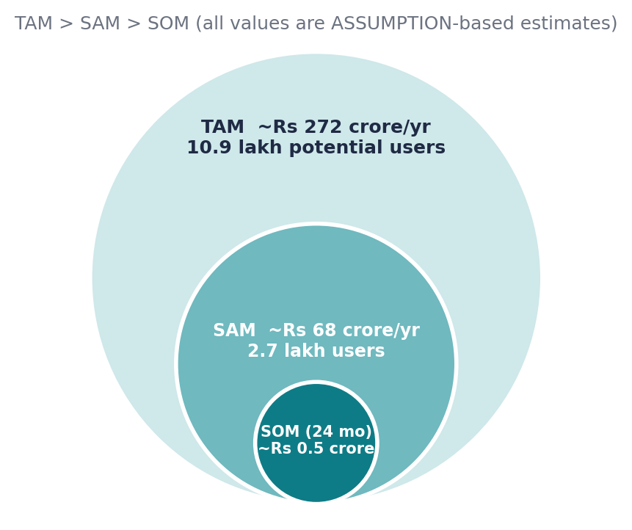

16. Competitor analysis
Competitor facts below are limited to what is publicly well known. Pricing and feedback columns say "verify" where a live check was not possible. Do not present them as verified until you have checked the vendor page and reviews.
Competitor | Type | Target customer | Product / positioning | Pricing | Strength | Weakness | Customer feedback
Slidebean | Direct | Startups raising capital | AI-assisted pitch-deck builder with investor-style templates; also offers consulting. Vendor says it has helped design over 30,000 startup decks (vendor claim) | Third-party trackers: from about US$7 a month billed yearly (verify) | Pitch-specific focus | Narrow scope; USD pricing; less India context | Check G2 and Capterra
Canva | Direct (general) | Everyone | General design platform with presentation templates | Varies by region and source (verify at canva.com/en_in/pricing) | Brand, reach, templates | Not structured around investor evidence | Check G2 and app stores
Pitch | Direct | Teams and startups | Collaborative presentation software | Verify | Collaboration, design | General-purpose; priced in USD | Check G2
Gamma | Direct | Professionals | AI-generated decks and pages | Verify | Fast AI generation | Weak on evidence and founder workflow | Check G2
Beautiful.ai | Direct | Business users | Smart-layout presentation tool | Verify | Automatic layout | Not founder-specific | Check G2
Notion | Indirect | Individuals and teams | Flexible workspace used for portfolios and notes | Verify | Flexibility | Requires setup; no deck export logic | Check G2
PowerPoint / Google Slides | Indirect / alternative | Everyone | Default presentation tools | Verify (often free or bundled) | Ubiquity, free | Blank-page problem | n/a
Portfolio sites (Wix, Carrd, GitHub Pages) | Indirect | Creators | DIY portfolio websites | Verify | Control | No guidance or deck | n/a
Design freelancers and agencies | Alternative | Funded founders | Custom decks | Quote-based | High polish | Costly and slow | n/a

17. Competitive matrix
Ratings are the author's judgement (Strong / Partial / Limited), chosen to include areas where FounderFolio is weaker. FounderFolio is pre-product, so its cells are PLANNED.
Factor | FounderFolio (planned) | Slidebean | Canva | Pitch | Gamma
Design quality and brand | Limited (new) | Strong | Strong | Strong | Strong
Template variety | Limited (2 at MVP) | Strong | Strong | Strong | Partial
Investor-specific structure | Strong (planned) | Strong | Partial | Partial | Partial
AI drafting | Partial (planned) | Strong | Strong | Partial | Strong
Evidence and assumption labelling | Strong (planned, unique) | Limited | Limited | Limited | Limited
Portfolio plus deck in one place | Strong (planned) | Limited | Partial | Limited | Partial
India context and INR pricing | Strong (planned) | Verify | Partial | Verify | Verify
Collaboration | Limited | Partial | Strong | Strong | Partial
Trust, funding and resources | Limited | Strong | Strong | Strong | Strong

18. Positioning map
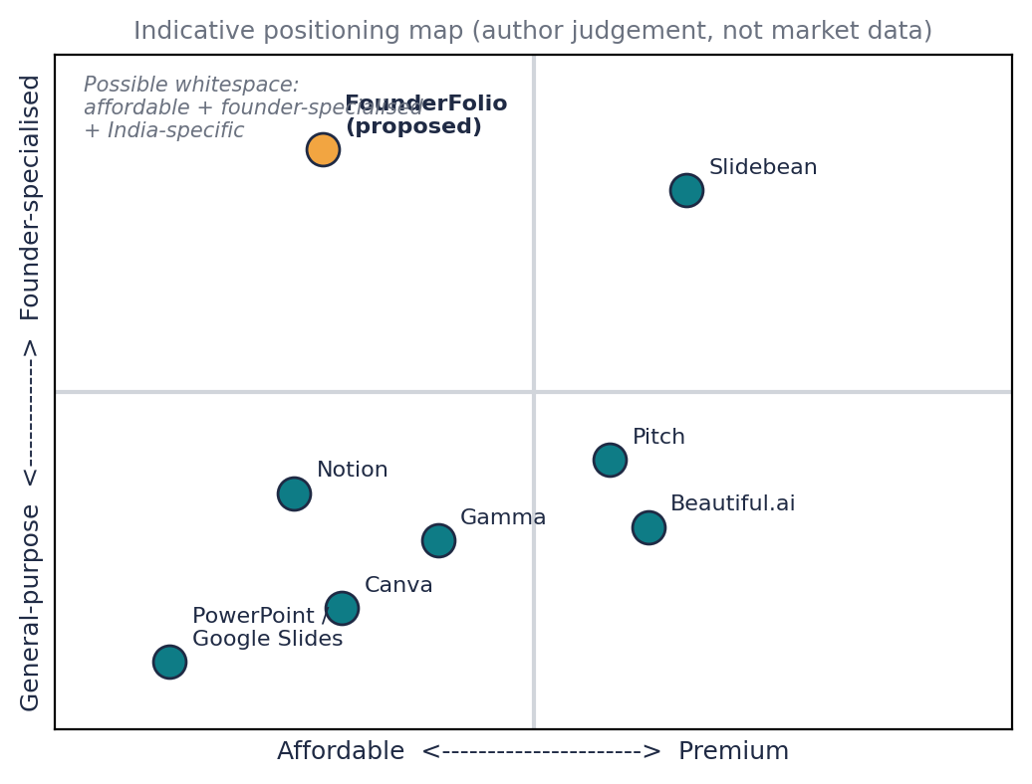
Possible whitespace: an affordable, founder-specialised, India-aware tool that enforces evidence discipline. The map is indicative; confirm with customer interviews and live pricing.

19. SWOT analysis
Internal | External
Strengths  - Clear niche and evidence-labelling angle  - Low-cost build using AI and no-code  - Founder understands student founder pain [if true]  Weaknesses  - No customers, brand or traction  - Solo founder, limited design and engineering depth  - Dependence on AI APIs and templates | Opportunities  - Growing startup ecosystem (verified trend)  - Colleges and incubators as distribution partners  - Competitors priced in USD and general-purpose  Threats  - Canva, Gamma and others adding similar features  - Students unwilling to pay  - AI cost or policy changes, data-privacy obligations

20. PESTLE analysis (relevant factors only)
Factor | Relevance to FounderFolio
Political | Government support for startups through Startup India programmes may raise demand and credibility.
Economic | Student price sensitivity; INR billing and UPI important; AI API costs in USD create margin risk.
Social | Rising interest in entrepreneurship among students; trust in AI-written content is mixed.
Technological | Generative AI, low-cost cloud, UPI payments; rapid feature copying by large platforms.
Legal | Data protection for user data, copyright for templates/fonts/images, honest-advertising rules; check current requirements.
Environmental | Minor; digital product reduces printing. Not a differentiator.

Part D. Business Model and Finance (Brief sections 21 to 28)

21. Business Model Canvas
Block | FounderFolio (PROPOSED)
Customer segments | Student founders; first-time founders; freelancers; institutions (colleges, E-Cells, incubators)
Value propositions | Evidence-labelled, investor-ready deck and portfolio, fast and affordable
Channels | Website and SEO, LinkedIn and Instagram content, college and E-Cell partnerships, YouTube tutorials, referrals
Customer relationships | Self-serve with templates and chat help; community; premium review sessions
Revenue streams | Subscriptions (Basic, Standard, Premium); institutional licences; later: optional paid expert review
Key resources | Template library, AI prompts and evidence logic, web app, founder time, early-user community
Key activities | Product development, customer discovery, content marketing, partnerships, quality assurance of AI output
Key partnerships | Colleges, E-Cells, incubators, payment gateway, cloud and AI API providers [none signed]
Cost structure | Cloud and AI API costs, tools, part-time help, marketing, payment fees, legal and compliance

22. Revenue model
Model | Fit | Decision
One-time sale | Weak: usage is episodic, but one-time pass could suit competitions | Maybe as a project pass
Subscription | Good for portfolio maintenance | SELECTED
Freemium | Good for student acquisition | SELECTED (free tier)
Commission | No transactions | No
Marketplace fee | Possible with expert reviewers later | Later
Licensing | Institutions pay per cohort | SELECTED (B2B2C)
Advertising | Hurts trust and student data | No
Service fee | Paid expert review | Later

23. Pricing strategy
Approach: competitor reference pricing and value-based pricing for Standard and Premium; penetration through a free tier. All prices below are ASSUMPTIONS to test with willingness-to-pay questions.
Package | Price (ASSUMPTION) | Target customer | Features | Expected margin | Strategic purpose
BASIC (free) | Rs 0 | Student exploring | Guided builder, 1 template, watermarked export | Negative (cost to serve) | Acquisition and learning
STANDARD | Rs 299 a month (about Rs 2,499 a year) | Active student founder | All templates, clean PPTX/PDF export, evidence tags, public page | High | Core revenue
PREMIUM | Rs 799 a month | Freelancer, MBA founder, team | Financial helper, multiple projects, priority review prompts | High | Higher ARPU
INSTITUTION | Rs 50,000 a year per college (ASSUMPTION) | E-Cell or incubator | Cohort seats and dashboard | Medium to high | Scale channel

24. Unit economics (PROJECTION, all inputs are ASSUMPTIONS)
Metric | Value | Basis
ARPU (paying, monthly) | Rs 420 | Blend of about 75% Standard (Rs 299) and 25% Premium (Rs 799) is roughly Rs 424, rounded to Rs 420
Variable cost per paying user | Rs 90 a month | AI API, hosting, payment fees
Contribution margin | Rs 330 a month (about 79% gross margin) | ARPU minus variable cost
CAC | about Rs 833 | Base-case 12-month marketing spend / paying customers added
Monthly churn | 6% | Assumed; average lifetime about 16.7 months
LTV | about Rs 5,500 | Contribution x lifetime
LTV:CAC | about 6.6x | Treat as optimistic until real churn and CAC are measured
CAC payback | about 2.5 months | CAC / contribution

CAC = Sales & Marketing Acquisition Cost / Customers Acquired. The model's 6.6x ratio is high because early assumptions are generous; pre-launch numbers must not be quoted as achievements.

25. 12-month financial projection (PROJECTION)
Base case, rupees. Customers are cumulative paying customers. Month 1 and 2 are build and validation. Two part-time helpers at Rs 10,000 each from month 4. No founder salary [ASSUMPTION].
M | Cust. | Revenue | Marketing | Product cost | Salaries | Tech | Ops+Other | Total exp. | Profit/Loss | Cumulative
1 | 0 | 0 | 15,000 | 0 | 0 | 8,000 | 8,000 | 31,000 | -31,000 | -31,000
2 | 0 | 0 | 15,000 | 0 | 0 | 8,000 | 8,000 | 31,000 | -31,000 | -62,000
3 | 10 | 4,200 | 20,000 | 900 | 0 | 8,000 | 8,000 | 36,900 | -32,700 | -94,700
4 | 25 | 10,500 | 22,500 | 2,250 | 20,000 | 8,000 | 8,000 | 60,750 | -50,250 | -1,44,950
5 | 50 | 21,000 | 27,500 | 4,500 | 20,000 | 8,000 | 8,000 | 68,000 | -47,000 | -1,91,950
6 | 90 | 37,800 | 35,000 | 8,100 | 20,000 | 8,000 | 8,000 | 79,100 | -41,300 | -2,33,250
7 | 140 | 58,800 | 40,000 | 12,600 | 20,000 | 8,000 | 8,000 | 88,600 | -29,800 | -2,63,050
8 | 200 | 84,000 | 45,000 | 18,000 | 20,000 | 8,000 | 8,000 | 99,000 | -15,000 | -2,78,050
9 | 270 | 1,13,400 | 50,000 | 24,300 | 20,000 | 8,000 | 8,000 | 1,10,300 | 3,100 | -2,74,950
10 | 350 | 1,47,000 | 55,000 | 31,500 | 20,000 | 8,000 | 8,000 | 1,22,500 | 24,500 | -2,50,450
11 | 440 | 1,84,800 | 60,000 | 39,600 | 20,000 | 8,000 | 8,000 | 1,35,600 | 49,200 | -2,01,250
12 | 540 | 2,26,800 | 65,000 | 48,600 | 20,000 | 8,000 | 8,000 | 1,49,600 | 77,200 | -1,24,050

Scenario summary
Scenario | Customers at M12 | Revenue M12 | 12-month revenue | 12-month expenses | Cumulative cash at M12 | Peak cash need
Conservative (50% of base customers) | 270 | Rs 1,13,400 | Rs 4,43,940 | Rs 7,82,130 | Rs -3,38,190 | Rs 3,51,290
Base | 540 | Rs 2,26,800 | Rs 8,88,300 | Rs 10,12,350 | Rs -1,24,050 | Rs 2,78,050
Optimistic (160% of base) | 864 | Rs 3,62,880 | Rs 14,21,280 | Rs 12,88,560 | Rs 1,32,720 | Rs 2,42,680

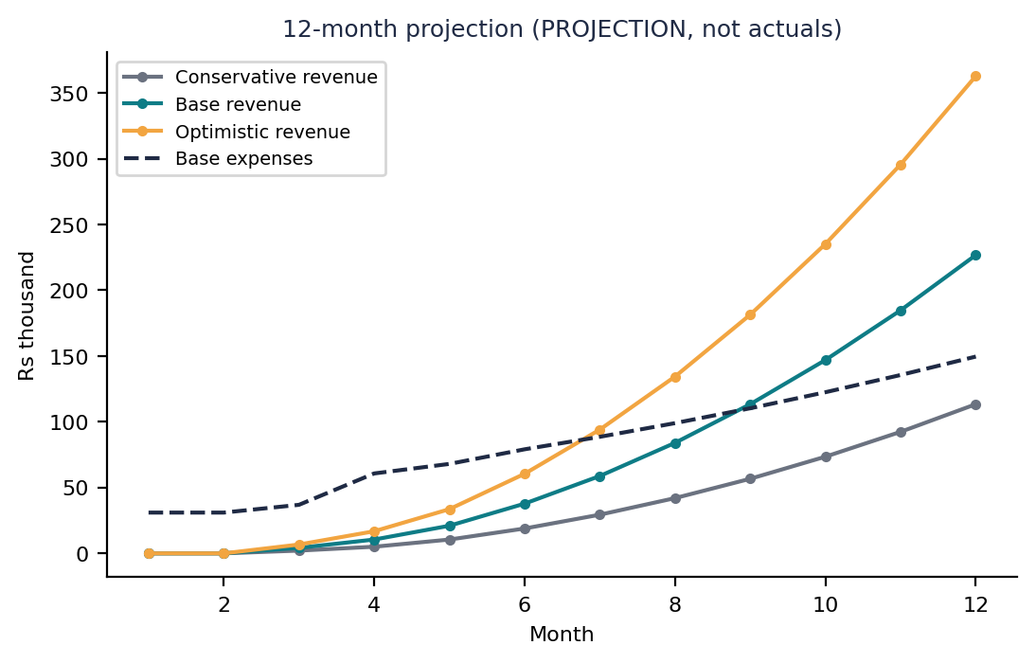

26. Break-even analysis
Item | Calculation | Result
Contribution margin | Selling price Rs 420 minus variable cost Rs 90 | Rs 330 per customer a month
Fixed costs (steady state) | Marketing base 15,000 + salaries 20,000 + tech 8,000 + ops 5,000 + other 3,000 | Rs 51,000 a month
Break-even customers | Fixed costs / contribution margin = 51,000 / 330 | about 155 paying customers (monthly)
Break-even revenue | 155 x Rs 420 | about Rs 65,000 a month
Timeline in the model | Growth spend (Rs 500 per new customer on top of the fixed Rs 15,000) pushes the monthly profit point to about 270 customers | Month 9 in the base case (PROJECTION)

The 155-customer figure counts only fixed marketing. The 12-month model also pays for growth, so it turns monthly-profitable later, in month 9 at about 270 customers. Cumulative break-even (recovering all earlier losses) is not reached within 12 months in the base case.

27. Funding requirement
Question: how much money does the startup need to reach its next meaningful milestone? Milestone: 270 paying customers and a monthly operating profit (base case month 9). Peak cumulative cash need in the base case is about Rs 2.8 lakh; the conservative case needs about Rs 3.5 lakh. With a contingency, the proposed requirement is Rs 4.0 lakh. This is a small, bootstrap or grant-scale figure, not a venture round.

28. Use of funds (PROPOSED)
Category | Amount (Rs) | % of funding | Purpose | Expected milestone
Marketing | 1,20,000 | 30% | Content, campus campaigns, test ads | Reach first 500 users
Product development | 80,000 | 20% | Build and test MVP | MVP live in 8 weeks
Hiring | 60,000 | 15% | Two part-time helpers | Support and content
Technology | 40,000 | 10% | Hosting, AI API, tools | Stable service
Contingency | 40,000 | 10% | Cost overruns | Buffer
Operations | 20,000 | 5% | Admin | Smooth operation
Legal / compliance | 20,000 | 5% | Entity set-up, policies, trademark check | Compliant launch
Working capital | 20,000 | 5% | Payment timing | Liquidity

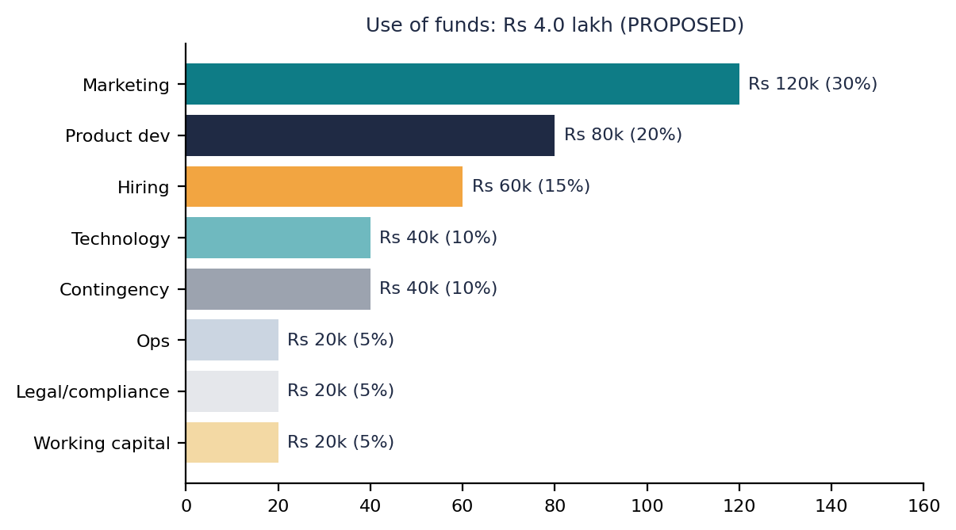

Part E. Go-to-Market and Brand (Brief sections 29 to 32)

29. Go-to-market strategy (PROPOSED STRATEGY)
Phase | Objective | Customer | Channel | Activity | KPI | Timeline
1 Validation | Confirm the problem | Student founders | Interviews, E-Cells | 15 interviews, 100 survey responses | Interviews done; problem confirmed | Months 0-2
2 MVP | Build and test | Early adopters | Direct outreach | Concierge MVP with 20-30 users | Completion rate; feedback | Months 2-4
3 Early adopters | First paying users | E-Cell members | Campus partners, LinkedIn | Launch Standard plan | First 10 paying; retention | Months 4-6
4 Launch | Public launch | Student and first-time founders | SEO, social, referrals | Launch page, content, referral code | Visitors to sign-up conversion | Months 6-9
5 Growth | Scale and institutions | Colleges and incubators | Partnerships | Pilot with 3 institutions | Paying customers; churn | Months 9-24

30. Marketing strategy
Channel | Objective | Audience | Content or offer | KPI | Budget (ASSUMPTION)
SEO | Capture how-to searches | Founders | Pitch-deck templates and guides | Organic visits | Rs 3,000 a month
Content | Build trust | Students | Case studies, teardown posts | Subscribers | Rs 2,000 a month
Social media | Awareness | Students | Short videos and carousels | Followers, clicks | Rs 3,000 a month
Paid ads | Test demand | Students | Free-plan offer | CAC | Rs 5,000 a month
Influencers | Reach | Student creators | Referral deals | Sign-ups | Rs 2,000 a month
Communities | Credibility | E-Cells | Workshops | Leads | Rs 0 to 1,000
Partnerships | Distribution | Colleges, incubators | Pilot licences | Pilots signed | Rs 0
Email | Retention | Users | Tips, reminders | Open rate | Rs 0
Referral | Low-cost growth | Users | Credits for invites | Referral share | Rs 0
Direct sales | Institutions | Administrators | Demo and pilot | Meetings | Time only

31. Sales funnel (TARGET KPIs, not results)
Stage | Definition | Target conversion KPI (ASSUMPTION)
Awareness | Sees content | n/a
Visitor | Lands on site | 2% of reach
Lead | Signs up for free plan | 8% of visitors
Qualified lead | Completes a draft deck | 40% of leads
Customer | Upgrades to paid | 10% of qualified leads
Repeat customer | Stays or returns | 60% after 3 months
Referral | Invites at least one person | 15% of customers

32. Brand strategy
Element | Definition
Name | FounderFolio
Tagline | Your story, investor-ready, and honest about the evidence.
Brand purpose | Help new founders be judged on substance.
Personality | Clear, supportive, rigorous, practical
Voice | Simple, direct, encouraging; no hype
Core message | Credible beats flashy.
Brand promise | You will always know which parts of your pitch are proven and which are assumptions.

30-SECOND ELEVATOR PITCH: Most first-time founders lose chances because their pitch looks weak or their claims are hard to trust. FounderFolio guides them through building a clean portfolio and a 12-slide deck and labels every claim as verified, assumed or projected. It is free to start, affordable after, and built for India. We are pre-launch and currently interviewing student founders to confirm the problem before building the MVP.

Part F. Portfolio, Roadmap and Risk (Brief sections 33 to 38)

33. Digital entrepreneur portfolio structure
Section | Contents
1 Founder profile | Bio, photo, links, strengths
2 Entrepreneurial skills | Skills matrix with evidence
3 Startup concept | Name, tagline, one-line pitch
4 Problem and customer | Problem statement, personas, interview summaries
5 Market research | Verified statistics with sources, TAM-SAM-SOM
6 Competitor analysis | Matrix and positioning
7 Product / MVP | Features, mockups, test plan
8 Business model | Canvas, pricing, revenue model
9 GTM strategy | Phases and channels
10 Financial model | Assumptions, scenarios, break-even
11 Roadmap | Milestones
12 Pitch deck | Slides and script
13 Key learnings | What changed after research
14 Contact / links | LinkedIn, GitHub, email

34. Portfolio website structure
Page | Suggested content
HOME | Name, tagline, one-line pitch, links to deck and GitHub
ABOUT THE FOUNDER | Short bio, skills, why this problem
STARTUP PROJECT | Concept, status label (pre-launch), vision
MARKET RESEARCH | Sourced statistics, TAM-SAM-SOM, competitor summary
BUSINESS MODEL | Canvas, pricing, revenue streams
MVP | Feature list, mockups, test results when available
FINANCIAL MODEL | Assumptions and scenarios clearly labelled PROJECTION
PITCH DECK | Embedded deck and 3-minute video if recorded
KEY LEARNINGS | What you learned, what changed your mind
CONTACT | Email, LinkedIn, GitHub

35. Startup roadmap
Period | Objective | Activities | KPI | Milestone
0-3 months | Validation and MVP | Interviews, survey, concierge MVP | 15 interviews; 100 survey responses | Problem validated or pivot decided
3-6 months | Early customers | Launch Standard plan to E-Cell users | First 10 to 25 paying | First paying customer
6-12 months | Improvement and growth | Content, referrals, partnerships | Retention and CAC measured | Base-case customer target reviewed
12-24 months | Scale | Institutional pilots, new templates | Pilot signed; revenue growth | Decision: scale, stay lean or fundraise

36. Milestones
Milestone | Status
Concept and business analysis (this report) | ACHIEVED (document only)
Customer interviews completed | PLANNED
MVP developed | PLANNED
First test users | PLANNED
First paying customer | PLANNED
Initial revenue | PLANNED
Retention target met | PLANNED
Institutional partnership | PLANNED
Product improvement cycle | PLANNED
Expansion | PLANNED

Only the written analysis is complete. Do not show planned milestones as achieved traction.

37. KPI dashboard (TARGET / MODELLED KPIs, not actual results)
KPI | Month 6 target (base) | Month 12 target (base)
Paying customers | 90 | 540
Leads (free sign-ups) | About 2,250 cumulative (derived from 4% lead-to-customer rate) | About 13,500 cumulative (same assumption)
Conversion (lead to paid) | Track from month 3 | Track
Monthly revenue | Rs 37,800 | Rs 2,26,800
CAC | about Rs 875 | about Rs 833
ARPU | Rs 420 | Rs 420
Gross margin | about 79% | about 79%
Retention (monthly churn) | 6% assumed | 6% assumed
LTV | about Rs 5,500 | about Rs 5,500
Burn rate (net monthly loss) | Rs 41,300 | Profit of Rs 77,200 (month 12)
Runway | Depends on funding; at Rs 4.0 lakh, covers modelled losses | Positive monthly cash flow from month 9

38. Risk register
Risk | Probability | Impact | Level | Mitigation | Owner
Market: students will not pay | High | High | High | Test pricing early; institution licences | Founder
Product: output quality is weak | Medium | High | High | Human QA; templates; user testing | Founder
Customer: low engagement | Medium | Medium | Medium | Onboarding wizard; reminders | Founder
Competitive: big players copy | High | Medium | High | Focus on evidence angle and India niche | Founder
Financial: cash shortage | Medium | High | High | Lean spending; milestone gating | Founder
Technology: AI cost or API change | Medium | Medium | Medium | Cost caps; multiple providers | Founder
Operational: solo founder overload | High | Medium | High | Automate; part-time help | Founder
Legal: data privacy and copyright | Low to medium | High | Medium | Privacy policy; licensed assets; legal check | Founder
Team: no co-founder skills gap | Medium | Medium | Medium | Mentors; advisors | Founder
Scaling: support load grows | Low now | Medium | Low | Self-serve help; community | Founder

Part G. Pitch Deck, Pitch Scripts and Evaluation (Brief sections 39 to 46)

39. Pitch deck structure (12 slides)
A ready-made PowerPoint deck accompanies this report (FounderFolio_Pitch_Deck.pptx). Slide plan:
Slide | Title | Key content
1 | Cover | Name, logo concept (a folder with a check mark), tagline, one-line pitch
2 | Problem | Customer, pain points, evidence status
3 | Solution | What it does, how it works, benefit
4 | Market opportunity | TAM, SAM, SOM with assumptions
5 | Product / MVP | Core features and user journey
6 | Business model | Who pays, what for, pricing
7 | Competition | Matrix, positioning, differentiation
8 | Go-to-market | Channels, funnel, launch
9 | Validation | Pre-launch: research plan; no invented traction
10 | Financials | Projection, CAC, LTV, break-even (labelled)
11 | Team and roadmap | Founder and milestones
12 | Next step / ask | Funding or next step, use of funds, contact

40. Pitch deck design guide
Do:
- Minimal text, one major message per slide, clear headline stating the conclusion
- Large numbers for key metrics; professional, readable charts
- Strong visual hierarchy and consistent typography (one heading font and one body font)
- Clean icons and product mockups; data sources in the footer
- Label assumptions and projections on the slide
Do not:
- Paragraph-heavy slides
- Fake statistics, fake customers or fake partnerships
- Unrealistic hockey-stick projections
- Unreadable charts, too many colours, excessive animations

41. Three-minute founder pitch (script)
- Hook: Imagine spending three weeks on your startup idea, then losing a competition because your slides looked like a school project. That happens to first-time founders all the time.
- Problem: Students and first-time founders struggle to present their ideas clearly and credibly. They have no structure, little design skill and scattered evidence. [Add one real interview quote after interviews.]
- Customer: Our first customers are student founders in E-Cells and incubator applicants in India, plus solo freelancers.
- Solution: FounderFolio guides you through a short wizard, helps with the wording, and produces a clean 12-slide deck and a shareable portfolio. Every claim is tagged as verified, assumption or projection.
- Market: Over 2.23 lakh startups are DPIIT-recognised and over 4 crore students are enrolled in higher education. Even a small slice of those who actively pitch is a meaningful early market. Our own estimate is about Rs 68 crore of serviceable market; that figure rests on assumptions we are testing.
- Business model: Free to start. Standard at about Rs 299 a month. Colleges can license for cohorts.
- Competition: Canva is great for design. Slidebean serves startups but is general and priced in dollars. Our difference is evidence discipline and India focus.
- Go-to-market: We start with student communities and E-Cells, then content and referrals, then institutions.
- Validation: We are pre-launch. We are running 15 interviews and a 100-person survey, and we will test a concierge MVP with 20 to 30 founders.
- Financial opportunity: Our base model shows monthly profit around month nine at about 270 paying customers. That is a projection built on assumptions.
- Team: I am a solo founder with [your relevant evidence] and I am seeking mentors for design and engineering.
- Ask: I am looking for 15 founders to test the MVP and introductions to two incubators. Funding is not the next step; validation is.

42. Sixty-second elevator pitch
Problem: first-time founders struggle to make credible, well-structured pitches. Solution: FounderFolio is a guided builder that turns your inputs into a 12-slide deck and a portfolio, and labels each claim as verified, assumed or projected. Customer: student and first-time founders in India. Differentiation: evidence discipline, India focus and a free tier. Business model: freemium subscription plus institutional licences. Next step: we are pre-launch; we are interviewing founders and recruiting pilot users.

43. Investor and panel questions with evidence-based answers
# | Question | Suggested answer (do not invent traction)
1 | Is this a real problem? | I believe so, but I am validating it through 15 interviews and a survey. I will share findings; I will not claim demand before I have it.
2 | Why will students pay? | Unproven. I plan to test willingness to pay with a free tier first and a deadline-driven paid plan; institutions may pay for cohorts.
3 | How big is the market? | TAM about Rs 272 crore, SAM about Rs 68 crore, SOM about Rs 0.5 crore. The startup count and enrolment figures are sourced; the participation percentages are my assumptions.
4 | Why not just use Canva? | Canva is excellent for design. It is general-purpose and does not enforce investor structure or evidence labelling. I need to test whether founders value that.
5 | Who are your direct competitors? | Slidebean, Pitch, Gamma, Beautiful.ai and Canva. Each is stronger in brand and design than I am today.
6 | What is your moat? | Early on, none strong. Potential: evidence-labelled data format, institutional relationships and India-specific templates.
7 | How will you acquire customers? | Campus communities, content, referrals, then institutions; modelled CAC about Rs 830 is an assumption.
8 | What is your CAC and is it realistic? | Modelled, not measured. I will run a Rs 5,000 test campaign to get a real number.
9 | What is LTV and churn? | About Rs 5,500 on a 6% monthly churn assumption. Real churn is unknown and could be higher.
10 | Why this pricing? | Anchored to student affordability and competitor price points that I still need to verify.
11 | What are your margins? | About 79% gross margin on assumed AI and hosting costs; AI cost changes are a risk.
12 | What is the MVP and what are you testing? | Concierge or no-code deck builder to test completion, repeat use and willingness to pay.
13 | What if AI writes poor or false content? | Evidence tags, fact-check prompts and human QA; AI is a drafting aid, not a source.
14 | Can big platforms copy you? | Yes. My response is speed, niche focus and trust, and I accept this as a real risk.
15 | Why are you the right founder? | [Answer with true evidence only.] I am a solo founder and I am looking for mentors to fill design and engineering gaps.
16 | What do your financials show? | A modelled base case reaches monthly profit in month 9 with about 270 customers. It is a projection, not a result.
17 | How much funding do you need and why? | About Rs 4.0 lakh to reach the first meaningful milestone; I am not raising a venture round now.
18 | What are the biggest risks? | Willingness to pay, competition, solo founder load, and AI cost.
19 | What traction do you have? | None yet. I have a validated plan, not customers, and I will report real numbers when I have them.
20 | What will you do in the next 30 days? | Complete interviews, run the survey, publish a landing page, recruit pilot users.

44. Pitch deck quality score (current honest self-score)
Category | Max | Score | Evidence | Weakness | Improvement
Problem clarity | 10 | 7 | Clear statement and personas | No real interview evidence | Add interview quotes
Solution strength | 10 | 7 | Defined features and differentiator | Unproven demand | Test MVP
Customer evidence | 10 | 1 | Research plan only | No data | Run interviews and survey
Market opportunity | 10 | 6 | Sourced start-up and enrolment counts | Key percentages are assumptions | Validate with survey
Business model | 10 | 7 | Clear revenue streams | Prices untested | Willingness-to-pay test
Competitive positioning | 10 | 6 | Matrix and map | Pricing not verified | Verify live pricing
GTM strategy | 10 | 6 | Phased plan | Untested channels | Run small experiments
Financial logic | 10 | 6 | Scenarios and break-even | All inputs assumed | Replace with measured data
Team / readiness | 10 | 3 | Solo founder | Skills gaps | Mentors, co-founder
Presentation quality | 10 | 7 | Clean structure | Needs real mockups | Add product screens

Total: 56 / 100. This is a fair score for a pre-validation concept. The largest gains come from customer evidence, not slide design.

45. Entrepreneur readiness score (developmental self-assessment)
This is a developmental self-assessment. It is not a psychological or personality diagnosis. Score each item 0 to 10 with evidence, then total out of 100.
Dimension | Score (0-10) | Evidence to cite
Customer understanding | [ ] | Interviews done
Market understanding | [ ] | Sources used
Financial literacy | [ ] | Model built and explained
Sales ability | [ ] | Real sales conversations
Communication | [ ] | Pitches delivered
Leadership | [ ] | Teams led
Execution | [ ] | Things shipped
Adaptability | [ ] | Pivots or changes made
Digital skills | [ ] | Tools used
AI skills | [ ] | Verified AI-assisted work

46. Final business recommendation
Item | Assessment
Current stage | Concept and business analysis; pre-validation
Strongest evidence | Rising startup activity and large student base (sourced); clear gap in evidence-first tooling (hypothesis)
Biggest assumption | Students and early founders will pay for a tool that structures and labels their pitch
Biggest risk | Willingness to pay and competition from general tools
Next experiment | 15 interviews and a 100-person survey; a landing page with a waitlist; a pricing test
Next milestone | First 20 pilot users completing a deck, then the first paying customer
Recommended next step | MORE VALIDATION, then MVP. Not fundraising.

30-day plan
- Weeks 1-2: finalise questionnaire; complete 8 interviews; publish the survey
- Weeks 3-4: complete 15 interviews; analyse; update personas and TAM assumptions; publish a landing page
90-day plan
- Month 2: build a concierge MVP and run it with 20 founders
- Month 3: test two price points; measure completion, repeat use and willingness to pay; decide to continue, pivot or stop

Part H. Career and Showcase Assets (Brief sections 47 to 53)

47. Resume content
One-line: Designed a complete entrepreneurial portfolio and 12-slide investor-style pitch deck for a proposed Indian startup, covering market sizing, competition, business model, pricing and financial modelling.
2 to 3 lines: Transformed a startup concept into a structured entrepreneur portfolio: customer problem, personas, TAM-SAM-SOM, competitor analysis, Business Model Canvas, MVP plan, pricing, go-to-market strategy, 12-month scenario financial model, break-even and risk register. Packaged the work as a 12-slide pitch deck, founder pitch scripts and a GitHub portfolio. All projections clearly labelled as assumptions.
ATS-friendly: Entrepreneurship Project | Startup Strategy, Pitch Deck, Market Research, Customer Discovery, Business Model Canvas, TAM-SAM-SOM, Competitive Analysis, Go-To-Market Strategy, Financial Modelling, Unit Economics, Startup Finance, Digital Marketing, AI Tools. Built a 12-month three-scenario financial model (CAC, LTV, break-even) and a 12-slide investor-style deck; documented assumptions and risks.

48. GitHub portfolio structure
Suggested repository name: founderfolio-startup-portfolio
Folder | Upload
/founder-profile | Profile summary, skills matrix (no private data)
/customer-research | Questionnaire, anonymised summaries, survey instrument (no confidential customer information)
/market-research | Sources table, TAM-SAM-SOM workbook
/competitor-analysis | Matrix, positioning map, source notes
/business-model | Canvas, revenue model, pricing
/mvp | Feature list, mockups, test plan
/gtm-strategy | Phases, marketing plan, funnel
/financial-model | Excel model and assumptions
/pitch-deck | PPTX and PDF, speaker script
/dashboard | KPI dashboard (target and modelled)
/screenshots | Images for README and LinkedIn
/docs | This report and supporting documents
README.md | Project overview with links

49. README.md (ready to paste)
# FounderFolio: Digital Entrepreneur Portfolio & Pitch Deck Builder
**Status:** Proposed startup concept. Pre-launch. No customers, revenue or investors.
## Overview
A structured entrepreneurial portfolio and 12-slide pitch deck for FounderFolio, an evidence-first portfolio and deck builder for Indian student and first-time founders.
## Business problem and target customer
Founders struggle to present ideas credibly. Primary customers are student and first-time founders in India.
## Customer research
Interview guide and survey plan are in /customer-research. Results will be added only after real interviews.
## Market opportunity (TAM-SAM-SOM)
TAM about Rs 272 crore, SAM about Rs 68 crore, SOM about Rs 0.5 crore a year. These rest on stated assumptions (see /market-research).
## Competitor analysis
Slidebean, Canva, Pitch, Gamma, Beautiful.ai. See /competitor-analysis.
## Value proposition and MVP
Evidence-labelled, investor-ready deck and portfolio. MVP: guided wizard, AI wording, 2 templates, PPTX export.
## Business model, pricing and GTM
Freemium subscription plus institutional licences. GTM phases: validation, MVP, early adopters, launch, growth.
## Financial model
12-month three-scenario model; base case reaches monthly profit in month 9 (projection). Unit economics are assumptions.
## Roadmap, risks and pitch deck
See /gtm-strategy, /docs and /pitch-deck.
## Key learnings
Evidence matters more than design; separate assumptions from facts.
## Tools used
AI assistants, spreadsheets, presentation software. AI output was verified by the author.
## Limitations
No customer evidence yet; competitor prices need live verification.
## Future scope
Interviews, MVP, landing page, pricing test, first paying users.
## Conclusion
The next step is validation, not fundraising.

50. LinkedIn showcase
Professional: I turned a startup concept into a full entrepreneurial portfolio and 12-slide investor-style pitch deck: customer problem, market sizing, competitor analysis, business model, pricing, go-to-market and a three-scenario 12-month financial model. Everything is labelled as verified, assumed or projected. GitHub Project: [LINK]
Recruiter-oriented: Project: Entrepreneurship Portfolio and Pitch Deck. Skills: market research, TAM-SAM-SOM, competitive analysis, Business Model Canvas, unit economics, financial modelling, GTM strategy. GitHub Project: [LINK]
Student-friendly: Built my first full startup case study: from problem to pitch deck. Biggest lesson: a good deck cannot fix a weak idea, and you must show what is proven and what is assumed. Feedback welcome. GitHub Project: [LINK]
Hashtags: #Entrepreneurship #StartupIndia #PitchDeck #MBA #MarketResearch #BusinessModel #FinancialModelling #GoToMarket #StartupStrategy
Recommended screenshots: startup overview, customer problem, TAM-SAM-SOM, competitor matrix, Business Model Canvas, financial model, roadmap, deck cover.

51. Interview preparation (60 to 90 seconds)
"My project is a Digital Entrepreneur Portfolio and Pitch Deck Builder. I took one startup concept, an evidence-first deck and portfolio builder for Indian student founders, and turned it into a structured portfolio and a 12-slide investor-style deck. I started with the customer problem and researched the market using sourced figures for startup counts and student enrolment, then sized the opportunity with TAM, SAM and SOM using clearly stated assumptions. I compared competitors honestly, including where they are stronger, designed the business model, pricing and unit economics, and built a 12-month financial model with conservative, base and optimistic scenarios. The most important thing I learned is that evidence matters more than design: I labelled every number as verified, assumed or projected, and my recommendation is more customer validation before any fundraising."

52. Future enhancements
REAL BUSINESS VALIDATION | PRESENTATION IMPROVEMENTS
- Conduct more customer interviews  - Launch a landing page and waitlist  - Build a live MVP  - Acquire first test users  - Validate pricing  - Generate first revenue  - Measure CAC and retention  - Improve unit economics  - Build an investor data room  - Explore funding only when appropriate | - Add product mockups and screenshots  - Record a 3-minute pitch video  - Polish the portfolio website  - Participate in startup competitions  - Improve chart design and typography

53. Image-generation prompt (dashboard visual)
"Create a single wide landscape infographic titled 'Digital Entrepreneur Portfolio & Startup Pitch Deck Dashboard' for the proposed startup FounderFolio with the tagline 'Your story, investor-ready, and honest about the evidence.' Premium venture-capital / consulting style: navy and teal palette with one amber accent, white background, clean sans-serif typography, thin card borders, modern icons. Arrange modular panels in a tidy grid, all fully visible with nothing cropped: Founder Profile (placeholder), Problem Statement, Proposed Solution, Target Customer, TAM / SAM / SOM concentric circles, Competitor Matrix table, Unique Value Proposition, MVP feature list, Business Model Canvas summary, Pricing (Basic, Standard, Premium), Revenue Model, Customer Acquisition Funnel, Go-To-Market phases, 12-Month Financial Projection line chart, KPI tiles for CAC, LTV and Break-Even, Startup Roadmap timeline, Key Risks list, and a Pitch Deck Readiness Score gauge (56/100). Label projected numbers with a small 'PROJECTION' tag. Minimal text per panel, readable at LinkedIn and GitHub README sizes."

Appendix. Sources and verification notes
Item | Status | Where to verify
Over 2.23 lakh DPIIT-recognised startups as of 31 March 2026; 55,200 recognised in FY26 | VERIFIED (Inc42 reporting a ministry statement) | https://inc42.com/buzz/centre-recognises-record-55200-startups-in-fy26/
Nearly 4.33 crore higher-education enrolment (2021-22); 78.9% UG, 12.1% PG | VERIFIED (Ministry of Education, AISHE 2021-22) | https://education.gov.in/sites/upload_files/mhrd/files/statistics-new/AISHE%20Book_2021-22_4.pdf
Slidebean paid plans from about US$7 a month billed yearly | UNVERIFIED third-party tracker (June 2026) | slidebean.com/pricing
Slidebean helped design over 30,000 startup decks | Vendor claim (Capterra listing) | slidebean.com
Canva India pricing | Sources conflict; not quoted | canva.com/en_in/pricing
Pitch, Gamma, Beautiful.ai pricing and reviews | Not verified; marked "verify" | Vendor pricing pages; G2; Capterra
75% of funding decisions rely on deck quality; $7.5B presentation software market by 2030; $500 to $2000 agency cost | From the source brief; no source given. Not used | Find original publication before using
All TAM/SAM/SOM percentages, prices, CAC, churn and customer counts | ASSUMPTION or PROJECTION | Replace with measured data

