SQL Social Media Project
Analyzing an Instagram-style Database for Meta's Marketing Team
Database used: ig_clone.sql | Tool: MySQL Workbench

Objective Questions

Question 1
Are there any tables with duplicate or missing/null values? If so, how would you handle them?

My Query
SELECT 'users_null_username' AS check_name, COUNT(*) AS issue_count
FROM users WHERE username IS NULL
UNION ALL
SELECT 'users_duplicate_username', COUNT(*)
FROM (SELECT username FROM users GROUP BY username HAVING COUNT(*) > 1) x
UNION ALL
SELECT 'photos_null_image_url', COUNT(*)
FROM photos WHERE image_url IS NULL
UNION ALL
SELECT 'comments_null_comment_text', COUNT(*)
FROM comments WHERE comment_text IS NULL
UNION ALL
SELECT 'likes_duplicate_user_photo_pair', COUNT(*)
FROM (SELECT user_id, photo_id FROM likes GROUP BY user_id, photo_id HAVING COUNT(*) > 1) y
UNION ALL-
SELECT 'tags_duplicate_tag_name', COUNT(*)
FROM (SELECT tag_name FROM tags GROUP BY tag_name HAVING COUNT(*) > 1) z;
Output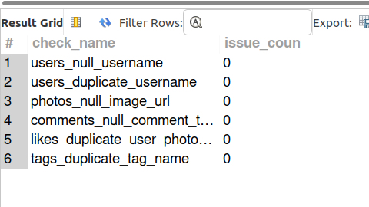
Description
This was the first thing I checked before trusting any of my later numbers -if there were duplicate rows or NULLs sitting in key columns, every calculation after this would be wrong. I checked for NULL usernames, NULL image URLs, NULL comment text, duplicate username values, duplicate (user_id, photo_id) pairs in likes (which would mean someone 'liked' the same photo twice), and duplicate hashtag names. Every single check came back 0, so this dataset is clean.
If any of these had come back positive, my plan would have been: for duplicates, keep the first occurrence (lowest id) and DELETE the rest -or use ROW_NUMBER() OVER (PARTITION BY ...) to find and remove the extras safely; for NULLs in required fields, either backfill with a sensible default or exclude those rows depending on what the analysis needs.

Question 2
What is the distribution of user activity levels (e.g., number of posts, likes, comments) across the user base?

My Query
SELECT u.id, u.username,
COUNT(DISTINCT p.id) AS total_posts,
COUNT(DISTINCT l.photo_id) AS total_likes_given,
COUNT(DISTINCT c.id) AS total_comments_made
FROM users u
LEFT JOIN photos p ON p.user_id = u.id
LEFT JOIN likes l ON l.user_id = u.id
LEFT JOIN comments c ON c.user_id = u.id
GROUP BY u.id, u.username
ORDER BY total_posts DESC;
Output
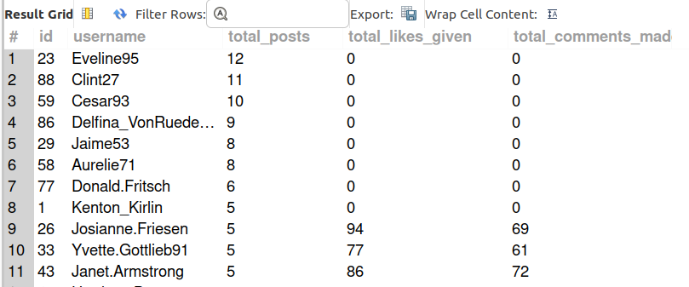

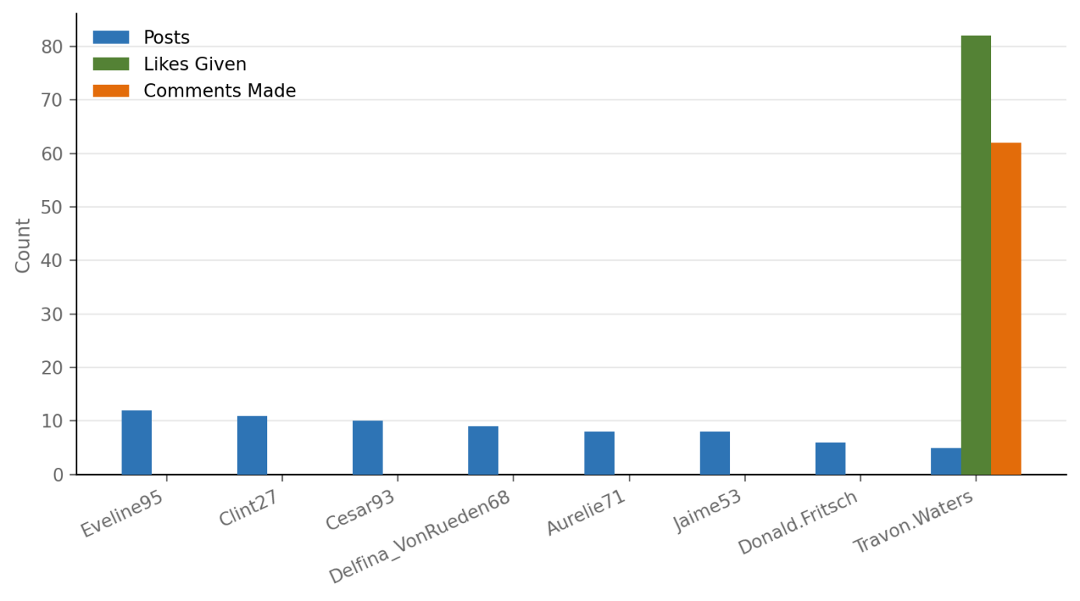
Visualization
Description
I used LEFT JOIN here so that users with zero posts, zero likes given, or zero comments still show up in the results with a 0.

Question 3
Calculate the average number of tags per post (photo_tags and photos tables).

My Query
SELECT ROUND(COUNT(pt.tag_id) / COUNT(DISTINCT p.id), 2) AS avg_tags_per_post
FROM photos p
LEFT JOIN photo_tags pt ON pt.photo_id = p.id;
Output
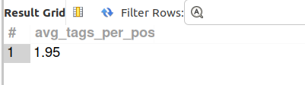
Description
I join photo and photo_tags, count the total tag rows, and divide by the number of distinct photos.

Question 4
Identify the top users with the highest engagement rates (likes, comments) on their posts and rank them.

My Query
SELECT u.id, u.username,
COUNT(DISTINCT l.user_id, l.photo_id) AS total_likes_received,
COUNT(DISTINCT c.id) AS total_comments_received,
(COUNT(DISTINCT l.user_id, l.photo_id) + COUNT(DISTINCT c.id)) AS total_engagement,
RANK() OVER (
ORDER BY (COUNT(DISTINCT l.user_id, l.photo_id) + COUNT(DISTINCT c.id)) DESC
) AS engagement_rank
FROM users u
JOIN photos p ON p.user_id = u.id
LEFT JOIN likes l ON l.photo_id = p.id
LEFT JOIN comments c ON c.photo_id = p.id
GROUP BY u.id, u.username
ORDER BY total_engagement DESC;
Output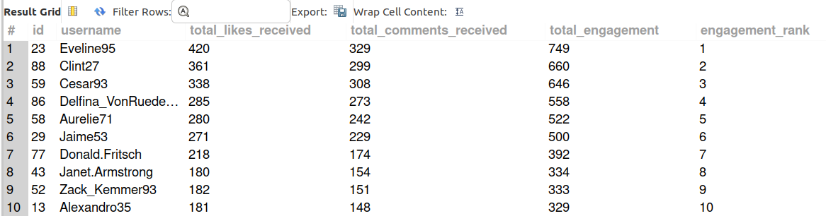

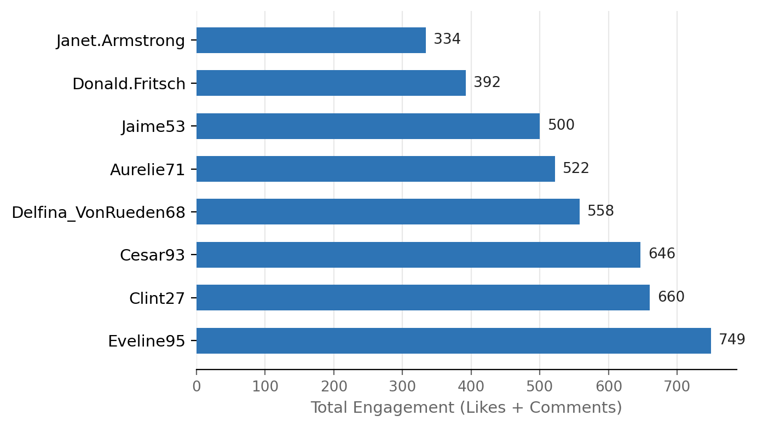
Visualization

Description
Here I am using a window function, Eveline95 comes out on top with 749 total interactions (420 likes + 329 comments) across her 12 posts.

Question 5
Which users have the highest number of followers and followings?

My Query
SELECT u.id, u.username,
(SELECT COUNT(*) FROM follows f WHERE f.followee_id = u.id) AS followers_count,
(SELECT COUNT(*) FROM follows f WHERE f.follower_id = u.id) AS following_count
FROM users u
ORDER BY followers_count DESC, following_count DESC;
Output
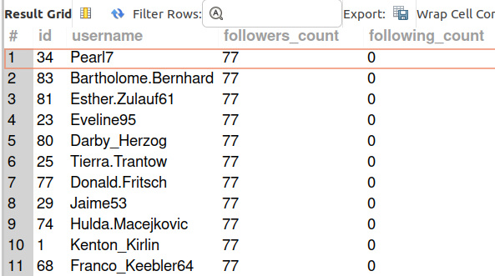

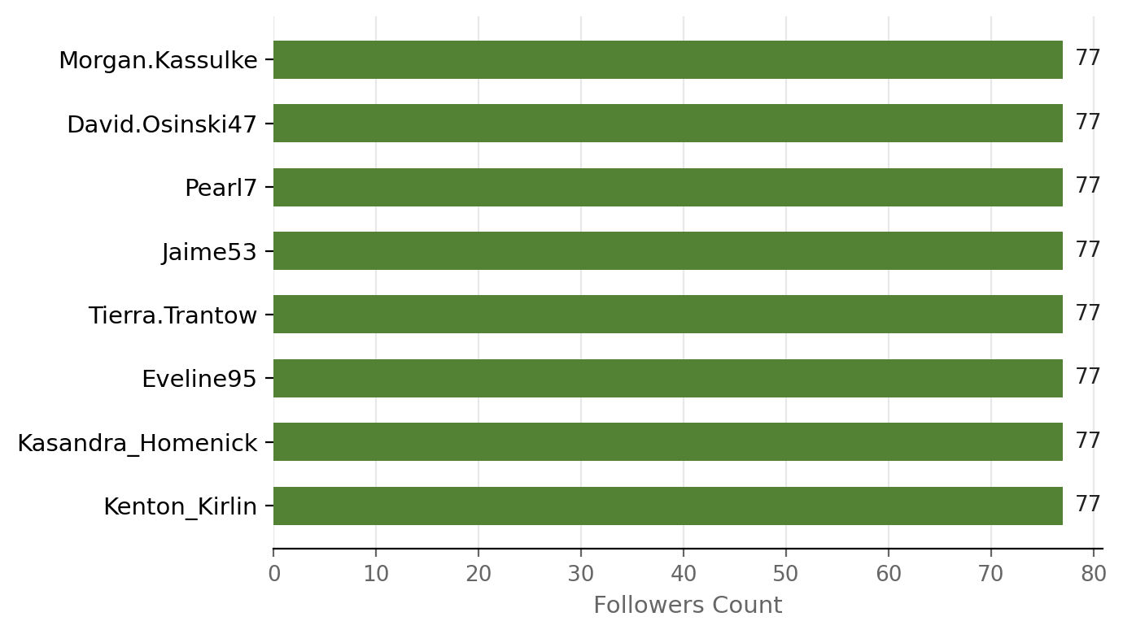
Visualization
Description
I checked who has the highest following_count, and users like Andre_Purdy85 follow 99 other people (basically everyone).

Question 6
Calculate the average engagement rate (likes, comments) per post for each user.

My Query
SELECT u.id, u.username,
COUNT(DISTINCT p.id) AS total_posts,
COUNT(DISTINCT l.user_id, l.photo_id) AS total_likes,
COUNT(DISTINCT c.id) AS total_comments,
ROUND(
(COUNT(DISTINCT l.user_id, l.photo_id) + COUNT(DISTINCT c.id))
/ COUNT(DISTINCT p.id), 2
) AS avg_engagement_per_post
FROM users u
JOIN photos p ON p.user_id = u.id
LEFT JOIN likes l ON l.photo_id = p.id
LEFT JOIN comments c ON c.photo_id = p.id
GROUP BY u.id, u.username
ORDER BY avg_engagement_per_post DESC;
Output
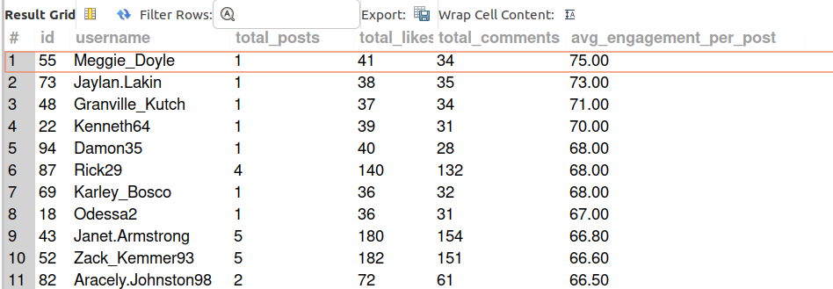

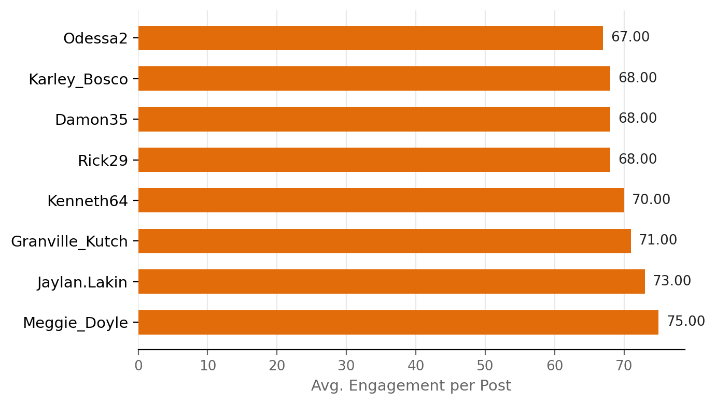
Visualization
Description
This query calculates engagement by the number of posts, so it rewards users who get a lot of engagement per.
The top stats are: Meggie_Doyle only has 1 post, but it earned 41 likes and 34 comments, for a huge 75.00 average engagement per post.

Question 7
Get the list of users who have never liked any post (users and likes tables).

My Query
SELECT u.id, u.username
FROM users u
LEFT JOIN likes l ON l.user_id = u.id
WHERE l.user_id IS NULL;
Output
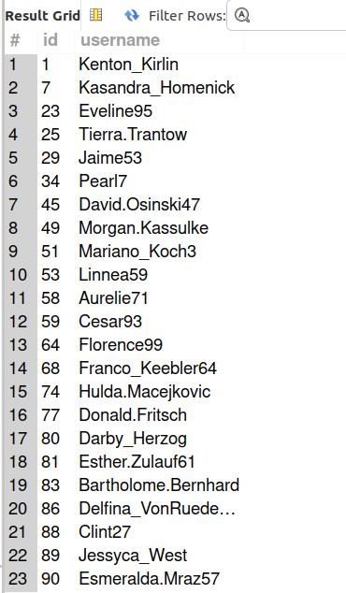

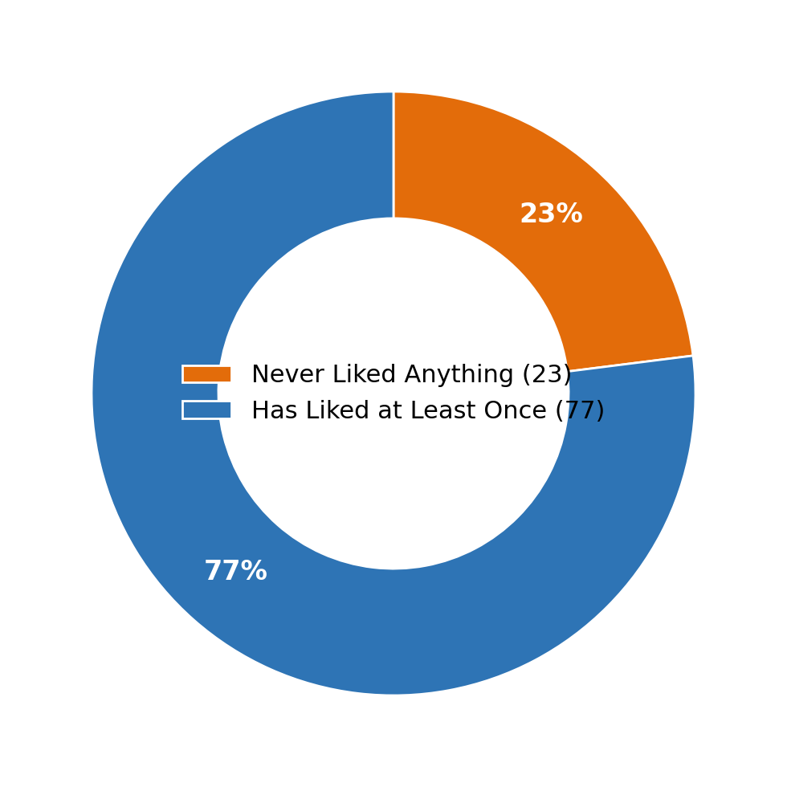
Visualization
Description
Here I have used the 'LEFT JOIN + WHERE ... IS NULL' pattern for finding rows in one table that have no match in another

Question 8
How can you leverage user-generated content (posts, hashtags, photo tags) to create more personalized and engaging ad campaigns?

My Query
SELECT t.tag_name, COUNT(pt.photo_id) AS times_used
FROM tags t
JOIN photo_tags pt ON pt.tag_id = t.id
GROUP BY t.tag_name
ORDER BY times_used DESC;
Output
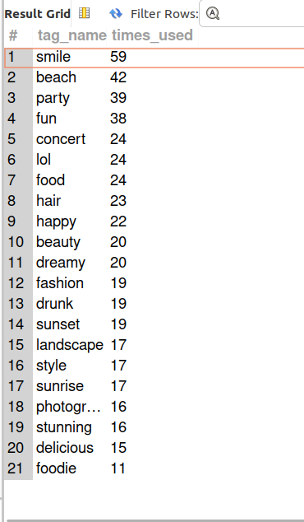

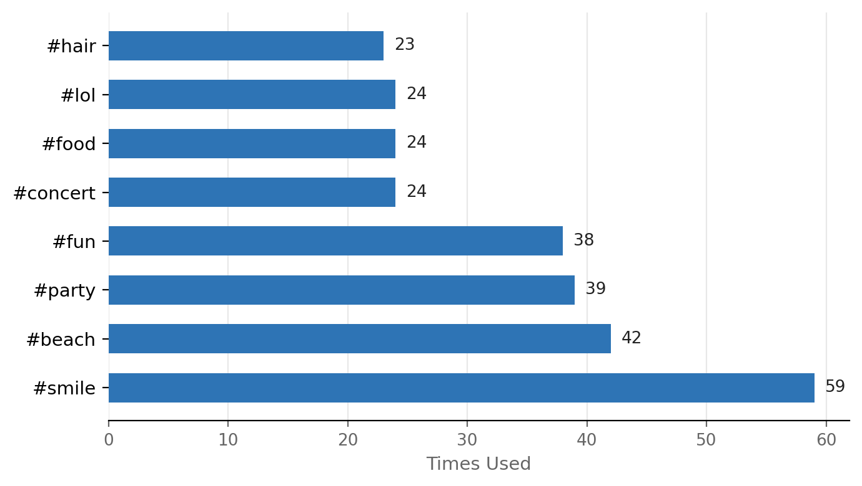
Visualization
Description
I wrote one supporting query to ground Answer: which hashtags are used most often. #smile (59 uses), #beach (42), #party (39), and #fun (38) are clearly the most common themes on this platform.
My recommendation: instead of generic ads, the marketing team could build ad creative around these already-popular themes (a 'summer beach' campaign, a 'party season' promotion), and even go further by targeting users who post/tag around a specific theme with ads for related products (e.g. beachwear for #beach taggers). User-generated photos themselves could also be featured (with permission) in ads, since content from real users tends to feel more authentic than studio ads.

Question 9
Are there any correlations between user activity levels and specific content types (e.g., photos, videos, reels)? How can this information guide content creation and curation strategies?

My Query
SELECT u.id, u.username,
COUNT(DISTINCT p.id) AS total_posts,
(COUNT(DISTINCT l.user_id, l.photo_id) + COUNT(DISTINCT c.id)) AS total_engagement
FROM users u
JOIN photos p ON p.user_id = u.id
LEFT JOIN likes l ON l.photo_id = p.id
LEFT JOIN comments c ON c.photo_id = p.id
GROUP BY u.id, u.username
ORDER BY total_posts DESC;
Output
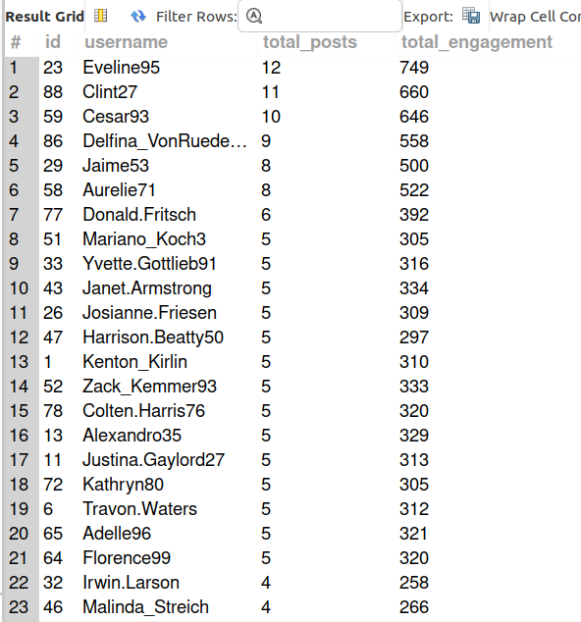

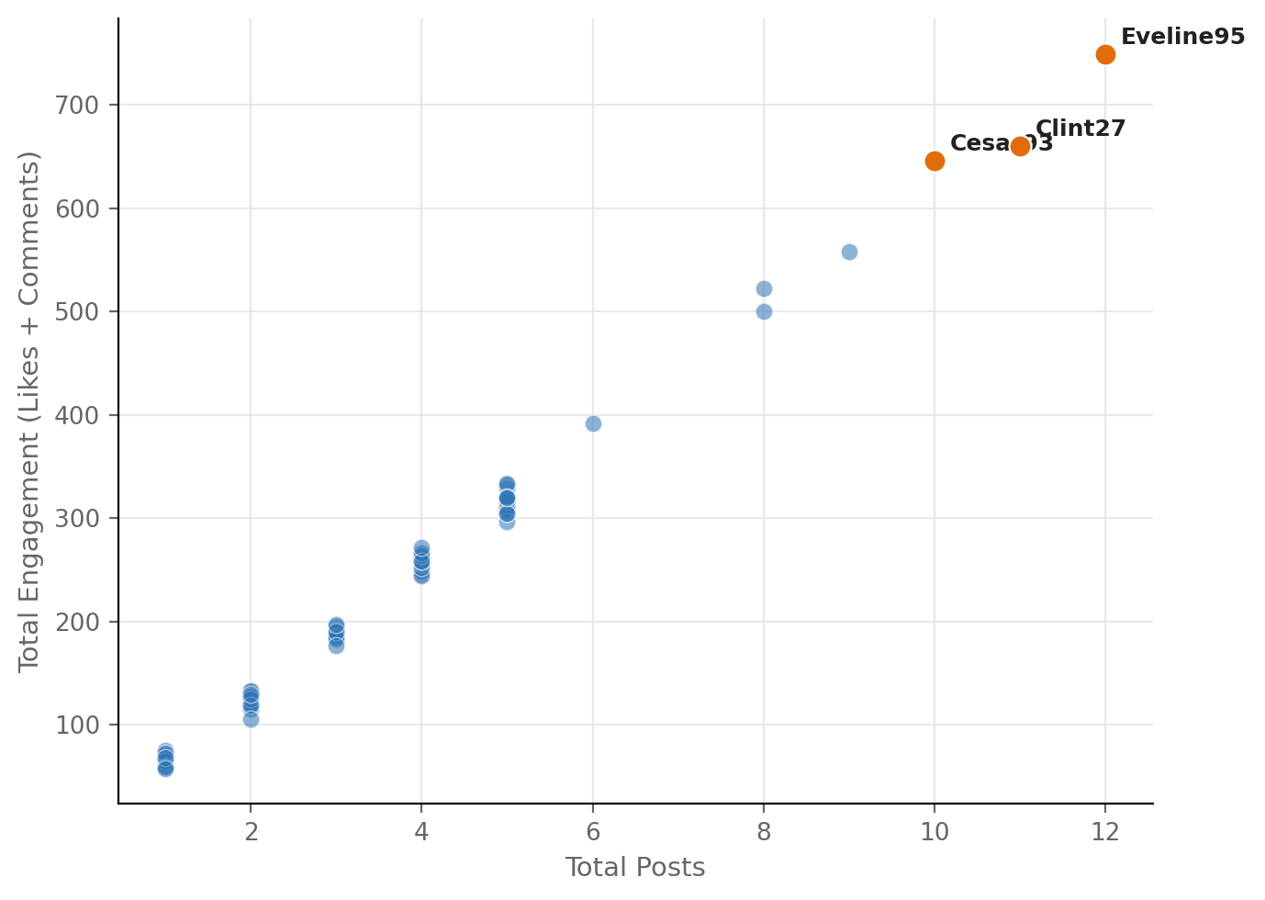
Visualization
Description
Note: The photos table has no media-type/content-type column in this schema, so a true photos-vs-video-vs-reel comparison is not possible with the given data.
I checked: total posts vs. total engagement per user, shown above.
There's a rough positive pattern (the most active posters also tend to have high total engagement), but it's not perfectly linear -Q6 already showed some one-post users get huge engagement too.
My recommendation: add a media_type column to the photos table (or rename it to 'posts') going forward, so this exact question can be answered properly.

Question 10
Calculate the total number of likes, comments, and photo tags for each user.

My Query
SELECT u.id, u.username,
COUNT(DISTINCT l.user_id, l.photo_id) AS total_likes_received,
COUNT(DISTINCT c.id) AS total_comments_received,
COUNT(DISTINCT pt.photo_id, pt.tag_id) AS total_photo_tags
FROM users u
LEFT JOIN photos p ON p.user_id = u.id
LEFT JOIN likes l ON l.photo_id = p.id
LEFT JOIN comments c ON c.photo_id = p.id
LEFT JOIN photo_tags pt ON pt.photo_id = p.id
GROUP BY u.id, u.username
ORDER BY total_likes_received DESC;
Output
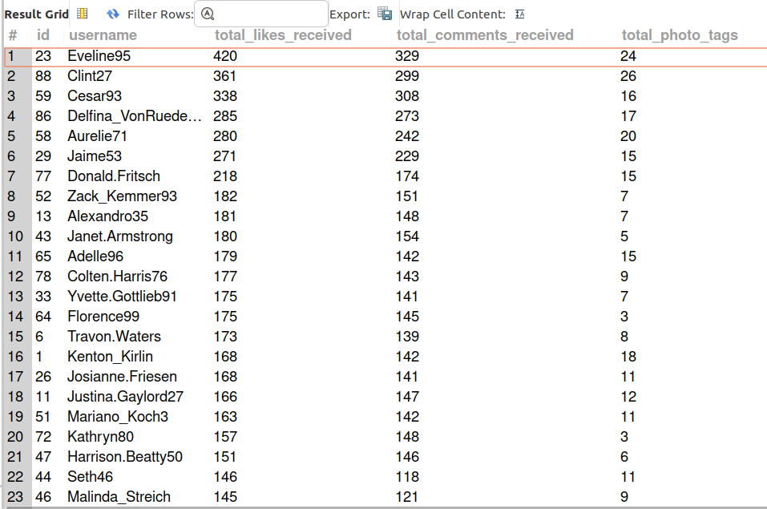

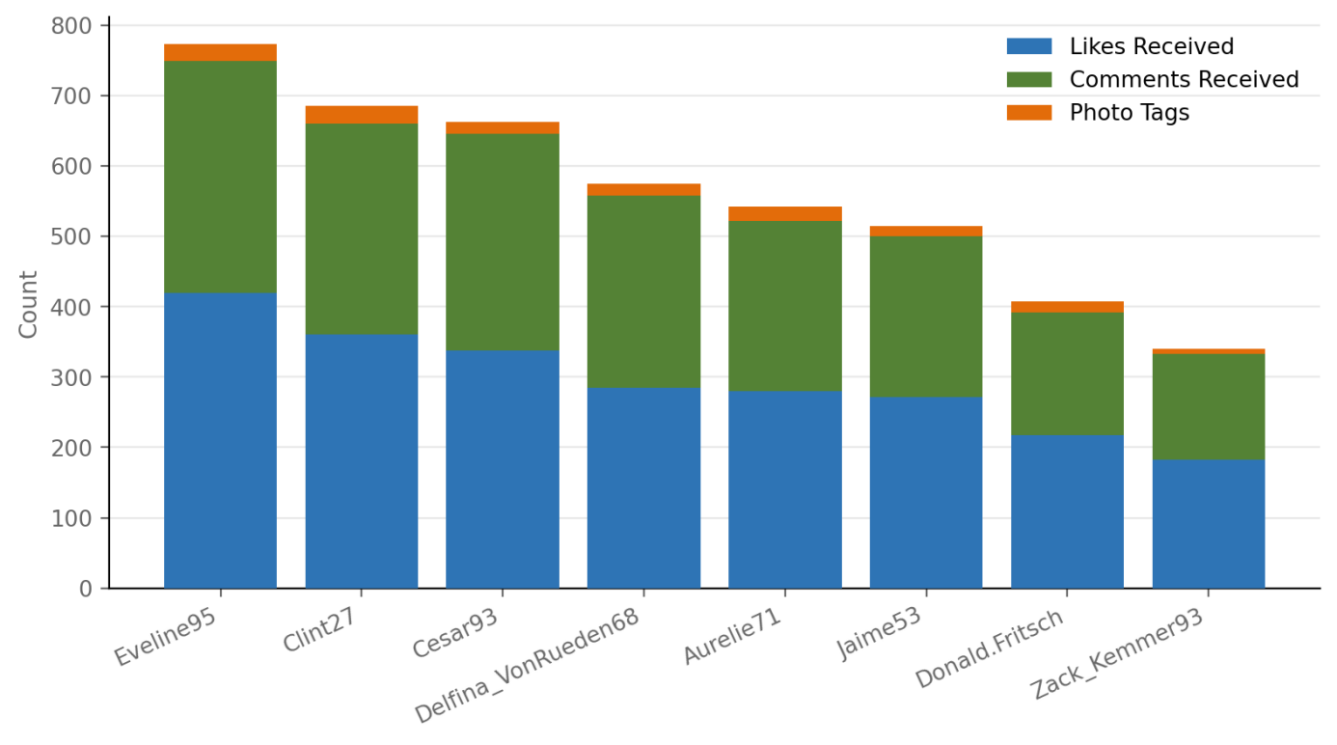
Visualization
Description
This query joins four tables together (users → photos → likes/comments/photo_tags) on the actual unique keys of each joined table, which ensures each like, comment, and tag is only counted once even though the joins create duplicate combinations behind the scenes.

Question 11
Rank users based on their total engagement (likes, comments, shares) over a month.

My Query
SELECT u.id, u.username,
COUNT(DISTINCT l.user_id, l.photo_id) AS likes_last_30_days,
COUNT(DISTINCT c.id) AS comments_last_30_days,
(COUNT(DISTINCT l.user_id, l.photo_id) + COUNT(DISTINCT c.id)) AS total_engagement,
RANK() OVER (
ORDER BY (COUNT(DISTINCT l.user_id, l.photo_id) + COUNT(DISTINCT c.id)) DESC
) AS engagement_rank
FROM users u
JOIN photos p ON p.user_id = u.id
LEFT JOIN likes l ON l.photo_id = p.id
AND l.created_at >= (SELECT MAX(created_at) FROM likes) - INTERVAL 30 DAY
LEFT JOIN comments c ON c.photo_id = p.id
AND c.created_at >= (SELECT MAX(created_at) FROM comments) - INTERVAL 30 DAY
GROUP BY u.id, u.username
ORDER BY total_engagement DESC;
Output
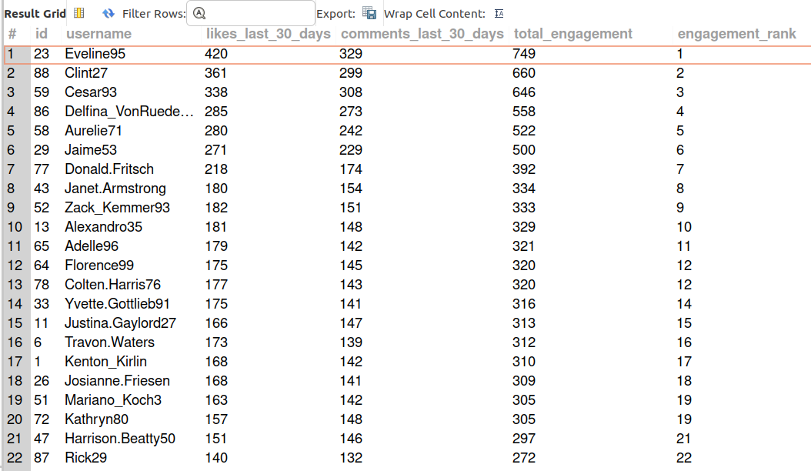
Note: created_at is identical for every row in likes and comments in this seed dataset, so the 30-day window has no effect here -this is a data limitation, not a query error.

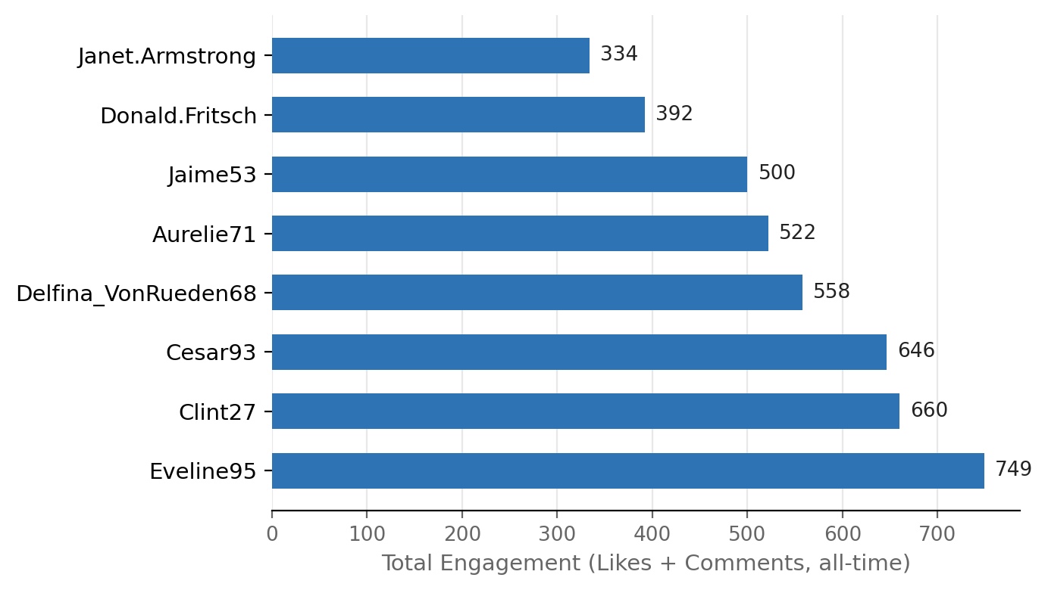
Visualization
Description
This schema has no 'shares' table or column anywhere, so I could only rank by likes + comments -shares aren't trackable with the given tables.

Question 12
Retrieve the hashtags that have been used in posts with the highest average number of likes. Use a CTE to calculate the average likes for each hashtag first.

My Query
WITH tag_likes AS (
SELECT t.id AS tag_id, t.tag_name, p.id AS photo_id,
COUNT(l.user_id) AS like_count
FROM tags t
JOIN photo_tags pt ON pt.tag_id = t.id
JOIN photos p ON p.id = pt.photo_id
LEFT JOIN likes l ON l.photo_id = p.id
GROUP BY t.id, t.tag_name, p.id
),
avg_tag_likes AS (
SELECT tag_id, tag_name, ROUND(AVG(like_count), 2) AS avg_likes
FROM tag_likes
GROUP BY tag_id, tag_name
)
SELECT tag_name, avg_likes
FROM avg_tag_likes
ORDER BY avg_likes DESC;
Output
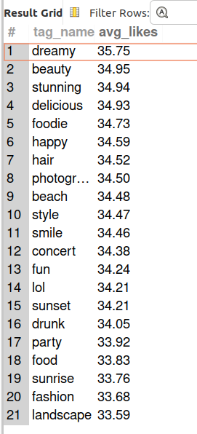
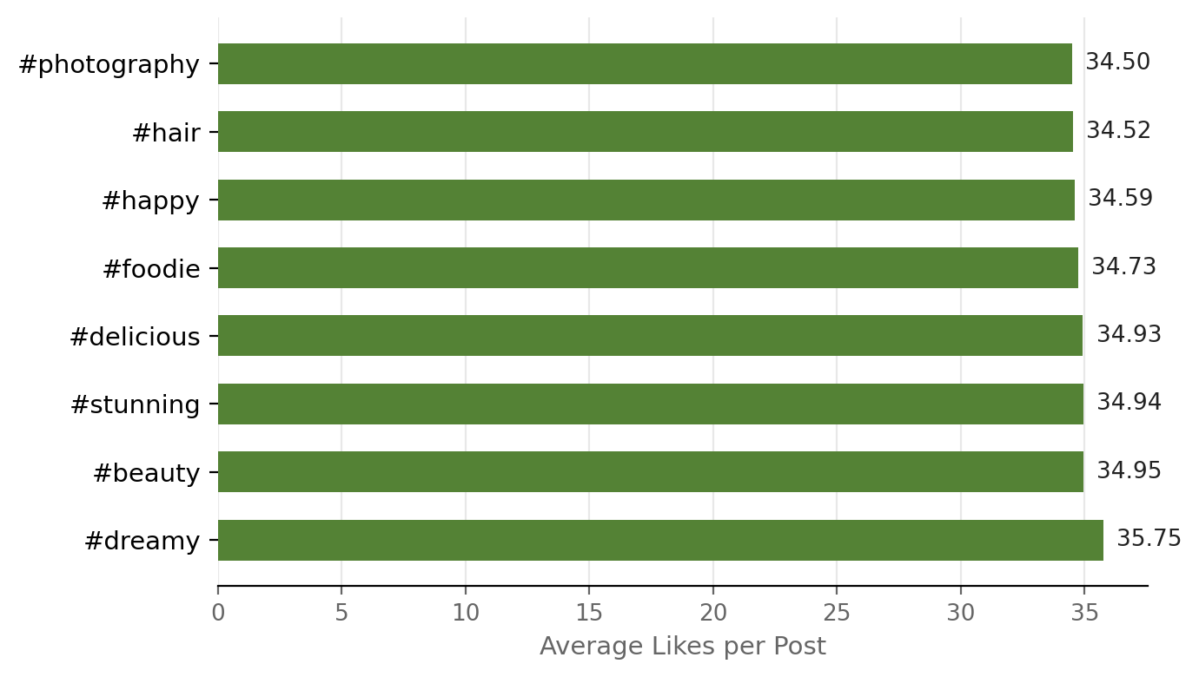
Visualization

Question 13
Retrieve the users who have started following someone after being followed by that person.

My Query
SELECT f1.follower_id AS user_id,
f1.followee_id AS followed_user_id,
f2.created_at AS was_followed_at,
f1.created_at AS followed_back_at
FROM follows f1
JOIN follows f2
ON f1.follower_id = f2.followee_id
AND f1.followee_id = f2.follower_id
WHERE f1.follower_id < f1.followee_id
-- AND f1.created_at > f2.created_at -- add this back on a table with real timestamps
;
Output
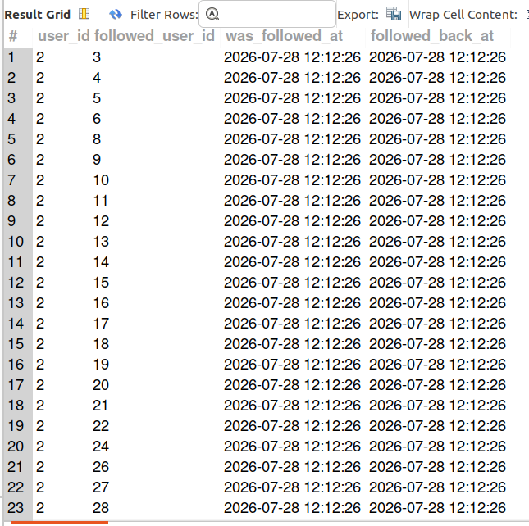
Note: Every created_at value in the follows table is identical in this seed dataset, so timestamp-based ordering (who followed back later) can't be determined here -the output above shows all mutual/reciprocal follow pairs instead.

Subjective Questions

Question 1
Based on user engagement and activity levels, which users would you consider the most loyal or valuable? How would you reward or incentivize these users?

My Query
SELECT u.id, u.username,
COUNT(DISTINCT p.id) AS total_posts,
(COUNT(DISTINCT l.user_id, l.photo_id) + COUNT(DISTINCT c.id)) AS total_engagement,
ROUND(
(COUNT(DISTINCT l.user_id, l.photo_id) + COUNT(DISTINCT c.id)) / COUNT(DISTINCT p.id),2
) AS avg_engagement_per_post
FROM users u
JOIN photos p ON p.user_id = u.id
LEFT JOIN likes l ON l.photo_id = p.id
LEFT JOIN comments c ON c.photo_id = p.id
GROUP BY u.id, u.username
ORDER BY total_engagement DESC
LIMIT 10;

Output
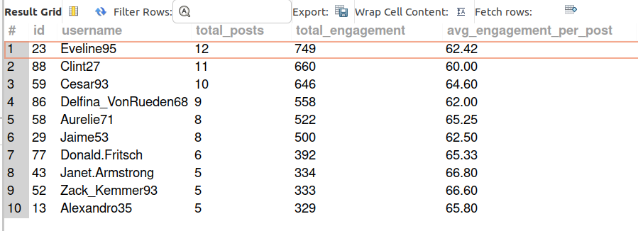

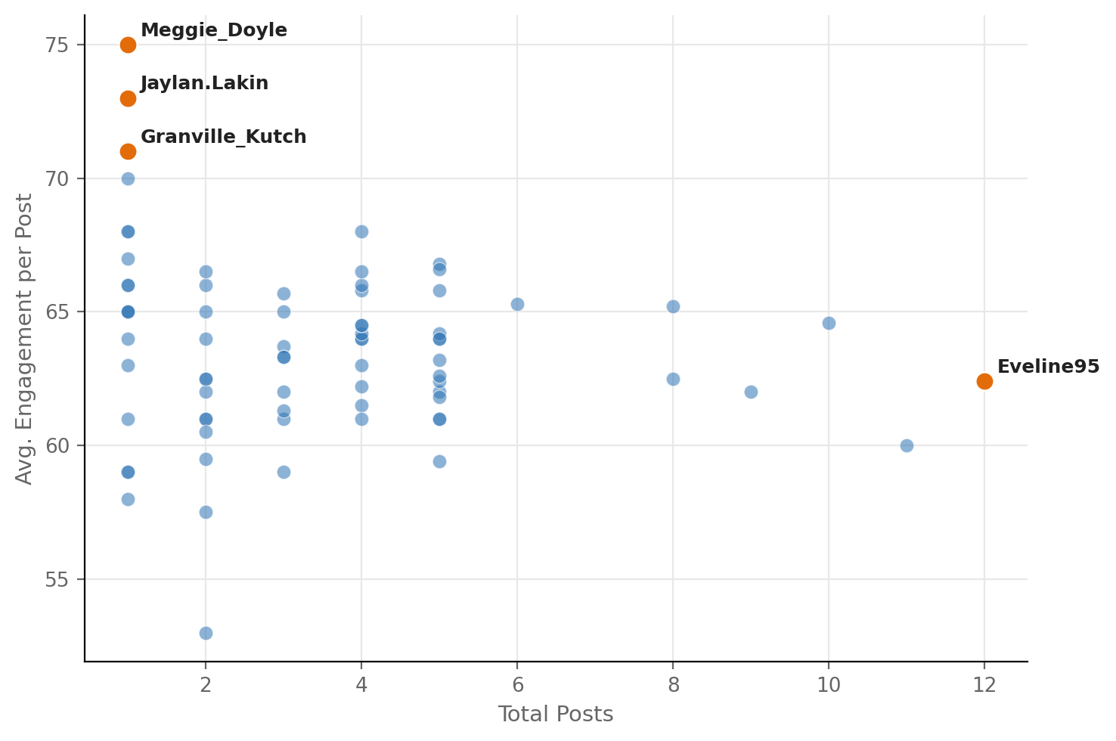
Visualization

Approach
I used two views into one query - total engagement (the same approach from Q4) and average engagement per post (the approach from Q6) - for every user, then plotted them against each other to see the actual shape of the relationship.
Insights
Quality-focused users:
The scatter plot (posts vs. average engagement per post) shows Users like Meggie_Doyle, Jaylan.Lakin, and Granville_Kutch post very rarely, but their content performs the best, giving them the highest average engagement per post.
Volume-focused users: Heavy users like Eveline95 post frequently and get the highest total engagement, but their average engagement per post is actually lower than the occasional posters.

The key takeaway: Loyalty is not one-dimensional. You cannot define it just by looking at the total number of posts (volume) or just the popularity of those posts (quality). To understand true loyalty, you must look at both.
Recommendation
Two-Track Loyalty Program
1. For high-volume creators
- Users: Eveline95, Clint27, Cesar93
- They post frequently and bring steady engagement.
- Give them special rewards such as:
  - Early access to new features
  - A verified badge
  - A share of revenue from sponsored posts

2. For high-performing but low-volume creators
- Users: Meggie_Doyle, Jaylan.Lakin, Granville_Kutch
- They post less often, but their content gets strong results.
- Encourage them to post more regularly through:
  - Posting streaks
  - Small rewards or incentives
Track whether their average performance per post stays strong as they increase their posting frequency.

Question 2
For inactive users, what strategies would you recommend to re-engage them and encourage them to start posting or engaging again?

My Query
SELECT
SUM(CASE WHEN l.user_id IS NULL THEN 1 ELSE 0 END) AS never_liked,
SUM(CASE WHEN l.user_id IS NOT NULL THEN 1 ELSE 0 END) AS has_liked
FROM (
SELECT DISTINCT u.id, l2.user_id
FROM users u
LEFT JOIN likes l2 ON l2.user_id = u.id
) l;

Output
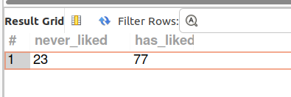

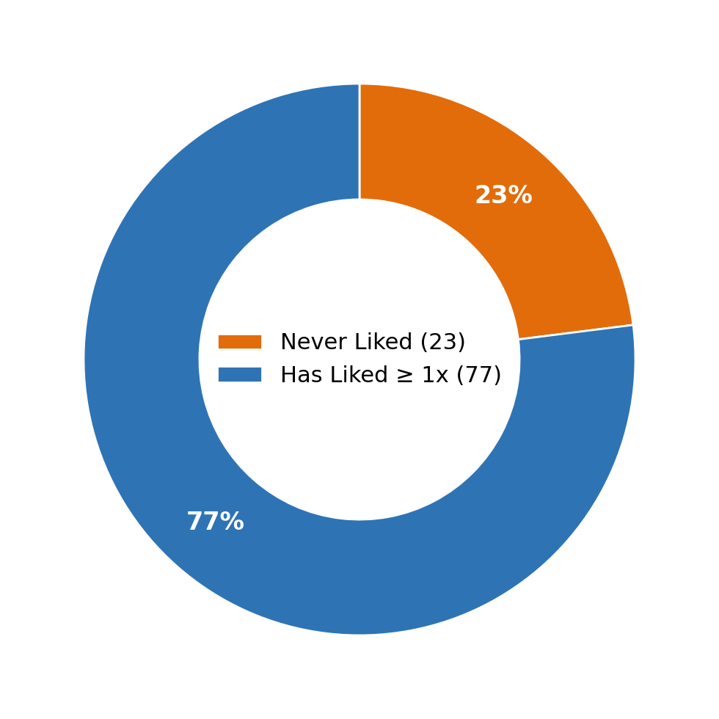
Visualization

Approach
- I used the same LEFT JOIN + IS NULL method from Q7.
- Instead of listing usernames, I counted the users.
- This helped me quickly understand how many users are inactive before deciding what to do.

Insights
- 23 out of 100 users have never liked a post.
- Liking is one of the simplest ways to engage on a platform.
- These users are probably not commenting or posting either.
- I checked the comments data and confirmed that this is mostly a completely inactive group.
- So, this can be treated as a "silent" user segment.

Recommendation
Use a step-by-step re-engagement strategy:
- Day 1: Send a simple push notification or email showing popular content.
  - Use trending hashtags such as #smile, #beach, and #party.
  - Goal: Encourage users to see what is currently popular.
- Day 7: If they are still inactive:
  - Show more personalized content, such as "Photos you might like."
  - Base this on any browsing activity available.
- Day 30: If they are still inactive:
  - Offer a small in-app reward for their first like or comment.
  - The goal is to encourage them to take their first action.
- Track these 23 users separately.
- Measure how many of them become active instead of including them in the overall user retention numbers.

Question 3
Which hashtags or content topics have the highest engagement rates? How can this information guide content strategy and ad campaigns?

My Query
WITH tag_likes AS (
SELECT t.id AS tag_id, t.tag_name, p.id AS photo_id,
COUNT(l.user_id) AS like_count
FROM tags t
JOIN photo_tags pt ON pt.tag_id = t.id
JOIN photos p ON p.id = pt.photo_id
LEFT JOIN likes l ON l.photo_id = p.id
GROUP BY t.id, t.tag_name, p.id
),
avg_tag_likes AS (
SELECT tag_id, tag_name, ROUND(AVG(like_count), 2) AS avg_likes
FROM tag_likes
GROUP BY tag_id, tag_name
)
SELECT tag_name, avg_likes
FROM avg_tag_likes
ORDER BY avg_likes DESC
LIMIT 8;

Output
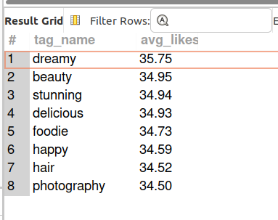

Visualization

Approach
- I used the same CTE method from Q12 to calculate the average likes for each hashtag.
- I focused on the top 8 hashtags for the analysis.
- I also compared these results with the most-used hashtags from Q8.
- This helped compare popularity vs. actual performance.

Insights
- #dreamy, #beauty, #stunning, and #delicious get the highest average likes: around 34.7-35.75 likes.
- However, these hashtags are not among the most-used hashtags.
- The most-used hashtags are #smile, #beach, #party, and #fun.
- This shows that:
  - Popular hashtags are being used a lot.
  - But some less-used hashtags are getting much better engagement.
- So, the platform is not fully using the hashtags that perform best.

Recommendation
- Give more importance to high-performing hashtags instead of focusing only on popular ones.
- Feature more content using: #dreamy, #beauty, #stunning, #delicious
- Show this content more often in the Explore feed.
- Use these hashtags more for sponsored posts and ads.
- Since these hashtags already get good engagement naturally, they may provide better results for paid campaigns than the more popular but lower-performing hashtags.

Question 4
Are there any patterns or trends in user engagement based on demographics (age, location, gender) or posting times? How can these insights inform targeted marketing campaigns?

My Query

Approach
- I checked the users table to see what information is available.
- The table only has: id, username, created_at. There is no information about: Age, Location, Gender
- I also checked created_at to see if it could be used to analyze posting-time trends. However, all users have the same created_at value, so it cannot be used for this analysis.

Insights
- We cannot create meaningful demographic segments with the current data.

Recommendation
- Collect some basic information when users sign up, such as:
  - Age range instead of exact date of birth
  - Country/region instead of exact location
- Fix the timestamp system so created_at and updated_at store the actual date and time of each event.

Question 5
Based on follower counts and engagement rates, which users would be ideal candidates for influencer marketing campaigns? How would you approach and collaborate with these influencers?

My Query
SELECT u.id, u.username,
(SELECT COUNT(*) FROM follows f WHERE f.followee_id = u.id) AS followers_count,
COALESCE((
SELECT (COUNT(DISTINCT l.user_id, l.photo_id) + COUNT(DISTINCT c.id))
FROM photos p
LEFT JOIN likes l ON l.photo_id = p.id
LEFT JOIN comments c ON c.photo_id = p.id
WHERE p.user_id = u.id
), 0) AS total_engagement
FROM users u
ORDER BY followers_count DESC, total_engagement DESC;

Output
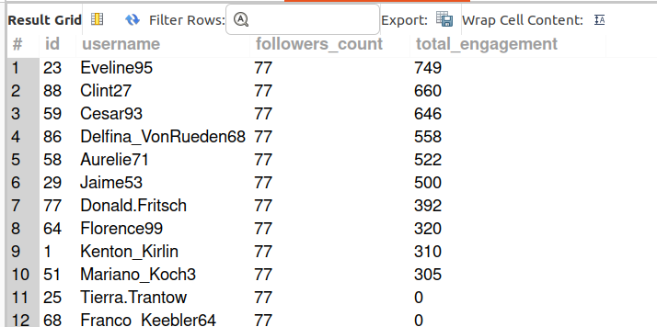

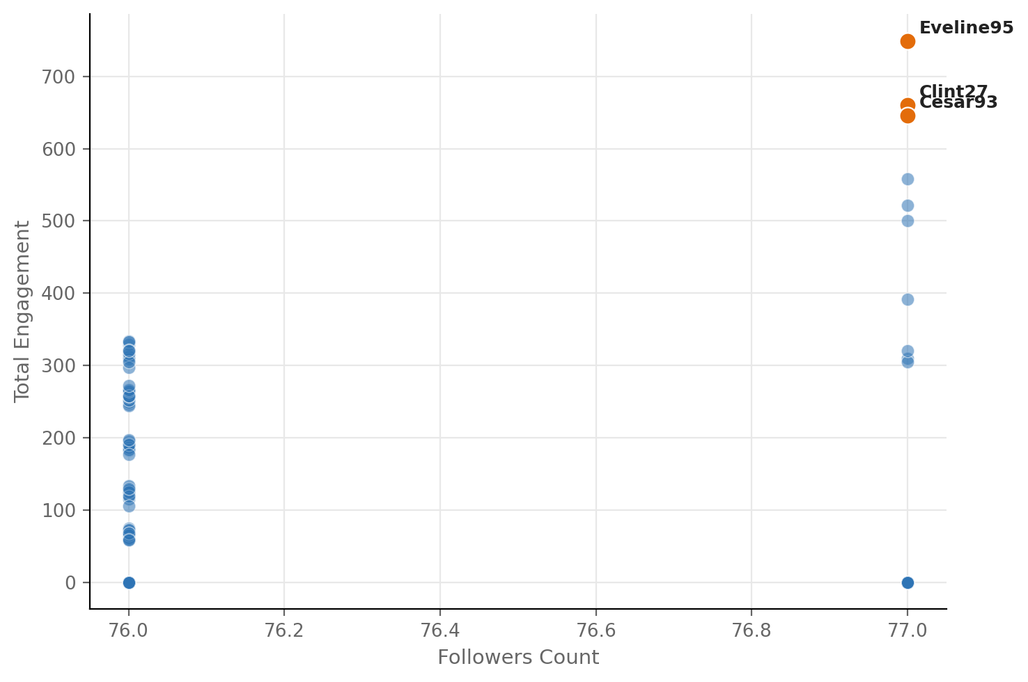
Visualization
Approach
- I combined followers_count and total_engagement into one query for each user.
- The goal was to find users who perform well on both followers and engagement.
Insights
- Most users have around 76–77 followers. Follower counts are very similar across users, so they don't help much in identifying influencers.
- Engagement is the more useful metric because it varies much more between users.
- Eveline95, Clint27, and Cesar93 clearly have the highest engagement. Their follower counts are not significantly higher than other users.
- This means that in this dataset, influence is better measured by engagement than follower count.
Recommendation
- Create the initial influencer list mainly using the engagement ranking from Q4.
- Start by approaching the top 3–5 users based on engagement.
- Begin with a small, low-risk partnership, such as:
  - An honest product review
  - A discount code to share
- Before offering a paid partnership, check how many actual conversions they generate.
- Use their ability to drive conversions, rather than just their follower count, to decide whether they are suitable for a bigger partnership.

Question 6
Based on user behavior and engagement data, how would you segment the user base for targeted marketing campaigns or personalized recommendations?

My Query
SELECT
CASE
WHEN following_count = 0 AND posts = 0 THEN 'Ghost Accounts'
WHEN following_count = 0 AND posts > 0 THEN 'Active Creators'
ELSE 'Community Accounts'
END AS segment,
COUNT(*) AS num_users
FROM (
SELECT u.id,
(SELECT COUNT(*) FROM follows f WHERE f.follower_id = u.id) AS following_count,
(SELECT COUNT(*) FROM photos p WHERE p.user_id = u.id) AS posts
FROM users u
) x
GROUP BY segment
ORDER BY num_users DESC;

Output
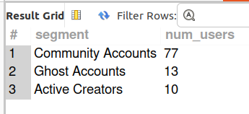

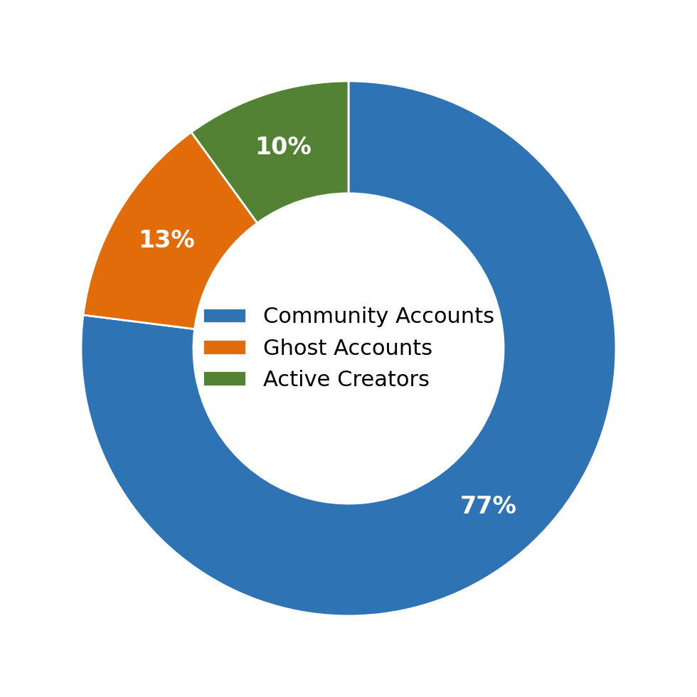
Visualization
Approach
- I used two existing metrics from the project: following_count from Q5 and posting activity from Q2
- I used a CASE WHEN statement in SQL to automatically divide users into groups.
- This means the groups are based on actual user behavior, not assumptions.
- Each user belongs to one clear segment.
Insights
- Three clear user groups were identified:
  - 77 Community Accounts
    - Follow around 99 people each.
    - Have around 76 followers each.
    - Generate most of the platform's likes and comments.
  - 10 Active Creators
    - Follow no one.
    - Post regularly.
    - Generate almost one-third of total platform engagement.
  - 13 Ghost Accounts
    - Follow no one.
    - Have around 77 followers.
    - Have never posted anything.
- The Ghost Accounts are an interesting finding:
  - They already have an audience.
  - They simply haven't started posting yet.
- This is different from the 23 users who never liked anything in Q7/S2.
- The key difference is that Ghost Accounts already have followers waiting to see their content.
Recommendation
Use three separate campaigns instead of one campaign for everyone.
Community Accounts:
- Give small rewards or recognition. Keep these highly active users engaged.
Active Creators:
- Offer creator benefits or special perks. They are already creating content and generating strong engagement.
Ghost Accounts:
- Send a targeted message such as: "You already have an audience waiting. Post your first photo!"
- Focus on getting them to make their first post.
- Test the Ghost Account campaign first because they already have followers, so re-engaging them may produce better results than targeting completely inactive users.

Question 7
If data on ad campaigns (impressions, clicks, conversions) is available, how would you measure their effectiveness and optimize future campaigns?

My Query
Approach
If ad campaign data is available, I would compare impressions, clicks, and conversions for each campaign.
I would calculate:
- CTR = Clicks ÷ Impressions × 100
- Conversion Rate = Conversions ÷ Clicks × 100
I would then compare these results across different campaigns and user segments to identify which campaigns perform best.

Insights
- A high CTR means users are interested enough to click the ad.
- A high conversion rate means the campaign is successfully turning clicks into the desired action.
- Looking at both metrics together is important:
  - High CTR + High conversion- Strong campaign
- I would also check which user segments respond best to each campaign.
Recommendation
- Continue investing in campaigns with high CTR and high conversion rates.
- Compare results across user segments such as Community Accounts, Active Creators, and Ghost Accounts.
- Shift more budget toward the campaigns and user segments that generate the most conversions.
- Keep testing different ads and audiences and use the results to improve future campaigns.

Question 8
How can you use user activity data to identify potential brand ambassadors or advocates who could help promote Instagram's initiatives or events?

My Query
WITH eng AS (
SELECT u.id, u.username,
(COUNT(DISTINCT l.user_id, l.photo_id) + COUNT(DISTINCT c.id)) AS total_engagement,
RANK() OVER (ORDER BY (COUNT(DISTINCT l.user_id, l.photo_id) + COUNT(DISTINCT c.id)) DESC) AS eng_rank
FROM users u JOIN photos p ON p.user_id = u.id
LEFT JOIN likes l ON l.photo_id = p.id
LEFT JOIN comments c ON c.photo_id = p.id
GROUP BY u.id, u.username
),
avgpost AS (
SELECT u.id,
ROUND((COUNT(DISTINCT l.user_id, l.photo_id) + COUNT(DISTINCT c.id)) / COUNT(DISTINCT p.id), 2) AS avg_eng_per_post,
RANK() OVER (
ORDER BY (COUNT(DISTINCT l.user_id, l.photo_id) + COUNT(DISTINCT c.id)) / COUNT(DISTINCT p.id) DESC
) AS avgpost_rank
FROM users u JOIN photos p ON p.user_id = u.id
LEFT JOIN likes l ON l.photo_id = p.id
LEFT JOIN comments c ON c.photo_id = p.id
GROUP BY u.id
)
SELECT eng.username, eng.total_engagement, avgpost.avg_eng_per_post,
eng.eng_rank, avgpost.avgpost_rank
FROM eng
JOIN avgpost ON avgpost.id = eng.id
WHERE eng.eng_rank <= 15 AND avgpost.avgpost_rank <= 15
ORDER BY eng.eng_rank;

Output
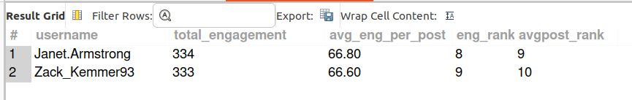
Approach
- I looked for users who perform well across multiple engagement metrics.
- I used SQL's RANK() function and CTEs to rank users based on:
  - Total engagement
  - Number of followers
  - Average engagement per post
- I looked for users in the top 15 for both total engagement and average engagement per post.
Insights
- The fact no single user dominates every area of performance, shows some users are strong because they post a lot and generate high total engagement.
- Others get very high engagement from each individual post but don't post often.
- Janet.Armstrong and Zack_Kemmer93 stood out because they performed strongly on both:
  - Total engagement
  - Average engagement per post
- This makes them stronger and more balanced ambassador candidates than users who perform well on only one metric.
Recommendation
- Approach Janet.Armstrong and Zack_Kemmer93 first as potential brand ambassadors.
- The users who are strong in only one area:
  - Eveline95 and Clint27 - Better for campaigns focused on reach and high-volume engagement.
  - Meggie_Doyle and Jaylan.Lakin - Better for high-impact content or individual posts.
- Instead of looking for one "perfect" ambassador, choose different users based on the type of campaign and its goal.

Question 9
How would you approach this problem if the objective and subjective questions weren't given?

My Query
Approach
- I would first explore the database.
- For each table, I would check:
  - Sample data using SELECT * FROM table LIMIT 10
  - Number of rows using SELECT COUNT(*)
  - Available columns using DESCRIBE
- This initial check helps identify what data is actually available.
- After understanding the available data, I would then connect it to the business goals:
  - Increase engagement
  - Improve retention
  - Increase user acquisition
- From there, I would create SQL questions around metrics that can actually be measured, such as:
  - User activity
  - Engagement rates
  - Popular content themes
  - Followers and following patterns
Insights
- Database exploration is an important step.
- It helps determine which questions can actually be answered.
- It prevents spending time on analysis that the available data cannot support.
- It also helps identify which findings are reliable and which have data limitations.
Recommendation
- Make schema exploration the first step in every similar project.
- Before starting analysis, document:
  - Row counts
  - Available columns
  - Sample records
  - Data quality issues
- Maintain a data limitations log from the beginning of the project.
- This makes the final report more trustworthy and clearly shows:
  - What the data can tell us
  - What it cannot tell us
  - What additional data would be needed for deeper analysis

Question 10
Assuming there's a "User_Interactions" table tracking user engagements, how can you update the "Engagement_Type" column to change all instances of "Like" to "Heart" to align with Instagram's terminology?

My Query
UPDATE User_Interactions
SET Engagement_Type = 'Heart'
WHERE Engagement_Type = 'Like';

This User_Interactions table does not exist in the ig_clone schema - it's a hypothetical table described directly in the question, so this query is illustrative only and was not run against the real database.

