A Project Report On
BANK MANAGEMENT SYSTEM

Submitted in partial fulfillment of the requirement for the BCA Semester-4 Python Programming Subject Final Examination.
BACHELOR OF COMPUTER APPLICATIONS
(B.C.A.)

Academic Year 2025 – 26

HEER GADESHA - (92400527098)

INTERNAL GUIDE
Prof. AMIT GOHEL


Rajkot-Morbi Road, At& PO : Gauridad, Rajkot 360 003. Gujarat. India.
CONTENTS

Chapters | Particulars | Page No.
1 | SYNOPSIS
2  2.1  2.2  2.3  2.4 | PREAMBLE  General Introduction  Statement of Problem  Objective and Scope of the Study  Module Description with functionality
3  3.1  3.2  3.3  3.4 | SYSTEM DESIGN AND DEVELOPMENT  Data Flow Diagram (DFD)  Table Structure  Screen Design (Screen shots with short description)  Menu Design
4 | CONCLUSION
5 | LEARNING DURING PROJECT WORK
6  6.1  6.2 | BIBLIOGRAPHY  Online References  Offline References

- SYNOPSIS :

The Bank Management System is an application that has been built with the Python programming language. The primary aim of this project is to automate banking activities such as opening a bank account, money deposits, withdrawals, modifications, and deletion of accounts.

In this project, Tkinter has been used for building the GUI design while Matplotlib library has been utilized for creating graphical representations. The system stores the information of the customers in terms of their names, account numbers, types of accounts, Aadhar numbers, and balances. There is a feature of graphical analysis such as balance graphs and account-type distribution graphs.
- PREAMBLE:

2.1 Introduction

The Bank Management System is a software program that helps manage bank transactions and processes through the use of computers. Some of its functions include account management, transaction processing, and balance viewing. This system makes it unnecessary to keep manual accounts and ensures quicker access to information.

The Bank Management System is created using Python and the Tkinter Graphical User Interface. The Bank Management System allows the user to create, modify, deposit, withdraw money, and delete accounts.

2.2 Statement of Problem

The manual process of banking involves huge paper work and takes a lot of time. There is always a possibility of committing mistakes and data being lost while maintaining such manual records. It is also hard to locate any kind of information.

Thus, there arises a need for a Computerized Bank Management System.

  - Objectives and Scope of the Project

- Objectives of the project are:

-Development of GUI-based banking system
-Digital storage of account details
-Carrying out deposits and withdrawals
-Updating and deleting account details
-Generation of graphics for account details

- Scope of the project:

-The project can be used for small banking activities
-Helps in easy management of account details
-Generates graphical presentation of account balance
-Error-free transactions
2.4 Module with Functionality Description

The system includes the following modules:

-Account Creation Module
In this module, the user can create an account for the bank using the data about the customers.

-Deposit Module
In this module, the user can make deposits to the chosen account.

-Withdraw Module
In this module, the user can withdraw money from the account after checking its balance.

-Update Module
In this module, account data can be updated.

-Delete Module
In this module, the chosen account can be deleted.

-Graph Module
This module shows balance and account types graphs.

- SYSTEM DESIGN AND DEVELOPMENT :

3.1 Data Flow Diagram (DFD)
Level-0 DFD shows how user interacts with the system. The user feeds data to the system. The system analyzes data and saves data in account database. The system accesses data whenever needed and presents account details and charts.
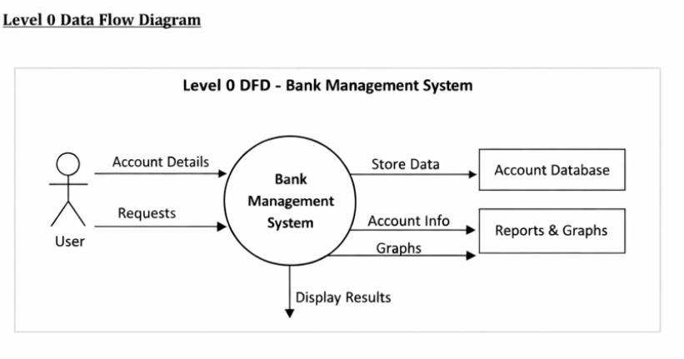

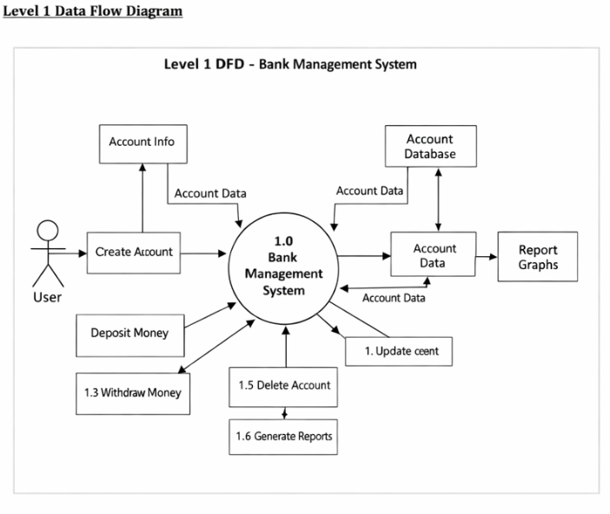
3.2 Table Structure

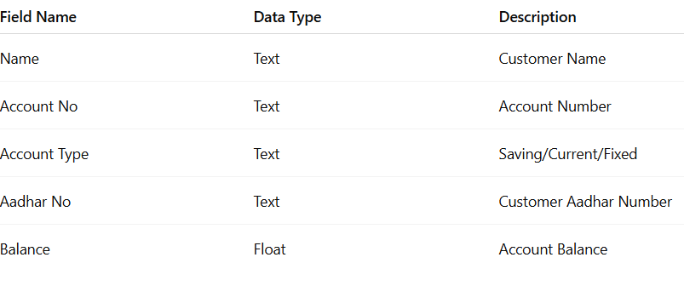

  - Screen Design (Screen shots with short description)

1)Add Account

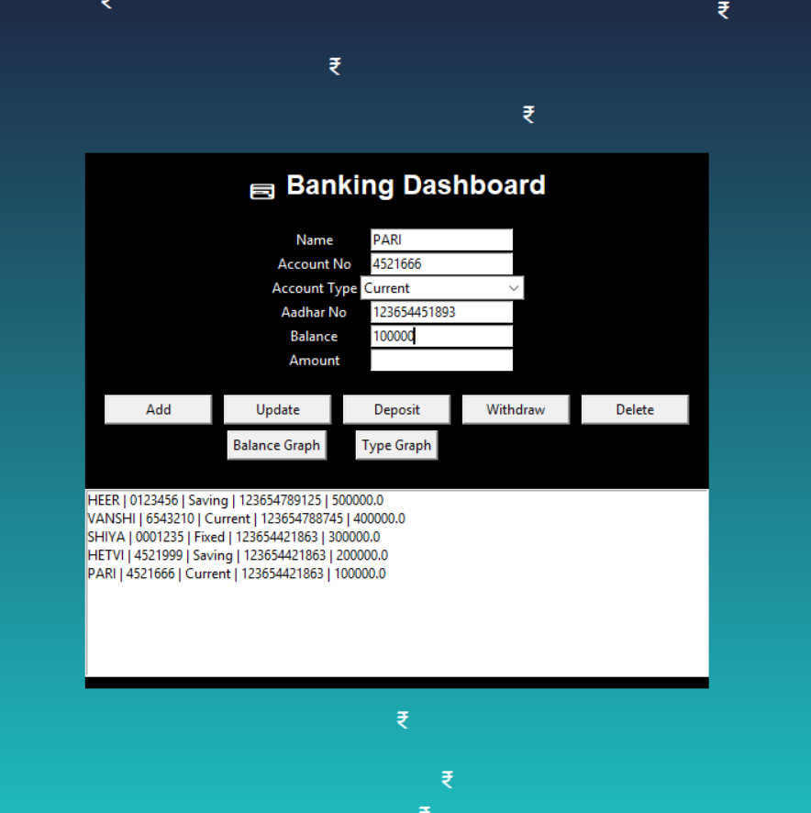

This option is used to create a new bank account by entering customer details.
The system stores name, account number, account type, Aadhar number and balance.
2)Update Account

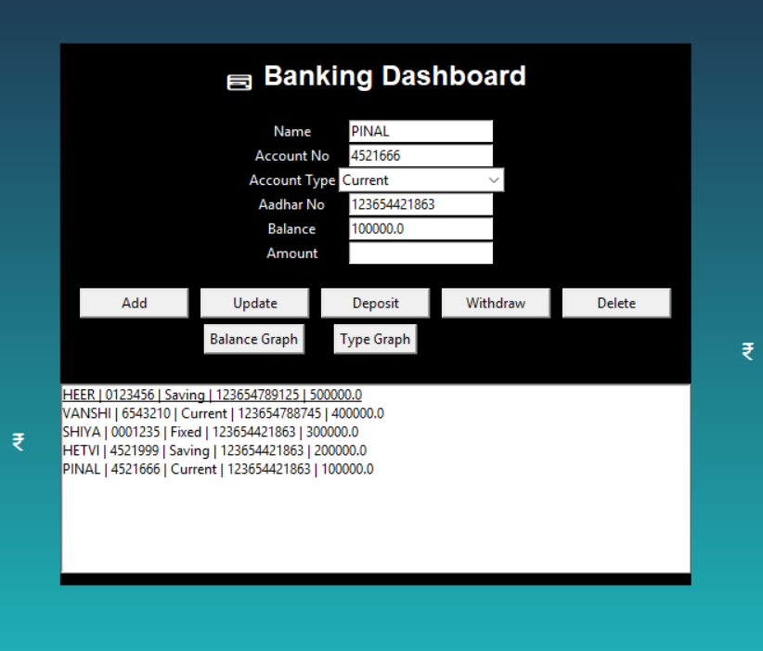

This option allows modification of existing account details.
The selected account information is edited and saved in the system.

3)Deposit Amount

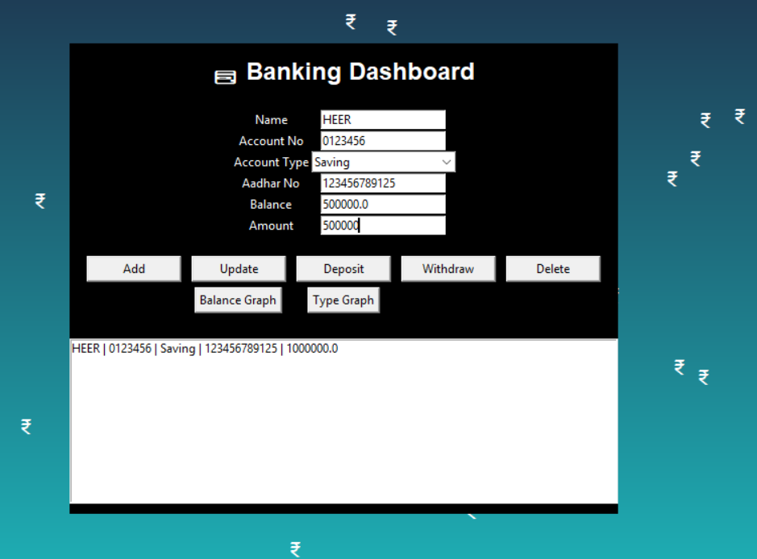

This option is used to deposit money into the selected account.
The entered amount is added to the existing account balance.

5)Withdraw Amount

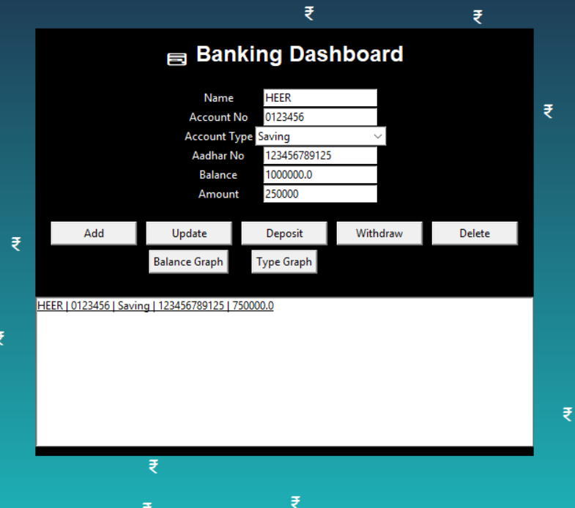

This option allows the user to withdraw money from the account.
The system checks balance and subtracts the entered amount.

6)Delete Account

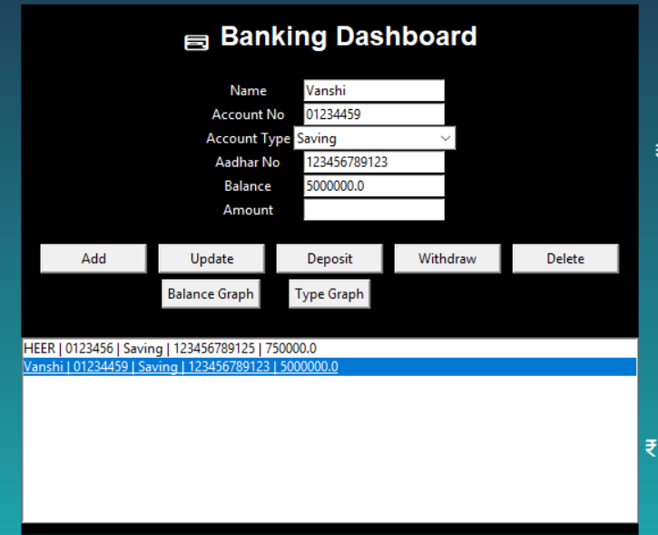

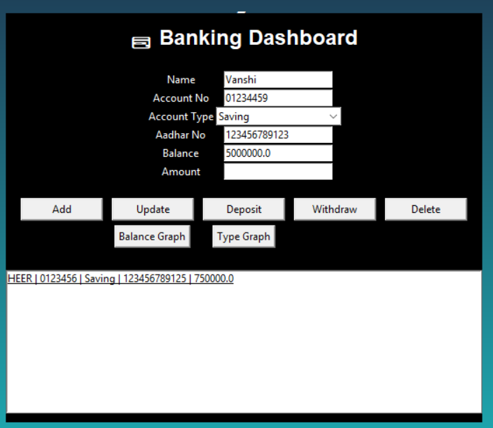

This option removes the selected account from the system.
The account details are permanently deleted from records.
7)Bar Graph

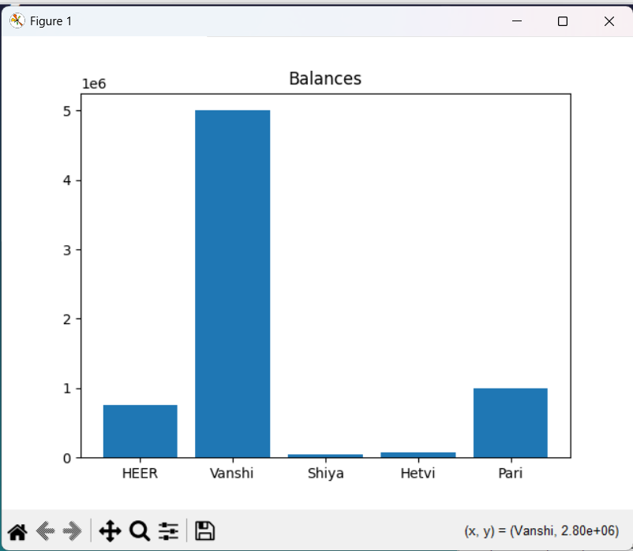

This option displays a bar graph of all account balances.
It helps in analyzing customer balance distribution visually.

8)Bar Graph

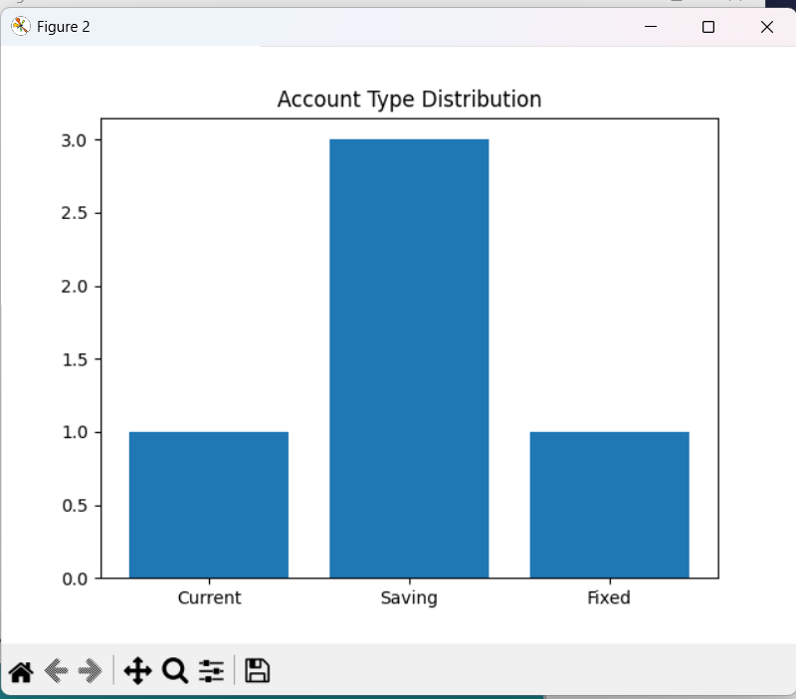

This option shows graphical distribution of account types.
It displays number of saving, current and fixed accounts.

3.4 Menu Design :The system provides the following menu options

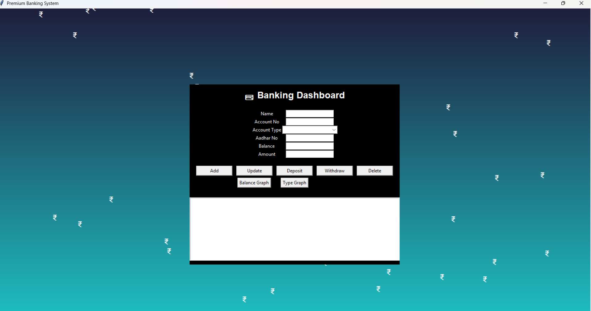

Input fields on the main form include name, account number, account type, Aadhar number, and balance. The system provides buttons for add, update, deposit, withdraw, and delete functions. Account records can be displayed using a list box. Graph buttons provide graphical representations of account balances and types.
4)CONCLUSION:

Bank Management System is an example of the implementation of banking activities through Python programming language. It offers user-friendly interface for carrying out tasks like updating account details and processing transactions. It makes the task easier and increases efficiency. The graphical view simplifies the analysis of account information.

5)LEARNINGS DURING PROJRCT:

While working on the project, I got to learn about the following:

- Python GUI development with Tkinter
- Event Driven programming
- Handling data using list and dictionary
- Graph Plotting with Matplotlib
- Creating user-friendly interface
- Debugging and Testing Programs in Python

6) BIBLIOGRAPHY:

6.1 Online References

- https://www.python.org
- https://www.w3schools.com/python
- https://matplotlib.org

6.2 Offline References
Notes on Python programming
Classroom Lecture Notes
Faculty Guidance

