AIM:

Create Profile page with proper validation and form-control for following information using NodeJs and Bootstrap only.

1. First Name and Last name
2. Email-id
3. Mobile Number
4. Date of Birth
5. Gender
6. Address
7. Select Institute
8. Select Department
9. Select Semester
10. Display all information in HTML Table.

CODE:

**app.js**

const express= require('express')

var bodyparser = require('body-parser')

const { check, validationResult } = require('express-validator');

const app=express()

app.set('view engine', 'pug')

const port=7000

app.use(express.urlencoded({

    extended:true

}))

app.get('/',(req,res)=>{

    res.sendFile(__dirname+"/form.html")

})

//get

app.get('/data',(req,res)=>{

    // var fname = req.query.fname;

    // console.log(fname)

    var value = JSON.parse(JSON.stringify(req.query))

       res.render("data.pug",{

        "data" : value

        })

})

//post

app.post('/xyz',

    check('mail','Email is not valid').isEmail().normalizeEmail(),

    check('ins',"this must be selected").exists(),

    check('sem',"this must be selected").exists(),

    check('no',"must be 10 digits").isLength({min:10}),

    check('gender',"this must be selected").exists()

,(req,res)=>{

        var errors = validationResult(req);

        const alert = errors.array()

        if (!errors.isEmpty()) {

            // alert

            console.log(errors.mapped())

            // return res.status(422).jsonp(errors.array)

            res.send(errors)

        }

        else {

            var value = JSON.parse(JSON.stringify(req.body))

            res.render("data.pug",{

                "data" : value

            })

        }

})

app.listen(port,()=>{

    console.log("server is listening")

})

**data.pug**

doctype html

html

    head

        title Form data

        meta(charset='UTF-8')

    body

        <table style="border:1px solid black">

        <tbody>

            <tr style="border:1px solid black">

                <td style="border:1px solid black">Fname</td>

                <td style="border:1px solid black">Lname</td>

                <td style="border:1px solid black">Email</td>

                <td style="border:1px solid black">MobileNo</td>

                <td style="border:1px solid black">DOB</td>

                <td style="border:1px solid black">Gender</td>

                <td style="border:1px solid black">Address</td>

                <td style="border:1px solid black">institue</td>

                <td style="border:1px solid black">Semester</td>

            </tr>

            <tr style="border:1px solid black">

                <td style="border:1px solid black">#{data.fname}</td>

                <td style="border:1px solid black">#{data.lname}</td>

                <td style="border:1px solid black">#{data.mail}</td>

                <td style="border:1px solid black">#{data.no}</td>

                <td style="border:1px solid black">#{data.dob}</td>

                <td style="border:1px solid black">#{data.gender}</td>

                <td style="border:1px solid black">#{data.add}</td>

                <td style="border:1px solid black">#{data.ins}</td>

                <td style="border:1px solid black">#{data.sem}</td>

            </tr>

        </tbody>

    </table>

**form.html**

<!DOCTYPE html>

<html lang="en">

<head>

    <meta charset="UTF-8">

    <meta http-equiv="X-UA-Compatible" content="IE=edge">

    <meta name="viewport" content="width=device-width, initial-scale=1.0">

    <title>Form</title>

</head>

<body>

    <h1>Form</h1>

    <form action="http://localhost:7000/xyz" method="POST">

        <label for="fname">First Name:</label>

        <input type="text" name="fname" placeholder="First Name" id="fname" />

        <br /><br/>

        <label for="lname">Last Name:</label>

        <input type="text" name="lname" placeholder="Last Name" id="lname" />

        <br /><br/>

        <label for="mail">Enter Email:</label>

        <input type="mail" name="mail" placeholder="Email" id="mail" />

        <br /><br />

        <label for="no">Enter Mobile Number:</label>

        <input type="number" name="no" placeholder="Mobile Number" id="no" />

        <br /><br/>

        <label for="dob">Enter Date of Birth:</label>

        <input type="date" name="dob" placeholder="Date Of Birth" id="dob" />

        <br /><br/>

        <label for="gender">Enter Gender:</label><br/>

        <input type="radio" id="gender" name="gender" value="Female"  />

        <label for="ins">Female</label><br>

        <input type="radio" id="gender" name="gender" value="Male"  />

        <label for="ins">Male</label><br>

        <br />

        <label for="add">Enter Address:</label>

        <textarea type="text" name="add" id="add" placeholder="Address"  ></textarea>

        <br /><br/>

        <label for="ins">Enter Institute:</label></br>

        <input type="radio" id="ins" name="ins" value="cspit">

        <label for="ins">cspit</label><br>

        <input type="radio" id="ins" name="ins" value="depstar">

        <label for="ins">depstar</label><br>

        <br />

        <label for="sem">Enter Semester:</label></br>

        <input type="radio" id="sem" name="sem" value="1">

        <label for="sem">1</label><br>

        <input type="radio" id="sem" name="sem" value="2">

        <label for="sem">2</label><br>

        <input type="radio" id="sem" name="sem" value="3">

        <label for="sem">3</label><br>

        <input type="radio" id="sem" name="sem" value="4">

        <label for="sem">4</label><br>

        <input type="radio" id="sem" name="sem" value="5">

        <label for="sem">5</label><br>

        <input type="radio" id="sem" name="sem" value="6">

        <label for="sem">6</label><br>

        <input type="radio" id="sem" name="sem" value="7">

        <label for="sem">7</label><br>

        <input type="radio" id="sem" name="sem" value="8">

        <label for="sem">8</label><br>

        <br />

        <input type="submit" value="Submit"/>

    </form>

</body>

</html>

OUTPUT:

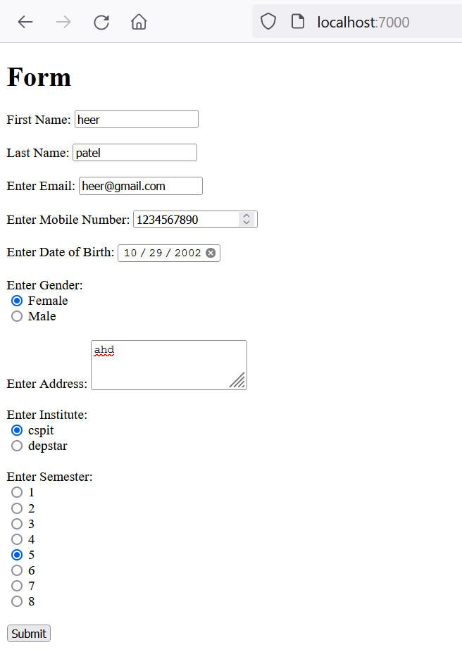

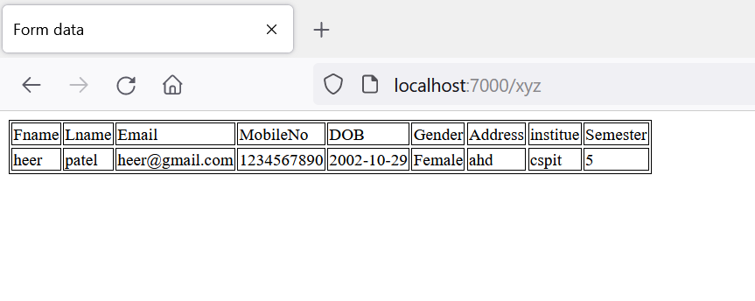

Validation:

