Definition:

Part-1

1. Create API
   1. Use JSON file which contains various products details such as product_id, product_name, product_type, product_image, product_quantity, product_cost and description.
   2. Create 5 products sets in JSON.
2. Display all product information on console and also on client browser. [ Create server first]
3. Define following routes to access page.
   1. localhost/ [Bydefault display default page as below]
   2. localhost/default
   3. localhost/api
   4. localhost/product
   5. localhost/product?id=0 [By default]
   6. localhost/anyother then display page not found with status code.

Part-2 [HTML template/placeholder] - Define placeholder and replace by the content dynamically

1. Create HTML temples for 1. Default page 2. Product page and 3. CardInfo page
   1. Default page: Display products information from JSON such as ID, Name, Type and Price in different cards/sections [You may use DIV/FIGURE]
   2. Default page contain tag like **20% Discount**on some specific products.
   3. Default page contain link like **more details to** view individual product information [Display remaining info from JSON]
   4. All the individual product with respective cards should be accessible using URI like localhost/product?id=0 and so on.
   5. Use proper CSS style or any bootstrap theme.
2. Upload Instruction: PDF file with code and screenshots of each output.

PART-1:

1. Product.json

[

    {

        "product_id":1,

        "product_name":"Ice-cream",

        "product_type":"eatable",

        "product_image":"🍦",

        "product_quantity":5,

        "product cost":100,

        "description":"Fresh ice cream made with premimum quality fruits."

    },

    {

        "product_id":2,

        "product_name":"rice",

        "product_type":"eatable",

        "product_image":"🌾",

        "product_quantity":"5 kg",

        "product cost":"500 per kg",

        "description":"Rice is from north eastern part of india"

    },

    {

        "product_id":3,

        "product_name":"cup cake",

        "product_type":"eatable",

        "product_image":"🧁",

        "product_quantity":40,

        "product cost":"50 per item",

        "description":"cup cakes are available in different 4 flavoures"

    },

    {

        "product_id":4,

        "product_name":"sushi",

        "product_type":"eatable",

        "product_image":"🍣",

        "product_quantity":30,

        "product cost":"80 per item",

        "description":"Sushi is one of the famous dishes"

    },

    {

        "product_id":5,

        "product_name":"salt",

        "product_type":"eatable",

        "product_image":"🧂",

        "product_quantity":"7 kg",

        "product cost":"20 per kg",

        "description":"salt is from western part of india"

    }

]

1. On console

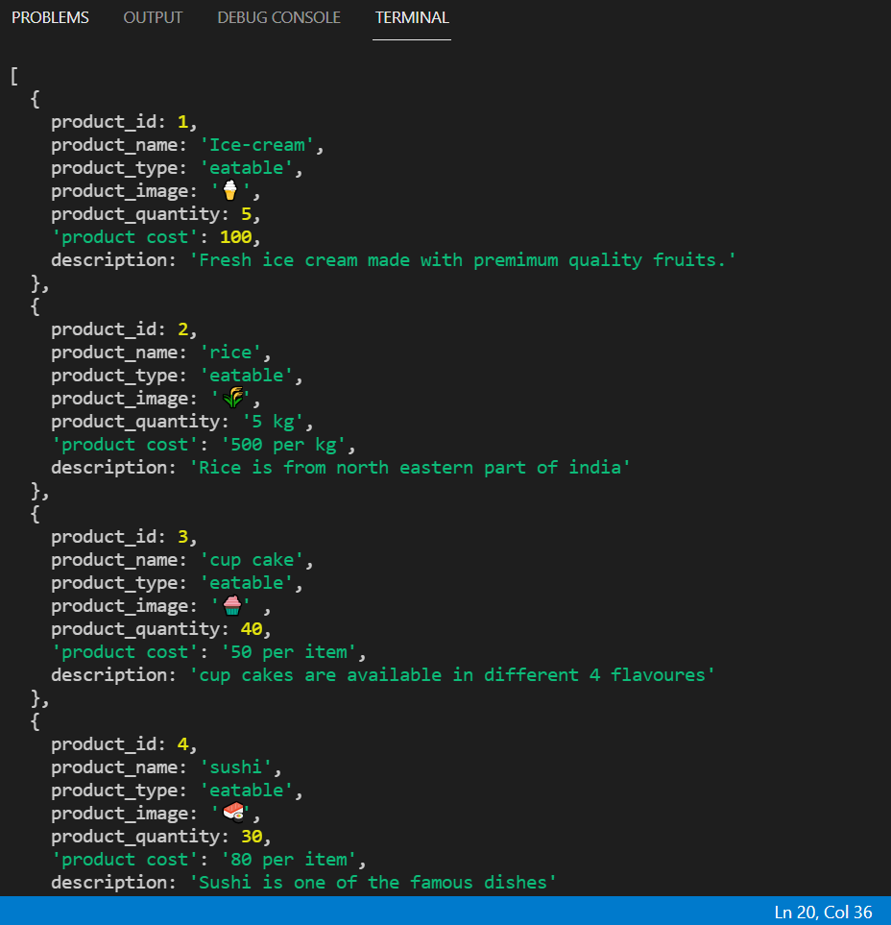

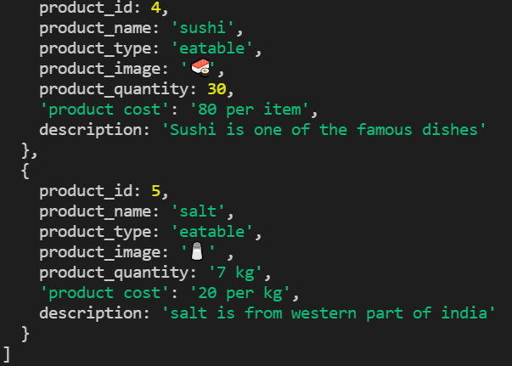

Index.js

const fs= require('fs')

const http= require('http')

const server = http.createServer((req,res)=>{

   // res.end('server call');

   const path = req.url;

    if(path === '/'){

        res.end("first page")

    }else if(path === '/default'){

        fs.readFile('default.html',function (err, data){

            res.writeHead(200, {'Content-Type': 'text/html','Content-Length':data.length});

            res.write(data);

            res.end();

        });

    }else if(path === '/product'){

        res.end("product page")

    }else if(path === '/api'){

        fs.readFile(`${__dirname}/product.json`,'utf-8',(err,data)=>{

            const productData = JSON.parse(data);

            console.log(productData);

            // res.writeHead(200,{ 'content-type' :'application/json'})

            // res.end(data)

        })

    }else{

        res.end("page not found")

    }

})

server.listen(3002,()=>{

    console.log("server is listening");

})

On Client Browser

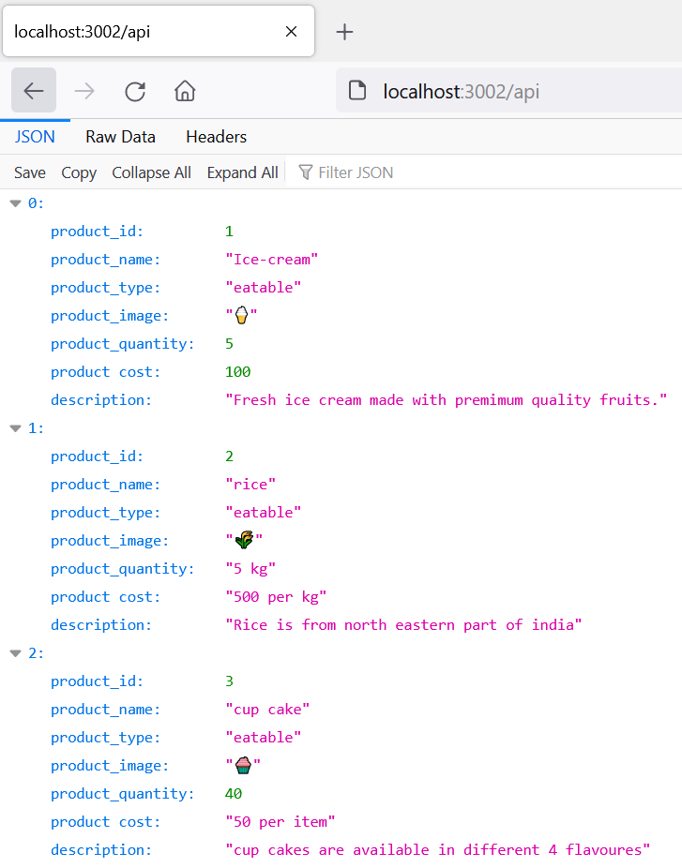

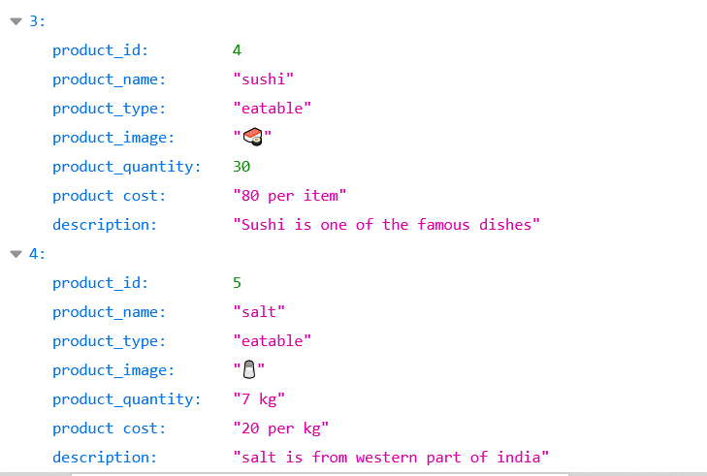

PART-2

1)localhost/default

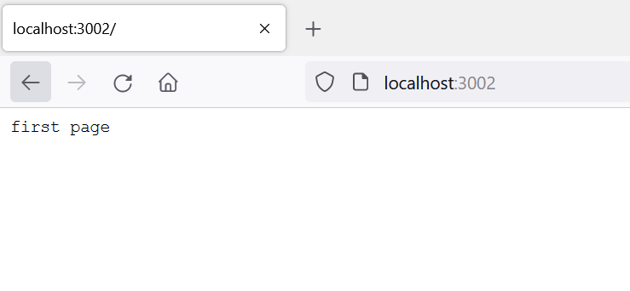

2)localhost/

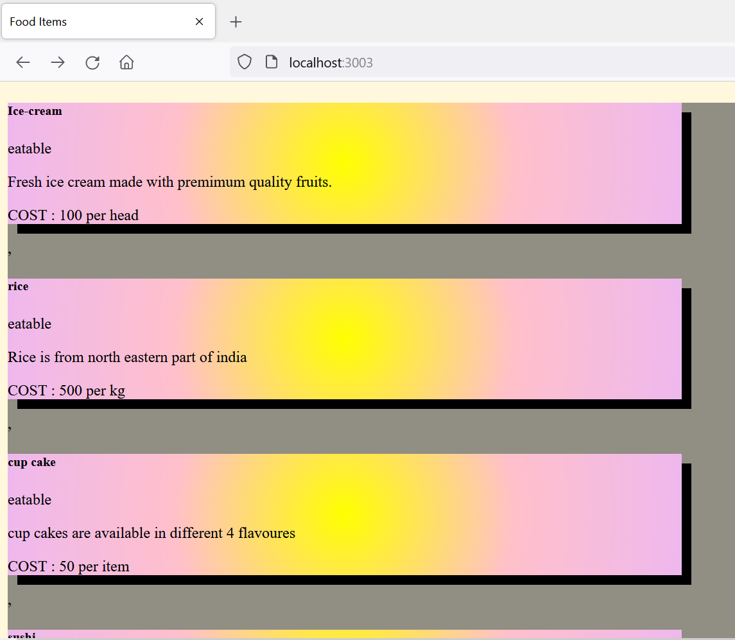

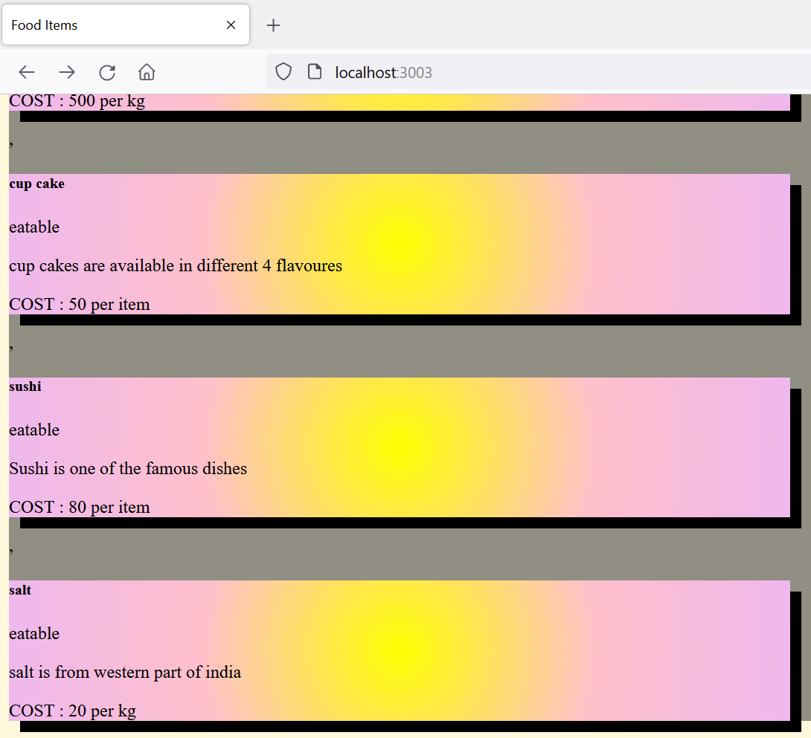

3)localhost/api





4)localhost/product

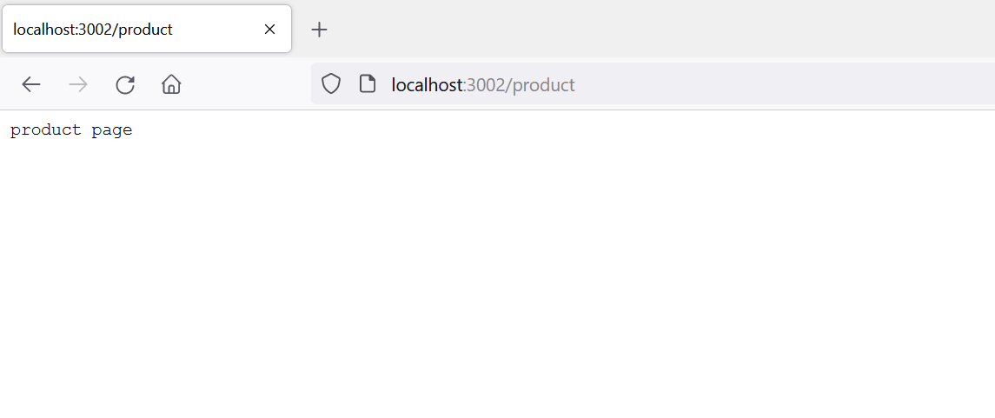

5)localhost/product?id=0

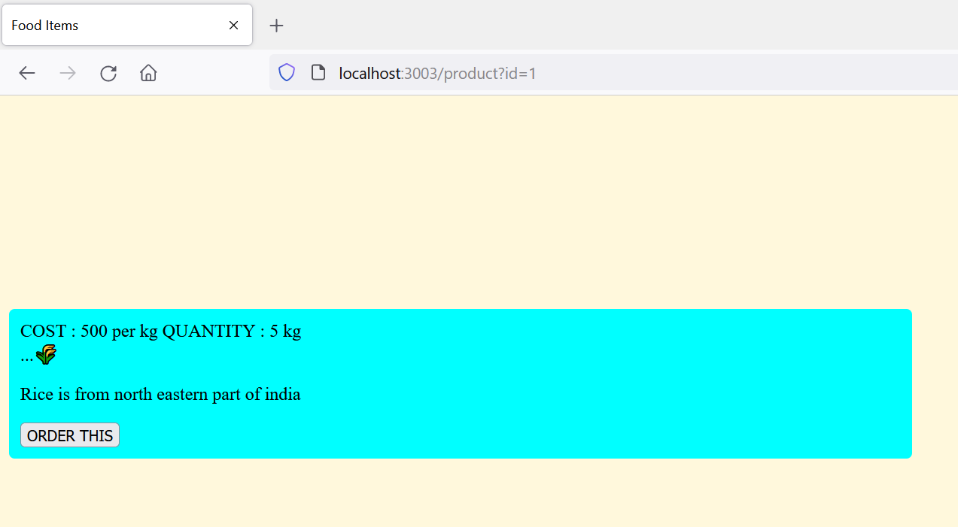

6)localhost/anyother

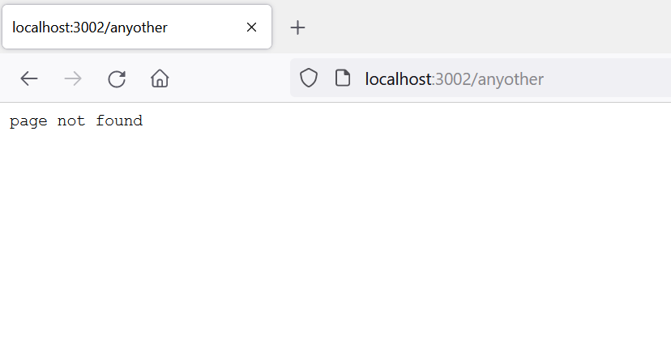

Product.html

<!DOCTYPE html>

<html lang="en">

<head>

 <meta charset="UTF-8">

 <meta http-equiv="X-UA-Compatible" content="IE=edge">

 <meta name="viewport" content="width=device-width, initial-scale=1.0">

 <link href="https://cdn.jsdelivr.net/npm/bootstrap@5.0.0-

beta2/dist/css/bootstrap.min.css" rel="stylesheet"

 integrity="sha384-

BmbxuPwQa2lc/FVzBcNJ7UAyJxM6wuqIj61tLrc4wSX0szH/Ev+nYRRuWlolflfl" crossorigi

n="anonymous">

 <title>Food Items</title>

 <style>

 .No-discount{

    display:none;

 }

 .margin-class{

    margin-top: 15%;

 }

 .outer-box{

     padding:10px;

     border-radius: 5px;

    background-color: cyan;

 }

 </style>

</head>

<body style="background-color:cornsilk;width: 1500px;height: 500px;"class="center margin-class" >

 <div class="card mb-lg-4" style="max-width: 800px;" class="cards">

 <div class="card-body outer-box">

 <span class="badge bg-primary ">COST : {%PRODUCTCOST%}</span>

 <span class="badge bg-danger">QUANTITY : {%PRODUCTQ%}</span>

 <span class="badge bgwarning {%NODISCOUNT%}">20% DISCOUNT</span>

 <div class="border-bottom mt-3"></div>

 <div id="carouselExampleInterval" class="carousel slide" data-bs-ride="carousel">

 <div class="carousel-inner">

 <div class="carousel-item " data-bs-interval="10000">

 <img class="d-block w-100" alt="...">{%IMAGE%}

 </div>

 </div>

 </div>

 <!-- <img src="https://images.moneycontrol.com/staticmcnews/2020/04/stock-in-the-news-770x433.jpg" class="img-fluid mb-2 mt2" alt="Responsive image"> -->

    <p class="card-text">{%DESCRIPTION%} </p>

    <div class="addthis_inline_share_toolbox"></div>

        <button type="button" class="btn btn-primary" data-bs-toggle="modal" data-bs-target="#exampleModal">ORDER THIS</button>

    </div>

 </div>

 <script src="https://cdn.jsdelivr.net/npm/bootstrap@5.0.0-

beta2/dist/js/bootstrap.bundle.min.js"

 integrity="sha384-

b5kHyXgcpbZJO/tY9Ul7kGkf1S0CWuKcCD38l8YkeH8z8QjE0GmW1gYU5S9FOnJ0"

 crossorigin="anonymous"></script>

 <script type="text/javascript"

 src="//s7.addthis.com/js/300/addthis_widget.js#pubid=ra60a607b2a29fdc53"></script>

</body>

</html

cardInfo.html

<style>

    .No-discount{

    display:none;

    }

    .box:hover{

        transition:scaleX(0.4);

    }

    </style>

   <a href="/product?id={%ID%}" style="text-decoration:none ; color:black">

    <div class="row g-0 box" style="background-image: radial-gradient(circle, yellow, pink,rgb(238, 184, 238));box-shadow: 10px 10px;">

    <div class="col-md-5 " style="background-image: url('https://source.unsplash.com/1600x900/?{%PRODUCTNAME%},{%PRODUCTTYPE%}');background-size: cover">

    </div>

    <div class="col-md-7 ">

        <div class="card-body">

            <h5 class="card-title">{%PRODUCTNAME%}</h5>

            <p>{%PRODUCTTYPE%}</p>

            <p class="card-text text-truncate">{%DESCRIPTION%}</p>

            <p class="card-text">COST : {%PRODUCTCOST%}</small></p>

            <li class="card-text {%NODISCOUNT%}">20% DISCOUNT </small></p>

            <b>👉Detail</b>

        </div>

    </div>

    </div>

   </a>

default.html

<!DOCTYPE html>

<html lang="en">

<head>

        <style>

            .cards {

            border: 3px solid black;

            padding: 10px;

            }

        </style>

 <meta charset="UTF-8">

 <meta http-equiv="X-UA-Compatible" content="IE=edge">

 <meta name="viewport" content="width=device-width, initial-scale=1.0">

 <link href="https://cdn.jsdelivr.net/npm/bootstrap@5.0.0-

beta2/dist/css/bootstrap.min.css" rel="stylesheet"

 integrity="sha384-

BmbxuPwQa2lc/FVzBcNJ7UAyJxM6wuqIj61tLrc4wSX0szH/Ev+nYRRuWlolflfl" crossorigi

n="anonymous">

 <title>Food Items</title>

</head>

<body style="background-color:cornsilk;width: 1400px;height:600px;" class="center" >

 <div class="container m-auto mt-3 row" style="background-color: rgb(145, 142, 131);">

 <div class="col-34">

 <div class="card mb-4" style="max-width: 700px;" class="cards">

 {%PRODUCT_CARDS%}

 </div>

 </div>

 </div>

 <script src="https://cdn.jsdelivr.net/npm/bootstrap@5.0.0-

beta2/dist/js/bootstrap.bundle.min.js"

 integrity="sha384-

b5kHyXgcpbZJO/tY9Ul7kGkf1S0CWuKcCD38l8YkeH8z8QjE0GmW1gYU5S9FOnJ0" crossorigi

n="anonymous">

 </script>

</body>

</html>

index.js

const fs= require('fs')

const http= require('http')

const url=require('url')

//non blocking way-synchronous

const replaceTemplate = (temp,product) => {

    let output;

    output = temp.replace(/{%PRODUCTNAME%}/g,product.product_name);

    output = output.replace(/{%DESCRIPTION%}/g,product.description);

    output = output.replace(/{%PRODUCTCOST%}/g,product.product_cost);

    output = output.replace(/{%IMAGE%}/g,product.product_image);

    output = output.replace(/{%ID%}/g,product.product_id);

    output = output.replace(/{%PRODUCTTYPE%}/g,product.product_type);

    output = output.replace(/{%PRODUCTQ%}/g,product.product_quantity);

    output = output.replace(/{%SID%}/g,product.product_id+1);

    if (!product.discount) output = output.replace(/{%NODISCOUNT%}/g,'No-discount');

    return output;

   }

   const tempOverview = fs.readFileSync(`${__dirname}/default.html`,'utf-8');

   const tempcards = fs.readFileSync(`${__dirname}/cardinfo.html`,'utf-8');

   const tempproduct = fs.readFileSync(`${__dirname}/productFile/product.html`,'utf-8');

//    const temperror = fs.readFileSync(`${__dirname}/pagenotfound.html`,'utf-8');

   const data=fs.readFileSync(`${__dirname}/data.json`,'utf-8');

   const dataObj = JSON.parse(data);

const server = http.createServer((req,res)=>{

   // res.end('server call');

    // const pathname = req.url;

   const { query , pathname}= url.parse(req.url,true);

    if(pathname === '/'){

        res.writeHead(200, {'Content-Type': 'text/html'})

        const cardsHtml = dataObj.map(el => replaceTemplate(tempcards,el));

        // console.log(cardsHtml);

        const output = tempOverview.replace('{%PRODUCT_CARDS%}',cardsHtml);

        // output = tempOverview.replace('{%PRODUCT_COST%}',cardsHtml.product_cost);

        // output = tempOverview.replace('{%DESCRIPTION%}',cardsHtml.description);

        res.end(output);

    }else if(pathname === '/default'){

        fs.readFile('default.html',function (err, data){

            res.writeHead(200, {'Content-Type': 'text/html','Content-Length':data.length});

            res.write(data);

            res.end();

        });

    }else if(pathname === '/product'){

        if(query.id === undefined){

            res.end('This is product page');

            }

            else{

            res.writeHead(200,{'content-type':'text/html'});

            console.log('query.id',query.id);

            const product = dataObj[query.id];

            const output = replaceTemplate(tempproduct,product);

            res.end(output);

            }

    }else if(pathname === '/api'){

        fs.readFile(`${__dirname}/product.json`,'utf-8',(err,data)=>{

            const productData = JSON.parse(data);

            console.log(productData);

            // res.writeHead(200,{ 'content-type' :'application/json'})

            // res.end(data)

        })

    }else{

        res.end("page not found")

    }

})

server.listen(3003,()=>{

    console.log("server is listening");

})