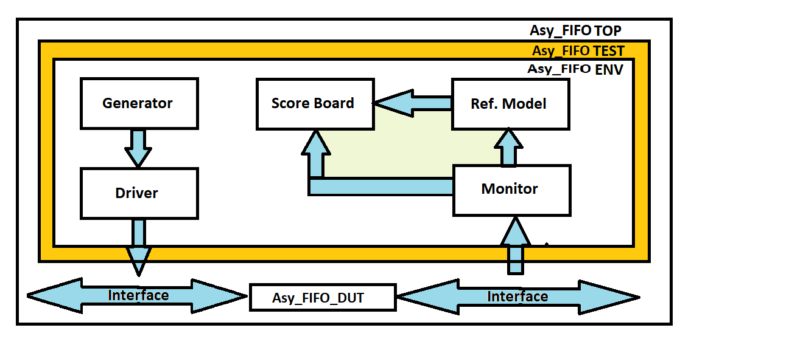

**Transaction Class: -**

* It’ s contains data members that represent the various signals or values that are part of the transaction.

**Generator: -**

* Responsible for stimulus/traffic (transaction items) generation and keep the same in mailbox which is further processed by driver.

i.e., stimulus generates randomly (preferred), through a file, hardcoded values, DPI

**Driver: -**

* Who's responsible to takes transaction or sequence level activity(stimulus) coming from generator and convert it into the pin or system level activity.
* Driver drives/provides this pin or system level activity to bus (interface) as per protocol.
* It basically drives input data to design adhering to the protocol.

**Monitor: -**

* Who's responsible to take pin or system level activity coming from bus (interface) and convert it into the transaction or sequence level activity.
* Monitor collect transaction or sequence level activity from bus (interface) as per the protocol.
* It basically sample/monitor interface data adhering to the protocol and send it to other component (i.e. scoreboard, reference model/predictor, coverage collector etc.)

**Reference Model: -**

* Reference model is a verification component where you wrote a logic to generate expected output (checker logics). (Predicting to output).

**Scoreboard: -**

* Scoreboard is responsible to check whether your design output is correct or not.
* It's collects expected value from reference model, actual value from monitor and compare those values and log the status.