|  |
| --- |
| **IT703**  Database Design and Implementation  Assignment 2 |



|  |  |
| --- | --- |
| **Daniel Kim / 2015004114, Min Ra / 2016009329** | **Date:30th OCT** |

Please sign the following statement: “We declare that this assignment submission will be our own work and we will not collude with anyone else on the preparation of this Assignment.”

|  |  |  |  |
| --- | --- | --- | --- |
| Item | Description | Max Marks | Result |
| GUI | Controls are easy to identify | 5 |  |
| Colours are easy on the eye |
| Design user friendly |
| Text readable |
| User Interaction | Intuitive | 5 |  |
| Easy to control |
| Conforms to known standards |
| Logical flow |
| Runs Error Free | You will lose marks for every error while demonstrating your software, so test it first! | 10 |  |
| Connected to a SQL Database | Reads from database | 10 |  |
| Writes to database |
| Can update data |
| Sum |  | 30 |  |

**Deliverables:**

Your team has been asked to develop a new web-based application for a hotel chain to be commissioned immediately by the Tomive Corporation. Your application will be tested in the first hotel to be completed and must be running bug-free before it will be accepted for the rest of the chain.

The user interface must be user-friendly and it is important to have a well-designed interface.

**Hotel**

Database (MS SQL)

# ERD

The system is for managing hotel rooms, housekeeping, user, guest and booking in hotel.

There are ten table for management and three tables for user.

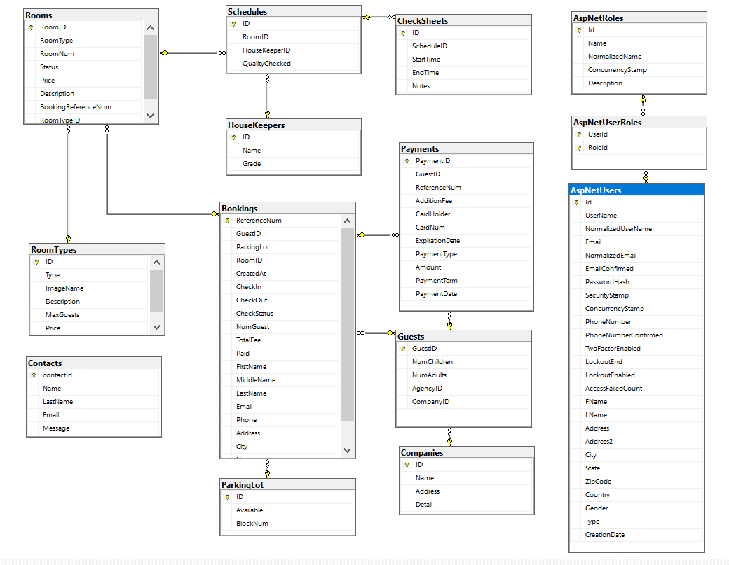

# Database Table

|  |
| --- |
| CREATE TABLE [dbo].[Bookings](  [ReferenceNum] [nvarchar](450) NOT NULL,  [GuestID] [nvarchar](450) NULL,  [ParkingLot] [bit] NOT NULL,  [RoomID] [nvarchar](max) NOT NULL,  [CreatedAt] [datetime2](7) NOT NULL,  [CheckIn] [datetime2](7) NOT NULL,  [CheckOut] [datetime2](7) NOT NULL,  [CheckStatus] [int] NOT NULL,  [NumGuest] [int] NOT NULL,  [TotalFee] [float] NOT NULL,  [Paid] [bit] NOT NULL,  [FirstName] [nvarchar](max) NOT NULL,  [MiddleName] [nvarchar](max) NULL,  [LastName] [nvarchar](max) NOT NULL,  [Email] [nvarchar](max) NOT NULL,  [Phone] [nvarchar](max) NULL,  [Address] [nvarchar](max) NULL,  [City] [nvarchar](max) NULL,  [Notes] [nvarchar](max) NULL,  [ParkingLotID] [nvarchar](450) NULL,  CONSTRAINT [PK_Bookings] PRIMARY KEY CLUSTERED  (  [ReferenceNum] ASC  )WITH (PAD_INDEX = OFF, STATISTICS_NORECOMPUTE = OFF, IGNORE_DUP_KEY = OFF, ALLOW_ROW_LOCKS = ON, ALLOW_PAGE_LOCKS = ON) ON [PRIMARY]  ) ON [PRIMARY] TEXTIMAGE_ON [PRIMARY] |

|  |
| --- |
| CREATE TABLE [dbo].[CheckSheets](  [ID] [nvarchar](450) NOT NULL,  [ScheduleID] [nvarchar](450) NULL,  [StartTime] [datetime2](7) NOT NULL,  [EndTime] [datetime2](7) NOT NULL,  [Notes] [nvarchar](max) NULL,  CONSTRAINT [PK_CheckSheets] PRIMARY KEY CLUSTERED  (  [ID] ASC  )WITH (PAD_INDEX = OFF, STATISTICS_NORECOMPUTE = OFF, IGNORE_DUP_KEY = OFF, ALLOW_ROW_LOCKS = ON, ALLOW_PAGE_LOCKS = ON) ON [PRIMARY]  ) ON [PRIMARY] TEXTIMAGE_ON [PRIMARY] |

|  |
| --- |
| CREATE TABLE [dbo].[Companies](  [ID] [nvarchar](450) NOT NULL,  [Name] [nvarchar](max) NOT NULL,  [Address] [nvarchar](max) NOT NULL,  [Detail] [nvarchar](max) NULL,  CONSTRAINT [PK_Companies] PRIMARY KEY CLUSTERED  (  [ID] ASC  )WITH (PAD_INDEX = OFF, STATISTICS_NORECOMPUTE = OFF, IGNORE_DUP_KEY = OFF, ALLOW_ROW_LOCKS = ON, ALLOW_PAGE_LOCKS = ON) ON [PRIMARY]  ) ON [PRIMARY] TEXTIMAGE_ON [PRIMARY] |

|  |
| --- |
| CREATE TABLE [dbo].[Contacts](  [contactId] [nvarchar](450) NOT NULL,  [Name] [nvarchar](max) NOT NULL,  [LastName] [nvarchar](max) NOT NULL,  [Email] [nvarchar](max) NOT NULL,  [Message] [nvarchar](max) NOT NULL,  CONSTRAINT [PK_Contacts] PRIMARY KEY CLUSTERED  (  [contactId] ASC  )WITH (PAD_INDEX = OFF, STATISTICS_NORECOMPUTE = OFF, IGNORE_DUP_KEY = OFF, ALLOW_ROW_LOCKS = ON, ALLOW_PAGE_LOCKS = ON) ON [PRIMARY]  ) ON [PRIMARY] TEXTIMAGE_ON [PRIMARY] |

|  |
| --- |
| CREATE TABLE [dbo].[HouseKeepers](  [ID] [nvarchar](450) NOT NULL,  [Name] [nvarchar](max) NOT NULL,  [Grade] [nvarchar](max) NOT NULL,  CONSTRAINT [PK_HouseKeepers] PRIMARY KEY CLUSTERED  (  [ID] ASC  )WITH (PAD_INDEX = OFF, STATISTICS_NORECOMPUTE = OFF, IGNORE_DUP_KEY = OFF, ALLOW_ROW_LOCKS = ON, ALLOW_PAGE_LOCKS = ON) ON [PRIMARY]  ) ON [PRIMARY] TEXTIMAGE_ON [PRIMARY] |

|  |
| --- |
| CREATE TABLE [dbo].[ParkingLot](  [ID] [nvarchar](450) NOT NULL,  [Available] [bit] NOT NULL,  [BlockNum] [nvarchar](max) NOT NULL,  CONSTRAINT [PK_ParkingLot] PRIMARY KEY CLUSTERED  (  [ID] ASC  )WITH (PAD_INDEX = OFF, STATISTICS_NORECOMPUTE = OFF, IGNORE_DUP_KEY = OFF, ALLOW_ROW_LOCKS = ON, ALLOW_PAGE_LOCKS = ON) ON [PRIMARY]  ) ON [PRIMARY] TEXTIMAGE_ON [PRIMARY] |

|  |
| --- |
| CREATE TABLE [dbo].[Payments](  [PaymentID] [nvarchar](450) NOT NULL,  [GuestID] [nvarchar](450) NULL,  [ReferenceNum] [nvarchar](450) NULL,  [AdditionFee] [int] NOT NULL,  [CardHolder] [nvarchar](max) NOT NULL,  [CardNum] [nvarchar](max) NOT NULL,  [ExpirationDate] [datetime2](7) NOT NULL,  [PaymentType] [int] NOT NULL,  [Amount] [float] NOT NULL,  [PaymentTerm] [nvarchar](max) NOT NULL,  [PaymentDate] [datetime2](7) NOT NULL,  CONSTRAINT [PK_Payments] PRIMARY KEY CLUSTERED  (  [PaymentID] ASC  )WITH (PAD_INDEX = OFF, STATISTICS_NORECOMPUTE = OFF, IGNORE_DUP_KEY = OFF, ALLOW_ROW_LOCKS = ON, ALLOW_PAGE_LOCKS = ON) ON [PRIMARY]  ) ON [PRIMARY] TEXTIMAGE_ON [PRIMARY] |

|  |
| --- |
| CREATE TABLE [dbo].[Rooms](  [RoomID] [nvarchar](450) NOT NULL,  [RoomType] [int] NOT NULL,  [RoomNum] [nvarchar](max) NOT NULL,  [Status] [int] NOT NULL,  [Price] [float] NOT NULL,  [Description] [nvarchar](max) NULL,  [BookingReferenceNum] [nvarchar](450) NULL,  [RoomTypeID] [nvarchar](450) NULL,  CONSTRAINT [PK_Rooms] PRIMARY KEY CLUSTERED  (  [RoomID] ASC  )WITH (PAD_INDEX = OFF, STATISTICS_NORECOMPUTE = OFF, IGNORE_DUP_KEY = OFF, ALLOW_ROW_LOCKS = ON, ALLOW_PAGE_LOCKS = ON) ON [PRIMARY]  ) ON [PRIMARY] TEXTIMAGE_ON [PRIMARY] |

|  |
| --- |
| CREATE TABLE [dbo].[RoomTypes](  [ID] [nvarchar](450) NOT NULL,  [Type] [int] NOT NULL,  [ImageName] [nvarchar](max) NULL,  [Description] [nvarchar](max) NULL,  [MaxGuests] [int] NOT NULL,  [Price] [int] NOT NULL,  CONSTRAINT [PK_RoomTypes] PRIMARY KEY CLUSTERED  (  [ID] ASC  )WITH (PAD_INDEX = OFF, STATISTICS_NORECOMPUTE = OFF, IGNORE_DUP_KEY = OFF, ALLOW_ROW_LOCKS = ON, ALLOW_PAGE_LOCKS = ON) ON [PRIMARY]  ) ON [PRIMARY] TEXTIMAGE_ON [PRIMARY] |

|  |
| --- |
| CREATE TABLE [dbo].[AspNetRoles](  [Id] [nvarchar](450) NOT NULL,  [Name] [nvarchar](256) NULL,  [NormalizedName] [nvarchar](256) NULL,  [ConcurrencyStamp] [nvarchar](max) NULL,  [Description] [nvarchar](max) NULL,  CONSTRAINT [PK_AspNetRoles] PRIMARY KEY CLUSTERED  (  [Id] ASC  )WITH (PAD_INDEX = OFF, STATISTICS_NORECOMPUTE = OFF, IGNORE_DUP_KEY = OFF, ALLOW_ROW_LOCKS = ON, ALLOW_PAGE_LOCKS = ON) ON [PRIMARY]  ) ON [PRIMARY] TEXTIMAGE_ON [PRIMARY] |

|  |
| --- |
| CREATE TABLE [dbo].[AspNetUsers](  [Id] [nvarchar](450) NOT NULL,  [UserName] [nvarchar](256) NULL,  [NormalizedUserName] [nvarchar](256) NULL,  [Email] [nvarchar](256) NULL,  [NormalizedEmail] [nvarchar](256) NULL,  [EmailConfirmed] [bit] NOT NULL,  [PasswordHash] [nvarchar](max) NULL,  [SecurityStamp] [nvarchar](max) NULL,  [ConcurrencyStamp] [nvarchar](max) NULL,  [PhoneNumber] [nvarchar](max) NULL,  [PhoneNumberConfirmed] [bit] NOT NULL,  [TwoFactorEnabled] [bit] NOT NULL,  [LockoutEnd] [datetimeoffset](7) NULL,  [LockoutEnabled] [bit] NOT NULL,  [AccessFailedCount] [int] NOT NULL,  [FName] [nvarchar](max) NULL,  [LName] [nvarchar](max) NULL,  [Address] [nvarchar](max) NULL,  [Address2] [nvarchar](max) NULL,  [City] [nvarchar](max) NULL,  [State] [nvarchar](max) NULL,  [ZipCode] [nvarchar](max) NULL,  [Country] [nvarchar](max) NULL,  [Gender] [nvarchar](max) NULL,  [Type] [nvarchar](max) NULL,  [CreationDate] [datetime2](7) NOT NULL,  CONSTRAINT [PK_AspNetUsers] PRIMARY KEY CLUSTERED  (  [Id] ASC  )WITH (PAD_INDEX = OFF, STATISTICS_NORECOMPUTE = OFF, IGNORE_DUP_KEY = OFF, ALLOW_ROW_LOCKS = ON, ALLOW_PAGE_LOCKS = ON) ON [PRIMARY]  ) ON [PRIMARY] TEXTIMAGE_ON [PRIMARY] |

|  |
| --- |
| CREATE TABLE [dbo].[AspNetUserRoles](  [UserId] [nvarchar](450) NOT NULL,  [RoleId] [nvarchar](450) NOT NULL,  CONSTRAINT [PK_AspNetUserRoles] PRIMARY KEY CLUSTERED  (  [UserId] ASC,  [RoleId] ASC  )WITH (PAD_INDEX = OFF, STATISTICS_NORECOMPUTE = OFF, IGNORE_DUP_KEY = OFF, ALLOW_ROW_LOCKS = ON, ALLOW_PAGE_LOCKS = ON) ON [PRIMARY]  ) ON [PRIMARY] |

# Web application demo

Main page of Hotel website



Searching for available Room with Check-in, Check-out date and Gust number

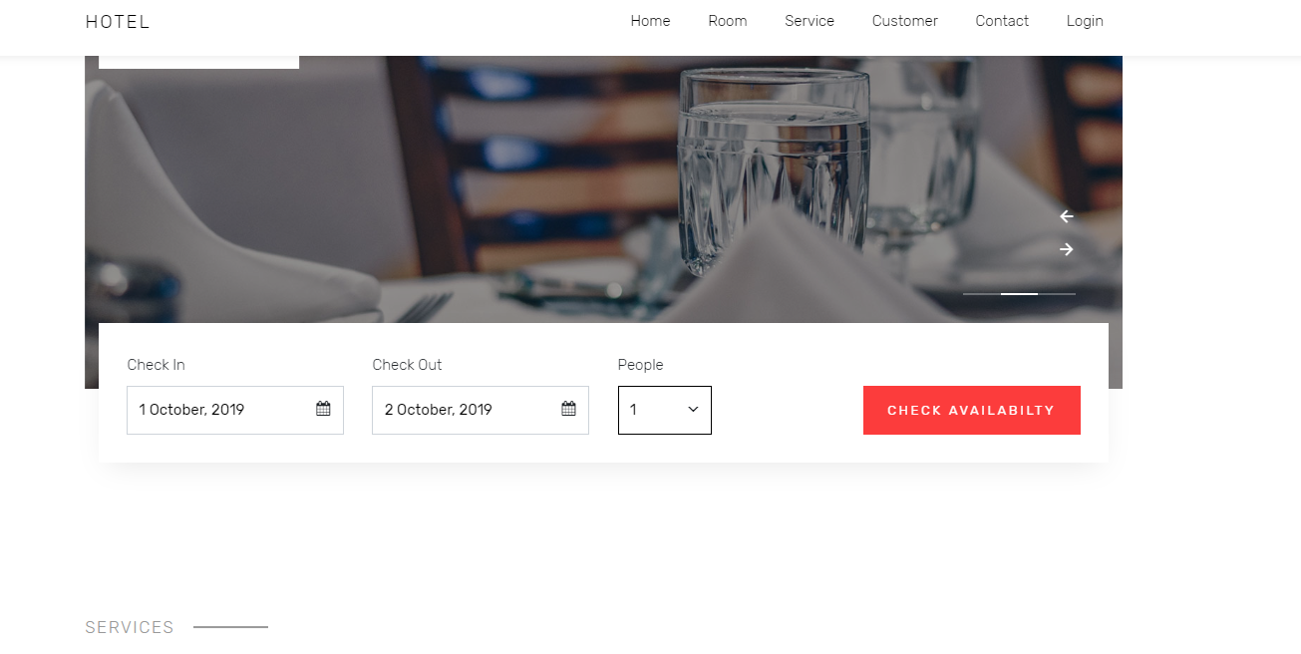

In database, there is Rooms table and 3 types such as single (max 2 people), two bed (max 4 people), superior (max 2 people).

Single room number is from R01 to R03, two bed room number is from R04 to R06, Superior room number is from R07 to R09

Total 9 rooms

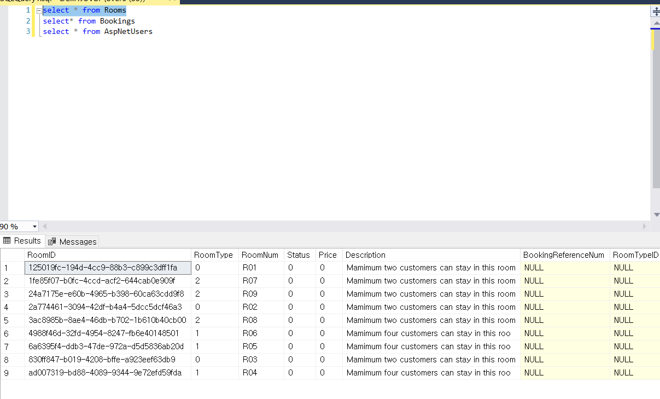

If click check availability button, then search result to show available room table based on the condition that the customer selected. For searching from database, we usedLINQ_ QUERY

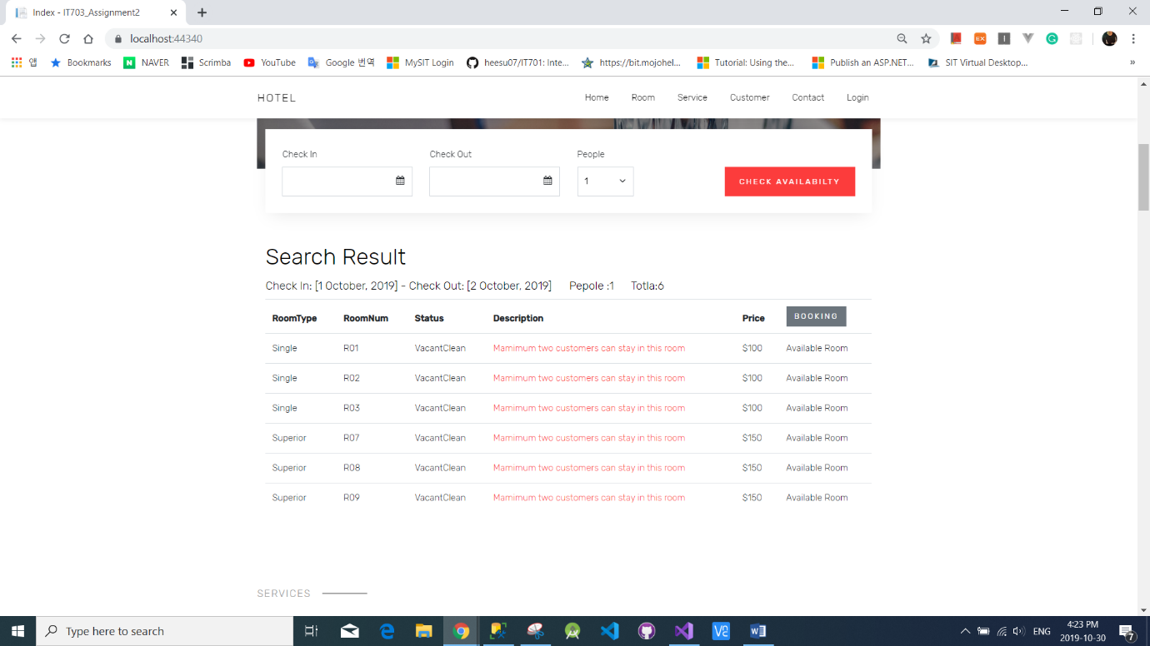

If the customer clicks the booking button, then the booking form will pop up and the customer needs to fill in the form for the booking room.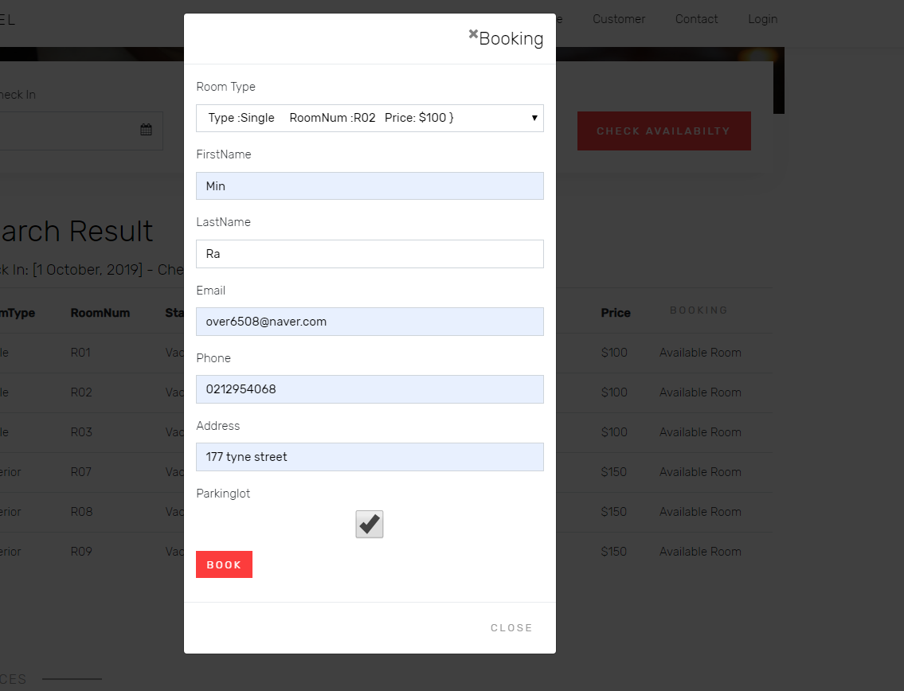

After that, Customer will get Booking Reference Number and customer can see the booking detail

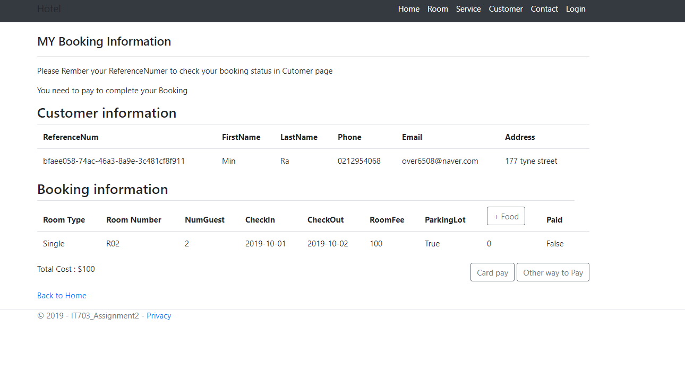

In database, booking data added in Bookings table

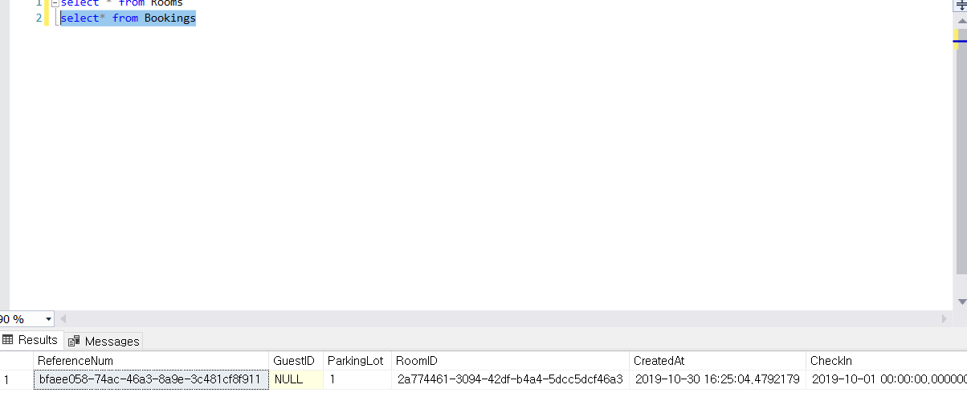

Option for food – Customer can add food and it will be added to total fee

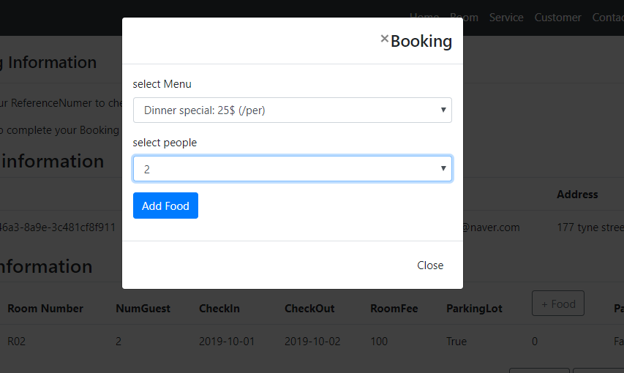

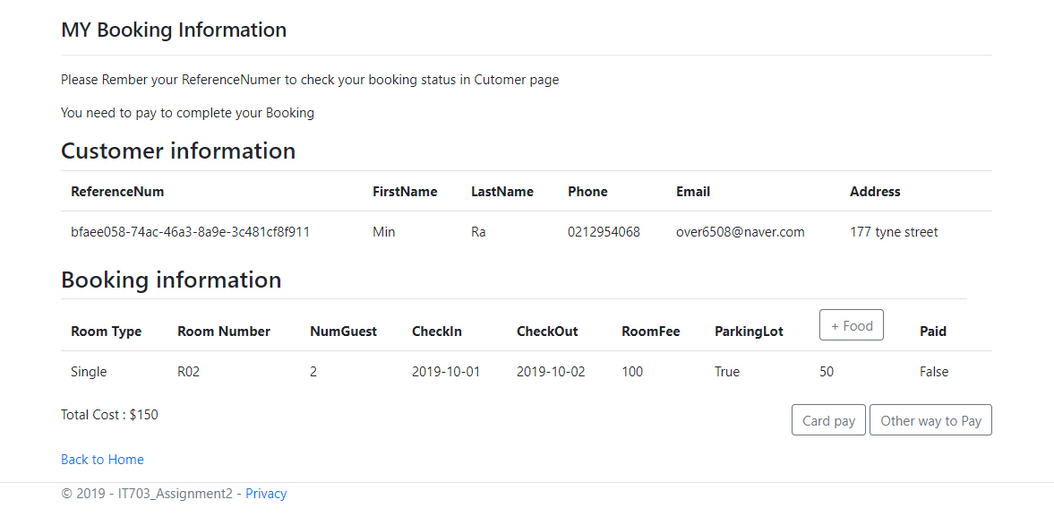

Option card pay – Customer can pay by using credit card

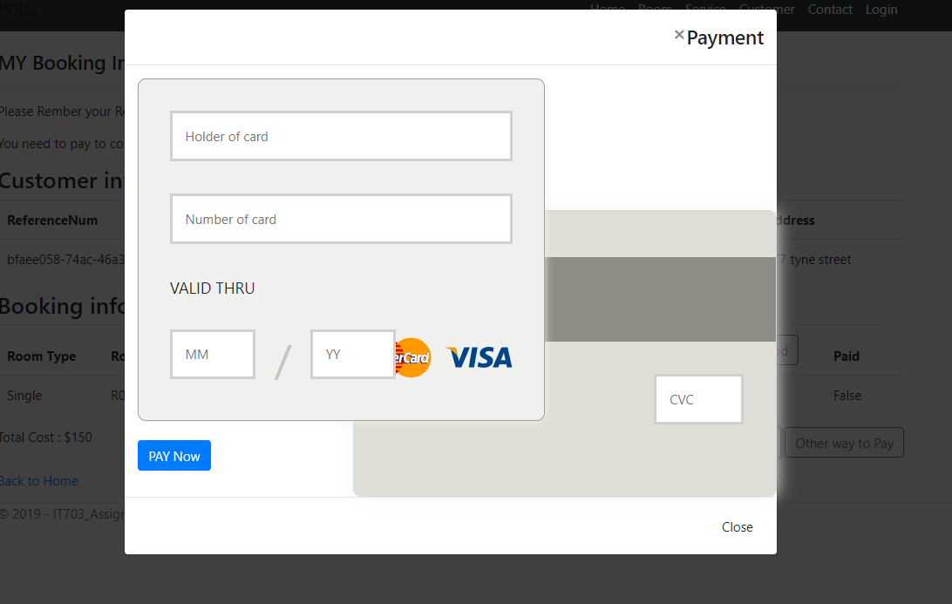

Option other way to pay – Customer can pay Cash and Voucher

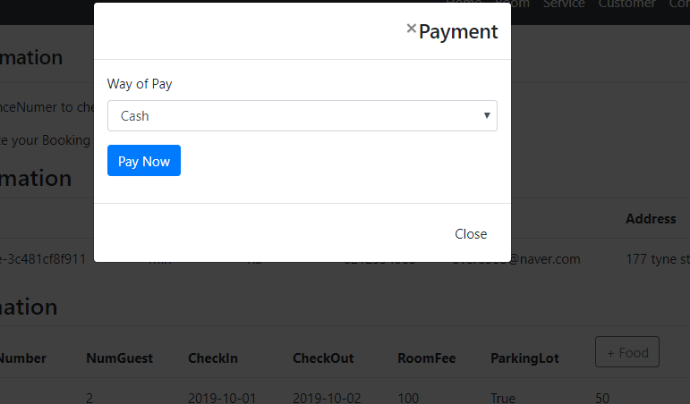

If Customer has Booking reference number, They can search their Booking information whenever in Customer page

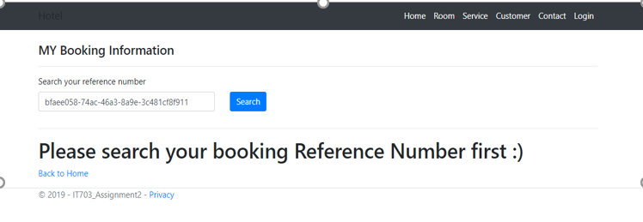

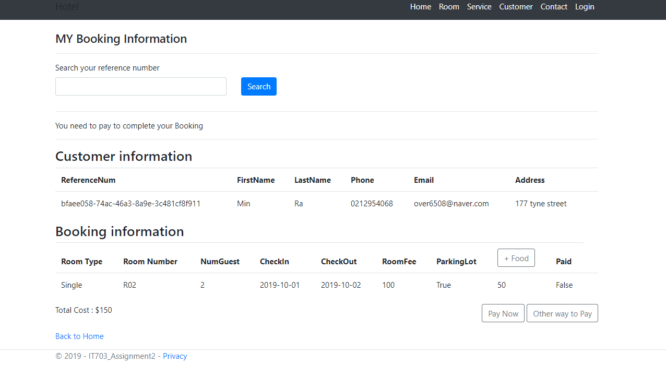

In database, there are 3type of user that need to login such as Manager, reception and housekeeper

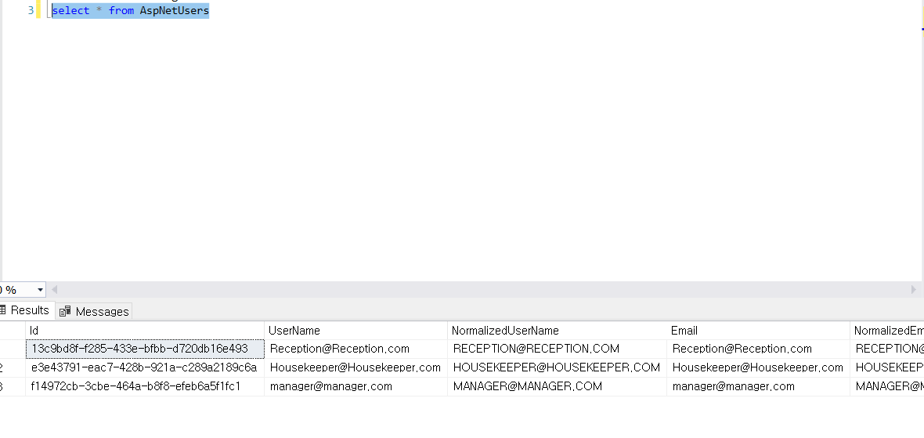

Manager and Reception – Manager and are, Reception required login

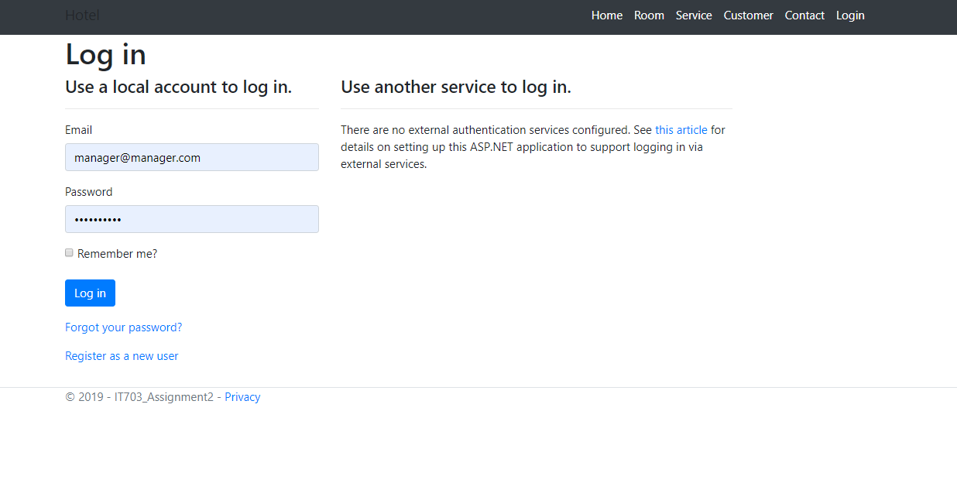

Manager and Reception, They can deal with Booking list data

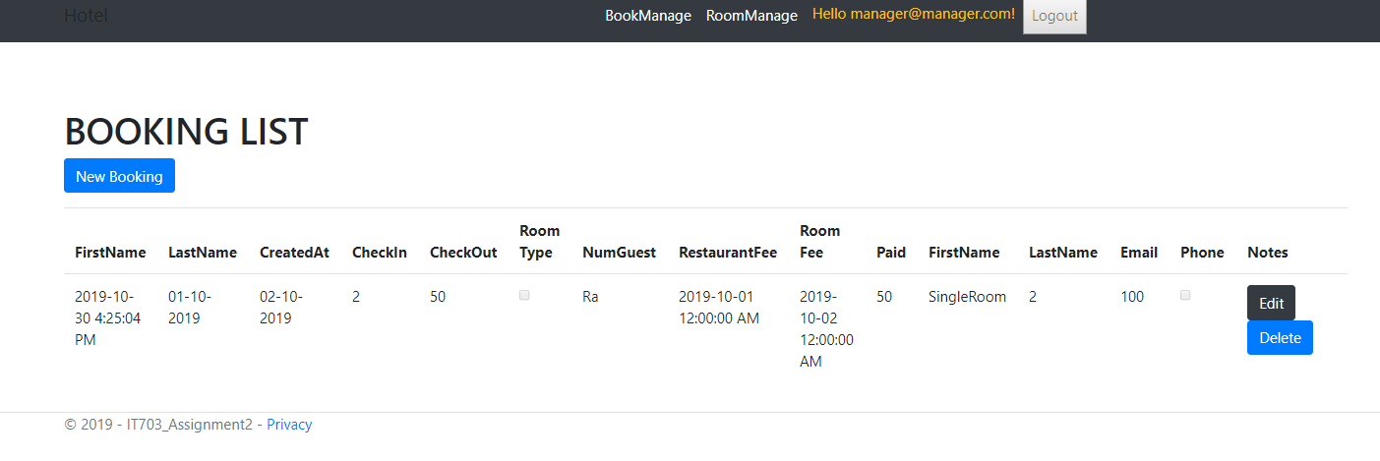

They can edit and delete Booking data like below capture images

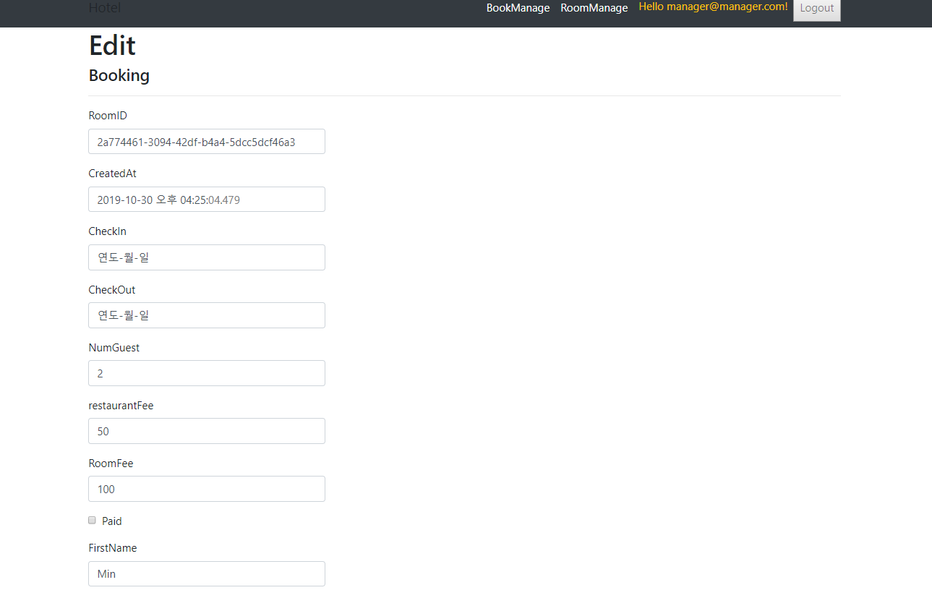

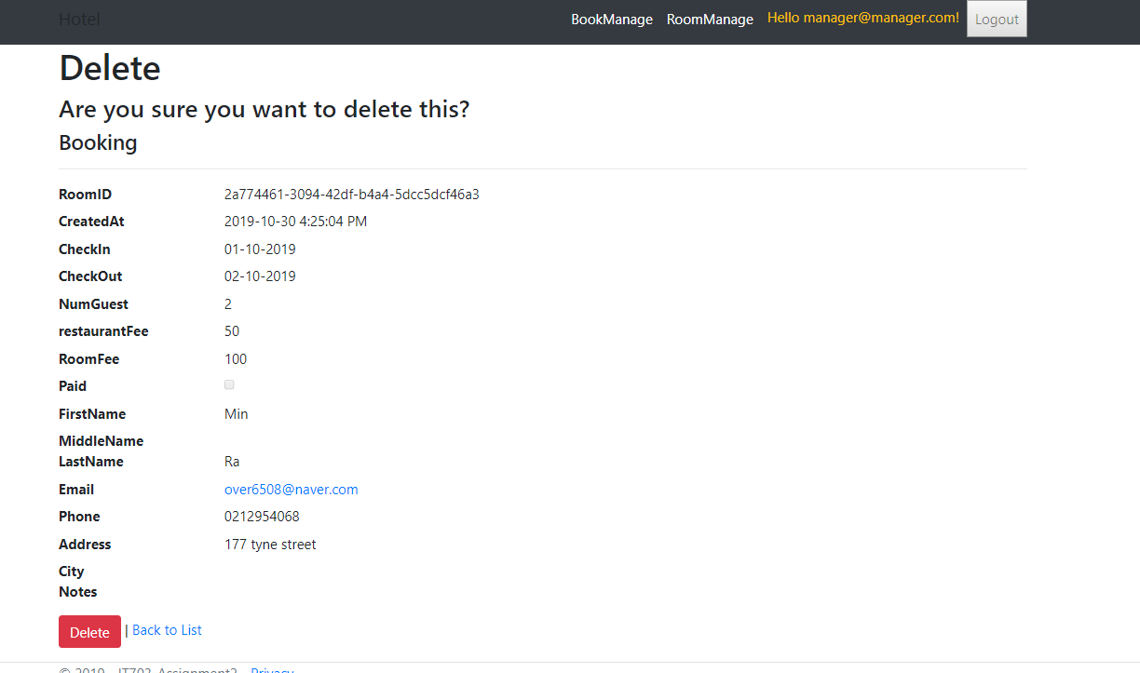

Manger, reception and housekeer – they can deal with Room list data

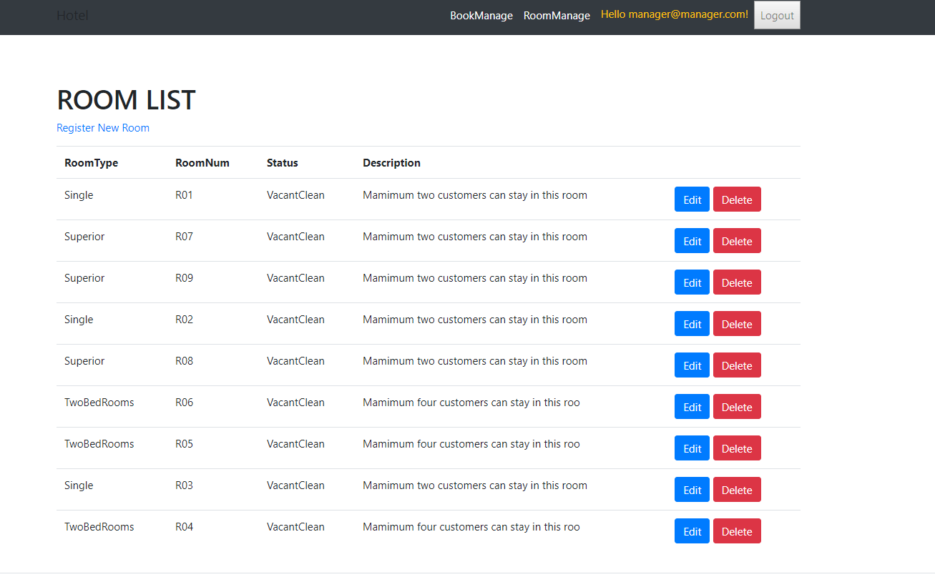

They can Edit room like Room number, status and description and delete the room data

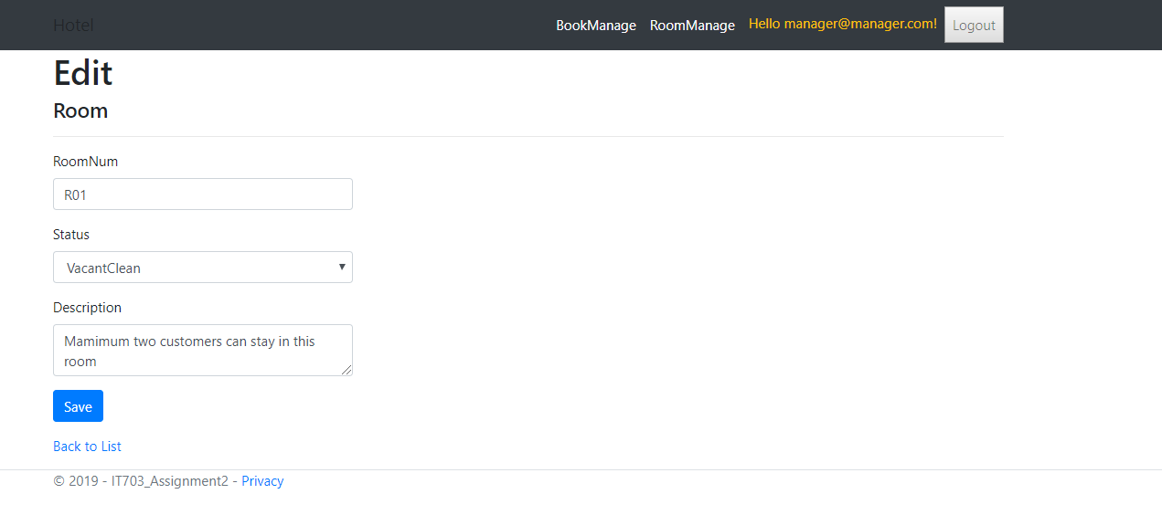 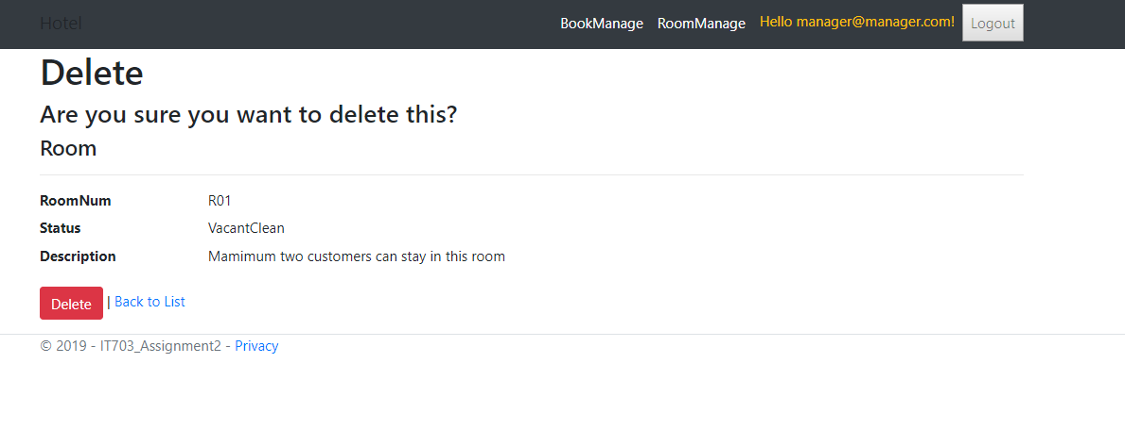

Conclusion

most of the features that mention in Assignment 2 Requirement was included in the MS SQL database. however, Website is not included all feature of the database that we made and we tried to do our best as much as we can