**Exp1 : Insertion and Deletion in an array**

**Aim: Write a program to insert an element and delete an element in an Array .**

**Theory:**

* Array is a container which can hold a fix number of items and these items should be of the same type.
* Most of the data structures make use of arrays to implement their algorithms. Following are the important terms to understand the concept of Array.

Element − Each item stored in an array is called an element.

Index − Each location of an element in an array has a numerical index, which is used to identify the element.

**Array Representation**

Arrays can be declared in various ways in different languages. For illustration, let's take C array declaration.

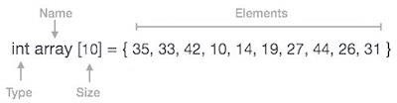

Arrays can be declared in various ways in different languages.

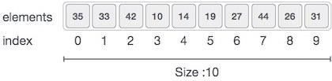

**Following are the important points to be considered.** Index starts with 0.

Array length is 10 which means it can store 10 elements. Each element can be accessed via its index.

**Basic Operations**

Following are the basic operations supported by an array.

**Traverse − print all the array elements one by one.**

**Insertion − Adds an element at the given index.**

**Deletion − Deletes an element at the given index.**

**Search − Searches an element using the given index or by the value. Update − Updates an element at the given index.**

**Procedure:**

Insertion Operation

Insert operation is to insert one or more data elements into an array. Based on the requirement, a new element can be added at the beginning, end, or any given index of array.

**Algorithm: Inserting new element in an array**

The algorithm INSERT will be declared as INSERT( LA, N, K, ITEM).

LA is a linear array with N elements and K is a positive integer such that K<=N.This algorithm inserts an element ITEM into the Kth position in LA.

**Step 1: [INITIALIZATION] SET J = N**

**Step 2: Repeat Steps 3 and 4 while J >= K**

**Step 3: [Move jth element downword] SET AL[J + 1] = AL[J]**

**Step 4: [Decrease Counter] SET J = J – 1**

**[End of step 2 loop]**

**Step 5: [Insert Element] SET LA[K]:= Item**

**Step 6: SET N = N + 1**

**Step 7: EXIT**

**Program:**

**OUTPUT:**

**Algorithm: Deleting an element from an array**

**The algorithm DELETE will be declared as DELETE ( LA, N, K,ITEM).**

**DELETE(LA,N,K,ITEM)**

Here LA is a linear array with N elements and K is a positive integer such that k<=N. this algorithm deletes the kth element from LA

**Step 1: Set ITEM:=LA[k]**

**Step 2: Reapeat for J=K to N-1:**

**[Move J+1st element upward.] SET LA[J]:= LA[J+1].**

**[End of loop]**

**Step 3: [Reset the number N of elements in LA.] SET N:=N-1**

**Step 4: EXIT**

**Program:**

**Output:**

**Conclusion**