# Linux Lab (SLA)

## 1. What is Linux and list its distributions.

Linux is a free and open-source operating system based on Unix, created by Linus Torvalds in 1991. It's known for its security, stability, and flexibility, making it popular for servers, desktops, and embedded systems.

  
  
**Popular Linux Distributions:**  
1. Ubuntu  
2. Debian  
3. Fedora  
4. CentOS  
5. Red Hat Enterprise Linux (RHEL)  
6. Arch Linux  
7. openSUSE  
8. Linux Mint  
9. Manjaro  
10. Zorin OS  
11. Elementary OS  
12. Kali Linux  
13. Gentoo  
14. Slackware  
15. MX Linux

## 2. Write the (atleast 5) features of any 5 Linux distributions.

**Ubuntu**  
1. User-Friendly  
2. LTS Versions  
3. Extensive Software Repository  
4. Community Support  
5. Regular Updates  
  
**Debian**  
1. Stability  
2. Package Management  
3. Security  
4. Flexibility  
5. Wide Architecture Support

  
  
**Fedora**  
1. Cutting-Edge Features  
2. Modular System  
3. Strong Security  
4. Developer-Friendly  
5. Regular Releases  
  
**Arch Linux**  
1. Rolling Release Model  
2. Customizability  
3. AUR (Arch User Repository)  
4. Minimalistic  
5. Detailed Documentation (Arch Wiki)

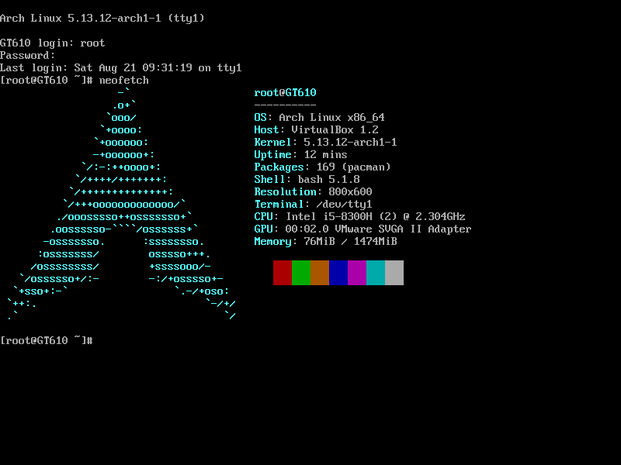  
  
**Linux Mint**  
1. User-Friendly Interface  
2. Pre-Installed Multimedia Codecs  
3. Cinnamon Desktop Environment  
4. Stability  
5. Software Manager

## 3. Compare Linux operating system with Windows OS. List 10 points or diagram.

1. Cost: Linux is free, while Windows requires a paid license.  
2. Open Source: Linux is open source, Windows is proprietary.  
3. Security: Linux is generally more secure due to its permission structure.  
4. Updates: Linux updates are user-controlled, Windows updates are often mandatory.  
5. Customizability: Linux offers greater customization options.  
6. Software Availability: Windows has a larger selection of commercial software.  
7. Hardware Compatibility: Windows supports a broader range of hardware out of the box.  
8. Community Support: Linux has strong community support and documentation.  
9. Performance: Linux can be more efficient and faster on older hardware.  
10. Use Cases: Linux is widely used for servers, while Windows dominates the desktop market.

## 4. List down the various applications of Linux OS (where it is deployed).

1. Web Servers  
2. Database Servers  
3. Cloud Computing  
4. Embedded Systems  
5. Desktop Computers  
6. Development Environments  
7. Supercomputers  
8. Network Routers and Firewalls  
9. IoT Devices  
10. Mobile Devices (e.g., Android)

## 5. Write about the file system of Linux OS. List the advantages and disadvantages of Linux OS.

**File System of Linux OS**:  
Linux uses various file systems such as ext3, ext4, XFS, Btrfs, and others, with ext4 being the most common. These file systems manage how data is stored and retrieved.  
  
**Advantages of Linux OS**:  
1. Free and Open Source  
2. Secure  
3. Stable and Reliable  
4. Flexible and Customizable  
5. Strong Community Support  
  
**Disadvantages of Linux OS**:  
1. Steeper Learning Curve  
2. Software Compatibility  
3. Hardware Compatibility  
4. Less User-Friendly for Beginners  
5. Limited Technical Support (for non-commercial versions)