CSS and CSS3

Q1) What are the benefits of using CSS?

CSS is used to give styling to the HTML elements.

CSS is stand for cascading style sheets and it allow us to style the web

Pages

With CSS we can create Responsive Design.

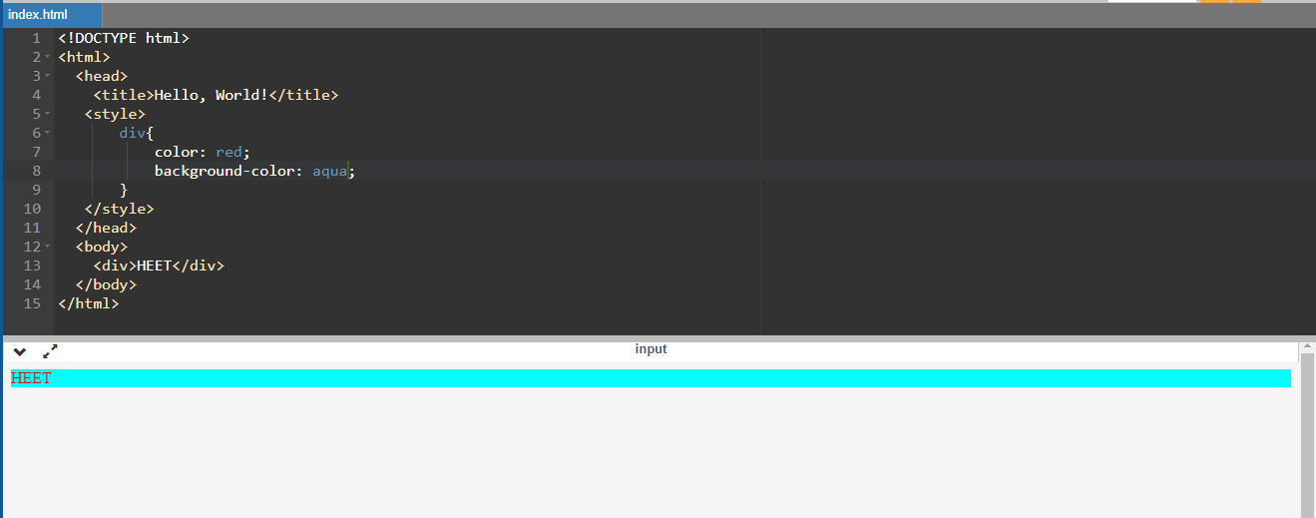

Q2) What are the disadvantages of CSS?

Using multiple css files can take long time to load the web page. Old browsers may not support CSS3.

CSS can be complex, especially for beginners. Learning to use CSS effectively

and efficiently may require time and effort, and understanding CSS layouts,

positioning, and specificity can be challenging.

Q 3) What is the difference between CSS2 and CSS3?

We can breakdown the code in modules in css3 but not in css2. Creating responsive design is not possible in css2 but in css3.

Selectors,Box-model ,Filters

Q 4) Name a few CSS style components ?

The few css style components are:

CSS style components also known as CSS properties or CSS attributes,

used to define visual presentation of HTML elements.

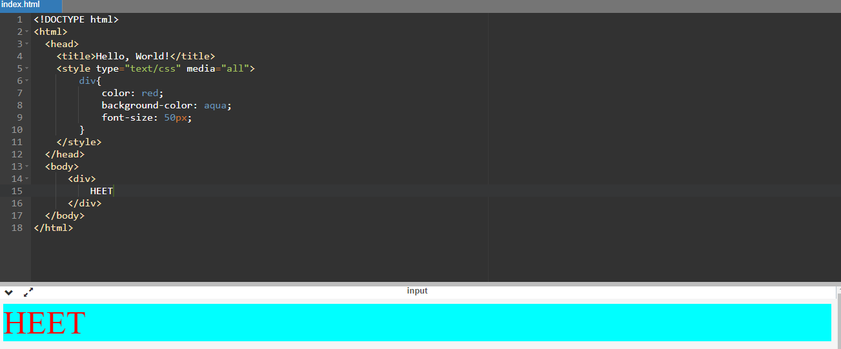

Q 5) What do you understand by CSS opacity?

The opacity property is used to define the transparency of an element.. Opacity is specified as a value between 0 and 1.

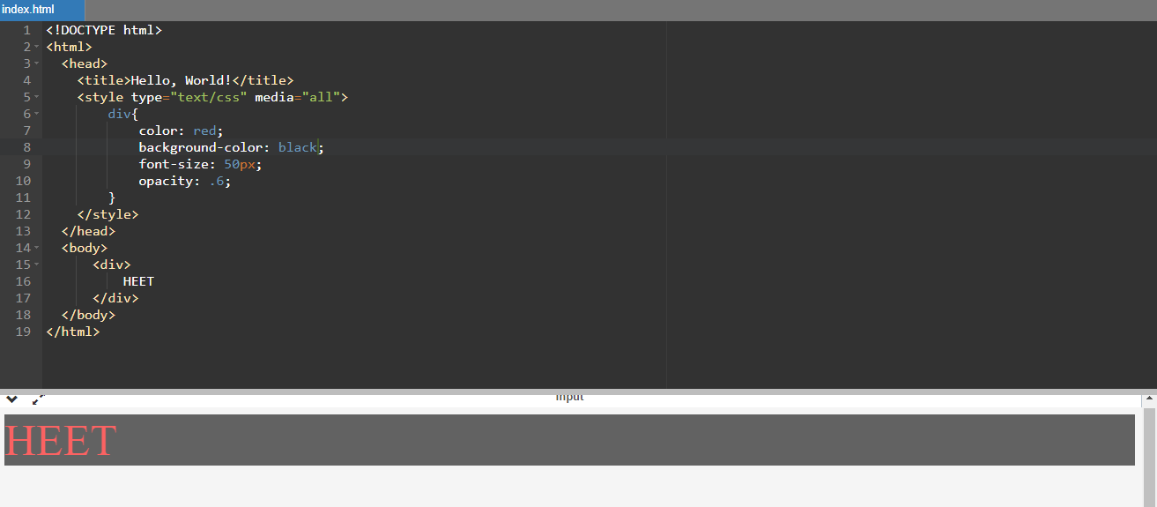

Q 6) How can the background color of an element be changed?

The background color can be changed by using “background-color”

property.

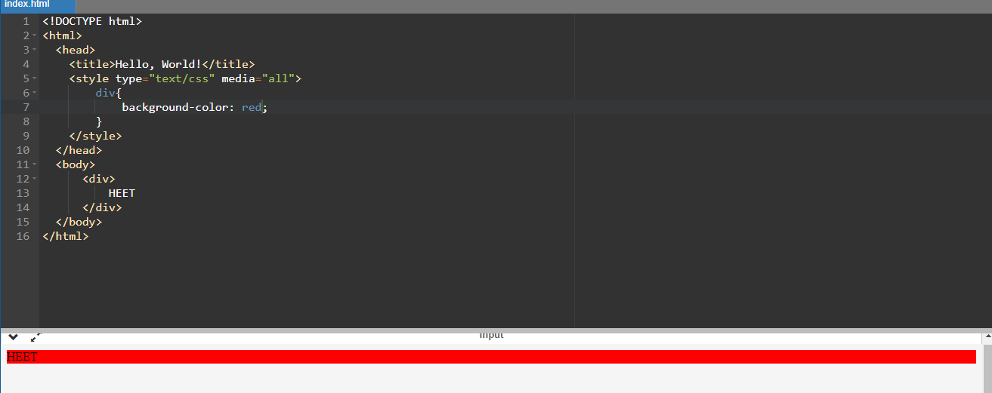

Q 7) How can image repetition of the backup be controlled?

We can stop image repetition of the background image with css property background-repeat: no-repeat;

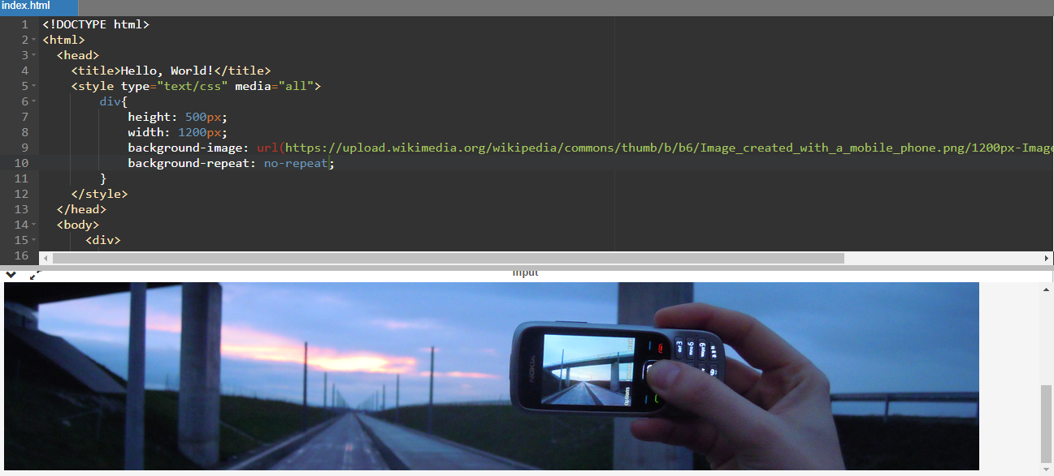

Q 8) What is the use of the background-position property?

background-position property is used to put the position in the four directions such as top, left, right, bottom.

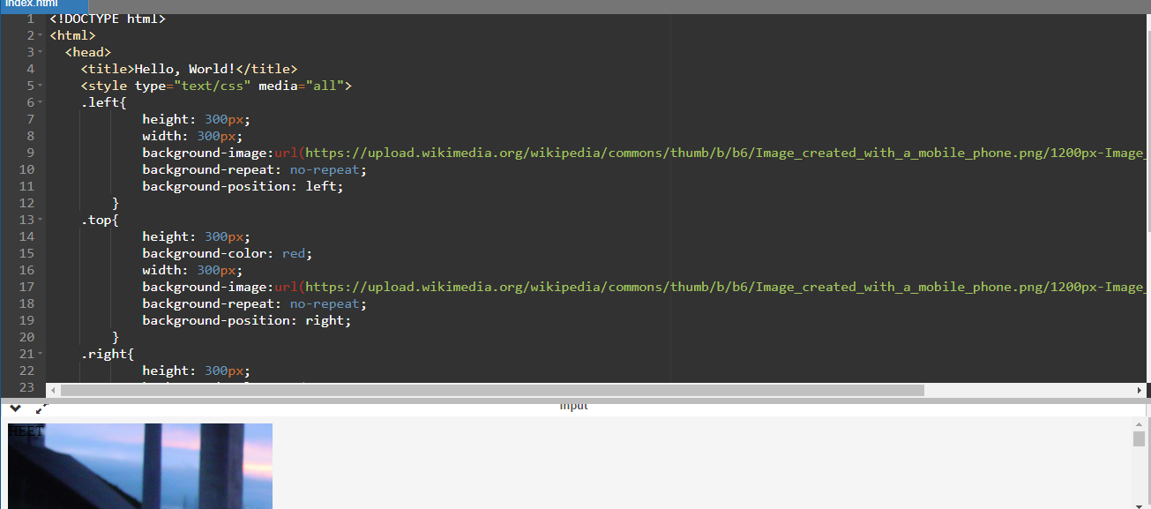

Q 9) Which property controls the image scroll in the background?

The property to control background in CSS is “background-attachment”

“background-attachment: scroll”: This causes the background image to scroll along with the content as the user scroll down the page.

“background-attachment: fixed”: This causes the background image remain fixed in place relative to the viewport.

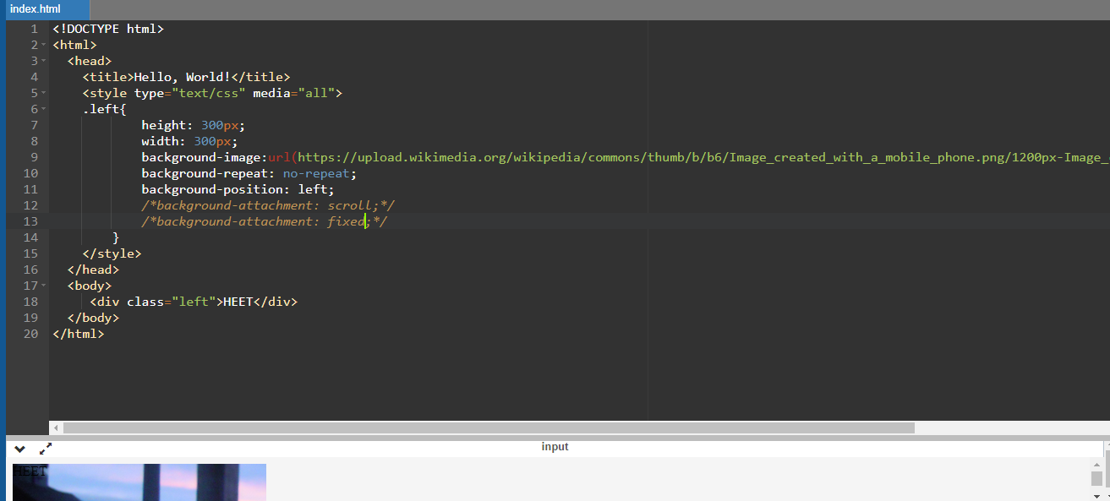

Q10) Why should background and color be used as separate properties?

We use background-color property to change the color of the background, while color property is only used to change the color of the font.

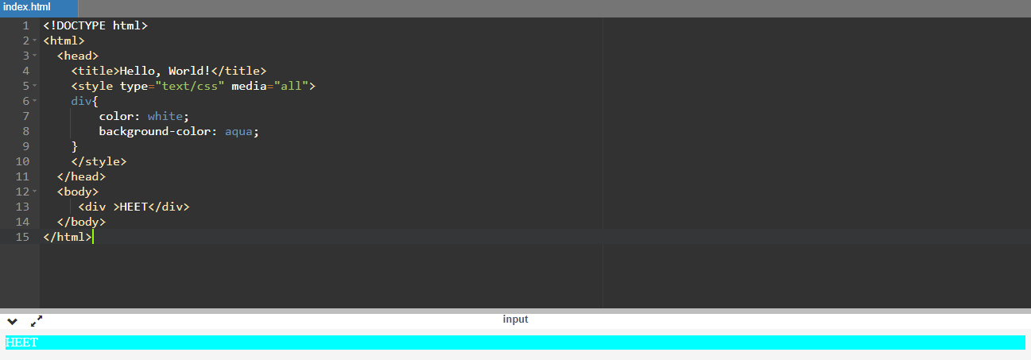

Q 11) How to center block elements using CSS1?

This is because the default width of block elements is 100% of the whole screen.

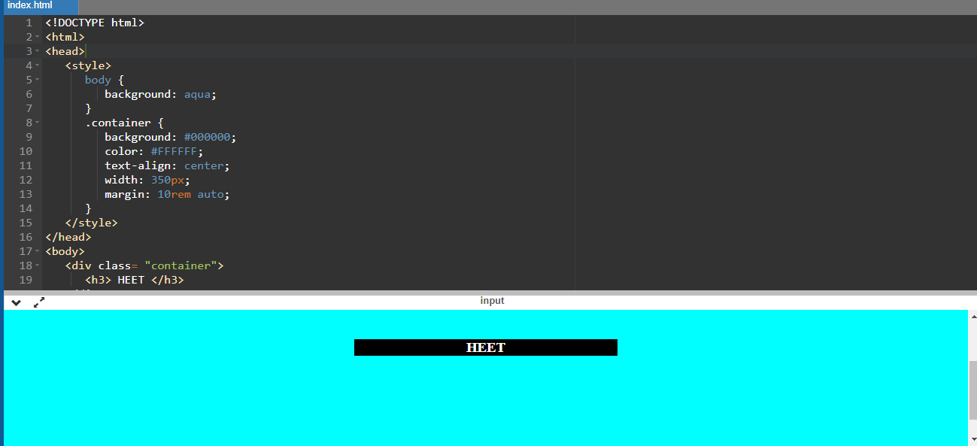

Q 12) How to maintain the CSS specifications?

* If the css code is larger than 400 lines then the html could should use external css file.
* Organize your CSS code into modular files or components. This makes it

easier to manage and maintain your styles, especially in larger projects.

* Keep up-to-date with the latest CSS specifications and developments. Follow resources like the official W3C (World Wide Web Consortium) website, web development blogs, and CSS-related forums or social media channels.

Q 13) What are the ways to integrate CSS in a web page?

There Are 3 Ways To Integrate CSS

1.Inline

2.Internal

3.External

1. We can apply CSS within the html document (within html opening tag) using style attribute. This method is not recommended for large-scale projects but can be used for quick styling adjustments.

2. Internal CSS can be defined within the “<style>” element in HTML document’s head section. It allows you to define CSS rules specific to that page.

3. External CSS involves creating a separate CSS file with the “.css” extension and linking it to the HTML document using the <link> element. This method promotes modularity and reusability of styles.

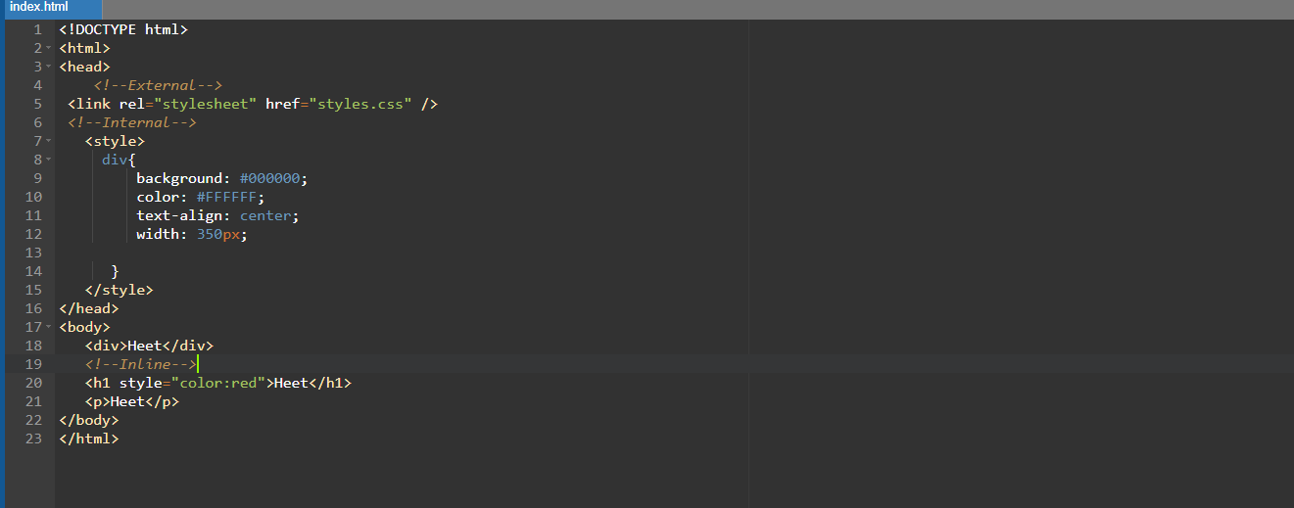

Q 14) What is embedded style sheets?

* Embedded style sheets, also known as “internal style sheets”
* Embedded style sheets means css code inside the style tag in the same html document.

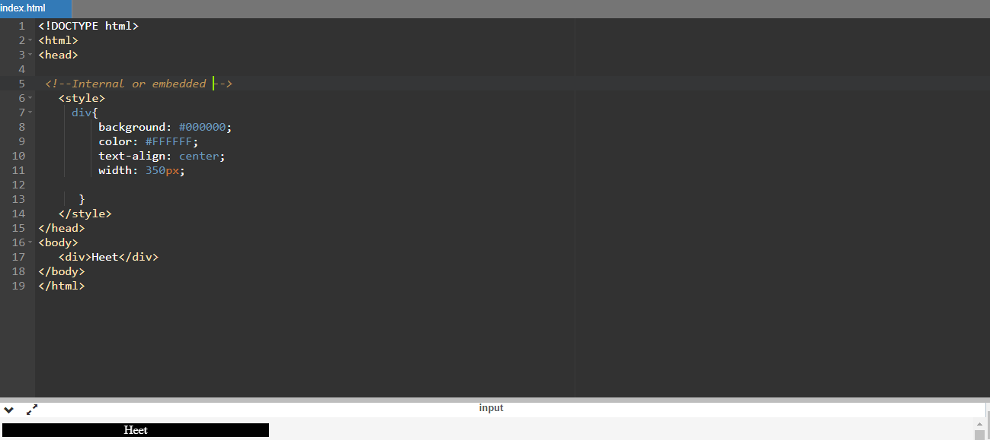

Q 15) What are the external style sheets?

External style sheets means to load CSS from different files

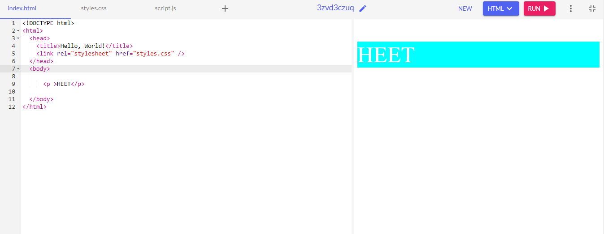

Q 16) What are the advantages and disadvantages of using external style sheets?

Advantage:

* It makes the code cleaner.
* Easy to read
* Styles are separated from the HTML content, making it easier to update the styling of your website.

Disadvantage:

* It can increase the network load.
* CSS on the page will not be applied until the css is loaded correctly.
* Managing multiple external CSS files and understanding how they interact with each other can be challenging for beginners.

Q 17) What is the meaning of the CSS selector?

In CSS a selector is a pattern or expression used to target and select specific HTML elements within an HTML document.

Element Selectors: ex H1,P

Class Selectors: <p class=”One”> .One{…}

ID Selectors: <p id=”One”> #One{…}

Group Selector: h1,h2

Universal Selector: target full body (\*)

Q 18) What are the media types allowed by CSS?

The media types allowed by CSS are Default, screen, print, speech, aural, braille. The most common used one is screen and print is also used as per its need.

screen media css can be written to style web page as per width of multiple devices.

* 320px — 480px: Mobile devices
* 481px — 768px: iPads, Tablets
* 769px — 1024px: Small screens, laptops
* 1025px — 1200px: Desktops, large screens
* 1201px and more —  Extra large screens, TV

Q 19) What is the rule set?

A CSS rule set contains one or more selectors and one or more declarations

A rule set, also known simply as a &quot;CSS rule,&quot; is a fundamental building block of CSS. It consists of a selector and one or more declarations, which define how selected HTML elements should be styled. Here&#39;s the basic structure of a CSS rule set

selector {

property1: value1;

property2: value2;

/\* Additional properties and values \*/

}