# **Web Development (Module - 3 HTML)**

**Q1: Are the HTML tags and elements the same thing?**

**Ans**: HTML tags are building blocks of an HTML document. They are enclosed in angle brackets (<>).HTML Tags consist of an opening tag and closing tag. And HTML elements are made up of HTML tags and the content between them. 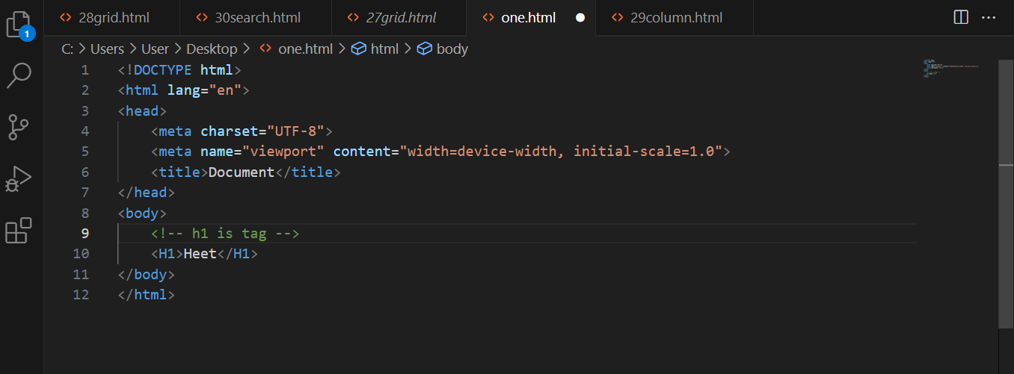

-> In this <h1> is starting tag and </h1> is closing tag and together starting tag, ending tag and in between content called HTML Element.

**Q2: What are tags and attributes in HTML?**

**Ans:**

Tag They are enclosed in angle brackets (<>).HTML Tags consist of an opening tag and closing tag

Attributes: Attributes are special words used to describe more about tags,

Such as height and width.

e.g.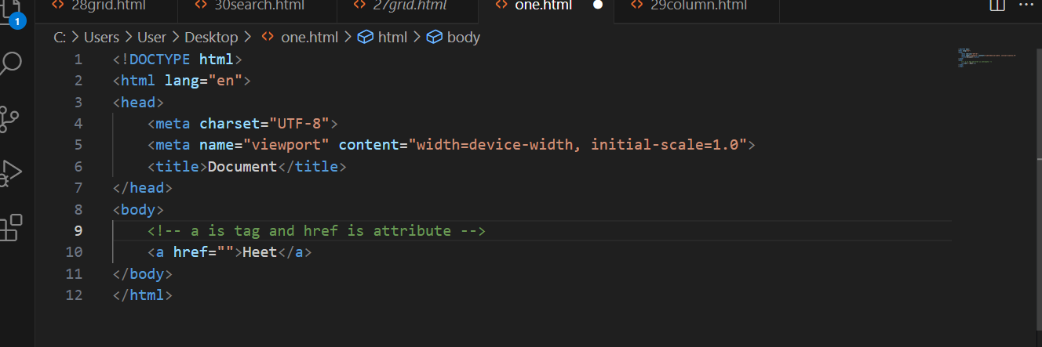

**Q3: What are void elements in HTML? With Example.**

**Ans:** Void elements also knowns as self-closing elements or empty elements, are special category of an elements that do not have closing tag

->those tag are not close is called void elements

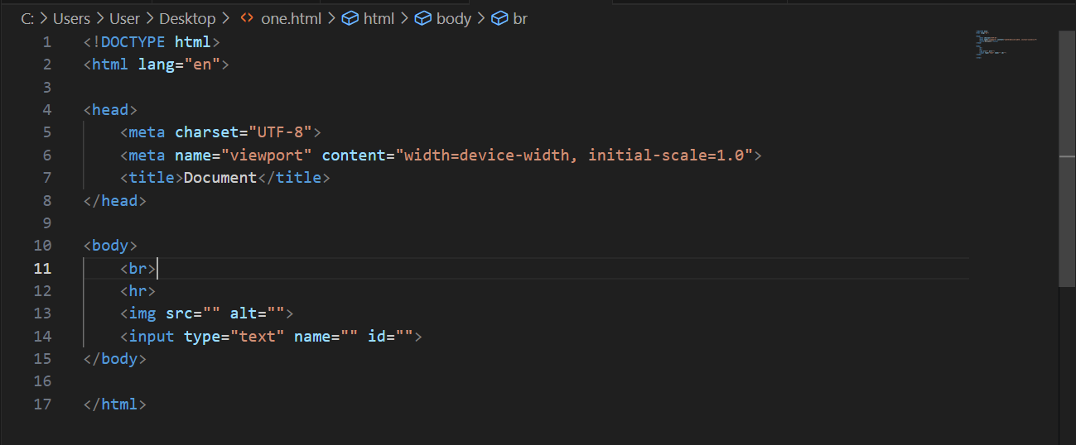

**Q4: What are HTML Entities? With Example**

**Ans:** HTML entities are special codes to represent reserved characters, symbols or special characters in HTML

-> There are two types of entities Numeric entities and Named entities.

->HTML entities are used to represent symbolic characters

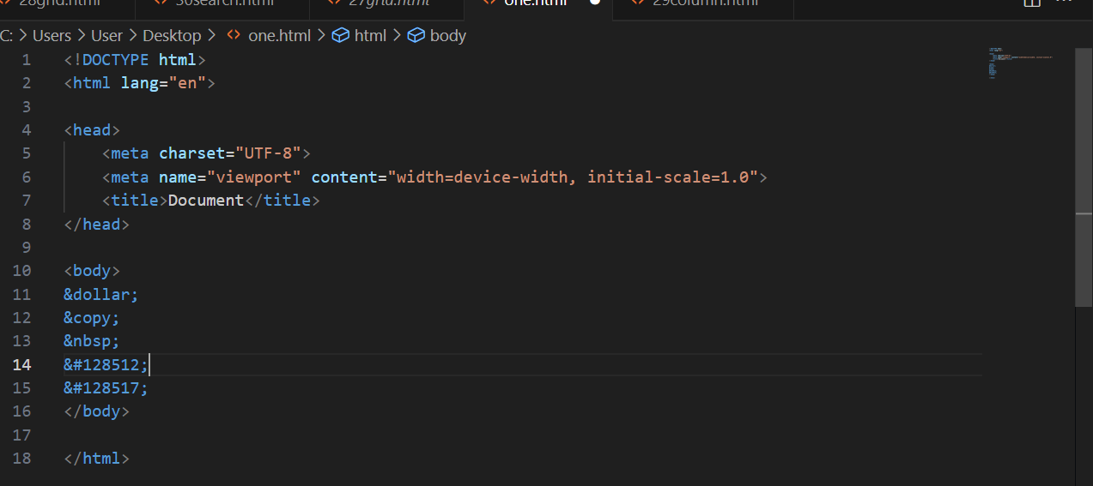

**Q5: What are different types of lists in HTML? With Example**.

**Ans**: There are 3 types of Lists in HTML: 1) Ordered List. 2) Unordered List. 3) Define List.

1) Order List (<ol>): An Ordered List is used to display a list of items in specific sequence, usually with numbers.

-> It takes <ol> & </ol> tags and in between them <li> tags as list items.

2) Unordered List (<ul>): An Unordered list is usually used to display list in bulleted format.

-> It takes <ul> & </ul> tags and in between them <li> tags as list items.

3) Define List (<dl>): A Define list is usually used to display terms along with their corresponding definition.

-> It takes <dt> tag for terms (dt for defined term) and <dd> tag for definition (dd for defined definition).

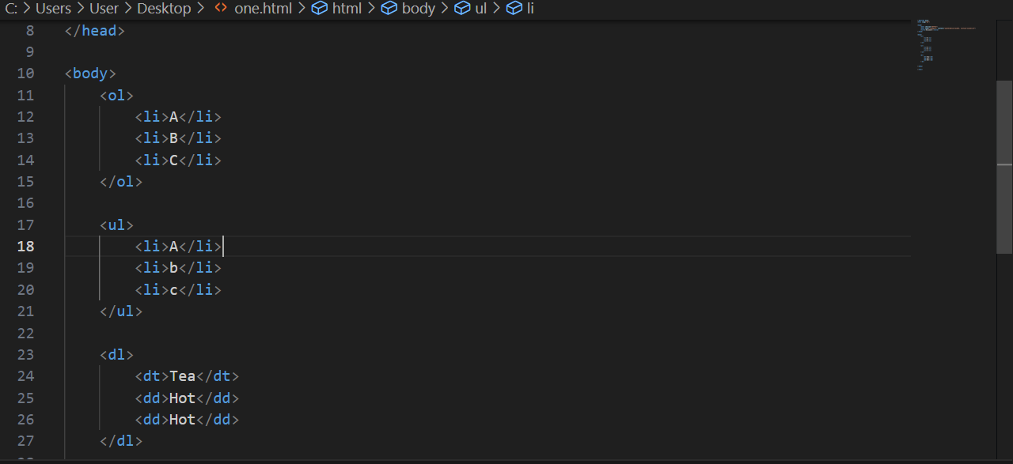

**Q6: What is the ‘class’ attribute in HTML? With Example**.

**Ans:** In HTML class attribute is used to assigned one or more class name to HTML element, and these assigned classes are used to style html element with CSS. Class names allow you to target multiple elements with same styling without repeating them and it makes easy to organize and maintaining consistent styling across the website.

Class: Class is used to group multiple html elements.

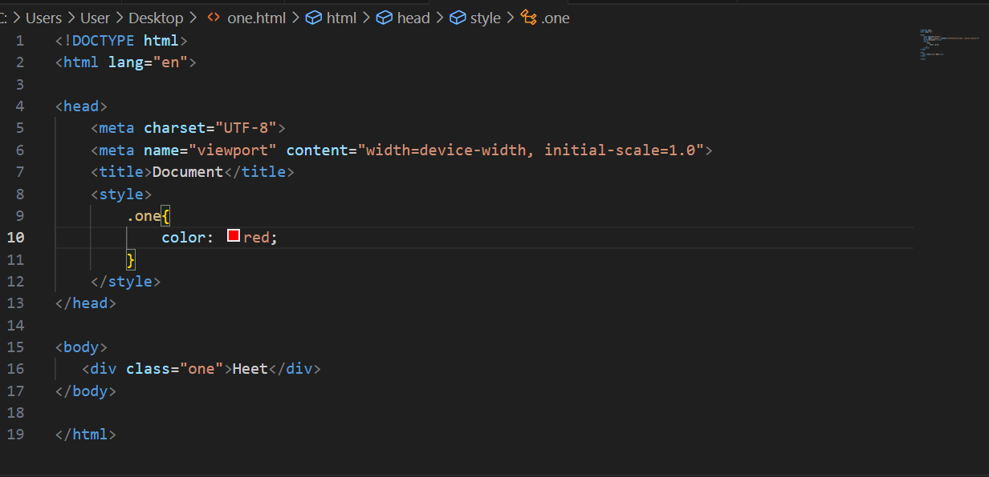

**Q7: What is the difference between the ‘id’ attribute and the ‘class’ attribute of HTML elements? With Example**

**Ans:** “id” attribute and “class” attribute both used in HTML to uniquely identify and styling elements, but they serve different purpose.

Class: Class is used to group multiple html elements. Classes can exist with the same name again and again in the same page.

Id: id is used to target a single element. It should be unique. Id of same name cannot exist in the same page.

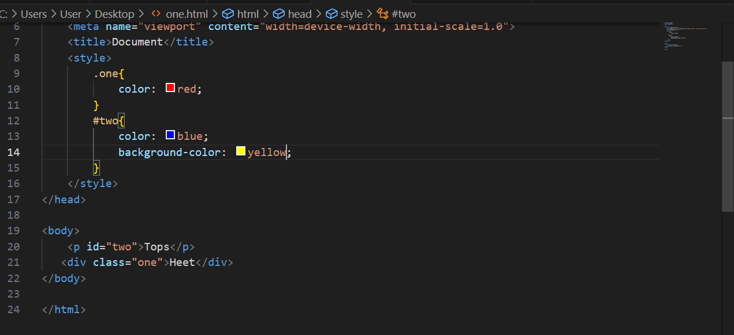

**Q8: What are the various formatting tags in HTML.**

**Ans**: Formatting tags are that tags that allows us to control visual presentation of text on our webpage.

-> Different formatting tags are listed below

1. <b>: Makes Text Bold

2. <i>: Makes Text Italic

3. <u>: Makes Text Underline

4. <strike> or <s>: Add a line through Text

5. <sub>: Display Text as Subscript

6. <sup>: Display Text as Superscript

7. <small>: Makes Text to appear smaller

8. <big>: Makes Text to appear bigger

9. <code>: To Display code or monospaced text

There are several types of html tags to format the content

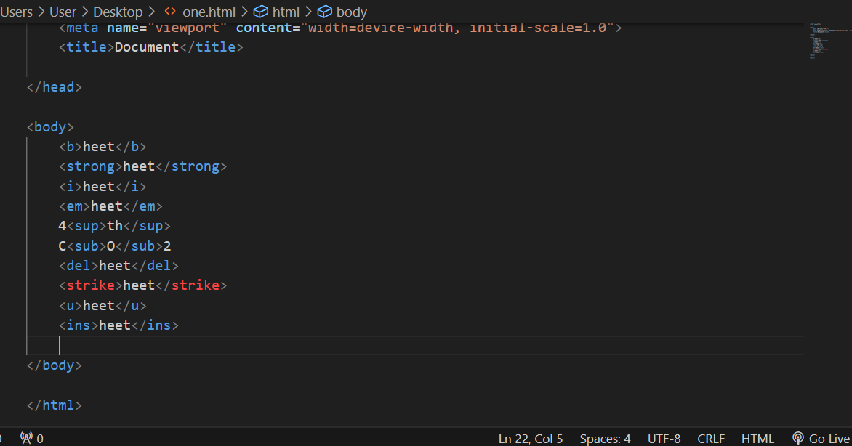

**Q9: How is Cell Padding different from Cell Spacing? With Example**.

**Ans:** Cell Padding and Cell Spacing are attributes used in HTML tables to control spacing and alignment of content within table cells.

-> Cell Padding attribute define the Spacing between the content of the cell and cells border.

-> Cell Spacing attribute define the Spacing between table cells and tables border

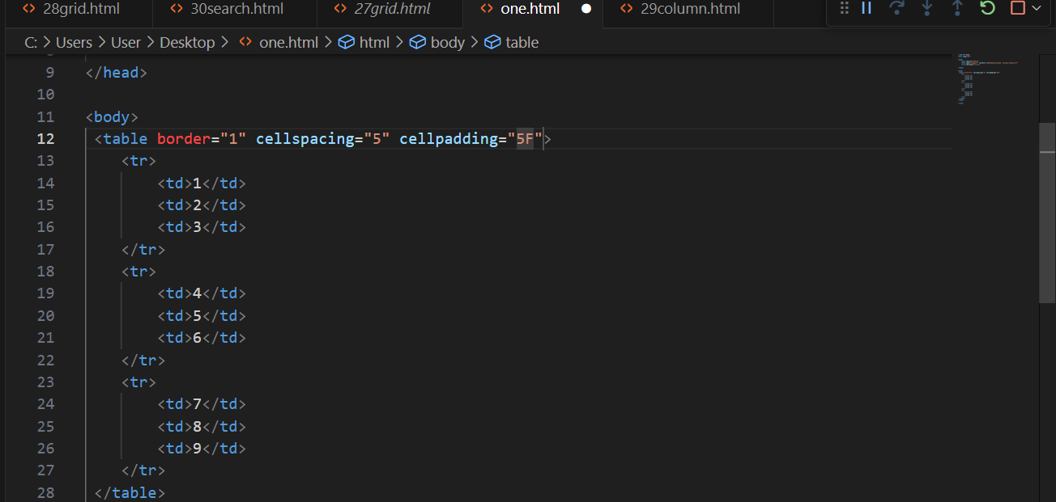

**Q10: How can we club two or more rows or columns into a single row or column in an HTML table? With Example.**

**Ans**: To club two or more rows or columns into single row or column in an HTML table we have to use rowspan and colspan attributes respectively. We can give rowspan and colspan attributes to respective <th> (table heading) or <td> (table data)

Rowspan: Rowspan is used to merge rows.

Colspan: Colspan is used to merge columns.

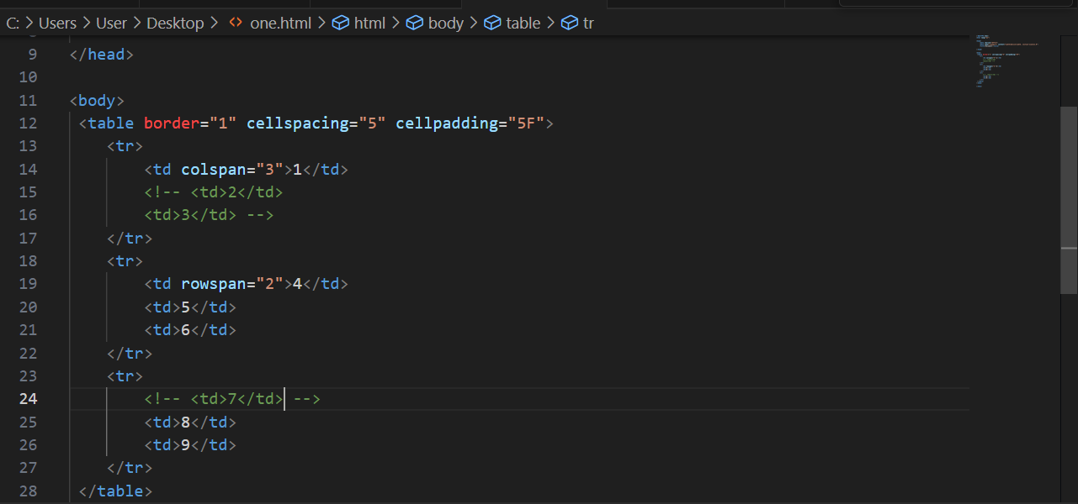

**Q11: What is the difference between a block-level element and an inline element?**

**Ans:** A Block-level Element means that the element will cover the full width of the page and the element after that will start form the below that. And an inline element will only cover the min-width it requires and the next element after that element start from that line.

Block-Level-Elements: Block level elements takes the full width.

Inline-Element: Inline elements takes the width according to the content.

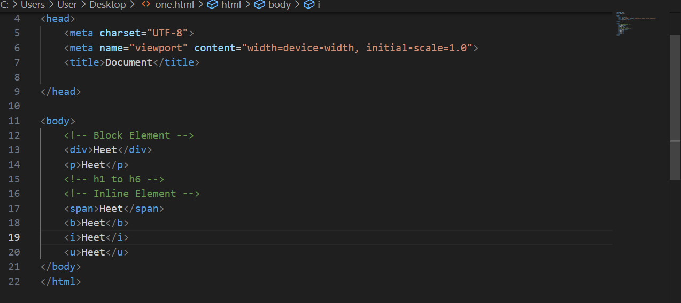

**Q12: How to create a Hyperlink in HTML? With Example**.

**Ans:** To create Hyperlink in HTML we can use anchor tag. And to add link to that we can assign “href” attribute and value of that

Hyperlinks are used to navigate through pages when the user clicks on it.

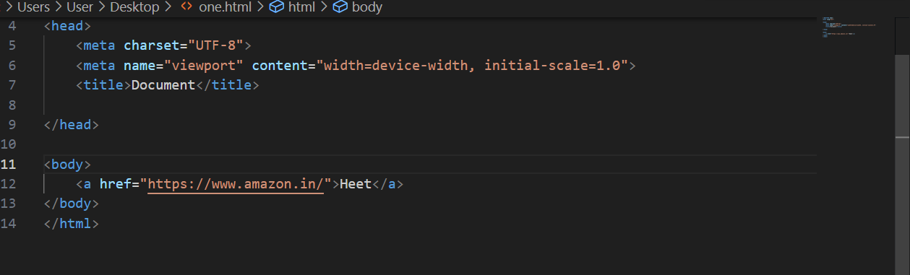

**Q13: What is the use of an iframe tag? With Example.**

**Ans:** The <iframe> tag in HTML is used to embed another HTML document or webpage within the current document.

-> This tag is commonly used for embedding videos, maps, social media content, ads and other external content within your own webpage

-> <iframe> tag has attributes like “src” in which we can give path of that external content we want to display, “width” & “height” in which we can assign width & height of that area, “frameborder” as we can give that area a border.

-> The use of iframe tag is to load another web page into the current web page.

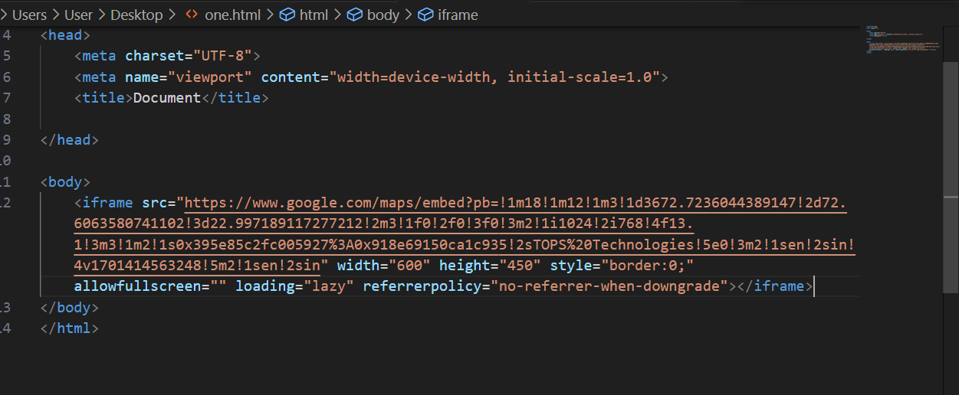

**Q14: What is the use of a span tag? Explain with example**.

**Ans:** <span> tag is specific inline container that used for styling or scripting for specific portion of text or content in block-level element. It doesn’t add any specific meaning or structure to the content but it provides a way to target and style that text that it wraps.

Span tag is used to give different stylings to a particular text in the content.

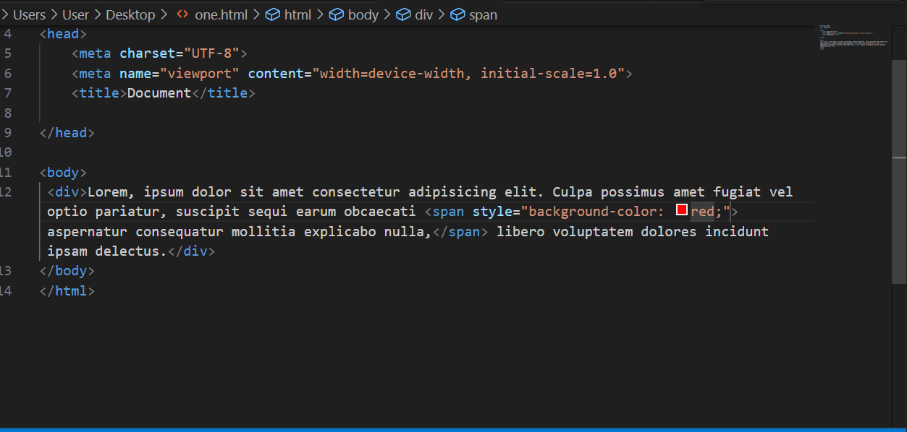

**Q15: How to insert a picture into a background image of a web page? With Example.**

**Ans:** To insert a picture into a background image of a web page we need to set “background-image” property in CSS

-> We can insert a picture to the background using css.

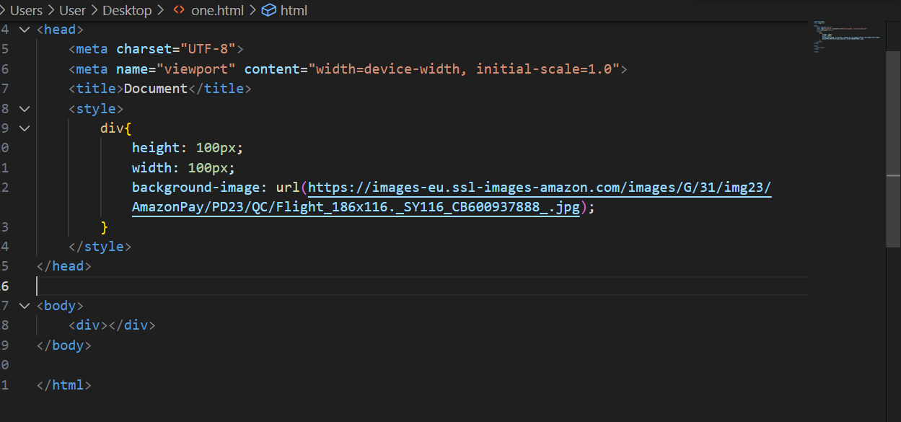

**Q16: How are active links different from normal links?**

**Ans:** Active links and normal links are different states of hyperlinks in webpages. These states reflect how a link appears and behave depending on its interaction with user.

-> **Normal Links**: A normal links is also known as default link or unvisited link, is the initial appearance of the hyperlink when it hasn’t been interacted with yet. By default, normal links are usually displayed with an underline and blue color to indicate that they can be clicked.

-> **Active Links:** An active links also known as visited links is the appearance of a hyperlinks after a user has clicked on it and visited the linked page. By default, active links has different color (typically purple), indication to differentiate them from unvisited links.

When a working url is the href attribute then the link becomes active and color changes to blue.

When a link is not given in the href attribute then the link becomes inactive and color changes to purple.

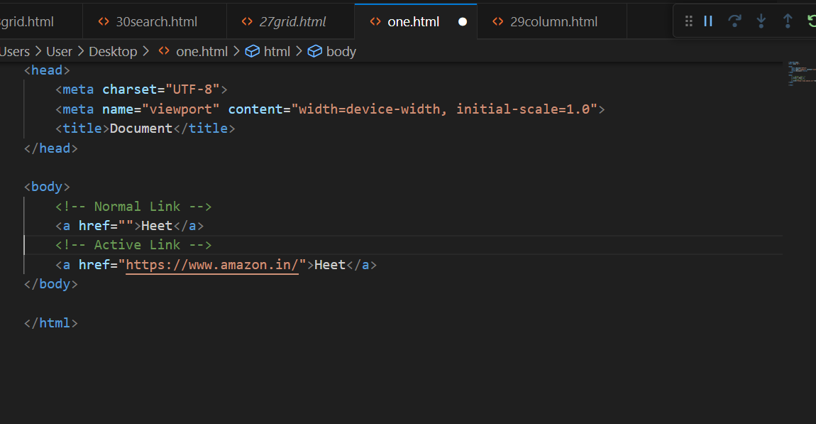

**Q17: What are the different tags to separate sections of text?**

**Ans:** In HTML there are several tags to separate sections of texts

-> Heading Tags (<h1> to <h6>): These tags represent separation of headings

-> Paragraph (<p>): Individual Text Separating from Other content of page.

-> Sections (<sections>): Creates individual sections in page.

-> Division (<div>): Creates division for the inner content.

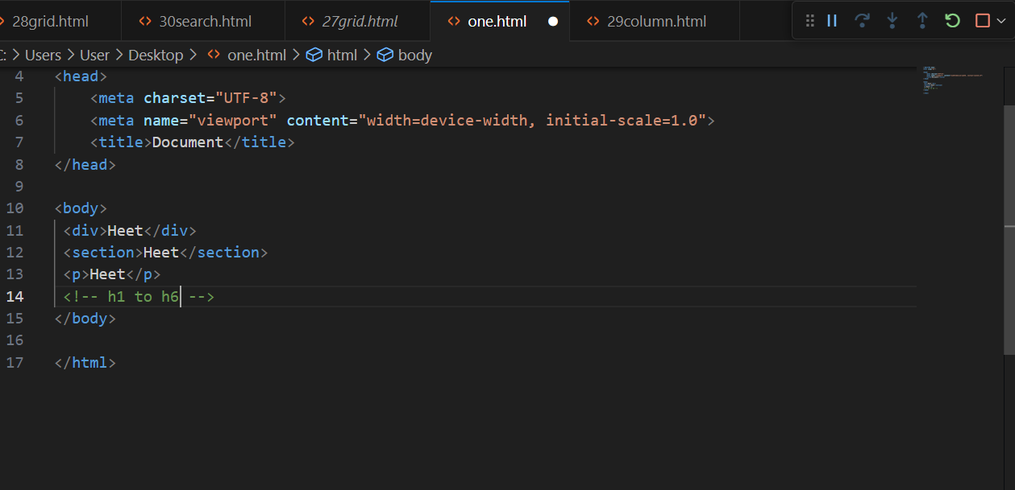

**Q18: What is SVG?**

**Ans:** SVG Stands for scalable vector graphics. It is an XML-based vector image format used to define two-dimensional vector graphics that can be displayed in web browsers. Unlike JPEG or PNG which are made up of a grid of pixels and can loose quality when resized, SVG images are resolutions independent and can be scaled up or down without loos of quality.

-> SVG is widely used for creating various types of graphics on the web, including icons, logos, charts, illustrations, animations and more.

->The full form of SVG is Scalable Vector Graphics. We can scale up SVG image a lot without losing the graphics.

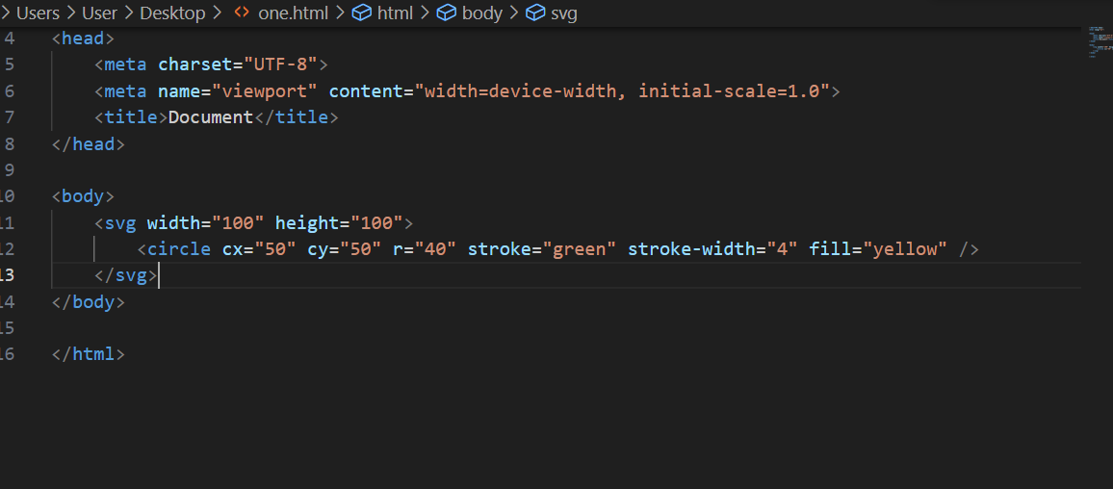

**Q19: What is difference between HTML and XHTML?**

**Ans:** HTML (Hypertext Markup Language) and XHTML (Extensible Hypertext Markup Language) are both markup languages and used to create structure of a web page.

-> They have many similarities but the key differences are given below.

-> Syntax: HTML has forgiving syntax, it allows some flexibility in how tags are written and nested which can lead to inconsistencies. Were XHTML having a stricter syntax that closely follow XML rules like tags must be properly closed and nested correctly and attribute values must be enclosed in quotes.

-> Parsing: For HTML, browsers try to interpret and display the content even if there are minor errors in the markup. Were for XHTML Browsers are less forgiving of syntax error, even minor errors can cause the entire document fail to render.

-> Case Sensitivity: HTML is not case sensitive; you can use uppercase for tags and attributes (e.g., “<p> or <P>”). And XHTML is case sensitive: tags must be in lowercase (e.g., “<p>”).

**Q20: What are logical and physical tags in HTML?**

**Ans:** Logical tags, also known as semantic tags, are HTML elements that convey meaning about the structure and content of a webpage. They define role of different sections of the content. Examples of logical tags include headings (<h1> to <h6>), paragraphs (<p>), lists (<ul>, <ol>, <li>), and structural elements like <header>, <nav>, <main>, <article>, <footer>, etc.

