HTML5

Q1) What are the new tags added in HTML5?

There are several new tags added in html 5 such as <video>, <iframe>, <nav>, <section>, <footer>,<header>,<main>,<summary>,<canvas>,<svg>,<audio>,<source>

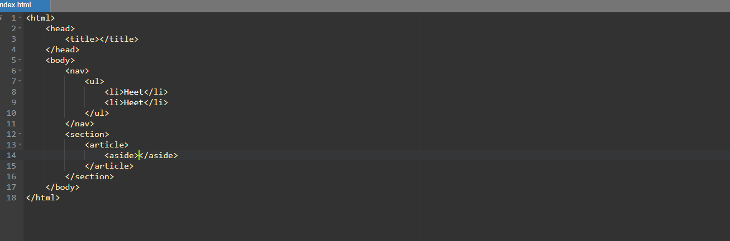

Q2) How to embed audio and video in a webpage?

We  can embed audio and video in web page like this.

In video and audio both tag we can use loop attribute for loop video and audio

And use control for control buttons

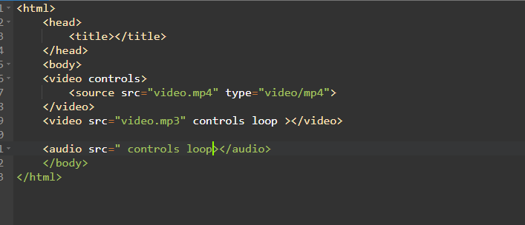

Q3) Semantic element in HTML5?

We can’t use <div> we can use similar tag like div ex

<section>,<aside>,<article>,<footer>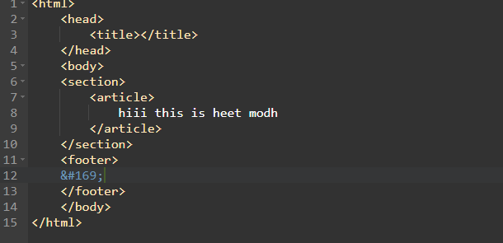

Q4) Canvas and SVG tags?

SVG

SVG (Scalable Vector Graphics) is a markup language that defines vector-based graphics.

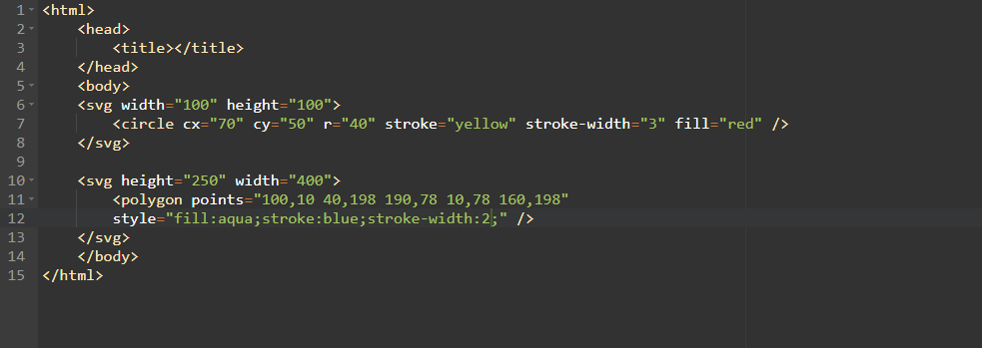

Canvas

The <canvas> element is used to draw graphics, including 2D shapes, text, and

images, on a web page dynamically using JavaScript.

