JQUERY Basic Effects and Advanced

Q1) What is jQuery?

JQuery Is Inbulit library Of JavaScript

The purpose of jQuery is to make it much easier to use JavaScript on your website

We Can Apply JQuery Using CDN Links

<scriptsrc="https://cdnjs.cloudflare.com/ajax/libs/jquery/3.7.0/jquery.min.js"></script>

Q2) How to Apply CSS Using jQuery, How to Add Class and Remove Class in jQuery, jQuery Animation?

CSS Using jQuery

You can use jQuery to apply CSS styles to HTML elements. The ‘.css()’ method is used to get or set the CSS properties of an element.

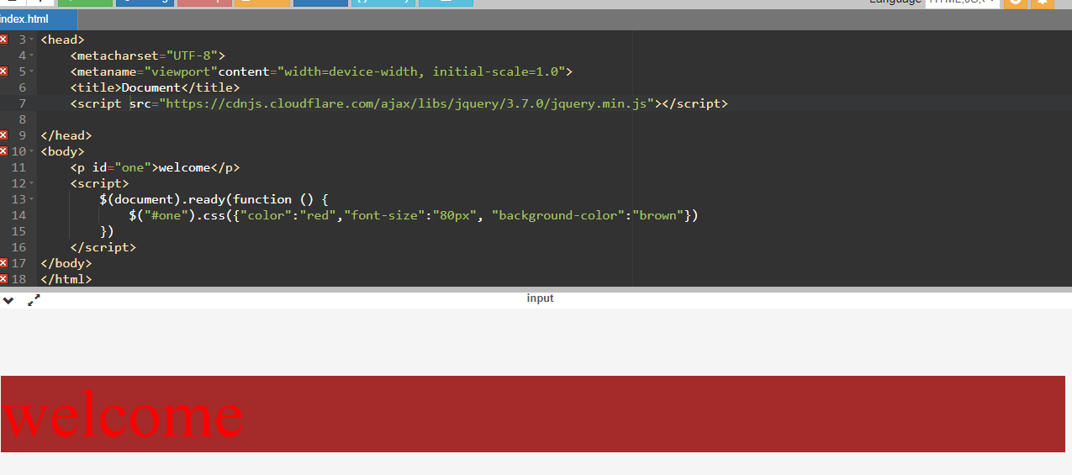

Add class and Remove class

You can use the ‘.addClass()’ and ‘.removeClass()’ methods to add and remove classes from HTML elements using jQuery.

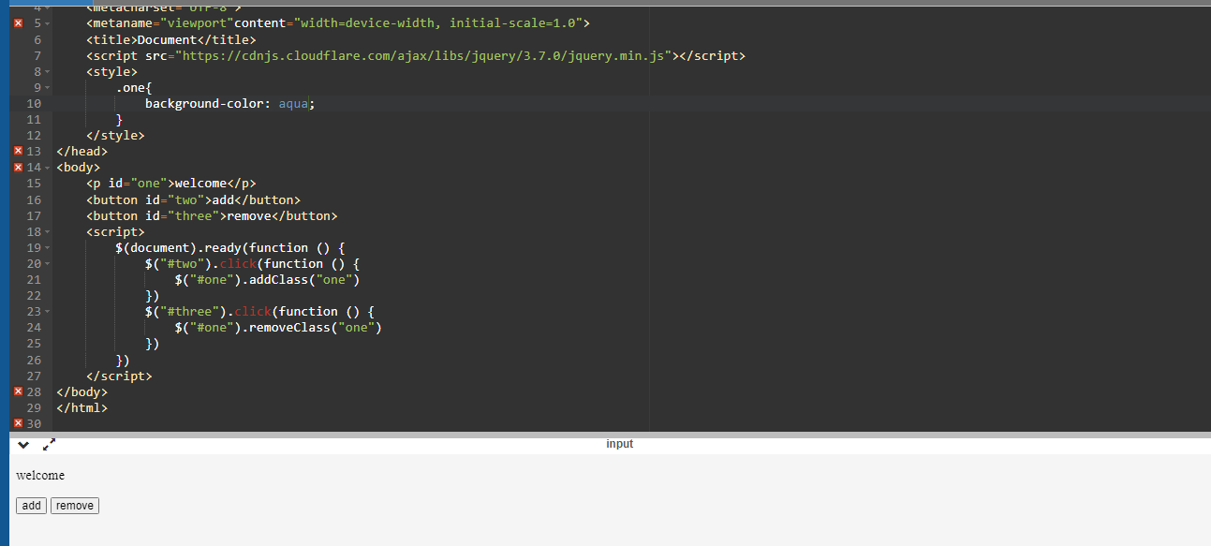

Animation in jQuery

You can use the ‘.animate()’ methods to create animation in HTML using jQuery

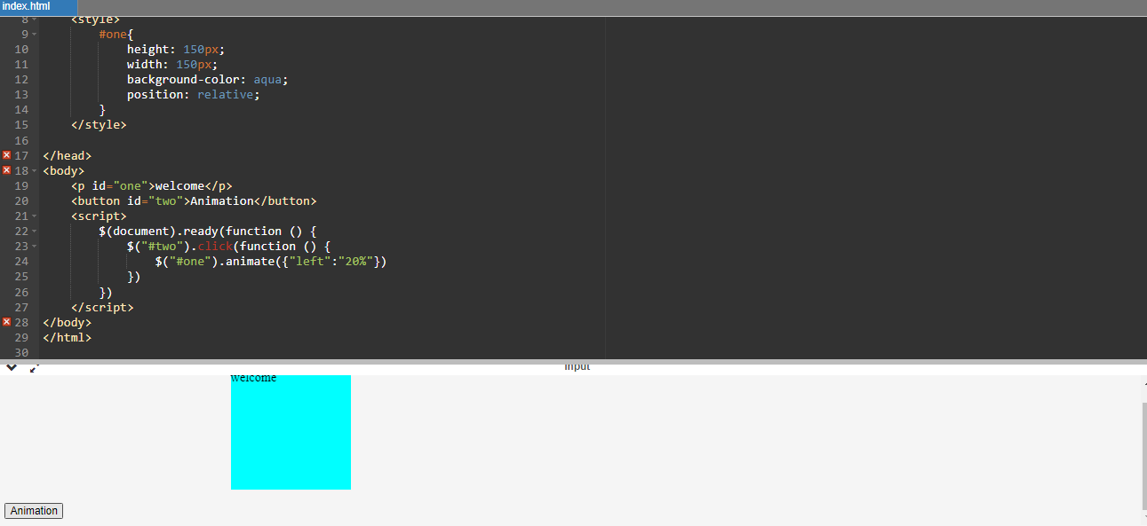

Q3) How to create slider with animation?

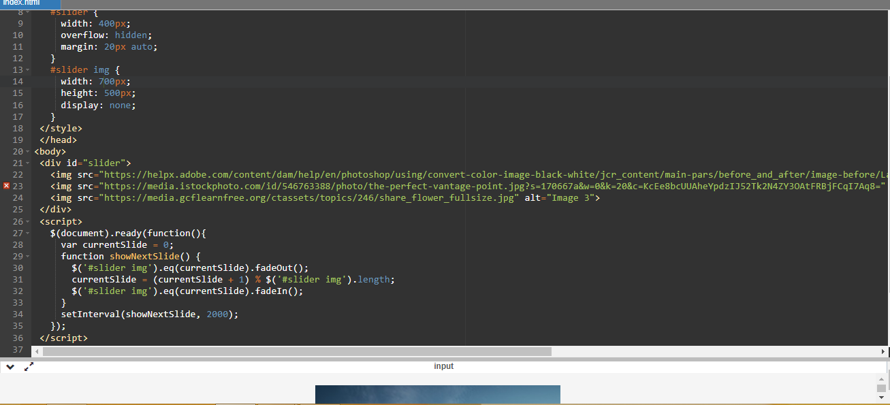

Q4) Event bubbling tickling example?

