JAVASCRIPT BASIC & DOM

Q1) What is JavaScript?

* JavaScript is a scripting language used to create and control dynamic website content,
* JavaScript is a dynamic programming language that's used for web development, in web applications, for game development, and lots more

Q2) What is the use of isNaN function?

isNan is a function that checks whether the passed parameter is a number or a different data type, if the argument passed in is a number then it will return false otherwise true.

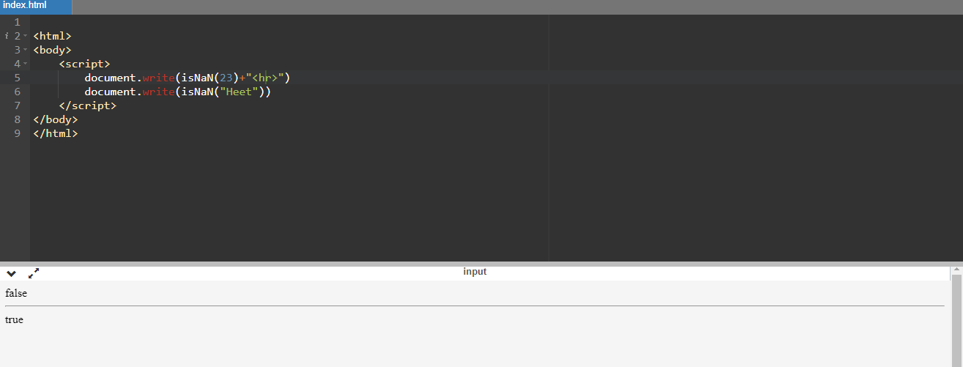

Q3) What is negative Infinity?

negative infinity is a special value that represents a numeric value that is infinitely small and negative

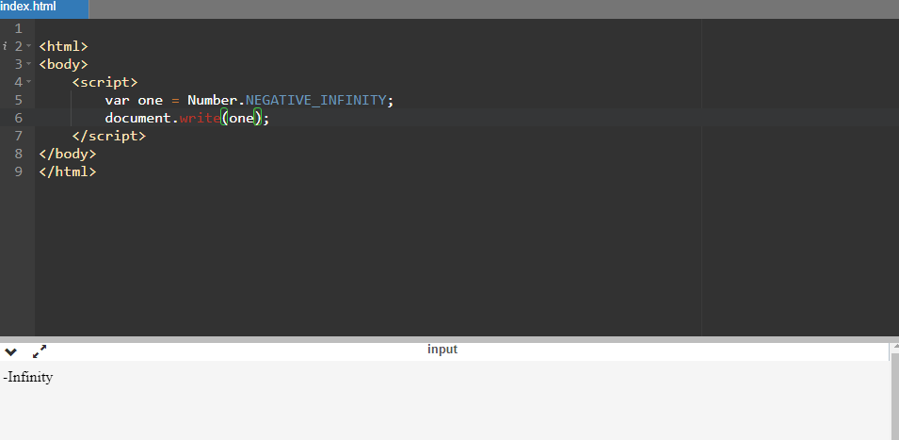

Q4) Which company developed JavaScript?

JavaScript was created at Netscape Communications by Brendan Eich in 1995.

Q5) What are undeclared and undefined variables?

Undeclared variables are the variables that are not declared but used in the program. Undefined variables are the type of variables that are declared but the values are not defined.

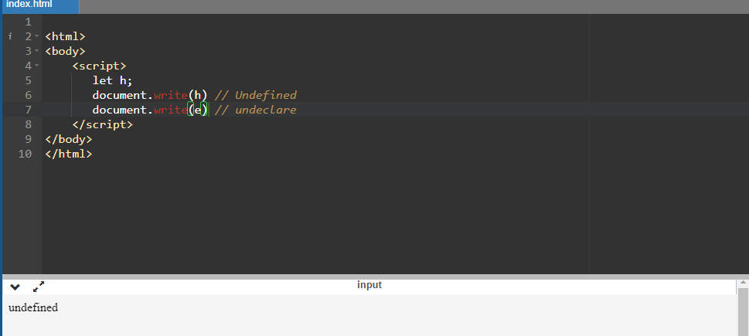

Q6) Write the code for adding new elements dynamically?

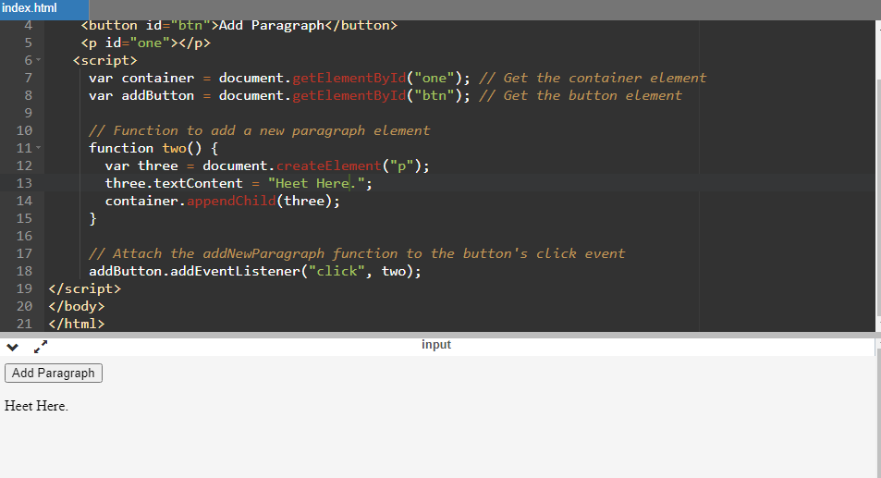

Q7) What is the difference between ViewState and SessionState?

ViewState is used for maintaining page-specific state on the client side, while SessionState is used for maintaining user-specific state on the server side.

Q8) What is === operator?

=== does the strict comparison between two values, it checks both values and the data type if they are same it returns true otherwise false.

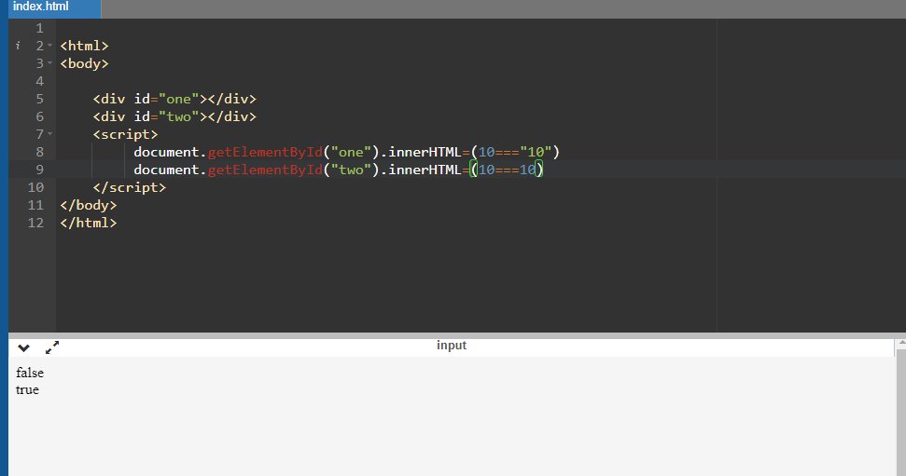

Q9) How can the style/class of an element be changed?

 We can change the style of an class/id with javascript by using style property.

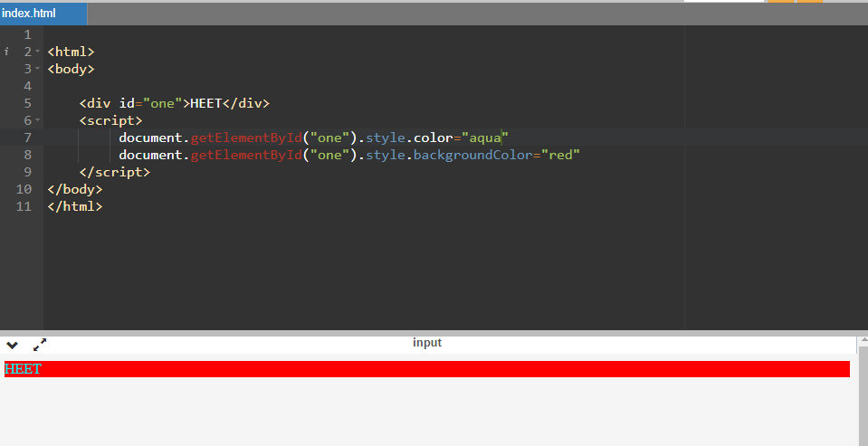

Q10) How to read and write a file using JavaScript?

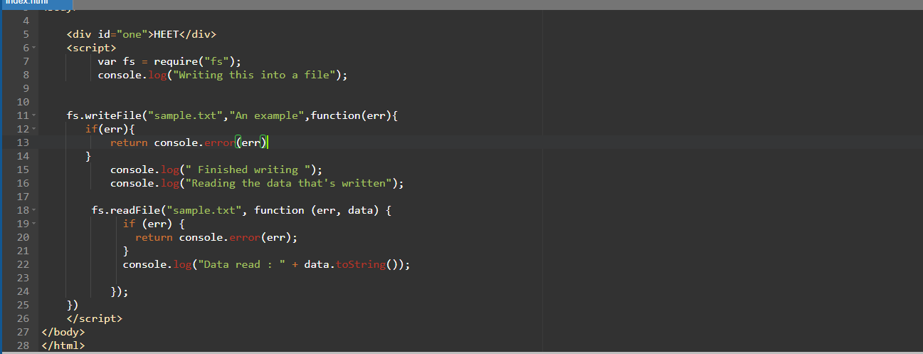

Q11) What are all the looping structures in JavaScript?

There are three types of loops in javascript.

1. For loop
2. While loop
3. Do while loop

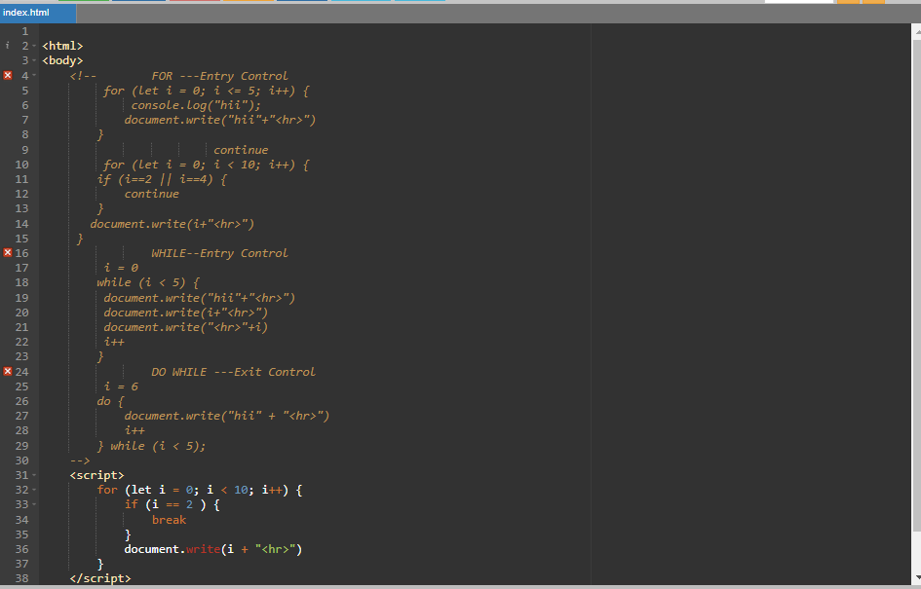

Q12) How can you convert the string of any base to an integer in JavaScript?

By using parseInt function in js we can convert a string to any base to an integer.

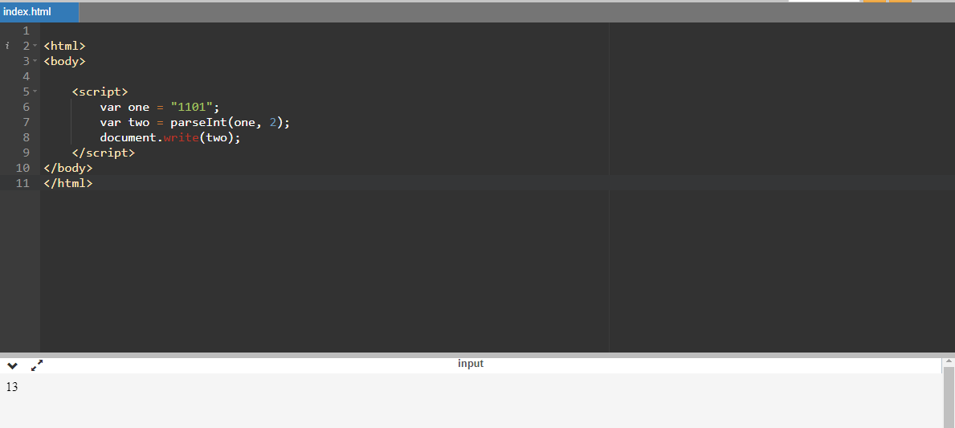

Q13) What is the function of the delete operator?

Delete operator is used to remove an item.

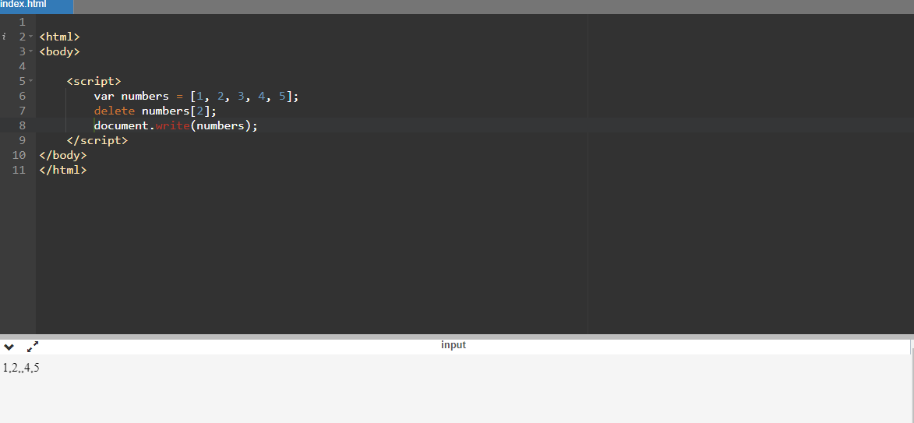

Q14) What are all the types of Pop up boxes available in JavaScript?

There are three types of pop up boxes available in js, they are confirm, prompt, alert boxes.

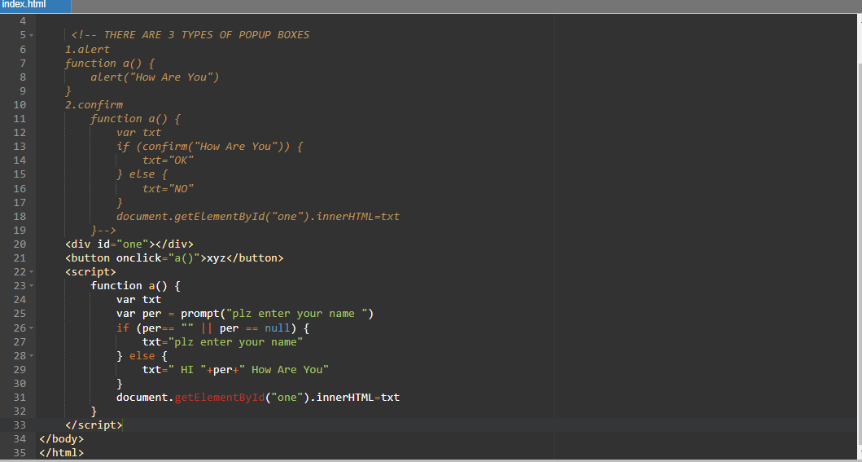

Q15) What is the use of Void (0)?

We can use the operand 0 in two ways that are void(0) or void 0. Both of the ways work the same. The JavaScript:void(0) tells the browser to "do nothing" i.e.,prevents the browser from reloading or refreshing the page. It is useful when we insert links that have some important role on the webpage without any reloading.So, using void(0) on such links prevents the reloading of the page but allows to perform a useful function such as updating a value on the webpage.

EX.. <a href="javascript:void(0)">HOME</a>

Q16) How can a page be forced to load another page in JavaScript?

We can use window.location.href to change the page.

Ex.. window.location.href = "https://www.example.com/newpage.html";

Q17) What are the disadvantages of using innerHTML in JavaScript?

Modifying an element's innerHTML can be less efficient than other methods like using the DOM API to directly manipulate individual elements or properties

Q18) Create password field with show hide functionalities?

