E-COMMERCE
PRODUCT SALES ANALYSIS
Exploratory Data Analysis (EDA)
A structured study of product prices, sales volume, customer ratings,
category performance and stock availability

PROJECT DETAILS | INFORMATION
Group Number | 14
Student Roll Numbers | 95, 59, 60, 61, 62, 71, 79, 87
Primary Dataset | ecommerce_dataset (3).csv
Dataset Size | 1,000 records; 7 original variables
Tools | Python, Pandas, NumPy, Matplotlib
Submission Date | 5 October 2026

ACADEMIC PROJECT REPORT

Report Roadmap
- 1. Introduction & objective
- 2. Dataset description
- 3. Data types and variables
- 4. Tools used for analysis
- 5. Data quality assessment
- 6. Descriptive statistics
- 7. Univariate analysis
- 8. Bivariate analysis
- 9. Grouping and aggregation
- 10. Correlation analysis
- 11. Visualization
- 12. Key findings
- 13. Conclusion
- 14. References
- 15. Code (GitHub)
Data integrity note: The uploaded materials include descriptions of more than one e-commerce dataset. To avoid mixing incompatible numbers, this report uses the supplied CSV with 1,000 rows and seven original columns as the primary source for all calculations. General online-selling advice from the other files is treated as background only, not as a result calculated from this dataset.

1. Introduction & Objective

1.1 Introduction
E-commerce businesses collect information about products, prices, units sold, customer ratings and stock availability. Exploratory Data Analysis (EDA) is the process of inspecting and summarising data with statistics and charts before drawing conclusions. It helps reveal patterns, unusual values and differences between groups.
This project analyses a supplied product-level e-commerce dataset. It focuses on two product categories—Electronics and Fashion—and ten product names. The report follows the 15-section sequence provided by the teacher and combines the useful, compatible material from the uploaded report, presentation and strategy documents.

1.2 Problem statement
The central problem is to understand how the available products differ in price, sales volume, rating and stock status, and whether simple relationships between these variables can be observed. These findings can help describe the dataset and suggest questions for future business analysis.

1.3 Objectives
- Understand the structure and meaning of the dataset fields.
- Check missing values, duplicate records, data types and value ranges.
- Summarise price, units sold, ratings and derived sales value using descriptive statistics.
- Study each variable individually and examine relationships between pairs of variables.
- Compare Electronics and Fashion through grouping and aggregation.
- Use charts to communicate results clearly and identify the limits of the analysis.

1.4 Scope and limitations
This is a descriptive EDA project, not a forecasting or causal-inference study. The supplied CSV does not contain order dates, customer IDs, discount fields, payment methods, city/region fields or costs. Therefore, this report does not claim to measure monthly trends, customer retention, discount effectiveness or profit. The derived sales value is price multiplied by units sold; it is not net profit.

2. Dataset Description
The primary file is a comma-separated values (CSV) file named ecommerce_dataset (3).csv. Each row represents one product record in the supplied data. The original columns describe a product identifier, product name, category, price, units sold, rating and whether the item is in stock.
Dataset property | Value
Number of records | 1,000
Original variables | 7
Product categories | Electronics, Fashion
Distinct product names | 10
Price range | 10.35 to 1499.04
Units-sold range | 1 to 499
Rating scale | 1.0 to 5.0
Stock field | Boolean: True / False

2.1 Variable dictionary
Field | Meaning | Example / role
product_id | Unique product record identifier | 1, 2, 3…
product_name | Name/type of product | Laptop, Camera, Shoes
category | Product category | Electronics / Fashion
price | Price of the product | Numeric value
units_sold | Number of units sold | Integer count
rating | Customer rating | Scale from 1 to 5
in_stock | Current stock status | True / False
sales_value | Derived measure: price × units_sold | Calculated for this report

2.2 Derived variable
For category and product comparisons, a derived field named sales_value was calculated using: sales_value = price × units_sold. This represents a simple gross sales-value estimate at the listed price. It does not account for discounts, shipping, taxes, returns or costs.

3. Data Types and Variables
Variable | Data type / role | Why it matters
product_id | Integer identifier | Identifies a record; it is not a measurement to average.
product_name | Categorical / text | Used to group records by product name.
category | Categorical / nominal | Used to compare Electronics and Fashion.
price | Numerical, continuous-style | Can be summarised with mean, median, range and histogram.
units_sold | Numerical, discrete count | Counts units and supports totals and averages.
rating | Numerical score (1–5) | Summarises customer ratings; interpret as a bounded rating scale.
in_stock | Boolean / categorical | Separates in-stock and out-of-stock records.
sales_value | Derived numerical measure | Calculated by multiplying price and units sold.

Correct classification matters because different variables require different summaries. For example, categories are compared using counts or grouped averages, while price is examined using numerical summaries and histograms. An identifier such as product_id should not be treated as a meaningful quantity.

4. Tools Used for Analysis
Tool | Purpose in this project
Python | Main programming language for loading, analysing and presenting data.
Pandas | Reads the CSV, checks data quality, creates derived columns, groups records and calculates summaries.
NumPy | Supports numerical operations and chart bin definitions.
Matplotlib | Creates histograms, bar charts, scatter plots and the correlation heatmap.
Microsoft Word | Used to prepare the structured academic report.
GitHub (planned) | Can host the analysis script, dataset if sharing is permitted, charts and README.

4.1 Basic workflow
- Load the CSV into a Pandas DataFrame.
- Inspect rows, columns, data types and missing values.
- Check duplicate rows and identifier uniqueness.
- Calculate sales_value from price × units_sold.
- Generate descriptive statistics and grouped summaries.
- Create charts and calculate correlations.
- Interpret findings, document limitations and prepare the report.

5. Data Quality Assessment
Check | Result from supplied CSV | Assessment
Rows and columns | 1,000 rows; 8 original columns | Dataset loaded successfully.
Missing values | 0 missing values across all original fields | No missing-value treatment was required.
Duplicate rows | 0 exact duplicate rows | No exact duplicate rows detected.
Duplicate product IDs | 0 repeated IDs | IDs are unique in this file.
Price range | 10.35–1499.04 | All values are numeric.
Units sold | 1–499 | Integer counts; no negative values.
Rating | 1.0–5.0 | Values fit the stated 1–5 rating scale.
Stock field | True / False | Consistent boolean-style values.

5.1 Assessment and caveats
The supplied CSV is structurally complete for the checks performed. This does not guarantee that every value reflects real-world business activity; it means the fields are present and fall within the observed ranges. Outliers should be investigated in context rather than automatically deleted. No outlier removal or imputation was necessary for the calculations in this report.
Important reconciliation note: another uploaded report describes a different dataset with 6,045 raw order lines and 12 columns, while the supplied CSV contains 1,000 product records and seven original columns. These are not treated as the same dataset, and their statistics have not been combined.

6. Descriptive Statistics
Descriptive statistics provide a compact summary of the data. The mean is the arithmetic average; the median is the middle value; standard deviation describes spread; and minimum/maximum show the observed range.
Measure | Mean | Median | Std. dev. | Minimum | Maximum
Price | 759.02 | 777.61 | 423.37 | 10.35 | 1499.04
Units sold | 250.51 | 254.00 | 142.87 | 1.00 | 499.00
Rating | 2.98 | 3.00 | 1.16 | 1.00 | 5.00
Sales value | 189167.12 | 140943.26 | 162501.30 | 265.50 | 719827.56

6.1 Overall figures
Metric | Value
Total units sold | 250,512
Derived total sales value | 189,167,121.68
Average price | 759.02
Average units sold per record | 250.51
Average rating | 2.98 / 5
In-stock records | 803 (80.3%)
Out-of-stock records | 197 (19.7%)

6.2 Interpretation
The average price is 759.02, while the median is 777.61. The average units sold per record is 250.51. The average rating is 2.98 out of 5. These are summaries of the supplied records; they should not be interpreted as customer-level or order-level statistics.

7. Univariate Analysis
Univariate analysis examines one variable at a time. It helps identify common values, ranges, spread and possible skewness.

7.1 Price distribution
Price values range from 10.35 to 1499.04. The histogram shows how frequently different price ranges appear. A histogram is useful for noticing whether records are concentrated in particular price bands.
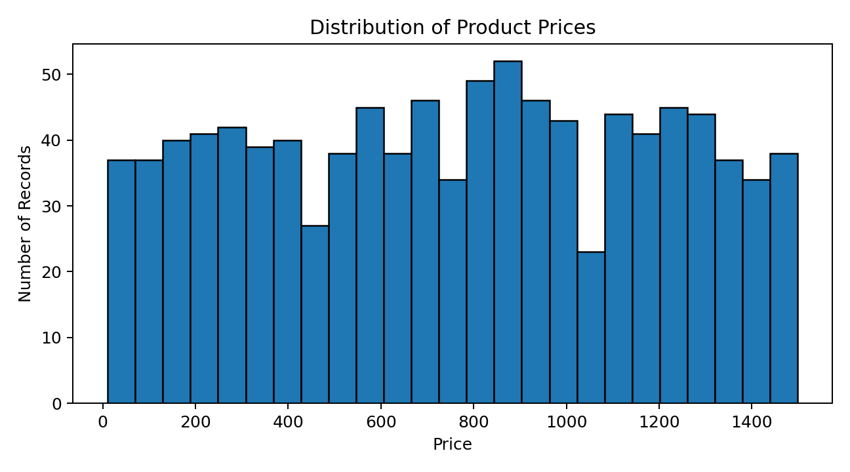
Figure 1. Distribution of price values in the supplied CSV.

7.2 Rating distribution
Ratings range from 1.0 to 5.0. The histogram shows the frequency of ratings across the 1–5 scale. The mean rating is 2.98; the median is 3.00.
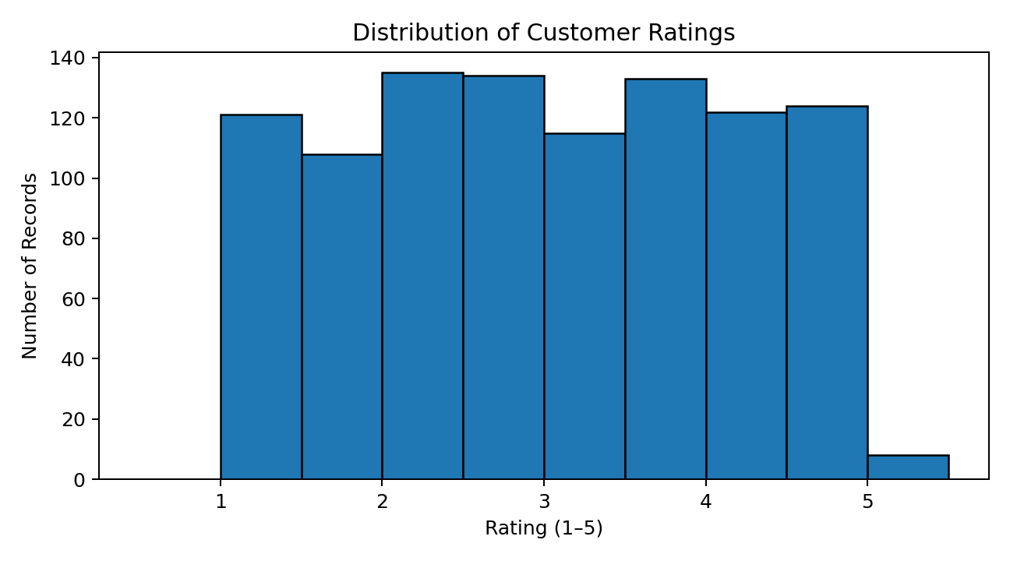
Figure 2. Distribution of customer ratings.

7.3 Units sold and stock status
Units sold range from 1 to 499 per record. There are 803 in-stock records and 197 out-of-stock records. Counts and percentages help describe the balance of stock statuses.

8. Bivariate Analysis
Bivariate analysis examines two variables together. Scatter plots can show patterns, clusters or unusual points, but a visible relationship does not by itself prove that one variable causes the other.

8.1 Price vs units sold
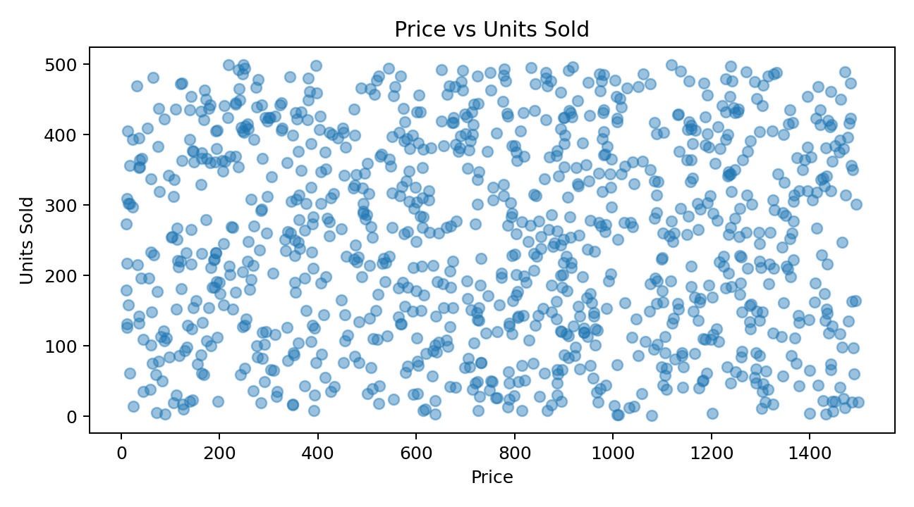
Figure 3. Scatter plot of price and units sold.
The Pearson correlation between price and units sold is -0.016, which is very close to zero. In this dataset, there is almost no linear association between these two variables. A near-zero linear correlation does not rule out every possible non-linear pattern.

8.2 Rating vs units sold
The correlation between rating and units sold is -0.006, also close to zero. Therefore, the supplied data does not show a meaningful linear relationship between these two variables.

8.3 Price vs rating
The correlation between price and rating is -0.021. This value is close to zero, indicating little linear association in the supplied records.

9. Grouping and Aggregation
Grouping combines records that share a category and calculates summary measures for each group. The following table compares the two categories present in the supplied CSV.
Category | Records | Avg. price | Total units | Avg. rating | Stock rate | Sales value
Electronics | 603 | 787.67 | 145,696 | 3.04 | 80.9% | 113,481,736.97
Fashion | 397 | 715.50 | 104,816 | 2.90 | 79.3% | 75,685,384.71

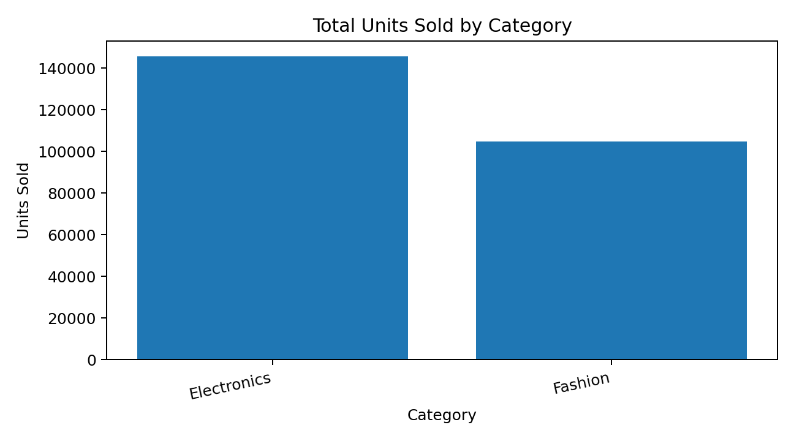
Figure 4. Total units sold by category.

9.1 Product-level comparison
Product name | Total units sold
Laptop | 28,478
Watch | 28,430
Mouse | 27,776
Backpack | 27,150
Smartphone | 25,831
Shoes | 24,757
T-shirt | 24,479
Camera | 22,747
Keyboard | 22,717
Headphones | 18,147

Among product names, Laptop has the highest total units sold (28,478) in the supplied dataset. Grouped results describe the records in this file and do not automatically generalise to other stores or periods.

10. Correlation Analysis
Correlation measures the direction and strength of a linear relationship. Values near +1 indicate a positive linear association, values near −1 indicate a negative linear association, and values near 0 indicate little linear association. Correlation does not establish causation.
Variable | Price | Units sold | Rating | Sales value
price | 1.000 | -0.016 | -0.021 | 0.636
units_sold | -0.016 | 1.000 | -0.006 | 0.665
rating | -0.021 | -0.006 | 1.000 | -0.039
sales_value | 0.636 | 0.665 | -0.039 | 1.000

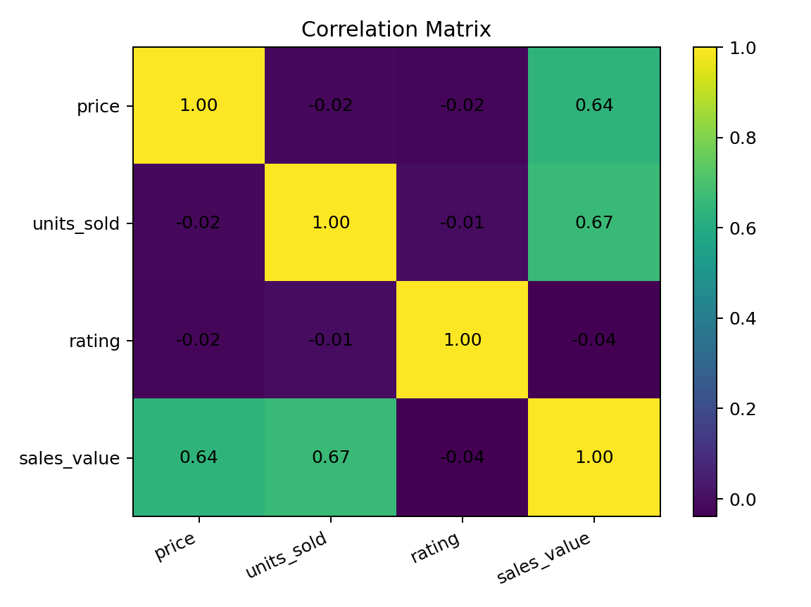
Figure 5. Correlation matrix for numerical variables.

10.1 Interpretation
Price and units sold have a correlation of -0.016; price and rating have -0.021; and units sold and rating have -0.006. These are all close to zero. Sales value has a positive correlation with price (0.636) and units sold (0.665), which is consistent with sales value being calculated as price multiplied by units sold. This mathematical relationship should be kept in mind when interpreting the correlation.

11. Visualization
Visualizations make patterns easier to interpret than a table of numbers alone. The charts in this report were generated from the supplied CSV using Matplotlib.
Visualization | Purpose | Used in this report
Histogram | Shows the distribution of one numerical variable. | Price and rating distributions.
Scatter plot | Displays the relationship between two numerical variables. | Price vs units sold.
Bar chart | Compares values across categories. | Total units sold by category.
Correlation heatmap | Summarises pairwise correlations in a compact view. | Price, units sold, rating and sales value.
Summary table | Makes grouped measures easy to compare. | Category and product summaries.

A clear chart should have a descriptive title, labelled axes, readable category names and units where relevant. Charts should support—not replace—careful interpretation of the underlying numbers.

12. Key Findings
- The primary dataset contains 1,000 records and 7 original variables; sales_value was added as a derived field for analysis.
- The dataset includes 10 distinct product names across Electronics and Fashion.
- All original fields are complete in the supplied CSV: 0 missing values were detected.
- No exact duplicate rows or duplicate product IDs were detected in the supplied CSV.
- The mean product price is 759.02, and the median is 777.61.
- The dataset contains 250,512 total units sold and a derived total sales value of 189,167,121.68.
- Overall stock availability is 80.3%: 803 records are in stock and 197 are out of stock.
- Laptop has the highest total units sold among the listed product names, at 28,478.
- Price, units sold and rating have pairwise correlations close to zero in this dataset.
- Because the dataset has no date, customer, discount or cost fields, it cannot support monthly trend, retention, discount-effectiveness or profit calculations.

12.1 Practical observations
- Monitor stock availability alongside sales volume so that products with demand can be reviewed for replenishment.
- Compare categories using more than one measure—such as average price, total units, rating and stock rate—rather than relying on one metric.
- Investigate low ratings with product-level context before making changes; ratings alone do not explain the reason for customer feedback.
- To assess profitability, collect product cost, shipping, tax, discount and return information in a future dataset.

13. Conclusion
This project used Exploratory Data Analysis to examine product prices, units sold, customer ratings and stock availability in the supplied 1,000-record e-commerce dataset. The quality checks found no missing values, exact duplicate rows or repeated product IDs. Descriptive statistics summarised the main numerical fields, while univariate charts showed distributions and bivariate analysis examined relationships between variables.
The category summaries show differences between Electronics and Fashion, and product-level aggregation identifies Laptop as the product name with the highest total units sold in this file. The linear correlations between price, units sold and rating are close to zero, so these variables alone do not explain sales volume through a simple linear relationship.
The analysis is limited by the fields available. In particular, the file does not include time, discounts, customer demographics, costs, returns or profit. Future work could combine a compatible transaction-level dataset with these fields to study seasonality, customer behaviour, discount outcomes and profitability. Any future findings should be calculated from the relevant raw data and should distinguish correlation from causation.

14. References
- Primary data source: ecommerce_dataset (3).csv, supplied for Group 14 project. All numerical results and charts in this report were calculated from this file.
- Python documentation: https://docs.python.org/
- Pandas documentation: https://pandas.pydata.org/docs/
- NumPy documentation: https://numpy.org/doc/
- Matplotlib documentation: https://matplotlib.org/stable/
- Kaggle dataset reference (as cited in the supplied EDA document): https://www.kaggle.com/datasets/kenzabz8/e-commerce-product-sales-dataset-1000-rows
- Supplementary project material: E-Commerce Strategy Blueprint and How to Sell Products Online files supplied with the project. Used only for general background, not as the source of calculated dataset statistics.
Note: The supplied materials contain different datasets and some inconsistent descriptions. The primary CSV was used for calculations in this report; references to other materials are clearly treated as background rather than merged data.

15. Code (GitHub)
The final code repository should contain the script or notebook used to load the dataset, perform the checks, calculate summaries and create the visualizations. The repository URL below is a placeholder and should be replaced after the group uploads its files.
File / folder | Purpose
README.md | Project summary, setup instructions, methods and key findings.
data/ecommerce_dataset.csv | Input dataset, if redistribution is permitted.
src/ecommerce_analysis.py | Python script for cleaning, statistics, grouping and correlation.
notebooks/eda_analysis.ipynb | Optional notebook showing the analysis step by step.
figures/ | Saved charts used in the report.
report/Group14_Ecommerce_Product_Sales_Analysis_Report.docx | Final report.
requirements.txt | Python libraries needed to reproduce the analysis.

15.1 Reproducible analysis code
import pandas as pd
import matplotlib.pyplot as plt
# Load the supplied CSV file
df = pd.read_csv("ecommerce_dataset (3).csv")
# Inspect the structure and data quality
print(df.shape)
print(df.isnull().sum())
print("Duplicate rows:", df.duplicated().sum())
print("Duplicate product IDs:", df["product_id"].duplicated().sum())
# Create a derived sales-value column
df["sales_value"] = df["price"] * df["units_sold"]
# Descriptive statistics
print(df[["price", "units_sold", "rating", "sales_value"]].describe())
# Group by category
summary = df.groupby("category").agg(
records=("product_id", "count"),
average_price=("price", "mean"),
total_units=("units_sold", "sum"),
average_rating=("rating", "mean"),
stock_rate=("in_stock", "mean"),
sales_value=("sales_value", "sum")
)
print(summary)
# Correlation matrix
print(df[["price", "units_sold", "rating", "sales_value"]].corr())
# Example visualisation
df["price"].plot(kind="hist", bins=25, edgecolor="black")
plt.title("Distribution of Product Prices")
plt.xlabel("Price")
plt.ylabel("Number of Records")
plt.tight_layout()
plt.show()

15.2 GitHub link
Repository URL: To be added by Group 14 after uploading the project.
Suggested steps: create a repository, upload the report and analysis code, include a README with setup instructions, and confirm that the dataset can legally be shared before uploading it publicly.

