**Task Battery:**

The task battery is described here in the order that testing takes place. It does not include our scheduled breaks and play times that we incorporate into testing time, which you can see described in the “Timeline” files mentioned above.

All participants take part in the following tasks/ parents fill in an assessment:

* The British Picture Vocabulary Scale III (BPVS) assesses age-appropriate vocabulary knowledge by asking the participant to match one of four pictures to a word spoken by the examiner.

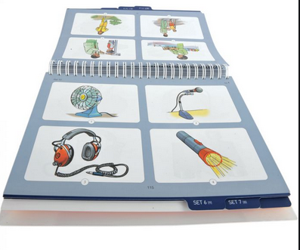

* The Wechsler Abbreviated Scale of Intelligence II [18] (WASI-II) is used as a measure of IQ. We administer the shorter, two-subtest test that includes a Matrix Reasoning task measuring visuo-spatial problem solving abilities and a Vocabulary task. In the first task participants view an incomplete picture matrix and are asked to identify the item that correctly completes the matrix. The second task asks participants to provide definitions of words that the assessor verbally delivers. The responses to the Vocabulary subtest are scored based on their descriptive quality. The assessment lasts between 10 and 15 minutes.
* Theory of Mind Task Inventory (TOMI) is a 60-item inventory intended as assessment of social cognition. This is completed by parents who answer questions

on a continuous scale (placing a cross on a line between 0 and 20. Example question: My child understands the difference between lies and jokes” 0 being not at all, 20 being definitely.

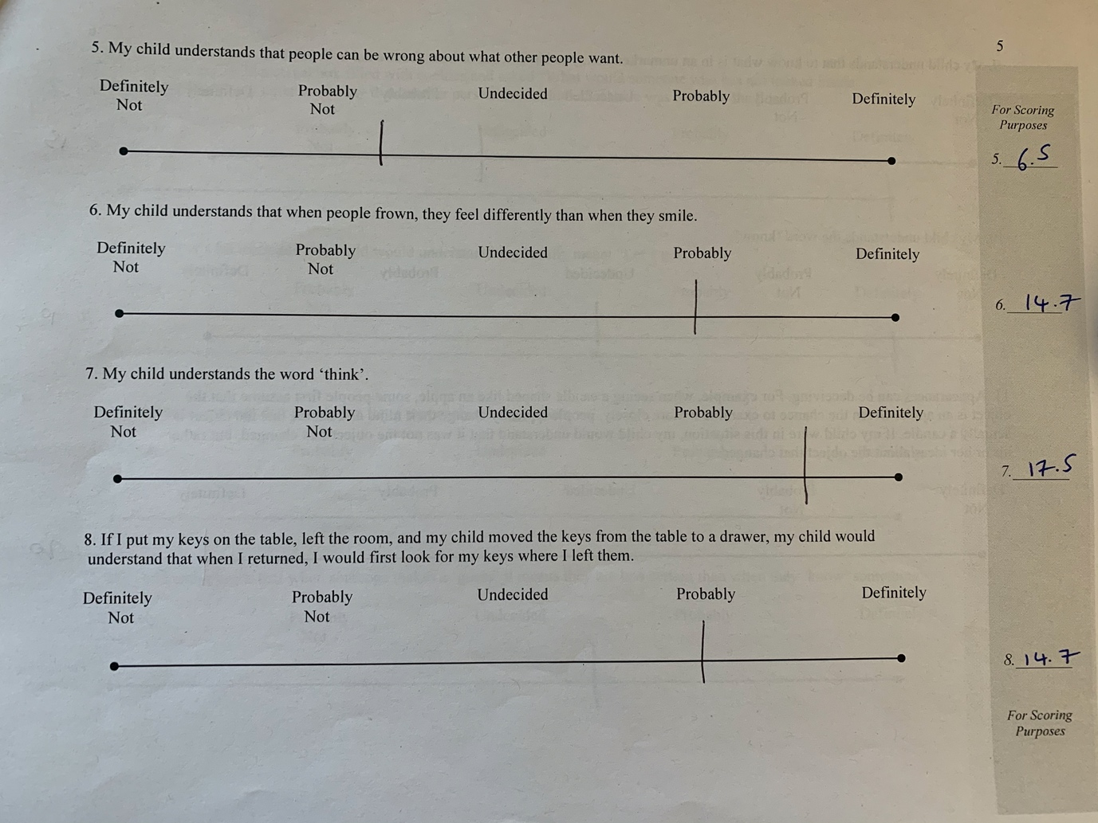There are three subscales relating to different sets of social skills (1. Early 2. Basic 3. Advanced). We have raw scores for each subscale. These subscales are also are combined for the composite score (mean of all raw scores) and Standard score).

* The Theory of Mind Task Battery (TOMTB) is a story book based assessment with intermittent questions and answers that are scored by the examiner. The assessment focusing on emotion recognition and perspective taking skills. This task lasts five minutes.

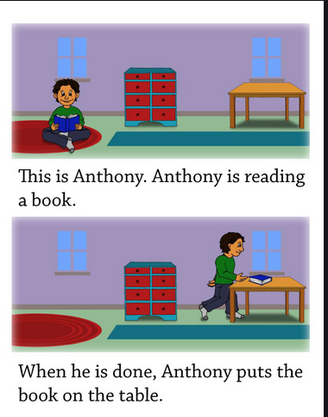

- The Psychomotor Vigilance Task is a sustained attention, reaction time-based assessment that is completed on a computer. Participants are instructed to press a single button on the keyboard as soon as a red stopwatch appears on the screen. The stopwatch will appear randomly every few seconds for 4 minutes. The main measurement of this task is not to assess the reaction time, but to measure how many times the button is not pressed when the stopwatch appears, or pressed when the stopwatch is not on the screen.

-The Flanker task is used as a measure of inhibition. Participants are asked to make directional responses to when viewing a horizontal array of cartoon fish (a new trial appears every 2.5 seconds) on the computer screen. They are instructed to pay attention to the direction of the fish in the middle of the array whilst ignoring the others (five fish in total). If the central fish faces left, they press the E button, and if the central fish faces right, they press the I button. The surrounding fish will randomly face the same (congruent trials) or opposite directions (incongruent trials) to the target fish. If they can complete 5 practise rounds, the participant completes 40 trials (with a 30 second break after 20 trials). The task takes around four minutes in total.

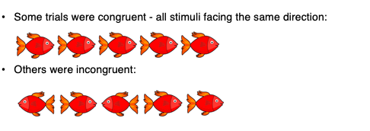

**Eye-tracking Tasks:**

1. **Figures Task:** We assess visual attention to interacting versus non-interacting human figures using a task by Stagg et al. Participants passively view photographs of real people (that have been transformed using Photoshop to produce colour, cartoonlike figures) who are facing one another (interacting) or are back-to-back (non-interacting) (there are always two pictures in each trial; one pair facing each other and one pair back-to-back. We measure participant preference by comparing looking times to each on every trial. We measure total looking time to interacting and non-interacting human figures.

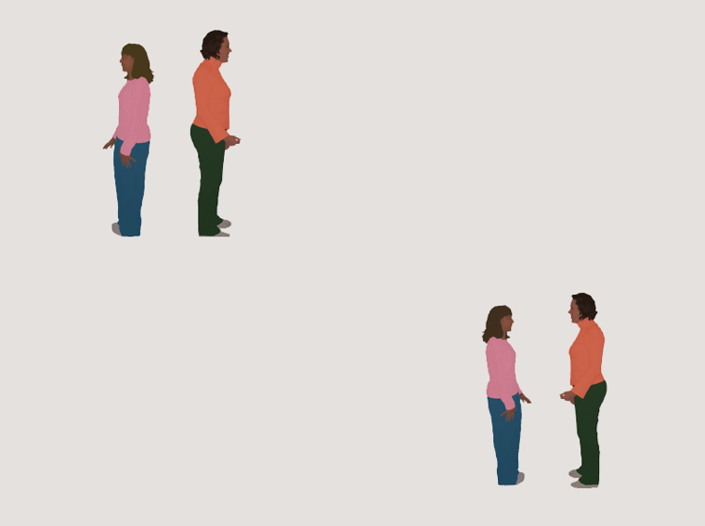

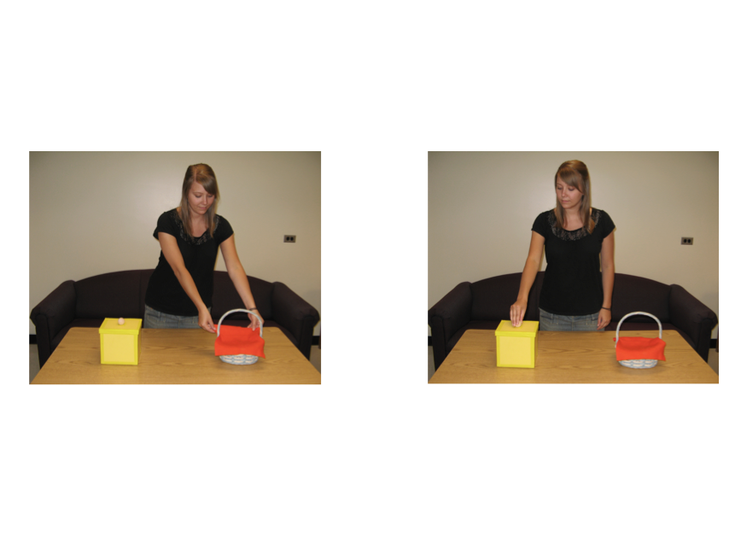**2. False Belief Task:** This measures oculomotor response to a classic false belief task (as seen in the Theory of Mind Task Battery). Participants view pictures set out like a story book (with 2 pictures on each page, as below. For each pair of pictures, they listening to an accompanying story, where one picture represents what is going on in the story and the other doesn’t. The story takes around 90 seconds. The measure we take is Looking time to each picture on the last page (false belief trial). One picture is a correct response, the other is an incorrect response. Children looking longer at the correct picture are seen to answer the question correctly.

**3. Language Processing Speed:**

-  The first task is a computerised version of the British Picture Vocabulary Scale (as above) examining understanding of language. Participants hear “Look! Look at the ...” whilst viewing four pictures on the screen. They are not required to respond verbally or physically but instructed to “look at the screen”. We measure the looking time to correct and incorrect responses to understand whether there are differences in understanding the words.

