Implementation on PLC side

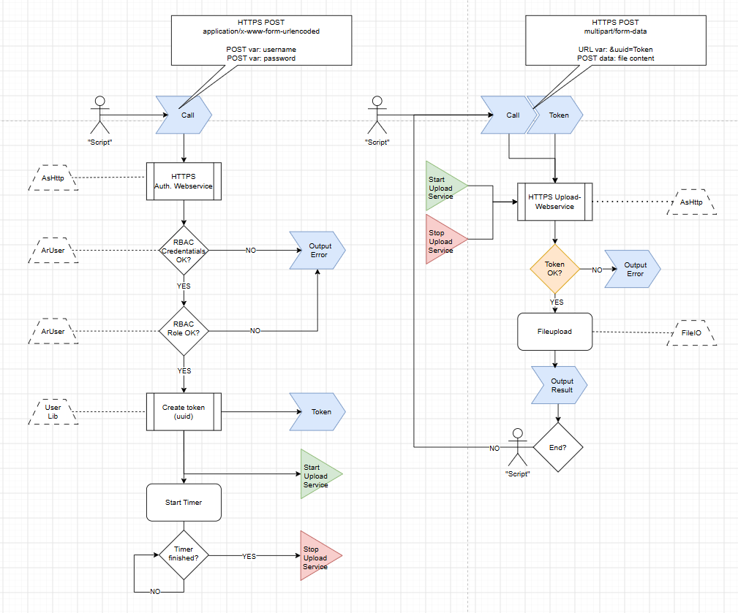

Logger on PLC side

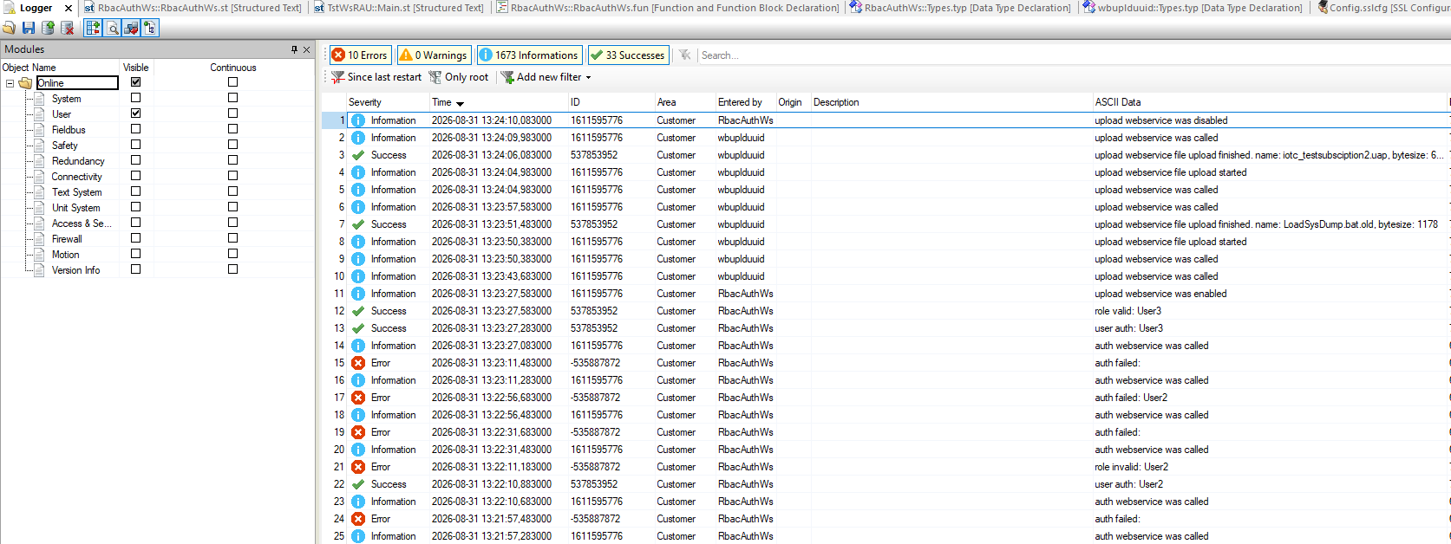

Powershell (script is already prepared for multiple uploads)

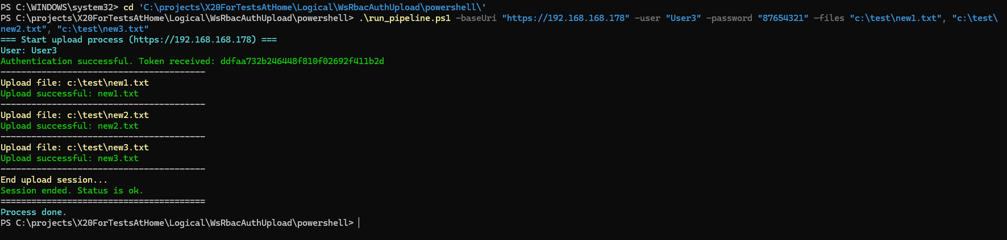

CMD (script is prepared just for single upload)

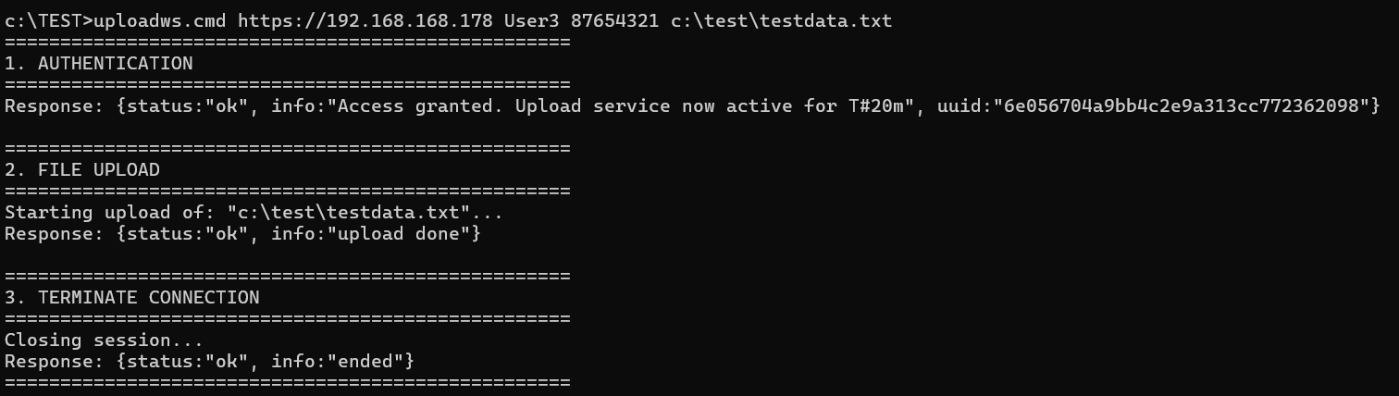

Linux Bash (script is prepared just for single upload)

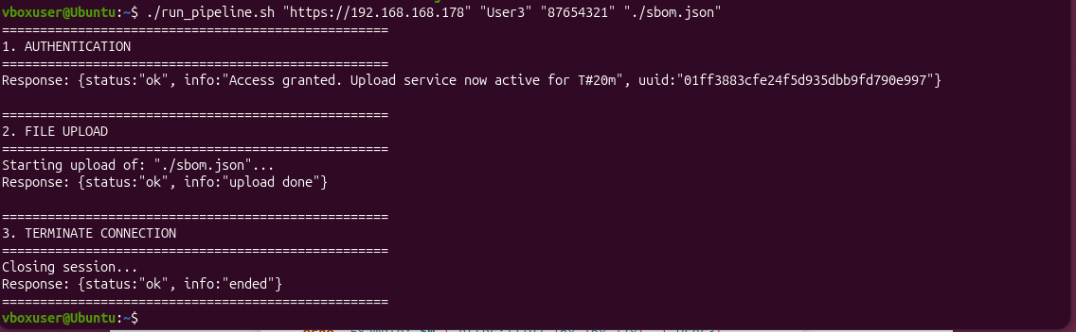

User / Role Setup

