**Plot of detected communities in bipartite network using Louvain Algorithm**

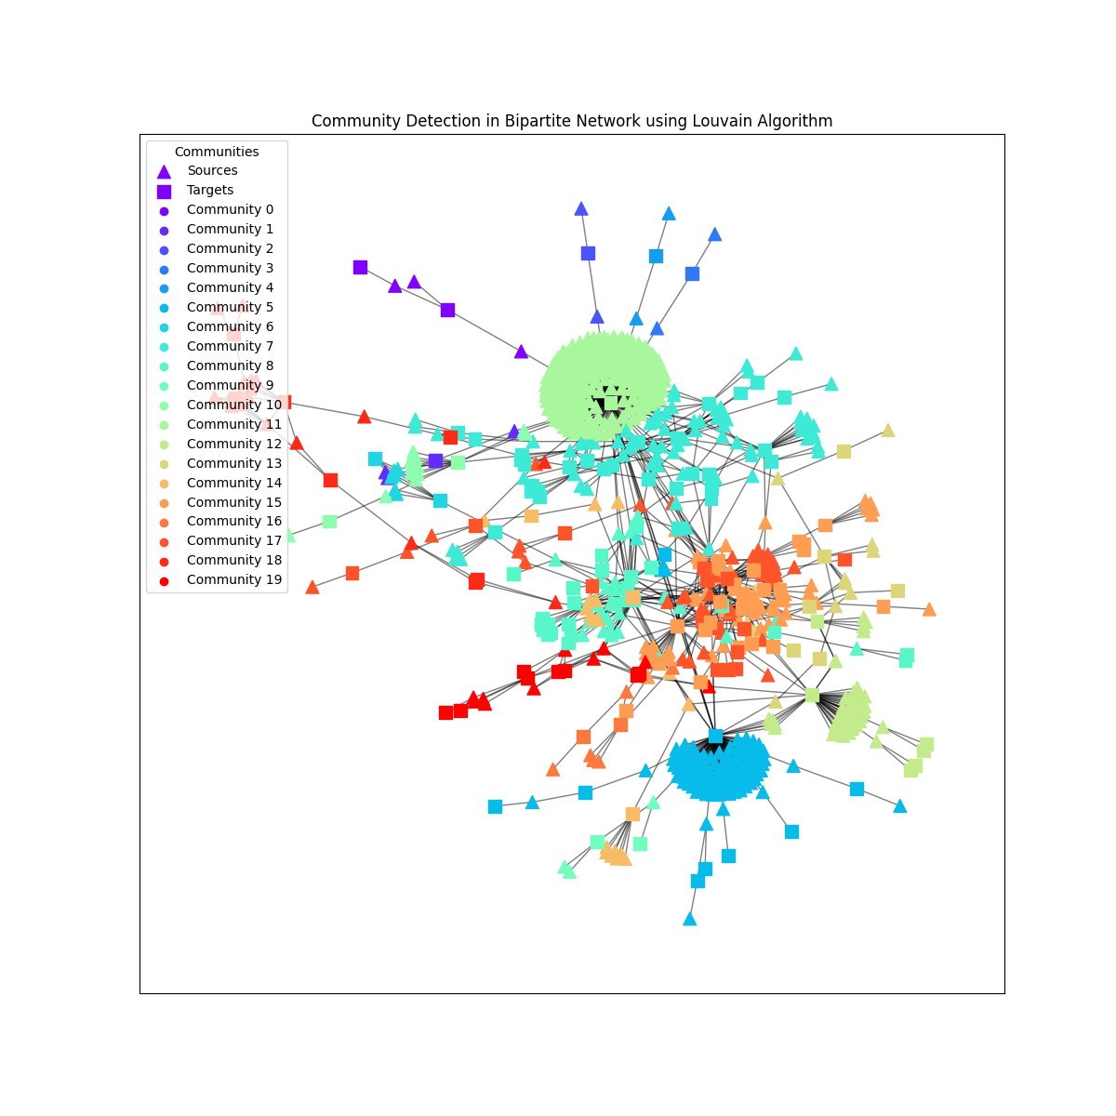

**Plot of detected communities in bipartite network using Leiden Algorithm**

