Q1 configure the cortex search and &amp, cortex search preview for the semantic document retrieval
1a create table and insert statements execution
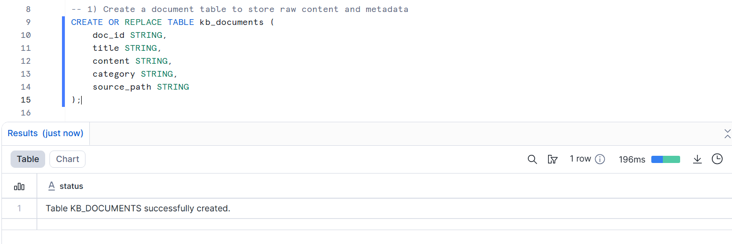
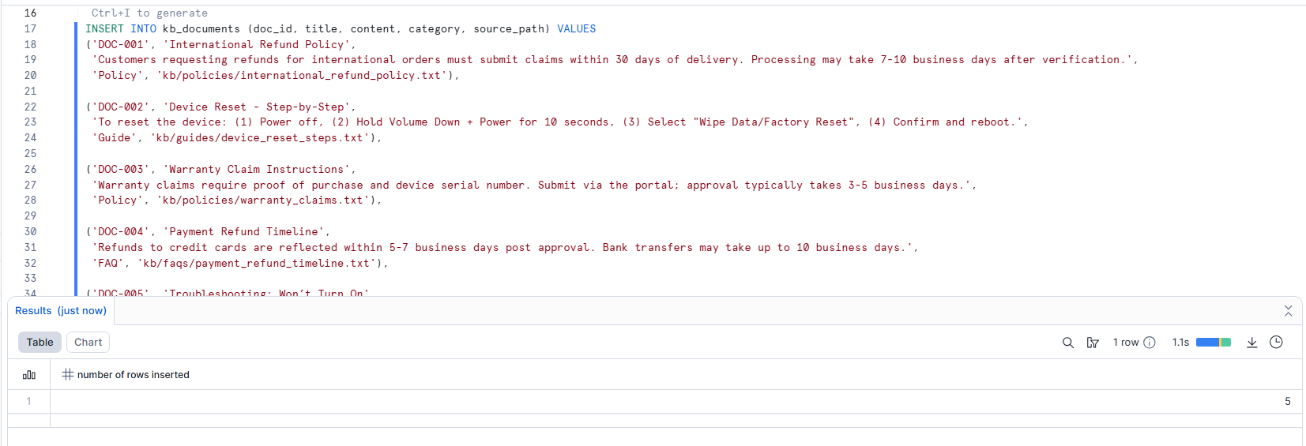
Successful loading of data
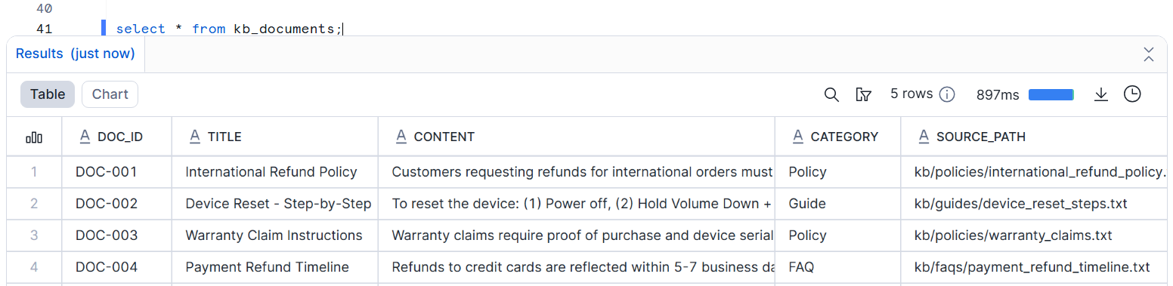

1b cortex search preview configuration creation screenshot
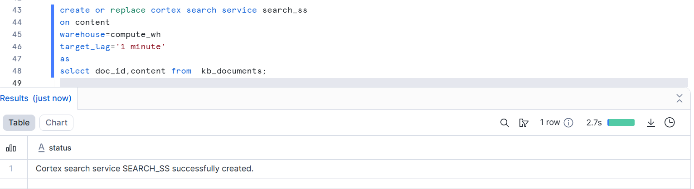
1c semantic query execution screenshot

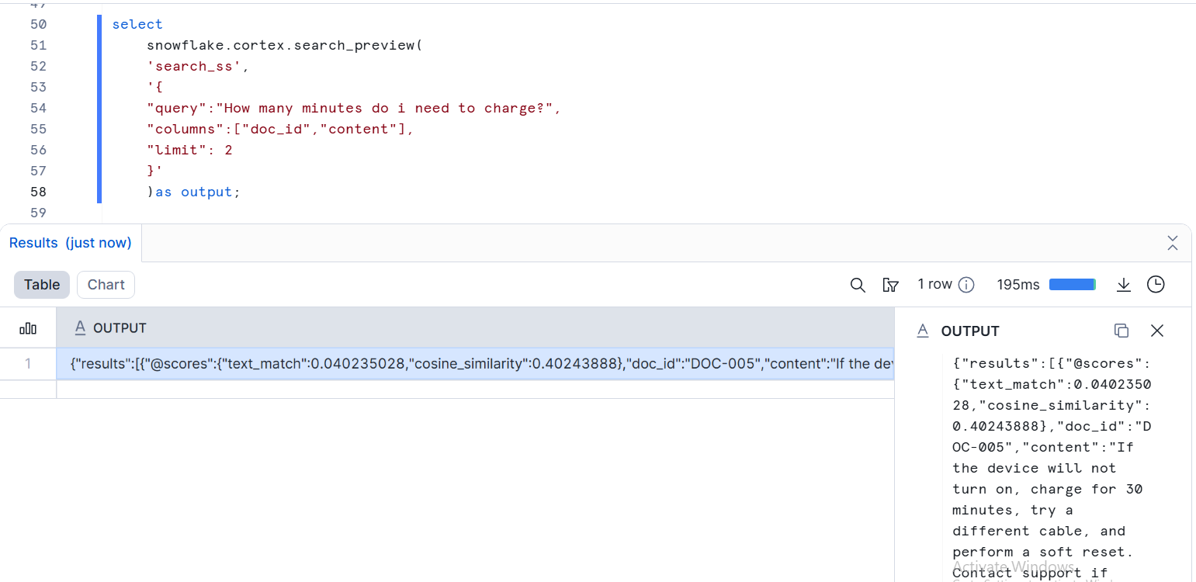
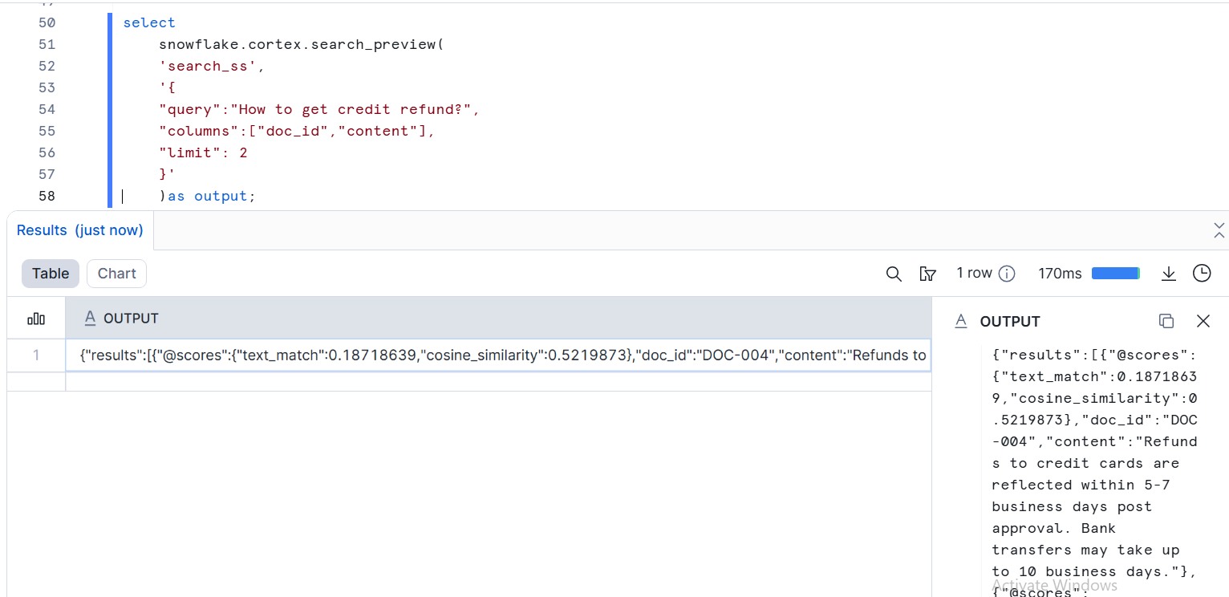
1d Final tabular output screenshot with columns query,matched title,snippet ,score ,category,doc_id.
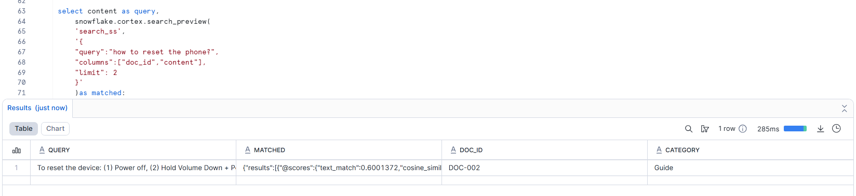
Q2 Build a streamlit app for category- wise sales by product
2a App running with the sidebar filters visible
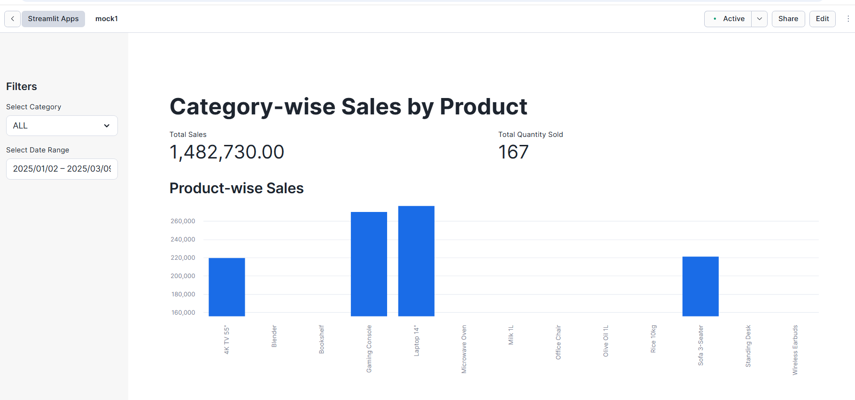

2b bar chart showing category sales by product
Whole bar chart
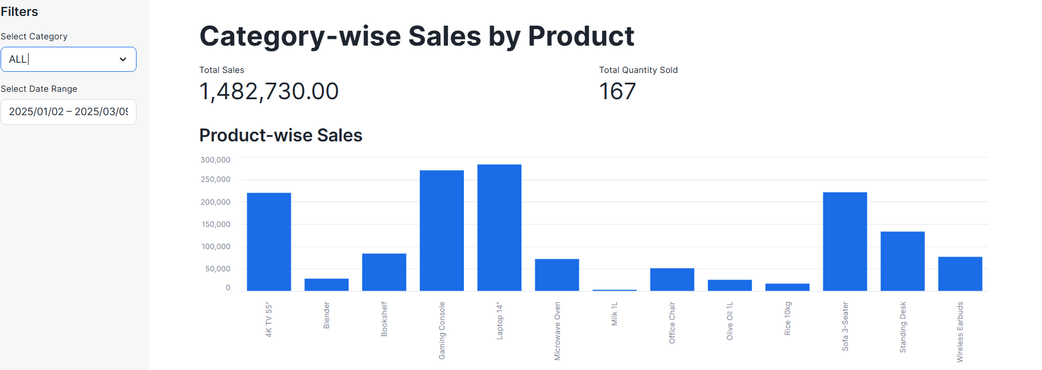
Bar chart for category electrinics
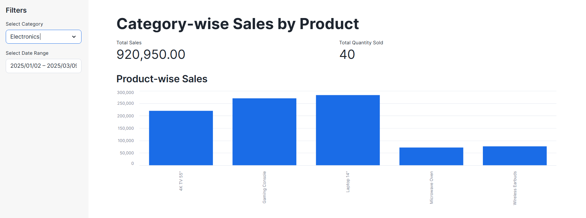
2c pie chart showing sales share by category

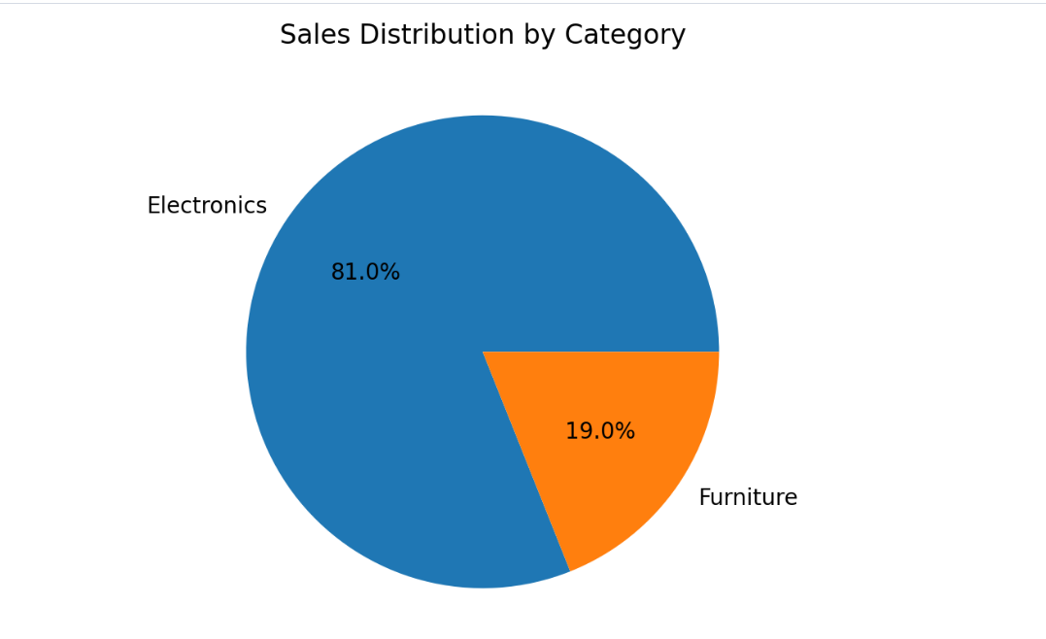
2d line chart + summary table showing time series trends and top products
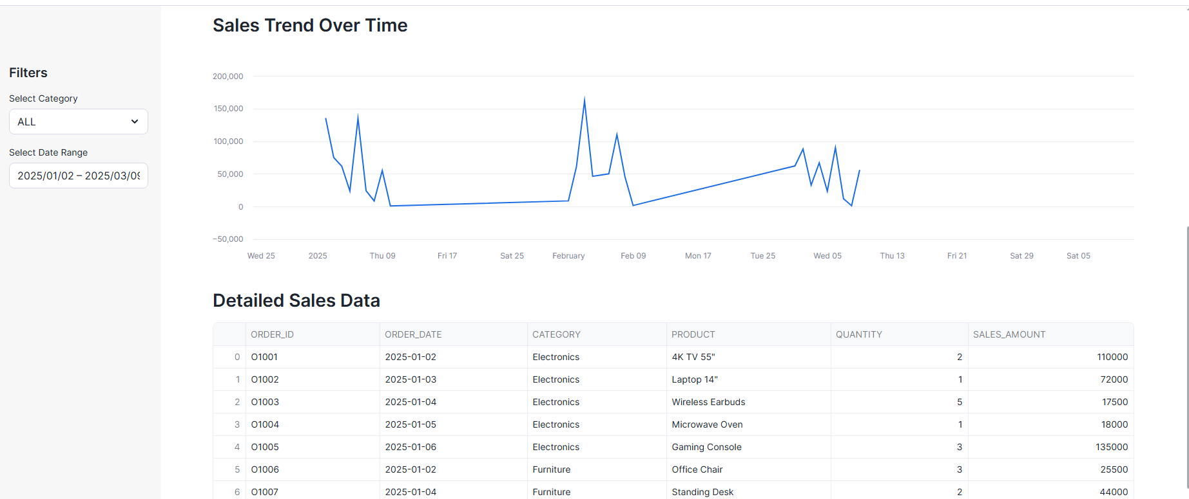
Applying of date filter
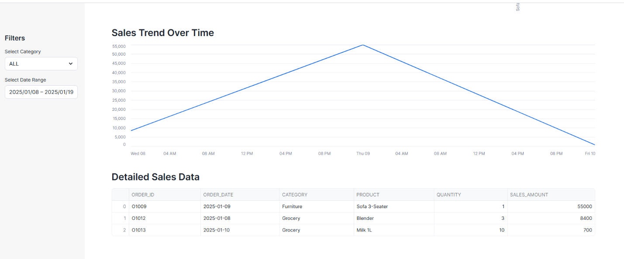
Q3 Join two snowpark dataframes, aggregate and apply having filters and sort descending (SNOWPARK)
3a snowpark session initialization and dataframe from sales orders and product masters
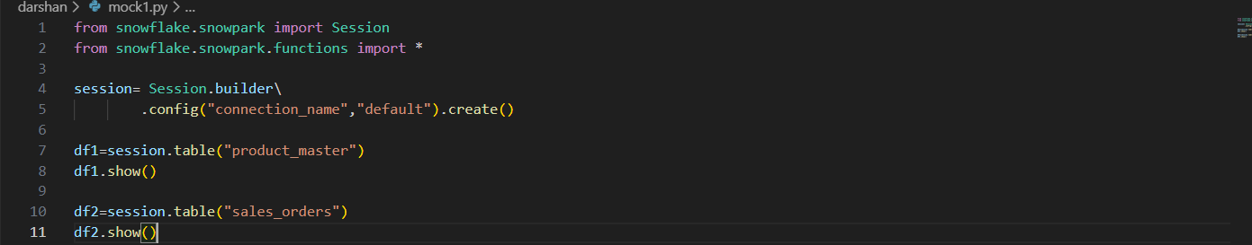
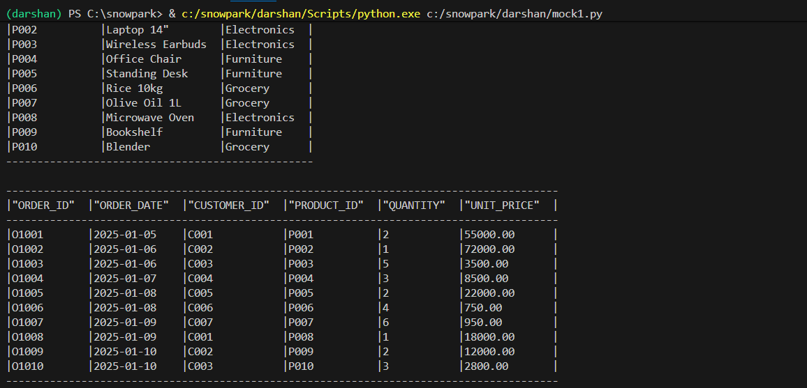
3b join step showing snowpark dataframe .join and revenue derivation
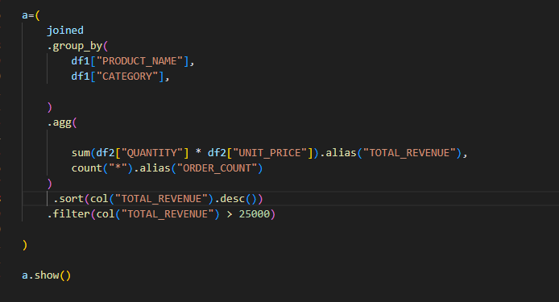
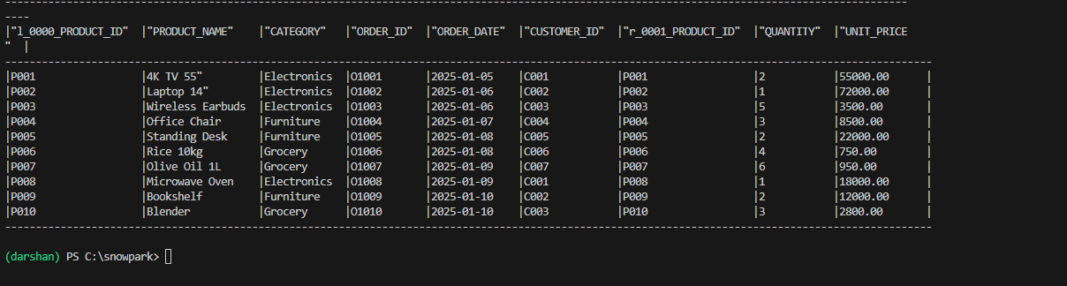

3c aggregation + having like filter step (group by ,agg,filter/where)

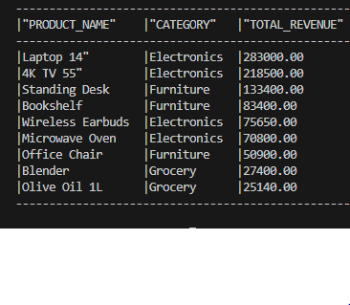
3d Final sorted output table
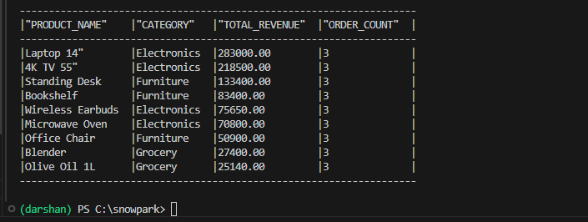

Q4 Load json data using the stage and flatten array of marks
4a Create table / stage/file format/copy into statement and execution
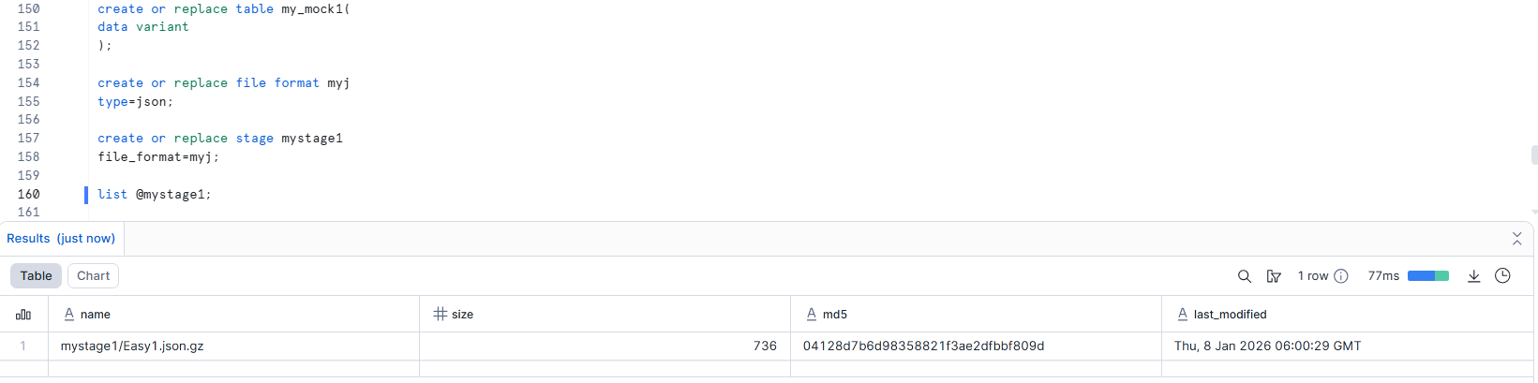
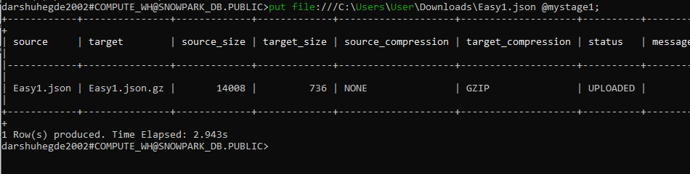
4b select query of showing raw variant data
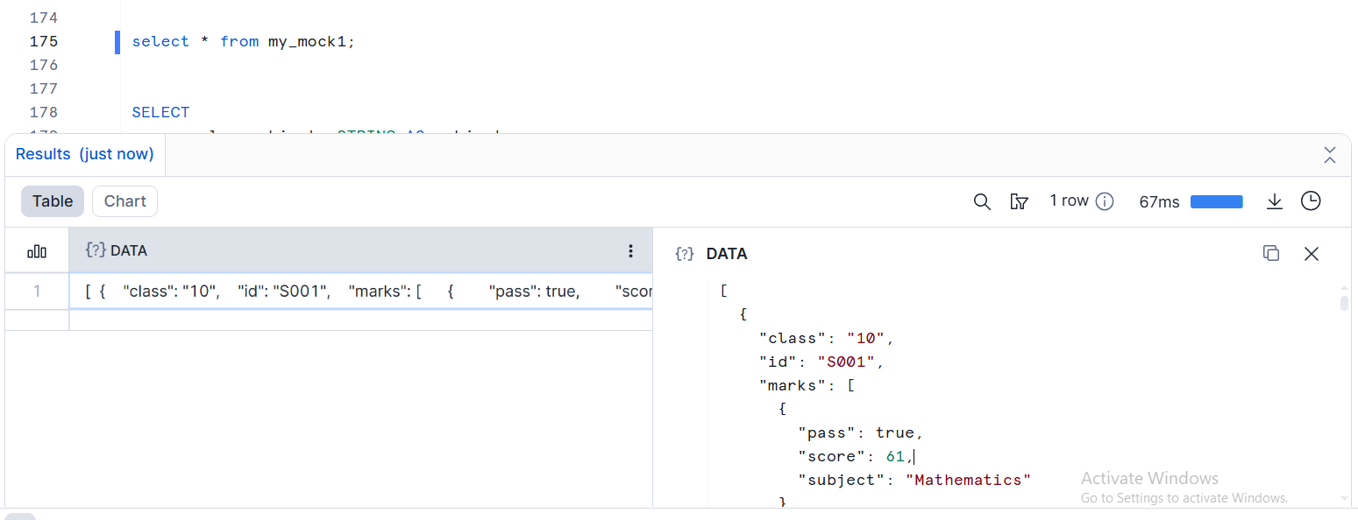

4c select query showing lateral flatten on the marks array with nested field extraction
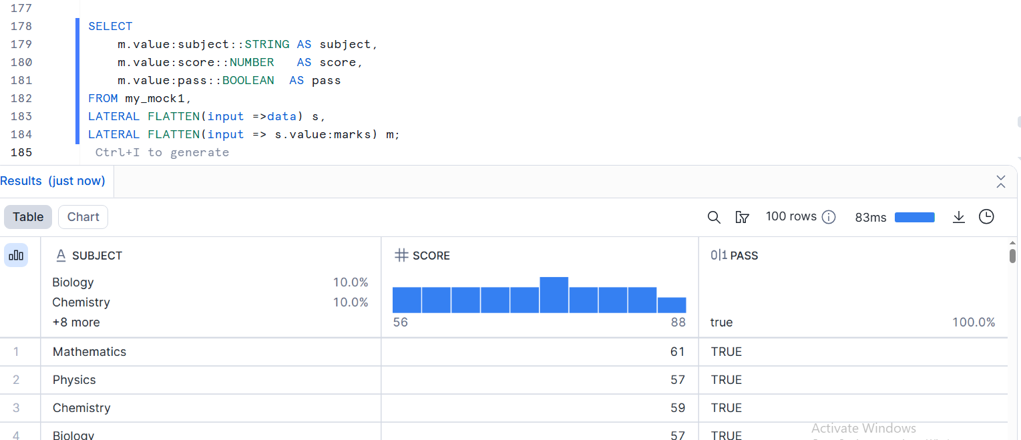

4d final query with flattened colums (student metadata + subject, score)
