Q1 Load json via stage and flatten array of sessions
1a Execution of create table,create stage,create file format , copy into statements
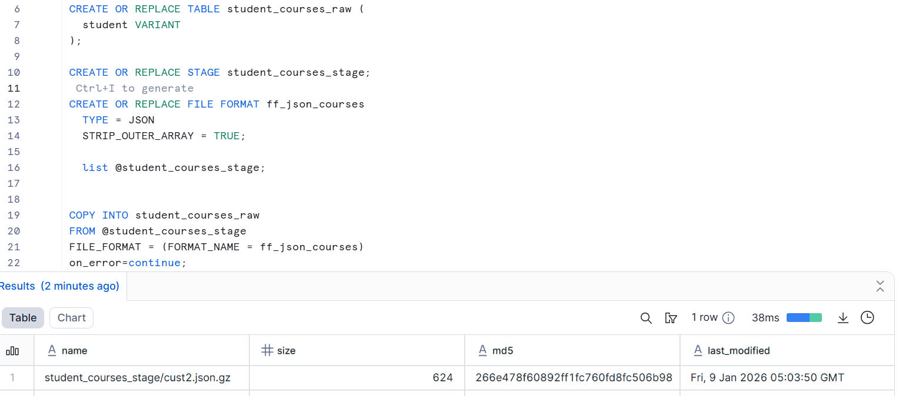
Json data loaded to stage
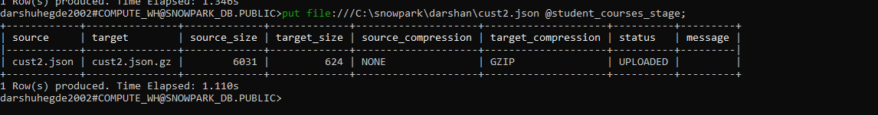
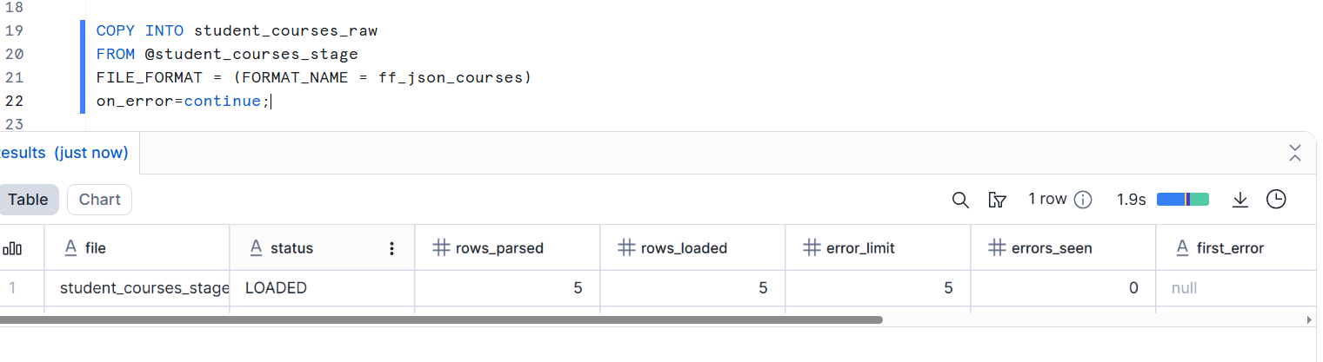
Select query showing raw variant data
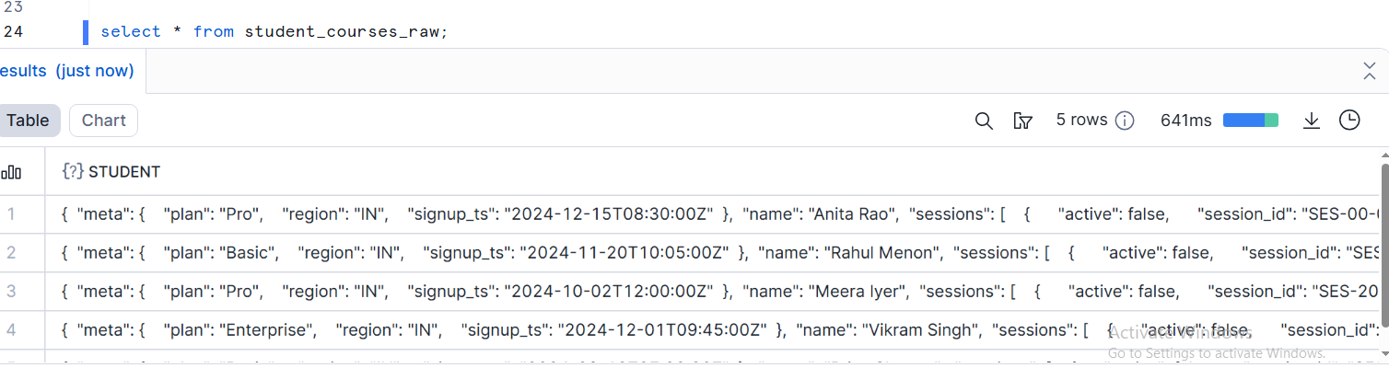

1b select query using lateral flatten on the session array with nested field extraction.
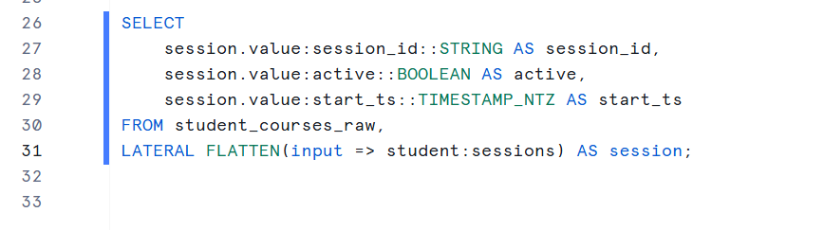
1c final output query displaying flattened columns
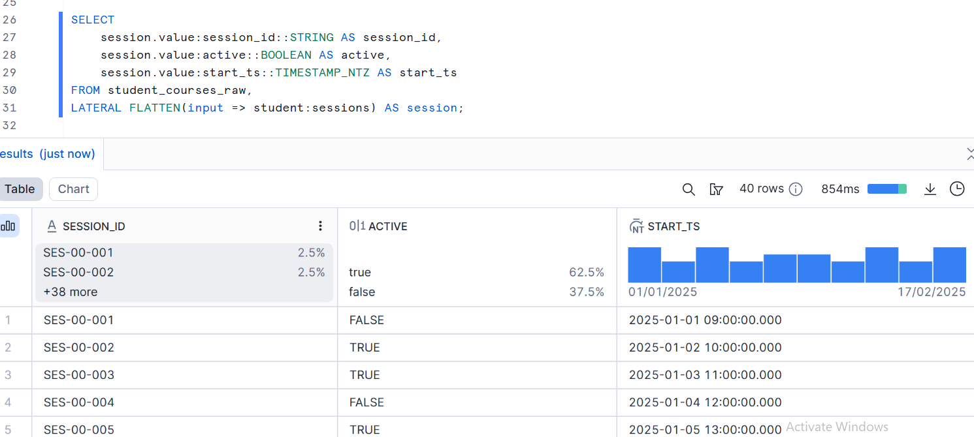
1d (user metadata+sessionID,start_ts,active)
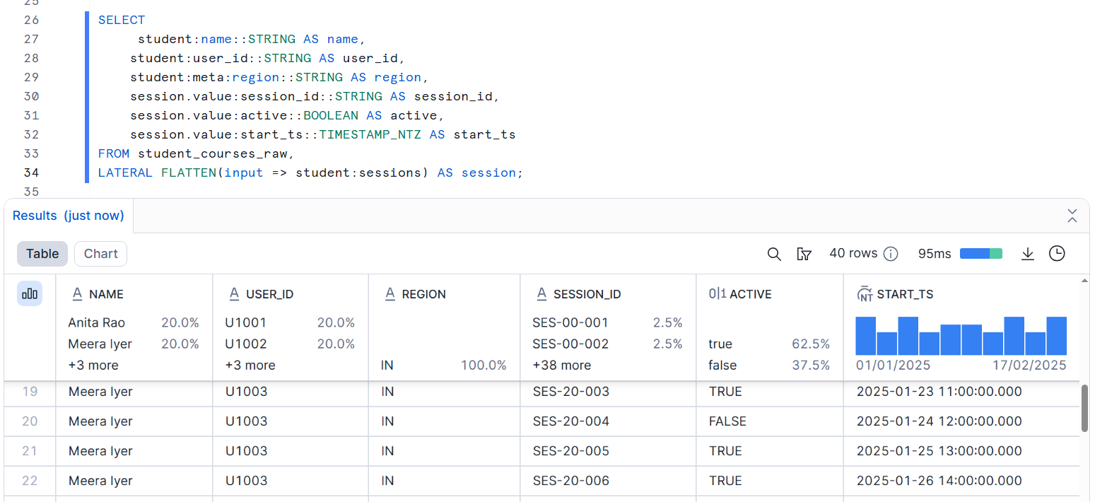
Q2 Build streamlit App for city-wise orders by fulfilment type (Interactive filters and native visuals )
2a App running with the sidebar filters visibe (city , fulfillment type, date range)
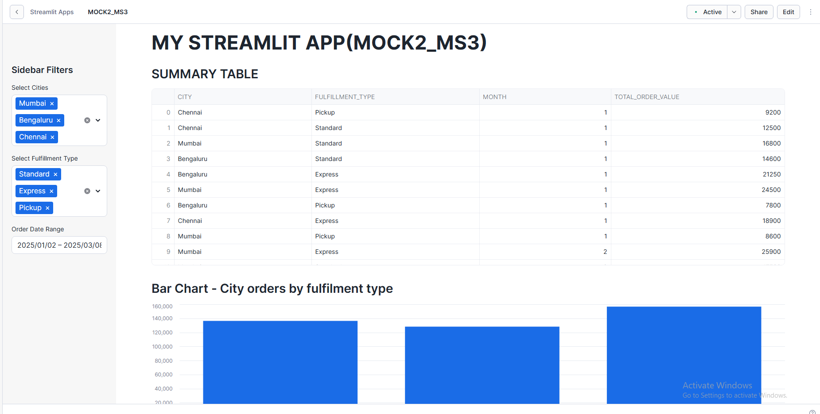
2b bar chart showing city orders by fulfillment type(filtered)
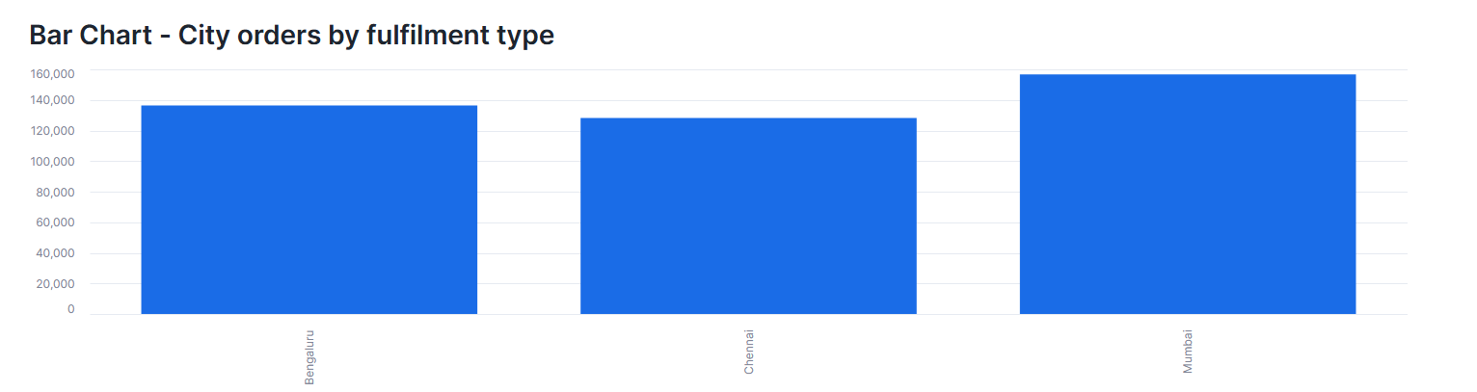
After applying filter
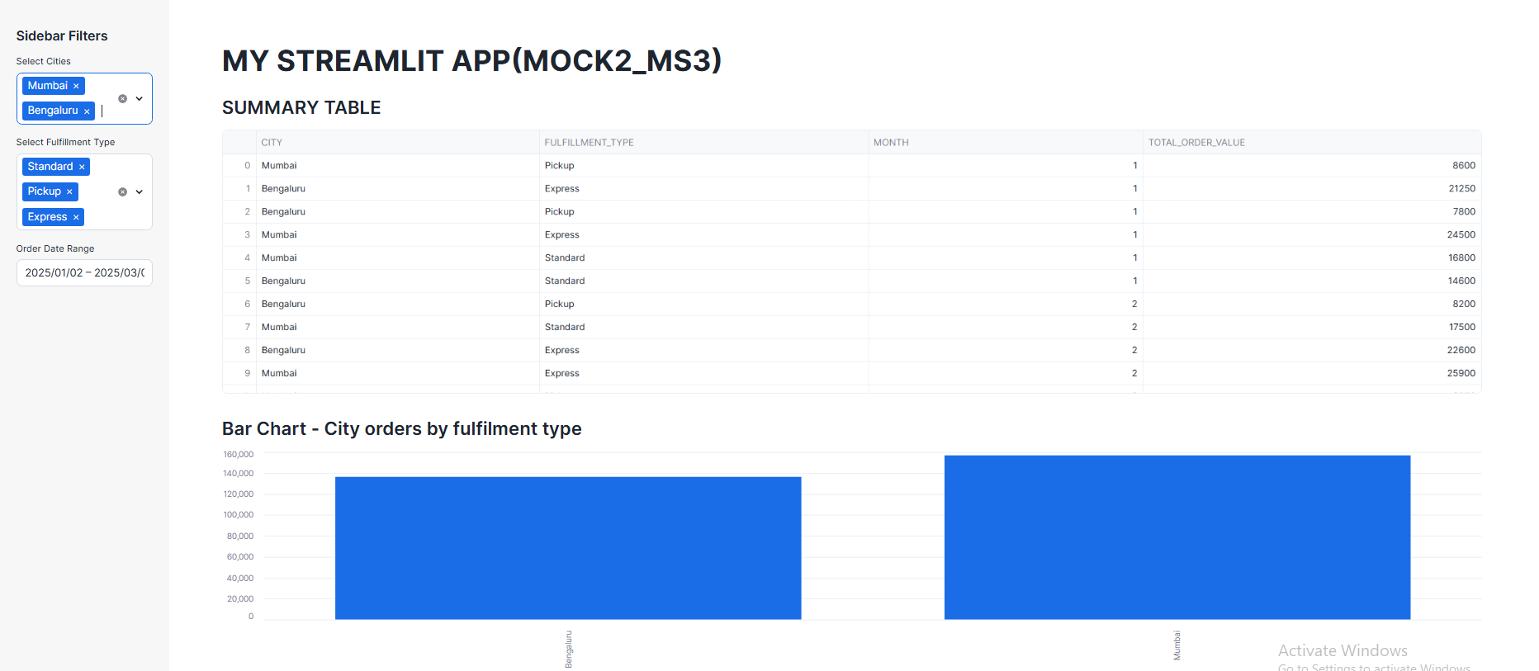
2c pie chart showing order value shared by city (filtered)

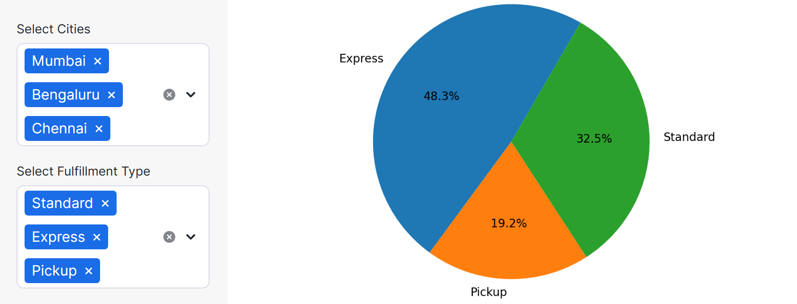

After the filter application
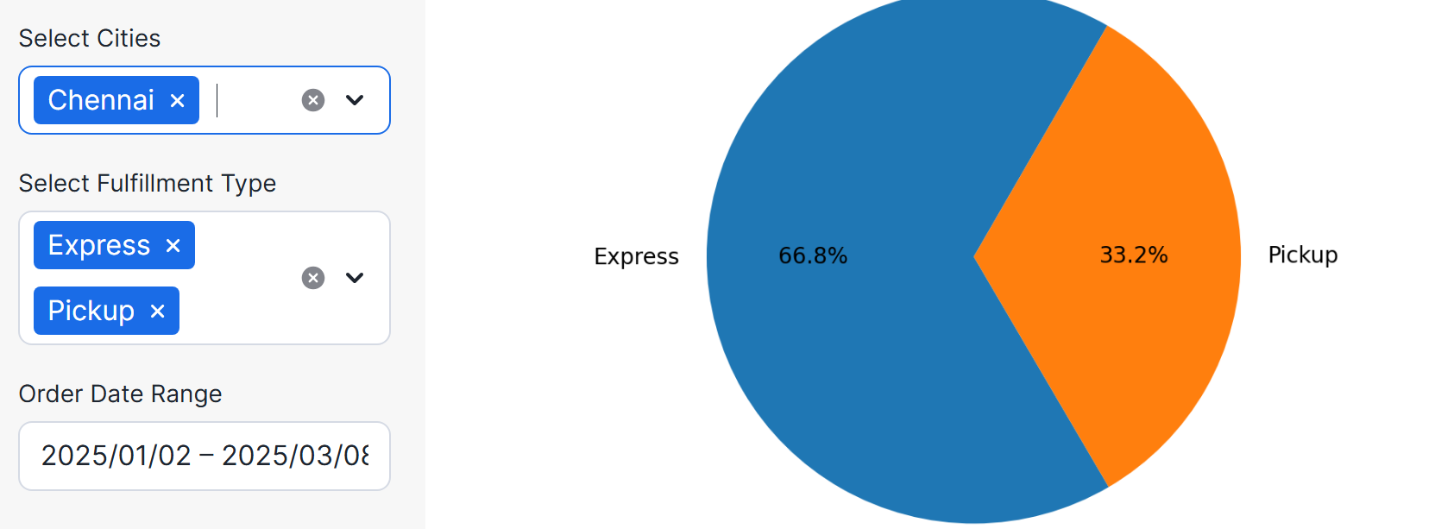
2d line chart + summary tables showing time series trends and top fullfillment types
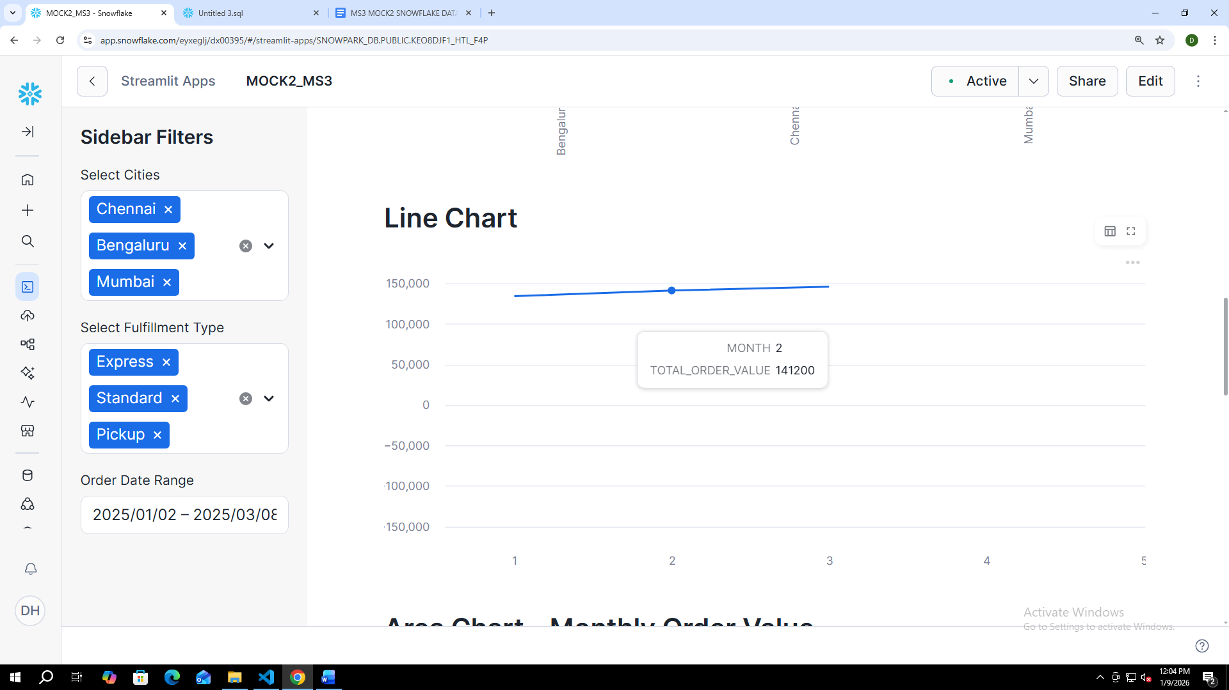

After applying filter
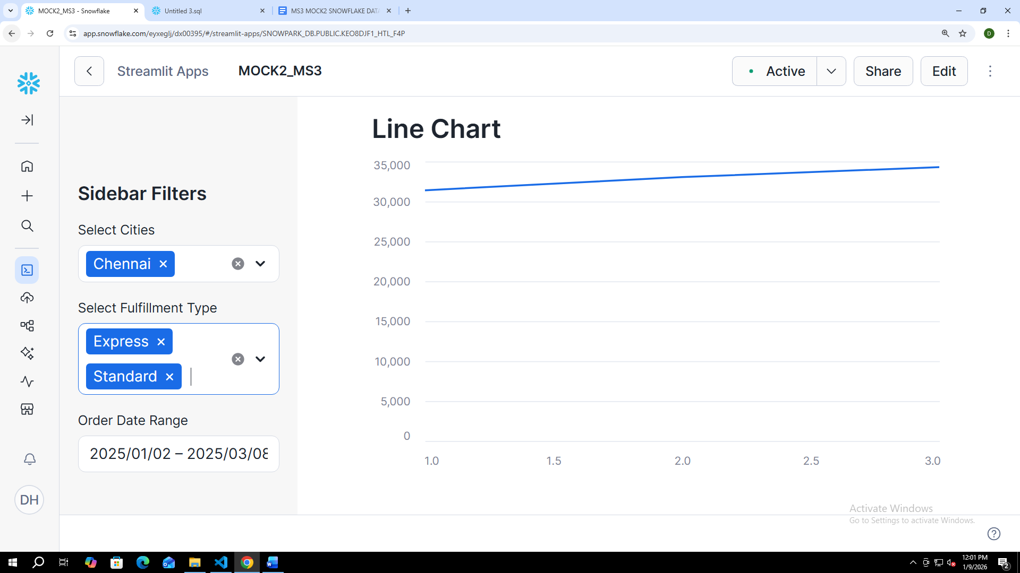

Q3 Configure the cortex search service and cortex search preview for semantic document retrieval
3a create table and insert statements execution
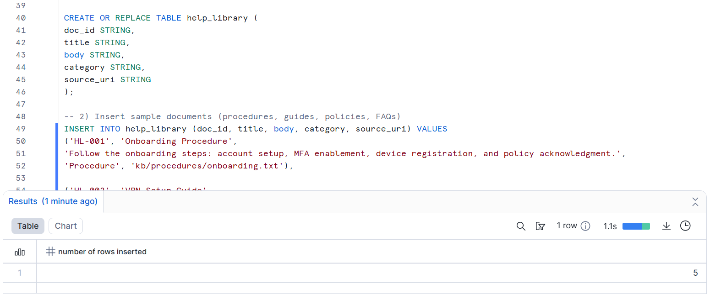
3b cortex search preview configuration creation screenshot (index and config setup)
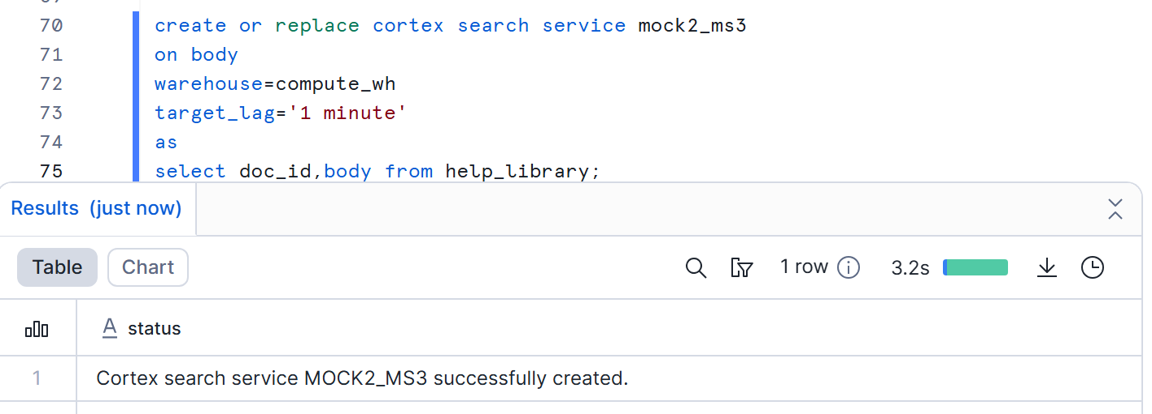
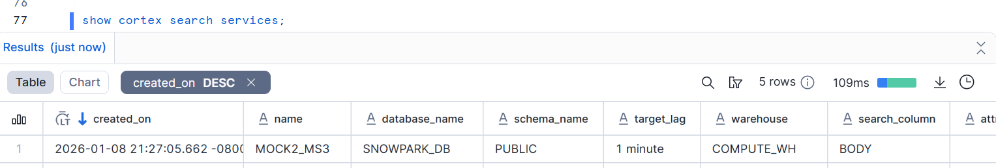

3c semantic query execution screenshot with two different queries, showing top matches the scores
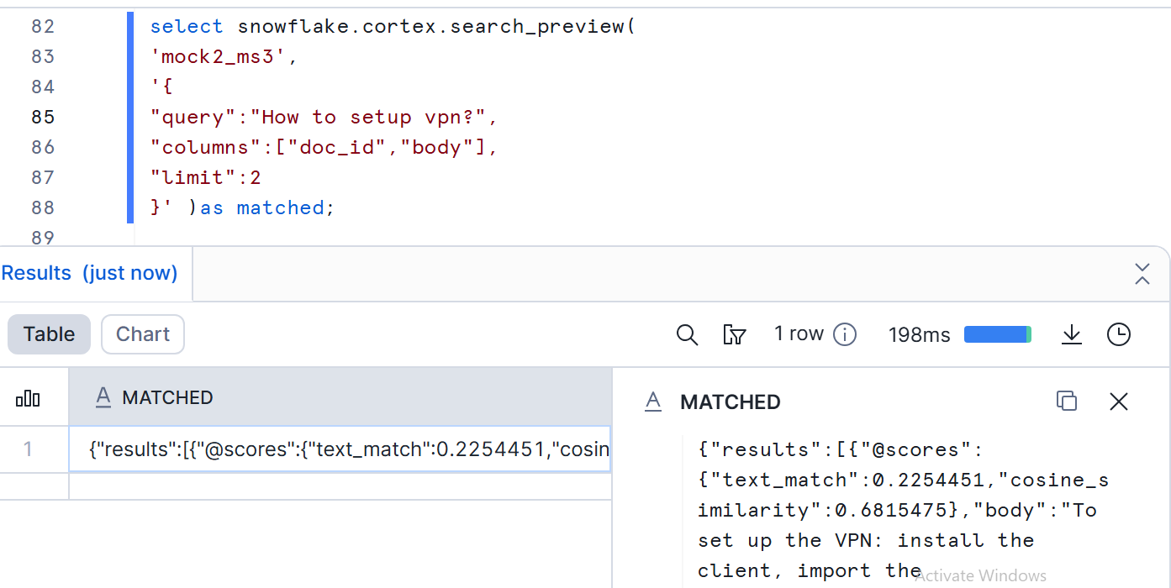
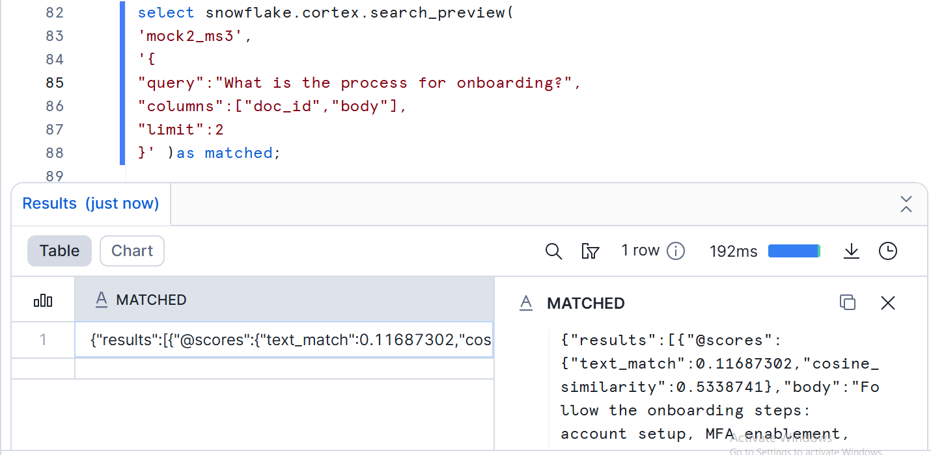

3d Final tabular output screenshot with columns query ,matched , snippet ,score ,category,docid
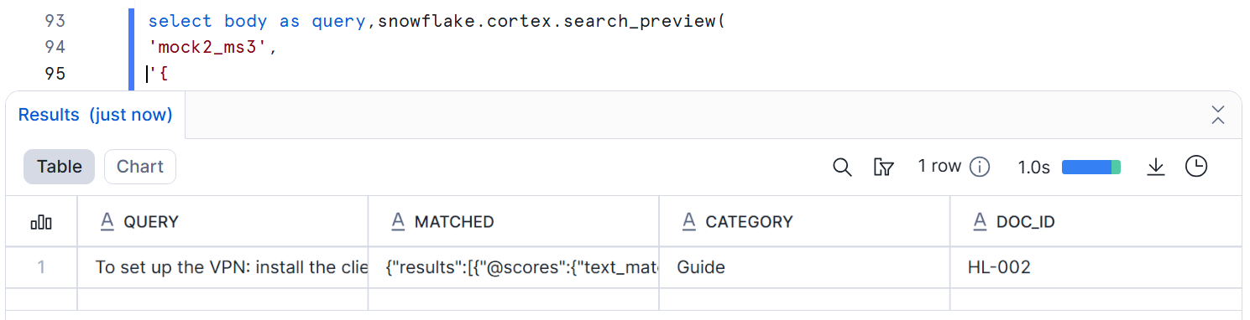

Q4 Join two snowpark dataframes, aggregrate , apply having like filter and sort descending
4a snowpark session initialization and dataframe creation from sales_lineitem and product_dim
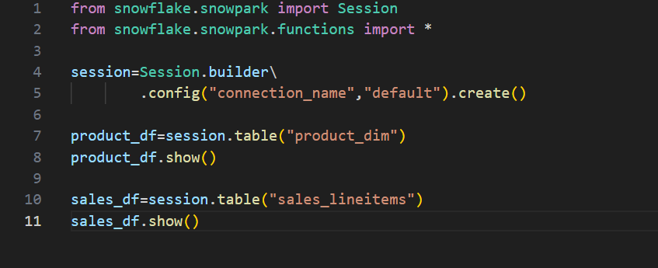
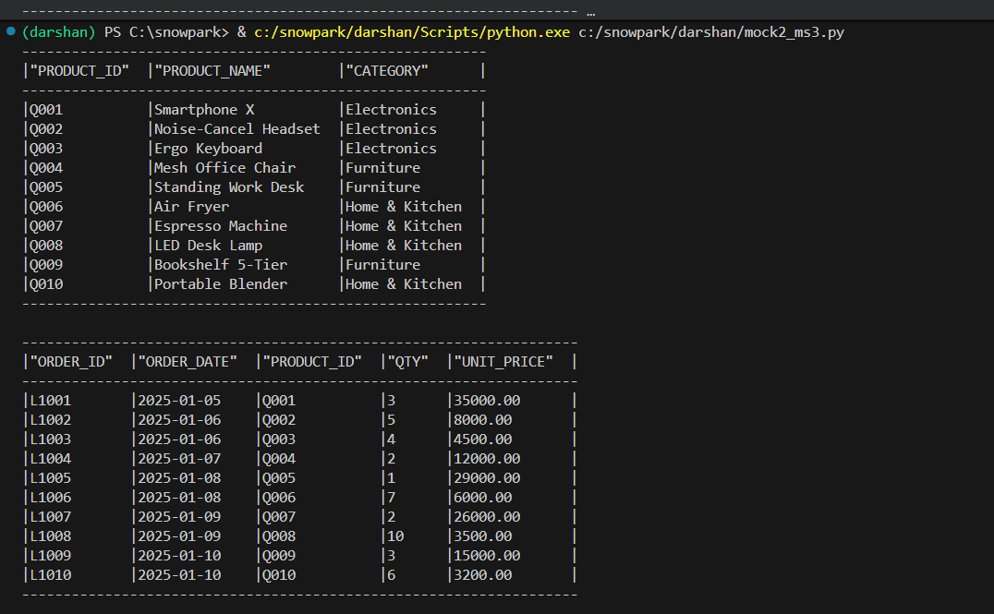

4b join step showing snowpark dataframe .join and revenue generation
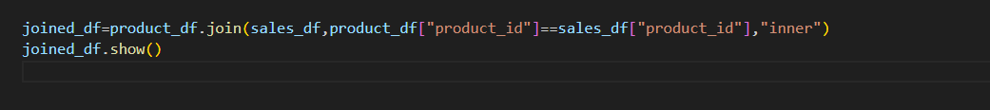
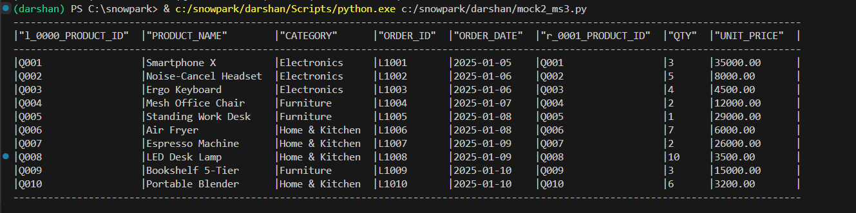
4c aggregation and having like filters step group by ,agg,filter
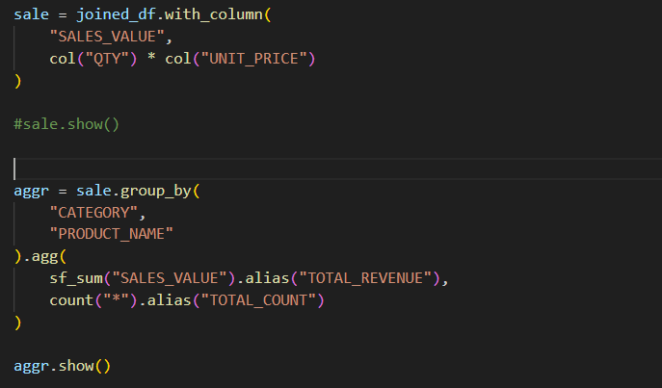
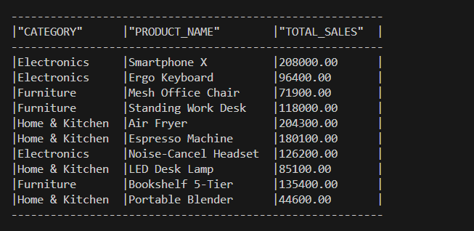

Application of filter
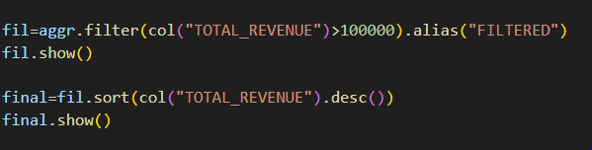
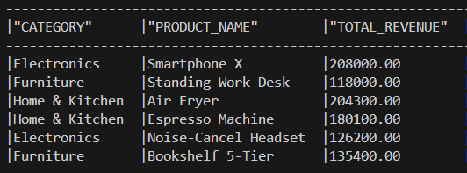

4d Final sorted output table with category product name total revenue order count

